Car Accident Analysis Questionaire

# **Intial Questions about the dataset**

## **Accident Info**

- Time period of the data goes from .... to ....

2012/01/01 - 2023/09/30

- Check the number of accidents within time period

Total 167043 rows of data

- What time does most accidents happen?

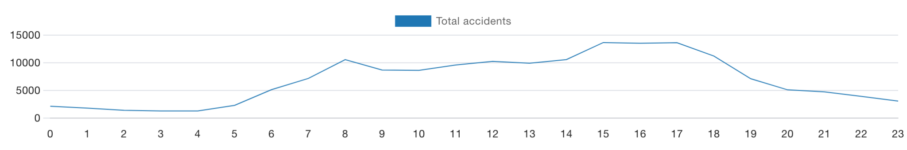

- What is the most occuring accident type?

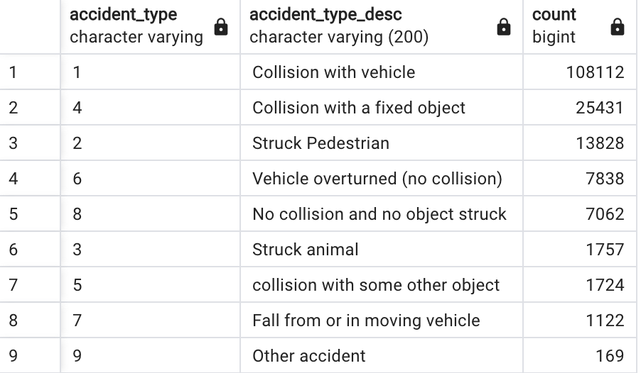

- Which day has the most accidents happen?

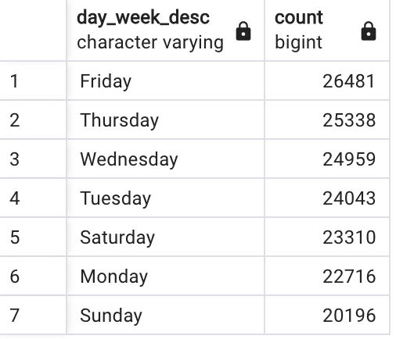

- The average number of police attendance related to number killed/injuried?

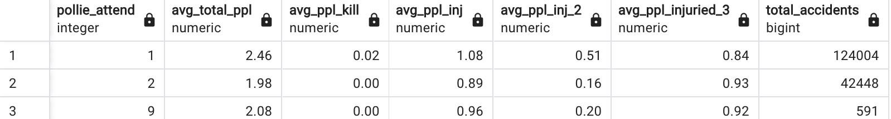

- What accident type kills/injures more people?

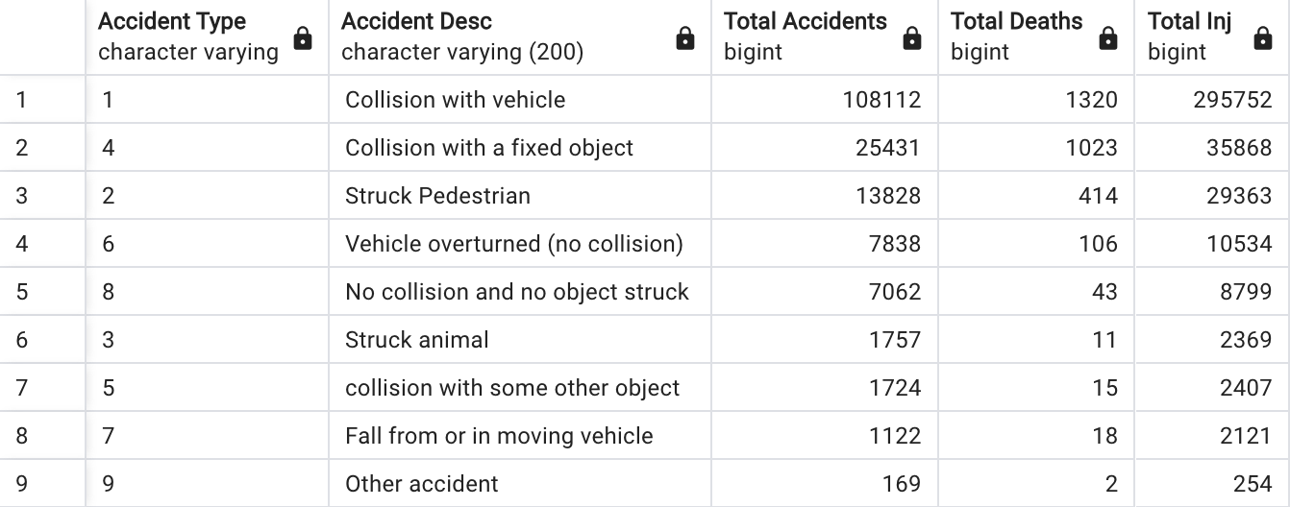

- What speed zone has more accidents? what type of accidents for each speed zone?

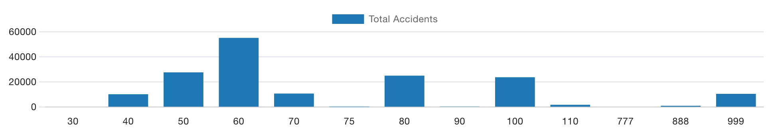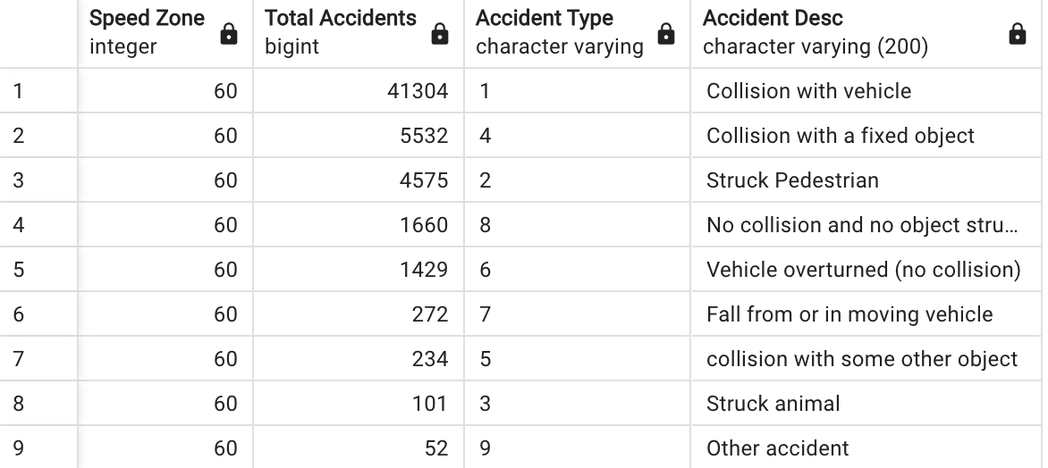

- Does speed zone correlate with severity of accident?

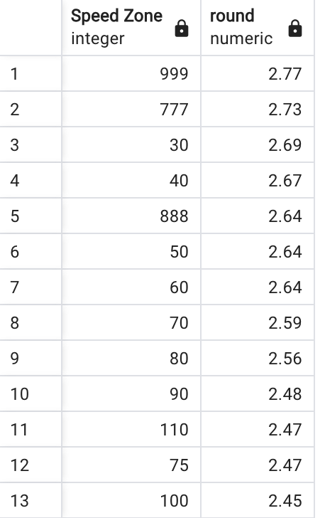

- Does road geometry correlate with amount of crashes?

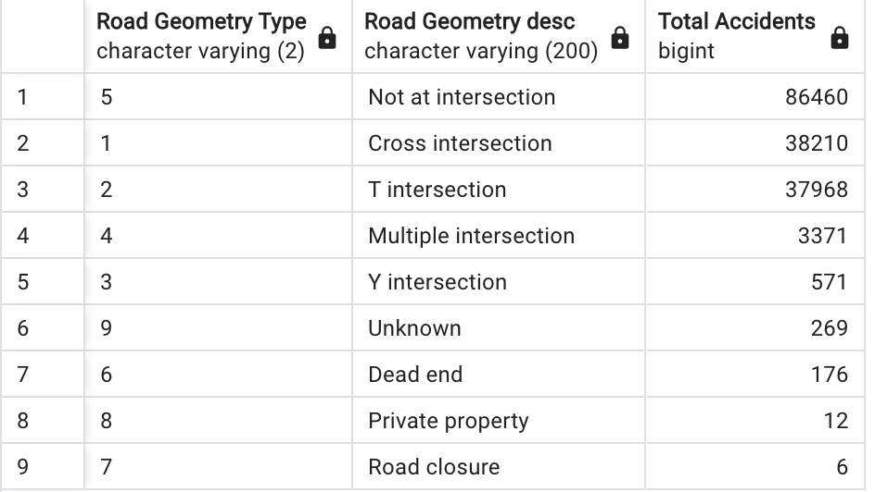

## **Vehicle dataframe**

- What brand has the most accidents?

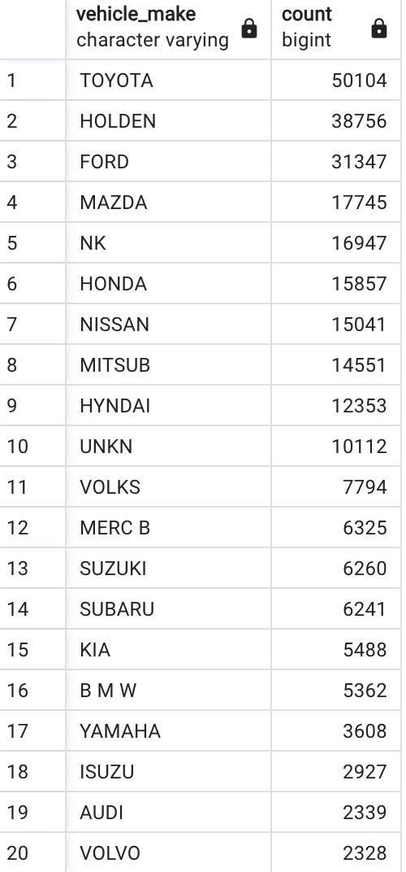

- Does color affect accident occurance?

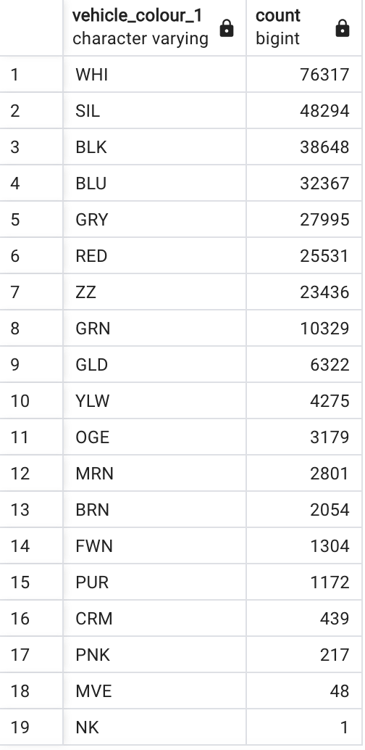

- Does Year manufacturing affect the accident occurance?

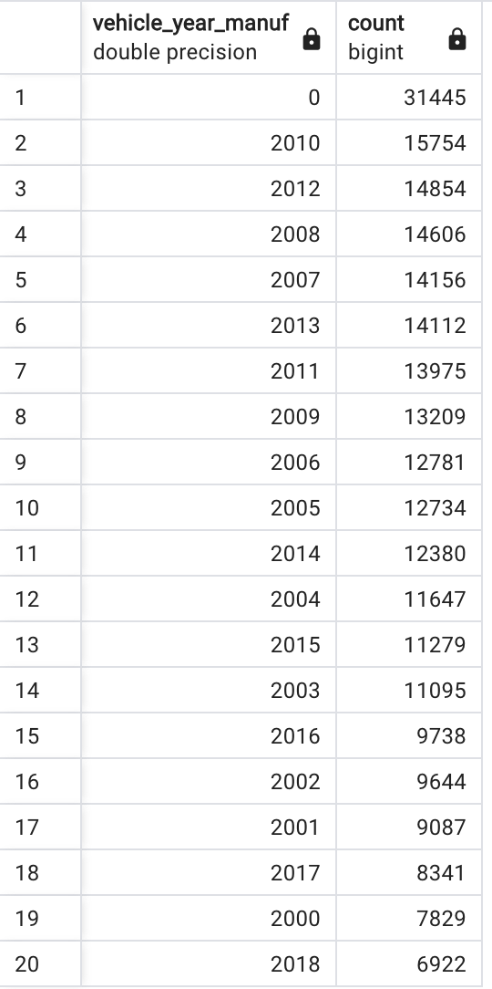

- Does Veh body style affect accident occurance

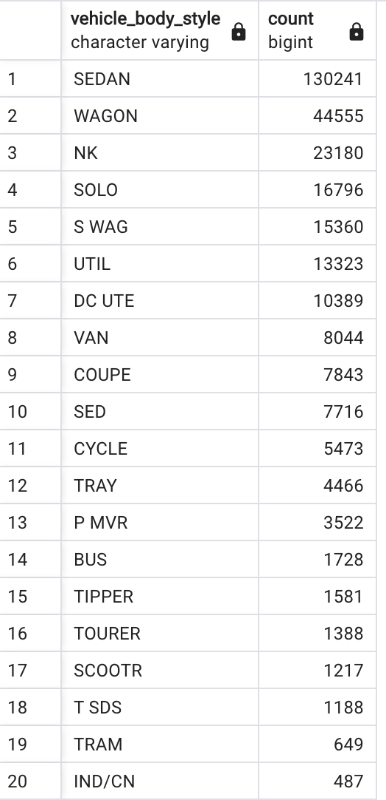

- What brand has higher level of damage?

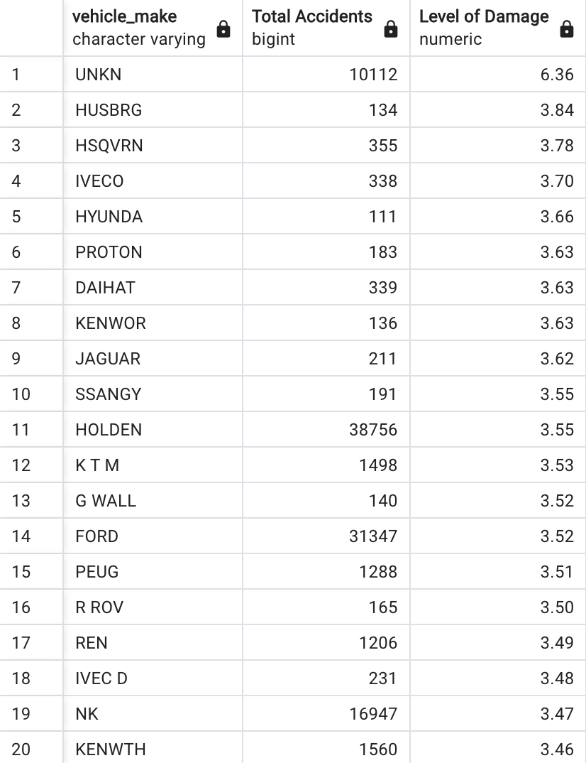

- Does direction affect accident occurance?

