Huynh, Peter

September 8, 2016

CSCI 3302

Homework 1

Introduction to Robotics

1. What are the degrees of freedom of a standard, four-wheel, hand-pushed lawnmower? Why are you still able to mow your entire lawn?

A hand-pushed lawnmower would possess **2** degrees of freedom:

* Traversal along the Row axis
* Rotation along the Yaw axis

Although a lawnmower only has 2 degrees, similar to a car, it is still able to traverse the entire lawn. It’s restrained to 1 degree each moment while moving, but can move into any perpendicular point to the previous at will whenever required. This is done via one axis movement and the rotation of that axis, thus it can fully traverse the lawn’s plane.

2. What are the maximum degrees of freedom for objects driving on the plane?

If you are considering the object in respect to the Earth, it is also considered suspended in air, and thus possesses the full **6** degrees of freedom like the plane.

3. (a) Calculate the angle between vectors (*cos*45o, **−***sin*45o, 0)T and (*sin*45o, *cos*45o , 0)T.

🡺 *cos*(45o) , **−**sin(45o) , sin(45o) 🡺 u̅ = (, , 0)T, v̅ = (, , 0)T

🡺 u̅ ∙ v̅ = || u̅ || || v̅ || cos(θ) 🡺 cos(θ) =

🡺 || u̅ || = = 1 🡺 || v̅ || = 1 🡺 u̅ ∙ v̅ = ux*vx + uy*vy + uz*vz = 0

🡺 cos(θ) = 🡺 θ = cos-1( ) 🡺θ = = **90o**

(b) Provide a third vector that forms a coordinate system with the other two.

In order for a third vector to form a coordinate system with the two previous vectors, it must be perpendicular to both, possessing a 90o angle between both vectors. Once vector that satisfies this condition would be **(0, 0, *cos*45o)T**.

4. (a) Write out the entries of a rotation matrix R assuming basis vectors XA, YA, ZA, and XB, YB, ZB.

R = [AX̂B AŶB AẐB] 🡺 AX̂B = (X̂B ∙ X̂A, X̂B ∙ ŶA, X̂B ∙ ẐA)T 🡺

**R =**

|  |  |  |  |  |
| --- | --- | --- | --- | --- |
|  | **X̂B ∙ X̂A** | **ŶB ∙ X̂A** | **ẐB ∙ X̂A** |  |
|  | **X̂B ∙ ŶA** | **ŶB ∙ ŶA** | **ẐB ∙ ŶA** |  |
|  | **X̂B ∙ ẐA** | **ŶB ∙ ẐA** | **ẐB ∙ ẐA** |  |

(b) Express X̂B = [0, 1, 0]T in frame {A}.

**{A} =**

|  |  |  |  |  |
| --- | --- | --- | --- | --- |
|  | **0** | **ŶB ∙ X̂A** | **ẐB ∙ X̂A** |  |
|  | **ŶA** | **ŶB ∙ ŶA** | **ẐB ∙ ŶA** |  |
|  | **0** | **ŶB ∙ ẐA** | **ẐB ∙ ẐA** |  |

(c) Write out the entries of rotation matrix R.

The inverse of R as RT 🡺 R = RT 🡺

**R =**

|  |  |  |  |  |
| --- | --- | --- | --- | --- |
|  | **X̂B ∙ X̂A** | **X̂B ∙ ŶA** | **X̂B ∙ ẐA** |  |
|  | **ŶB ∙ X̂A** | **ŶB ∙ ŶA** | **ŶB ∙ ẐA** |  |
|  | **ẐB ∙ X̂A** | **ẐB ∙ ŶA** | **ẐB ∙ ẐA** |  |

5. Consider a tri-cycle with two independent standard wheels in the rear and the steerable, actuated front-wheel. Assume *r* to be the radius of the front wheel and *l* be the distance between the front and rear axle. Chose a suitable coordinate system and use *φ* as the steering wheel angle and wheel-speed *ω*̇ (only the steered front-wheel is driven). Provide the forward kinematics of the mechanism.

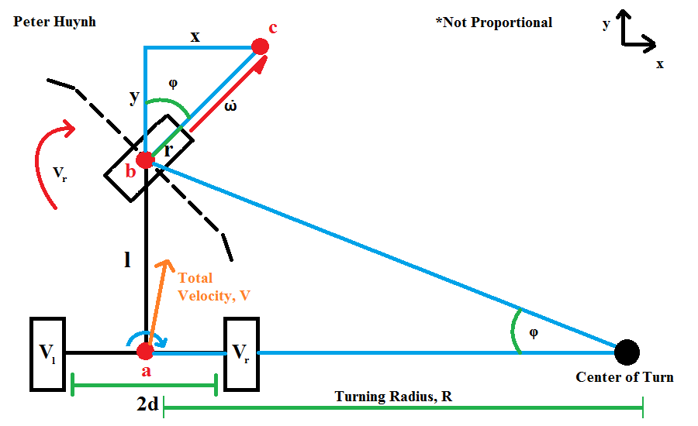

Each wheel has a different velocity when moving (*ω*̇, Vl, Vr), but the tricycle has a total velocity V, with Vr being the rotational velocity of the tricycle.

Vr = *ω*̇ *sin*(*φ*) / *l*

R = *l* / *tan*(*φ*)

V = Vr R = *ω*̇ *cos*(*φ*)

Vl = Vr (R + d)

Vr = Vr (R - d)

The head point b will travel up y and right x, while the point a will rotate by R and travel some distance y2 and x2. Point b will reach c at the speed of *ω*̇.