Peter Huynh

CSCI 3302

Intro to Robotics

September 4, 2016

Lab 1 Write-Up

Machine State Diagram:

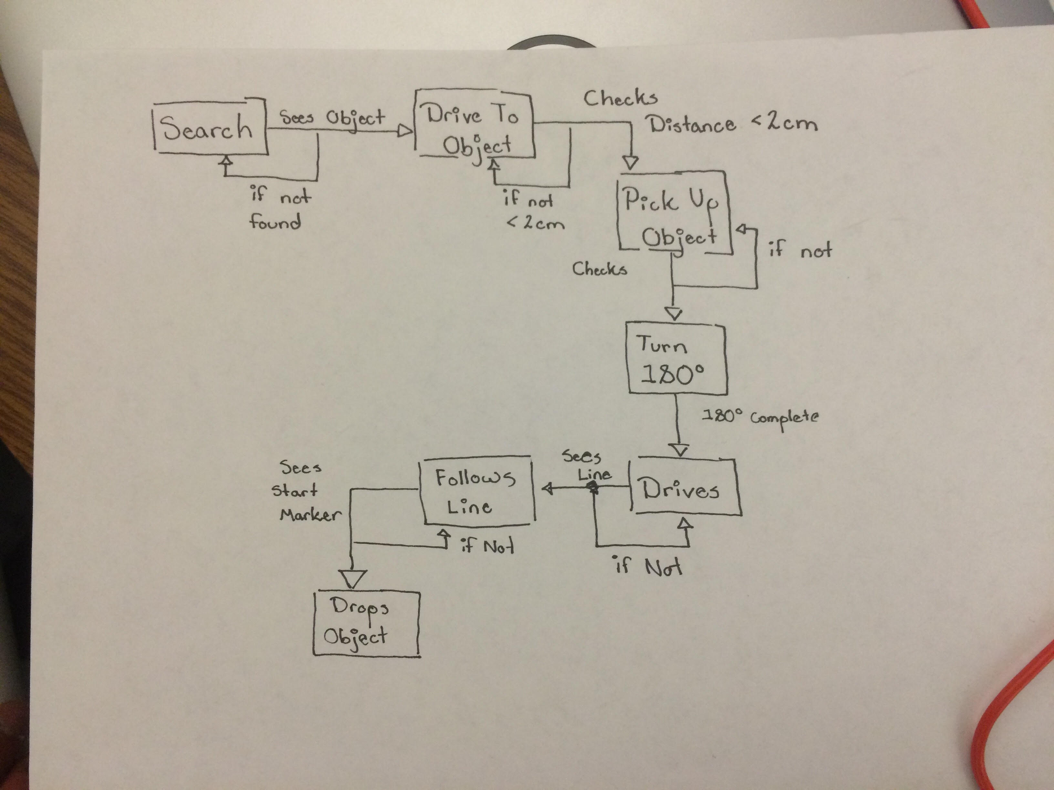

Source Code:

|  |
| --- |
| #include <Sparki.h>  #define SEARCH 1  #define DRIVE 2  #define PICKUP 3  #define ROTATE 4  #define TOLINE 5  #define FOLLOWLINE 6  #define DROP 7  // Yolo  int stateId = SEARCH;  void setup() {  // put your setup code here, to run once:  sparki.servo(SERVO_CENTER); // center the servo  sparki.gripperOpen();  delay(3000);  sparki.gripperStop();  }  void loop() {  // put your main code here, to run repeatedly:  int threshold = 900;  bool endLoop = false;  int cm, lineLeft, lineRight, lineCenter;  if(stateId > 7 || stateId < 1)  {  sparki.moveStop();  sparki.RGB(RGB_RED);  }    while(!endLoop)  {  switch(stateId)  {  case SEARCH:  sparki.moveLeft(5);  cm = sparki.ping();  if(cm != -1)  {  if(cm < 70)  {  sparki.beep();  sparki.moveLeft(6);  stateId = DRIVE;  }  }  delay(100);  break;    case DRIVE:  sparki.moveForward(5);  cm = sparki.ping();  if(cm != -1)  {  if(cm < 7)  {  sparki.beep();  sparki.moveForward(2);  stateId = PICKUP;  }  }  delay(100);  break;    case PICKUP:  sparki.beep();  sparki.gripperClose();  delay(3000);  sparki.gripperStop();  stateId = ROTATE;  break;    case ROTATE:  sparki.beep();  sparki.moveLeft(180);  stateId = TOLINE;  break;    case TOLINE:  lineLeft = sparki.lineLeft(); // measure the IR sensors  lineCenter = sparki.lineCenter  lineRight = sparki.lineRight();  if ( lineCenter < threshold && lineLeft < threshold && lineRight < threshold )  {  sparki.beep();  sparki.moveForward(4); // move forward  sparki.moveRight(90);  stateId = FOLLOWLINE;  }  else  {  if ( lineCenter < threshold )  {  sparki.moveForward(4); // move forward  if ( lineCenter < threshold )  {  stateId = FOLLOWLINE;  }  }  if (lineLeft < threshold)  {  sparki.moveLeft(45);  if ( lineCenter < threshold )  {  stateId = FOLLOWLINE;  }  }  if (lineLeft < threshold)  {  sparki.moveRight(45);  if ( lineCenter < threshold )  {  stateId = FOLLOWLINE;  }  }  else  {  sparki.moveForward(); // move forward  }  }  sparki.clearLCD(); // wipe the screen    sparki.print("Line Left: "); // show sensor on screen  sparki.println(lineLeft);    sparki.print("Line Center: ");  sparki.println(lineCenter);    sparki.print("Line Right: ");  sparki.println(lineRight);    sparki.updateLCD();  delay(100); // wait 0.1 seconds  break;    case FOLLOWLINE:  lineLeft = sparki.lineLeft(); // measure the sensor  lineCenter = sparki.lineCenter();  lineRight = sparki.lineRight();  if ( lineCenter < threshold )  {  if (lineLeft < threshold && lineRight < threshold)  {  stateId = DROP;  }  sparki.moveForward(); // move forward  }  else  {  if ( lineLeft < threshold )  {  sparki.moveLeft(); // turn left  }    else if ( lineRight < threshold )  {  sparki.moveRight(); // turn right  }  }  sparki.clearLCD(); // wipe the screen    sparki.print("Line Left: "); // show sensor on screen  sparki.println(lineLeft);    sparki.print("Line Center: ");  sparki.println(lineCenter);    sparki.print("Line Right: ");  sparki.println(lineRight);    sparki.updateLCD();  delay(100); // wait 0.1 seconds  break;    case DROP:  sparki.beep();  sparki.moveStop();  sparki.gripperOpen();  delay(3000);  sparki.gripperStop();  endLoop = true;  stateId = -1;  break;    default:  endLoop = true;  break;  }  }  } |
|  |

Summary:

Overall, this lab has been a great learning experience. We applied what we learned from lab 0 into action after we were given a set of specific tasks to accomplish. Initially, our team started off with a machine state diagram, in order to understand the basic structure of our simple switch statement robot code. After complete the diagram, we jumped into creating the switch diagram skeleton structure, and then applied what we saw within the wall avoidance, light follow, and line follow example codes into our switch cases. Once all the parts of code were in play, were adjusted aspects of the example codes to fit what we needed for the task at hand, and completed the lab.