CSE 469: Assignment 4

Decision Tree Classification

Peter M. VanNostrand

11/25/2019

# Assignment 4: Decision Tree Classification

## Classification Tree: Car Dataset

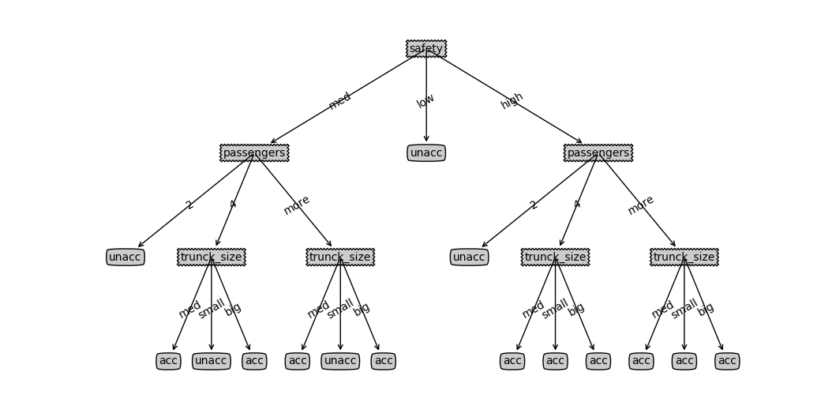

## Decision Tree Code

### Stop Criteria



### Choose Best Feature



### Calc Gini



### Get Vals

