AD4CHE Format
The Aerial Dataset for China Congested Highway and Expressway(AD4CHE) includes data extracted from 68 recordings in several China highways and expressways (Changchun, Hefei, Shenzhen, and Xi’an). For each recording, in total five files are provided: An image of the recorded highway/expressway section, an image of the road including lane position and topology, a csv file describing the recording location, another csv file containing an overview of recorded vehicle tracks and a csv file for the tracks' trajectories. These files are created for each recording to ensure easy handling of the data. In the following, the dataset format and especially the meaning of every column is explained in detail.
To improve the convenience of the dataset application, this AD4CHE format is referred to HighD (www.highd-dataset.com). However, due to the increasing complexity of scenarios, there is still one key difference, vehicle position in coordinates system, and some additional information in AD4CHE, e.g. numBuses, angle, orientation, yaw_rate, ego_offset.

Image of the Highway/Expressway Section (XX_highway.png)
For each recording an image of the highway section is added. The image was created from the used recording itself by removing all vehicles through filtering algorithm. All lane numbers are illustrated in different colors.

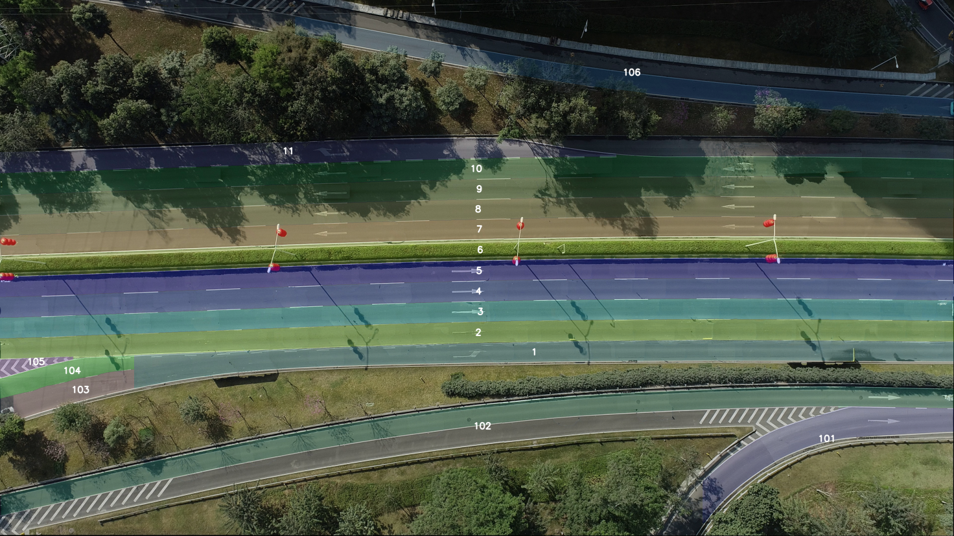
Recording Meta Information (XX_recordingMeta.csv)
This file contains metadata for each recording. The metadata provides a general overview, e.g. of the time of recording, the highway section considered and the total number of vehicles recorded.
Name | Description | Unit
id | The id of the recording. Every recording has a unique id. | [-]
frameRate | The frame rate which was used to record the video. | [hz]
locationId | The id of the recording location. | [-]
speedLimit | The speed limit of the driving lanes. In all recordings, the speed limit is the same for every driving lane. | [m/s]
month | The month the recording was done. | [-]
weekDay | The week day the recording was done. | [-]
startTime | The start time at which the recording was done. | [hh:mm]
duration | The duration of the recording. | [s]
totalDrivenDistance | The total driven distance of all tracked vehicles. | [m]
totalDrivenTime | The total driven time of all tracked vehicles. | [s]
numVehicles | The number of vehicles tracked including cars, trucks and buses. | [-]
numCars | The number of cars tracked. | [-]
numTrucks | The number of trucks tracked. | [-]
numBuses | The number of buses tracked. | [-]
LaneMarkings | The referred lane image describing lane markings and topology | [-]
scale | The scale between the lane image and the real lane | [-]

Example
id | frameRate | locationId | speedLimit | month | weekDay | startTime | duration | totalDrivenDistance | totalDrivenTime | numVehicles | numCars | numTrucks | numBuses | laneMarkings | scale
1 | 30 | 1 | -1 | 2.2021 | Tue | 9:45 | 327.27 | 176873.92 | 23408.63 | 1503 | 1360 | 133 | 10 | refer to: 01_lanePicture | 1 pixel = 0.0375 m

Track Meta Information (XX_tracksMeta.csv)
This file contains an overview of all tracks. For each track there are summary values like the distance covered or the average speed. The purpose of this file is to allow to filter tracks e.g. by class or driving direction.
Name | Description | Unit
id | The id of the track. The ids are assigned in ascending order. Some id is removed. | [-]
width | The width of the post-processed bounding box of the vehicle. This corresponds to the length of the vehicle. The width calculation uses L-shape algorithm. | [m]
height | The height of the post-processed bounding box of the vehicle. This corresponds to the width of the vehicle. | [m]
initialFrame | The initial frame in which the vehicle track starts. | [-]
finalFrame | The frame in which the track of the vehicle ends. | [-]
numFrames | The total lifetime of the track as number of frames. | [-]
class | The vehicle class of the tracked vehicle (Car, Truck or Bus). | [-]
drivingDirection | The driving direction of the vehicle. Either 1 for the left direction (upper lanes) or 2 for the right direction (lower lanes). | [-]
traveledDistance | The distance covered by the track. | [m]
minXVelocity | The minimal velocity in driving direction. | [m/s]
maxXVelocity | The maximal velocity in driving direction. | [m/s]
meanXVelocity | The mean velocity in driving direction. | [m/s]
minDHW | The minimal Distance Headway (DHW). This value is set to 0, if no preceding vehicle exists. | [m]
minTHW | The minimal Time Headway (THW). This value is set to 0, if no preceding vehicle exists. | [s]
minTTC | The minimal Time-to-Collision (TTC). This value is set to -1, if no preceding vehicle or valid TTC exists. | [s]
numLaneChanges | Number of lane changes detected by changing lane id. | [-]

Example
id | width | height | initialFrame | finalFrame | numFrames | class | drivingDirection | traveledDistance | minXVelocity | maxXVelocity | meanXVelocity | minDHW | minTHW | minTTC | numLaneChanges
1 | 14.14 | 2.1 | 0 | 796 | 797 | truck | 2 | 88.03 | 2.42 | 0.09 | 3.3 | 6.41 | 2.44 | 0 | 0
2 | 3.08 | 1.35 | 0 | 668 | 669 | car | 2 | 65.92 | 1.72 | 0.15 | 2.98 | 1.35 | 0.77 | -135.19 | 0
3 | 3.71 | 1.54 | 0 | 165 | 166 | car | 1 | 96.22 | -18.11 | 0.07 | -17.51 | 26.66 | 1.5 | 0 | 1
4 | 13.58 | 1.97 | 0 | 335 | 336 | truck | 2 | 41.72 | 1.97 | 0.17 | 3.71 | 3.38 | 1.67 | -81.72 | 0
5 | 5.1 | 1.82 | 0 | 805 | 806 | truck | 2 | 90.64 | 1.77 | 0.13 | 3.38 | 3.67 | 1.42 | 0 | 0
6 | 14.25 | 2.02 | 0 | 504 | 505 | truck | 2 | 41.59 | 1.64 | 0.09 | 2.44 | 1.31 | 0.65 | 0 | 0
7 | 13.13 | 1.99 | 0 | 987 | 988 | truck | 2 | 120.06 | 1.86 | 0.14 | 3.7 | 1.72 | 0.64 | 0 | 0
8 | 3.68 | 1.5 | 0 | 58 | 59 | car | 2 | 10.54 | 5.35 | 0.36 | 5.41 | 4.99 | 0.93 | -12.68 | 0
9 | 3.98 | 1.52 | 0 | 209 | 210 | car | 2 | 35.74 | 4.23 | 0.12 | 5.11 | 4.65 | 0.89 | 0 | 0
10 | 3.57 | 1.35 | 0 | 673 | 674 | car | 2 | 73.54 | 1.87 | -0.02 | 3.27 | 0.94 | 0.24 | 0 | 1
11 | 3.26 | 1.33 | 0 | 96 | 97 | car | 2 | 12.64 | 3.66 | 0.17 | 3.91 | 0 | 0 | 0 | 0
12 | 3.64 | 1.48 | 0 | 259 | 260 | car | 1 | 127.16 | -15.46 | 0.86 | -14.73 | 12.3 | 0.86 | 0 | 0

Tracks (XX_tracks.csv)
This file contains all time dependent values for each track. Information such as current velocities, viewing ranges and information about surrounding vehicles are included.
Name | Description | Unit
frame | The current frame. | [-]
id | The track's id. | [-]
x | The x position of the middle point of the vehicle's bounding box. | [m]
y | The y position of the middle point of the vehicle's bounding box. | [m]
width | The width of the bounding box of the vehicle. | [m]
height | The height of the bounding box of the vehicle. | [m]
xVelocity | The longitudinal velocity in the image coordinate system. | [m/s]
yVelocity | The lateral velocity in the image coordinate system. | [m/s]
xAcceleration | The longitudinal acceleration in the image coordinate system. | [m/s]
yAcceleration | The lateral acceleration in the image coordinate system | [m/s]
frontSightDistance | The distance to the end of the recorded highway section in driving direction from the vehicle's center. | [m]
backSightDistance | The distance to the end of the recorded highway section in the opposite driving direction from the vehicle's center. | [m]
dhw | The Distance Headway. This value is set to 0, if no preceding vehicle exists. | [m]
thw | The Time Headway. This value is set to 0, if no preceding vehicle exists. | [s]
ttc | The Time-to-Collision. This value is set to 0, if no preceding vehicle or valid TTC exists. | [s]
precedingXVelocity | The longitudinal velocity of the preceding in the image coordinate system. This value is set to 0, if no preceding vehicle exists. | [-]
precedingId | The id of the preceding vehicle in the same lane. This value is set to 0, if no preceding vehicle exists. | [-]
followingId | The id of the following vehicle in the same lane. This value is set to 0, if no following vehicle exists. | [-]
leftPrecedingId | The id of the preceding vehicle on the adjacent lane on the left in the direction of travel. This value is set to 0, if no such a vehicle exists. | [-]
leftAlongsideId | The id of the adjacent vehicle on the adjacent lane on the left in the direction of travel. In order for a vehicle to be adjacent and not e.g. preceding, the vehicles must overlap in the longitudinal direction. This value is set to 0, if no such a vehicle exists. | [-]
leftFollowingId | The id of the following vehicle on the adjacent lane on the left in the direction of travel. This value is set to 0, if no such a vehicle exists. | [-]
rightPrecedingId | The id of the preceding vehicle on the adjacent lane on the right in the direction of travel. This value is set to 0, if no such a vehicle exists. | [-]
rightAlsongsideId | The id of the adjacent vehicle on the adjacent lane on the right in the direction of travel. In order for a vehicle to be adjacent and not e.g. preceding, the vehicles must overlap in the longitudinal direction. This value is set to 0, if no such a vehicle exists. | [-]
rightFollowingId | The id of the following vehicle on the adjacent lane on the right in the direction of travel. This value is set to 0, if no such a vehicle exists. | [-]
laneId | The IDs start at 1 and are assigned in ascending order. Since the Lane ids are derived from the positions of the lane markings, the first and last ids typically do not describe any useable lanes. For details, see the definition of the coordinate system. | [-]
Above is similar to highd-dataset in Germany. Below is additional info in AD4CHE.
Name | Description | Unit
angle | The lane angle in the image coordinate system. | [rad]
orientation | The vehicle orientation in the image coordinate system. | [rad]
yaw_rate | The vehicle yaw rate in the image coordinate system. | [rad/s]
ego_offset | The offset between vehicle center point and lane center line. | [m]

Coordinate System
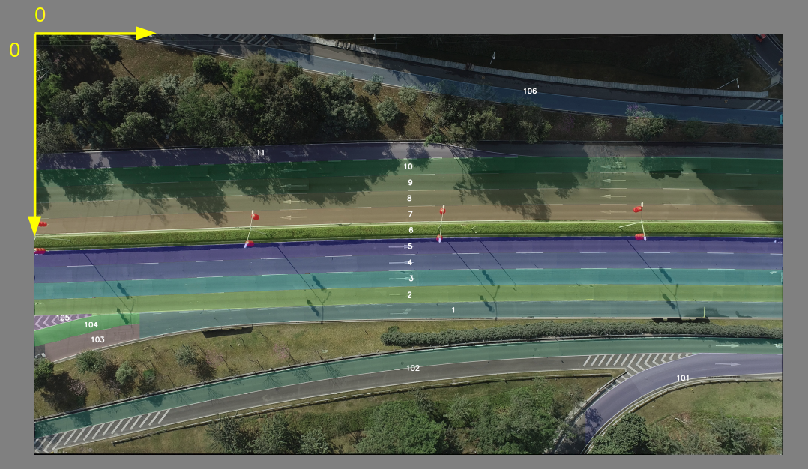
The global coordinate system used corresponds to the image coordinate system of the video recording. This means that the origin of the coordinate system is in the upper left corner, as shown in the image. The horizontal axis is the x-axis. This corresponds to the direction of travel of the vehicles and grows to the right. The vertical axis is the y-axis. However, this axis grows downwards.

Example
frame | id | x | y | width | height | xVelocity | yVelocity | xAcceleration | yAcceleration | frontSightDistance | backSightDistance | dhw | thw | ttc | precedingXVelocity | precedingId | followingId | leftPrecedingId | leftAlongsideId | leftFollowingId | rightPrecedingId | rightAlongsideId | rightFollowingId | laneId | angle | orientation | yaw_rate | ego_offset
0 | 1 | 48.73 | 52.39 | 14.14 | 2.1 | 2.82 | -0.09 | 0.22 | 0.02 | 95.27 | 48.73 | 10.72 | 3.81 | -12.66 | 3.67 | 10 | 54 | 69 | 51 | 7 | 29 | 0 | 61 | 2 | -0.032 | -0.0318 | 0 | 0.02
1 | 1 | 48.81 | 52.38 | 14.14 | 2.1 | 2.82 | -0.09 | 0.22 | 0.02 | 95.19 | 48.81 | 10.76 | 3.82 | -12.71 | 3.67 | 10 | 54 | 69 | 51 | 7 | 29 | 0 | 61 | 2 | -0.0326 | -0.0331 | -0.0397 | 0.01
2 | 1 | 48.96 | 52.39 | 14.14 | 2.1 | 2.83 | -0.09 | 0.39 | 0.06 | 95.04 | 48.96 | 10.72 | 3.79 | -12.77 | 3.67 | 10 | 54 | 69 | 51 | 7 | 29 | 0 | 61 | 2 | -0.0326 | -0.0331 | -0.0397 | 0.02
3 | 1 | 49.03 | 52.38 | 14.14 | 2.1 | 2.84 | -0.09 | 0.39 | 0.06 | 94.97 | 49.03 | 10.8 | 3.8 | -12.98 | 3.68 | 10 | 54 | 69 | 51 | 7 | 29 | 0 | 61 | 2 | -0.032 | -0.0323 | -0.0384 | 0.01
4 | 1 | 49.11 | 52.39 | 14.14 | 2.1 | 2.86 | -0.08 | 0.39 | 0.05 | 94.89 | 49.11 | 10.84 | 3.79 | -13.15 | 3.68 | 10 | 54 | 69 | 51 | 7 | 29 | 0 | 61 | 2 | -0.0309 | -0.0322 | -0.0371 | 0.02
5 | 1 | 49.26 | 52.39 | 14.14 | 2.1 | 2.87 | -0.08 | 0.38 | 0.05 | 94.74 | 49.26 | 10.8 | 3.76 | -13.22 | 3.69 | 10 | 54 | 69 | 51 | 7 | 29 | 0 | 61 | 2 | -0.0273 | -0.0323 | -0.0358 | 0.02
6 | 1 | 49.29 | 52.41 | 14.14 | 2.1 | 2.88 | -0.08 | 0.39 | 0.04 | 94.71 | 49.29 | 10.91 | 3.78 | -13.5 | 3.69 | 10 | 54 | 69 | 51 | 7 | 29 | 0 | 61 | 2 | -0.0261 | -0.0326 | -0.0346 | 0.04
7 | 1 | 49.37 | 52.41 | 14.14 | 2.1 | 2.9 | -0.08 | 0.38 | 0.03 | 94.63 | 49.37 | 10.95 | 3.78 | -13.69 | 3.7 | 10 | 54 | 69 | 51 | 7 | 29 | 0 | 61 | 2 | -0.0252 | -0.0332 | -0.0334 | 0.04
8 | 1 | 49.56 | 52.41 | 14.14 | 2.1 | 2.91 | -0.08 | 0.35 | 0.03 | 94.44 | 49.56 | 10.91 | 3.75 | -13.77 | 3.7 | 10 | 54 | 69 | 51 | 7 | 29 | 0 | 61 | 2 | -0.0249 | -0.0332 | -0.0322 | 0.06
9 | 1 | 49.74 | 52.41 | 14.14 | 2.1 | 2.92 | -0.08 | 0.31 | 0.03 | 94.26 | 49.74 | 10.84 | 3.71 | -13.8 | 3.7 | 10 | 54 | 69 | 51 | 7 | 29 | 0 | 61 | 2 | -0.0241 | -0.0325 | -0.0311 | 0.07
10 | 1 | 49.82 | 52.39 | 14.14 | 2.1 | 2.93 | -0.08 | 0.3 | 0.03 | 94.18 | 49.82 | 10.95 | 3.74 | -14.07 | 3.71 | 10 | 54 | 69 | 51 | 7 | 29 | 0 | 61 | 2 | -0.0258 | -0.0321 | -0.03 | 0.06
11 | 1 | 49.86 | 52.39 | 14.14 | 2.1 | 2.94 | -0.08 | 0.31 | 0.03 | 94.14 | 49.86 | 11.03 | 3.75 | -14.3 | 3.71 | 10 | 54 | 69 | 51 | 7 | 29 | 0 | 61 | 2 | -0.0269 | -0.0318 | -0.029 | 0.06
12 | 1 | 49.97 | 52.41 | 14.14 | 2.1 | 2.95 | -0.08 | 0.3 | 0.02 | 94.03 | 49.97 | 10.99 | 3.73 | -14.39 | 3.71 | 10 | 54 | 69 | 51 | 7 | 29 | 0 | 61 | 2 | -0.0296 | -0.0315 | -0.028 | 0.07
13 | 1 | 50.12 | 52.4 | 14.14 | 2.1 | 2.96 | -0.07 | 0.28 | 0.02 | 93.88 | 50.12 | 11.03 | 3.73 | -14.57 | 3.71 | 10 | 54 | 69 | 51 | 7 | 29 | 0 | 61 | 2 | -0.0316 | -0.031 | -0.0271 | 0.07
14 | 1 | 50.23 | 52.4 | 14.14 | 2.1 | 2.97 | -0.07 | 0.26 | 0.02 | 93.77 | 50.23 | 11.06 | 3.73 | -14.76 | 3.72 | 10 | 54 | 69 | 51 | 7 | 29 | 0 | 61 | 2 | -0.0319 | -0.0307 | -0.0262 | 0.07
15 | 1 | 50.34 | 52.4 | 14.14 | 2.1 | 2.97 | -0.07 | 0.25 | 0.02 | 93.66 | 50.34 | 11.1 | 3.73 | -14.94 | 3.72 | 10 | 54 | 69 | 51 | 7 | 29 | 0 | 61 | 2 | -0.0312 | -0.0305 | -0.0254 | 0.07
16 | 1 | 50.46 | 52.37 | 14.14 | 2.1 | 2.98 | -0.07 | 0.24 | 0.03 | 93.54 | 50.46 | 11.1 | 3.72 | -15.08 | 3.72 | 10 | 54 | 69 | 51 | 7 | 29 | 0 | 61 | 2 | -0.0296 | -0.0303 | -0.0245 | 0.04
17 | 1 | 50.53 | 52.38 | 14.14 | 2.1 | 2.99 | -0.07 | 0.24 | 0.03 | 93.47 | 50.53 | 11.17 | 3.74 | -15.33 | 3.72 | 10 | 54 | 69 | 51 | 7 | 29 | 0 | 61 | 2 | -0.0279 | -0.0306 | -0.0237 | 0.05
18 | 1 | 50.64 | 52.38 | 14.14 | 2.1 | 3 | -0.07 | 0.23 | 0.03 | 93.36 | 50.64 | 11.17 | 3.73 | -15.47 | 3.72 | 10 | 54 | 69 | 51 | 7 | 29 | 0 | 61 | 2 | -0.0254 | -0.031 | -0.0229 | 0.05
19 | 1 | 50.79 | 52.37 | 14.14 | 2.1 | 3.01 | -0.07 | 0.22 | 0.03 | 93.21 | 50.79 | 11.17 | 3.72 | -15.62 | 3.72 | 10 | 54 | 69 | 51 | 7 | 29 | 0 | 61 | 2 | -0.0248 | -0.0316 | -0.0221 | 0.04
20 | 1 | 50.87 | 52.39 | 14.14 | 2.1 | 3.01 | -0.07 | 0.22 | 0.02 | 93.13 | 50.87 | 11.21 | 3.72 | -15.83 | 3.72 | 10 | 54 | 69 | 51 | 7 | 29 | 0 | 61 | 2 | -0.025 | -0.0321 | -0.0214 | 0.07

