Advanced Petal Engineering Drawings

1. Dimensioned Petal
Includes width and height annotations with exact cm measurements.
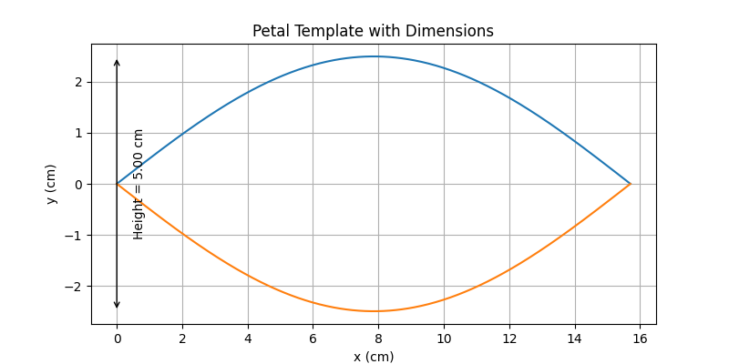

2. Grid Calibration View
1 cm grid overlay for real-world scaling.
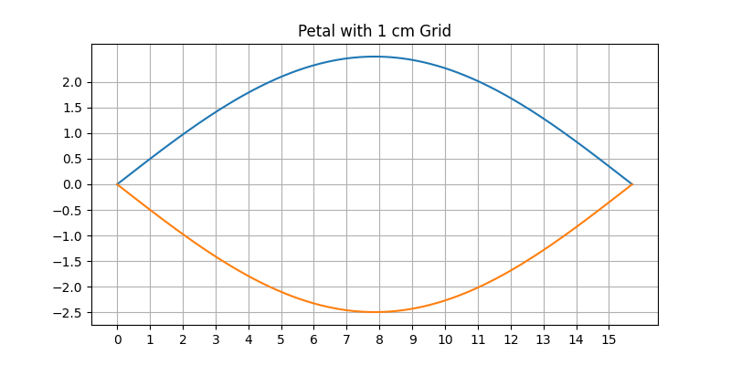

3. Construction Process
Step-by-step buildup of the petal curve.
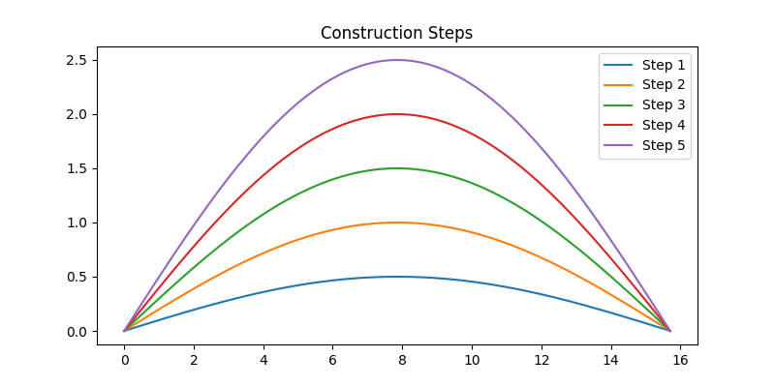

4. Final Template Layout
Final printable template similar to original concept.
