Petal Geometry – Fully Illustrated Engineering Document

1. Sphere Geometry
Radius R and Diameter D define the base geometry.
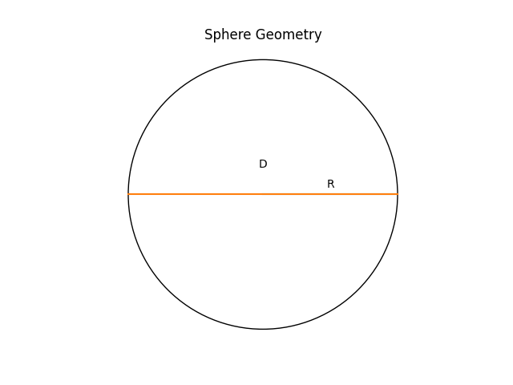

2. Petal Curve
y = R sin(pi/n) sin(x/R)
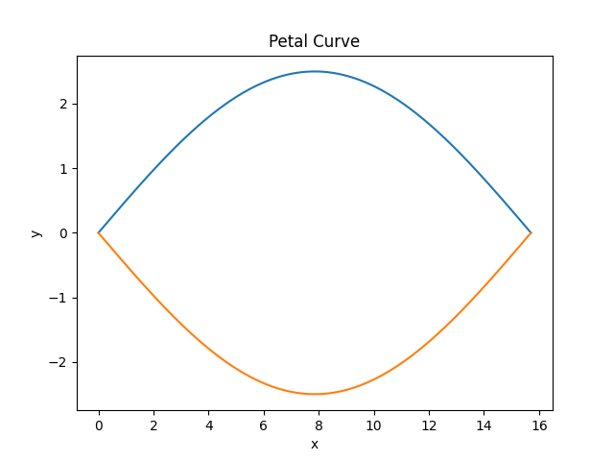

3. Petal with Measurement Grid
Grid represents 1cm spacing for real-world calibration.
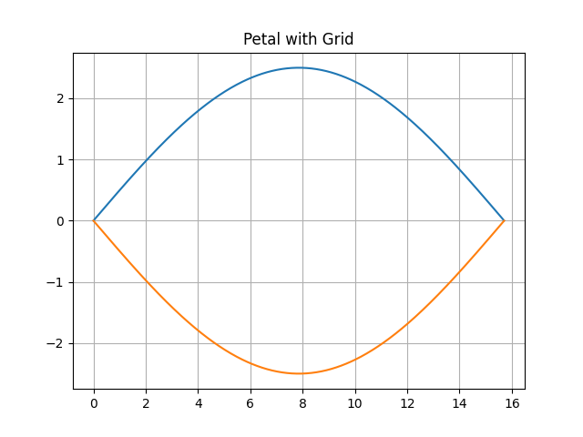

4. Step-by-Step Construction
Progressive formation of the petal shape.
