Question 1

Write a query in SQL to find the name and year of the movies.

Anwers:

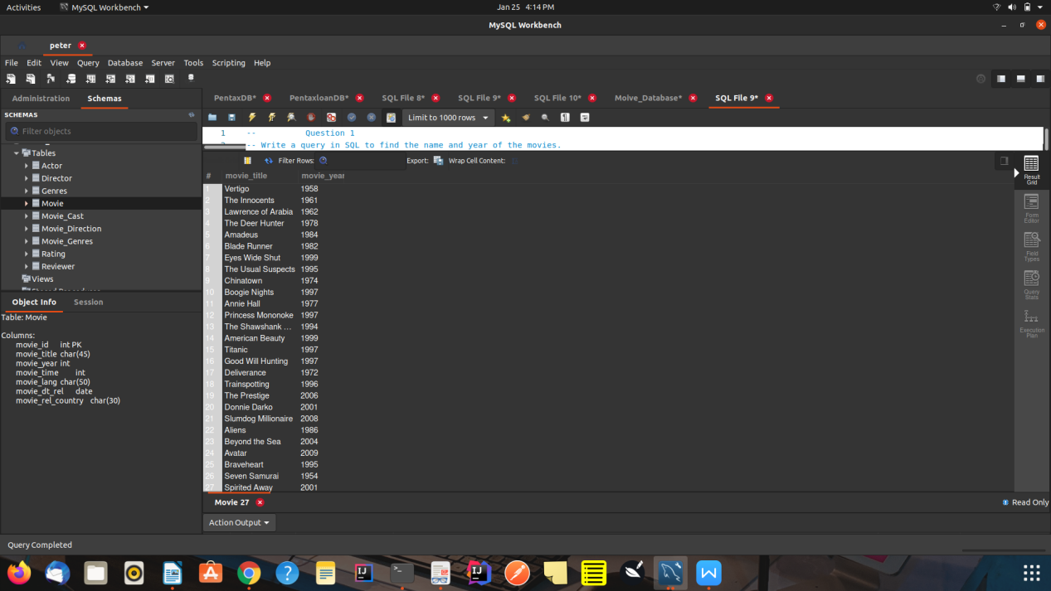

Question 2

Write a query in SQL to find the year when the movie American Beauty released.

Answer:

SELECT movie_year

FROM Movie

WHERE movie_title='American Beauty';

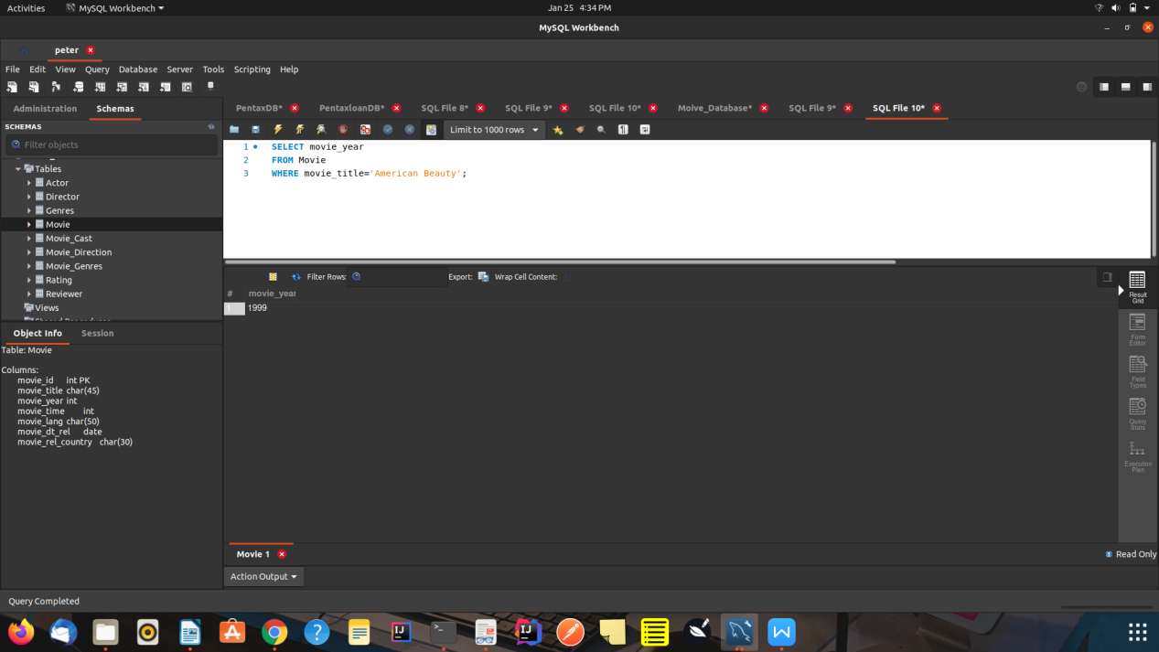

Question3

Write a query in SQL to find the movie which was released in the year 1999

Answer:

SELECT movie_year

FROM Movie

WHERE movie_title=1999;

Question4

Write a query in SQL to find the movies which was released before 1998.

Answer

SELECT movie_year

FROM Movie

WHERE movie_title<1998;

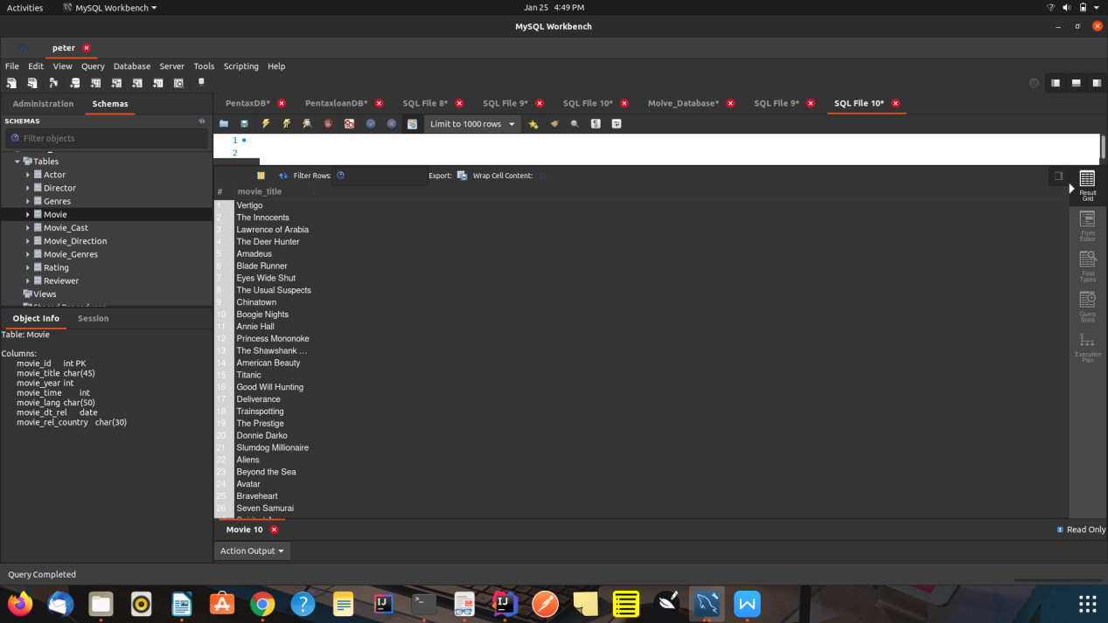

Question 5

Write a query in SQL to return the name of all reviewers and name of movies together in a single list.

Answer:

ELECT Reviewer.reviewer_name

FROM Reviewer

UNION

(SELECT Movie.movie_title

FROM Movie);

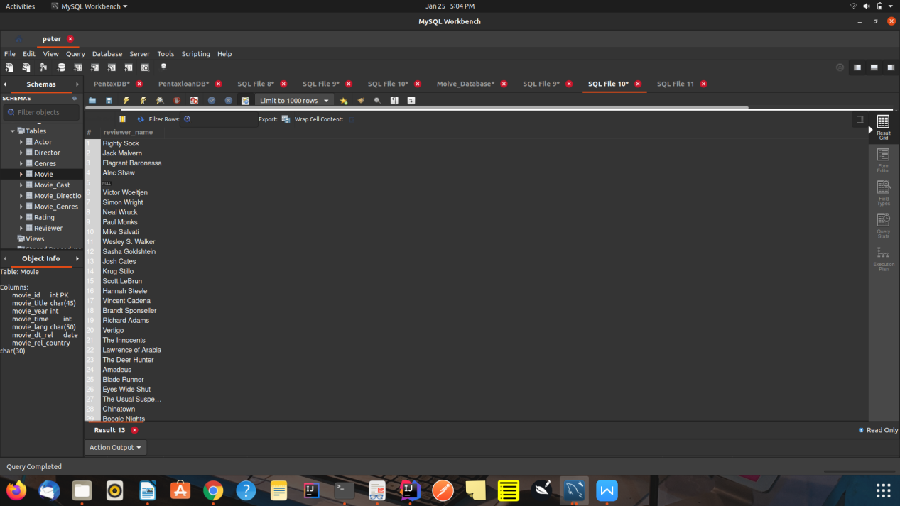

Question6

Write a query in SQL to find the name of all reviewers who have rated 7 or more stars to their rating

Answer:

SELECT Reviewer.reviewer_name FROM Reviewer,

Rating WHERE Rating.reviewer_id = Reviewer.reviewer_id

AND Rating.reviewer_stars>=7

AND Reviewer.reviewer_name IS NOT NULL;

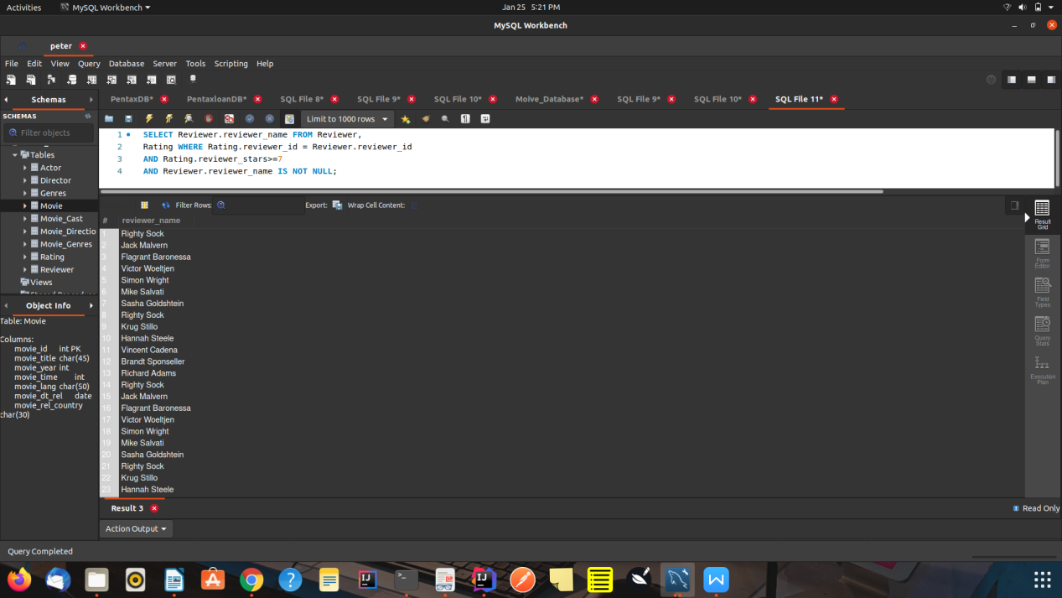

Question7

Write a query in SQL to find the titles of all movies that have no ratings.

Answer:

SELECT movie_title

FROM Movie

WHERE movie_id

NOT IN ( SELECT movie_id FROM rating );

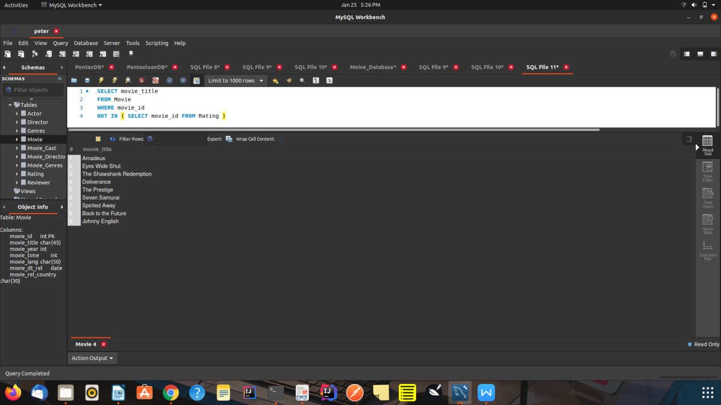

Question 8

Write a query in SQL to find the name of all reviewers who have rated their ratings with a NULL value.

Answer:

SELECT reviewer_name

FROM Reviewer

INNER JOIN Rating USING(reviewer_id)

WHERE reviewer_stars IS NULL

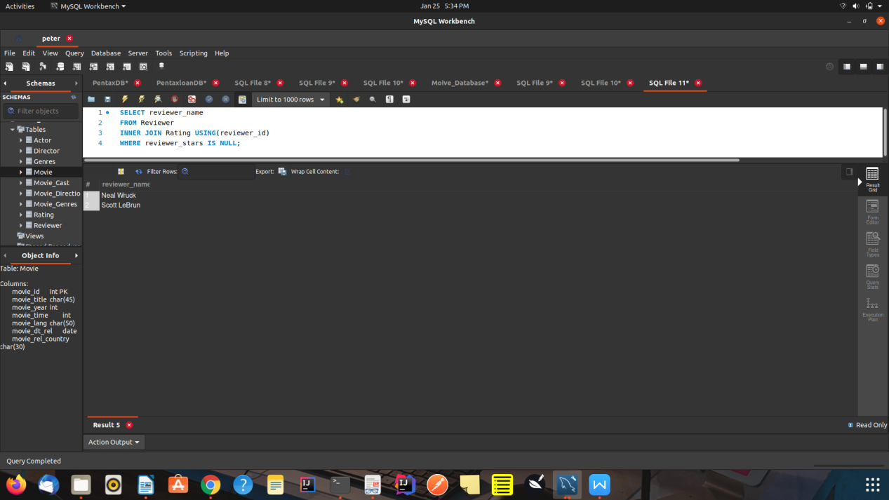

Question 9

Write a query in SQL to find the name of movie and director (first and last names) who directed a movie that casted a role for 'Eyes Wide Shut'.

Answer:

SELECT director_Fname, director_Lname, movie_title

FROM director

NATURAL JOIN movie_direction

NATURAL JOIN Movie

NATURAL JOIN movie_cast

WHERE role IS NOT NULL AND movie_title='Eyes Wide Shut';

