|  |
| --- |
| [鍵入公司名稱] |
| GCB 檢測程式說明文件 |
| [鍵入文件副標題] |
|  |
| **Peter Hsieh** |
|  |

1. 前言

政府組態基準(Government Configuration Baseline, 以下簡稱GCB)目的在於規範資通訊終端設備(如：個人電腦)的一致性安全設定(如：密碼長度、更新期限等)，以降低成為駭客入侵管道，進而引發資安事件之疑慮。而相關設備之組態設定檔案(configuration)內容龐雜，如果以人工檢查方式進行比對勢必發生檢查錯誤或漏查之情事，且效率低落，為了改善以上情形，本公司著手開發GCB parser程式，可讀入設備組態設定檔案後自動輸出對每條GCB規範的檢測結果，例如「正確設定」，「錯誤設定」或「尚未設定」，快速提供檢查人員參考。

1. 執行環境

GCB parser程式由Python3語言開發，請至官方網站下載安裝Python3環境

<https://www.python.org/downloads/>

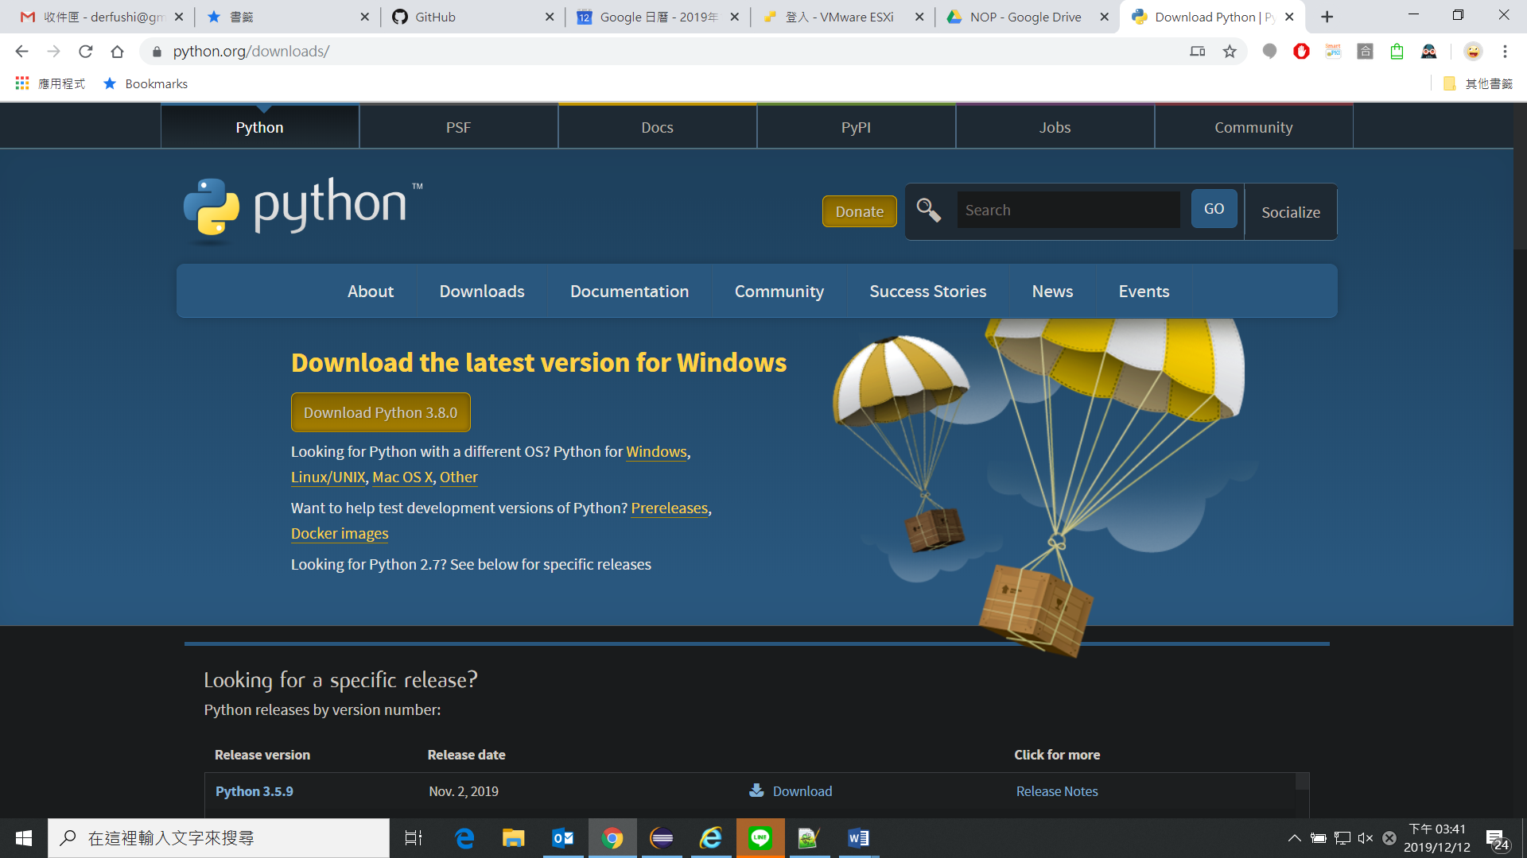

Figure 1：Python3下載網站

1. 程式運作流程

檢測程式GCB_parser.py的運作流程如Figure 2：程式接收2個輸入檔：GCB規則檔與設備組態檔，並產生輸出結果，以下為程式的使用語法

*python GCB_parser.py* ***-r*** *input/FortiGate100D_config.txt* ***-p*** *input/GCB_FortiGate.txt* ***-o*** *output/output.csv* ***-d*** *fortigate*

Figure 2：程式運作流程

GCB 規則檔

(-p指定)

設備組態檔

(-r指定)

檢測程式

輸出結果

(-o指定)

執行檢測程式(以python GCB_parser.py進行)，設定以下參數：

1. -r：設備組態檔案路徑
2. -p：GCB規則檔案路徑
3. -o：輸出檔案路徑
4. -d：設備類型
5. 檔案說明

以下詳細說明檢測程式所需要之檔案

1. **設備組態檔**

設備組態檔乃由設備內直接下載之configuration檔案，檔案第一行應為組態設定之第一行，其餘無關內容請刪除後再輸入檢測程式。

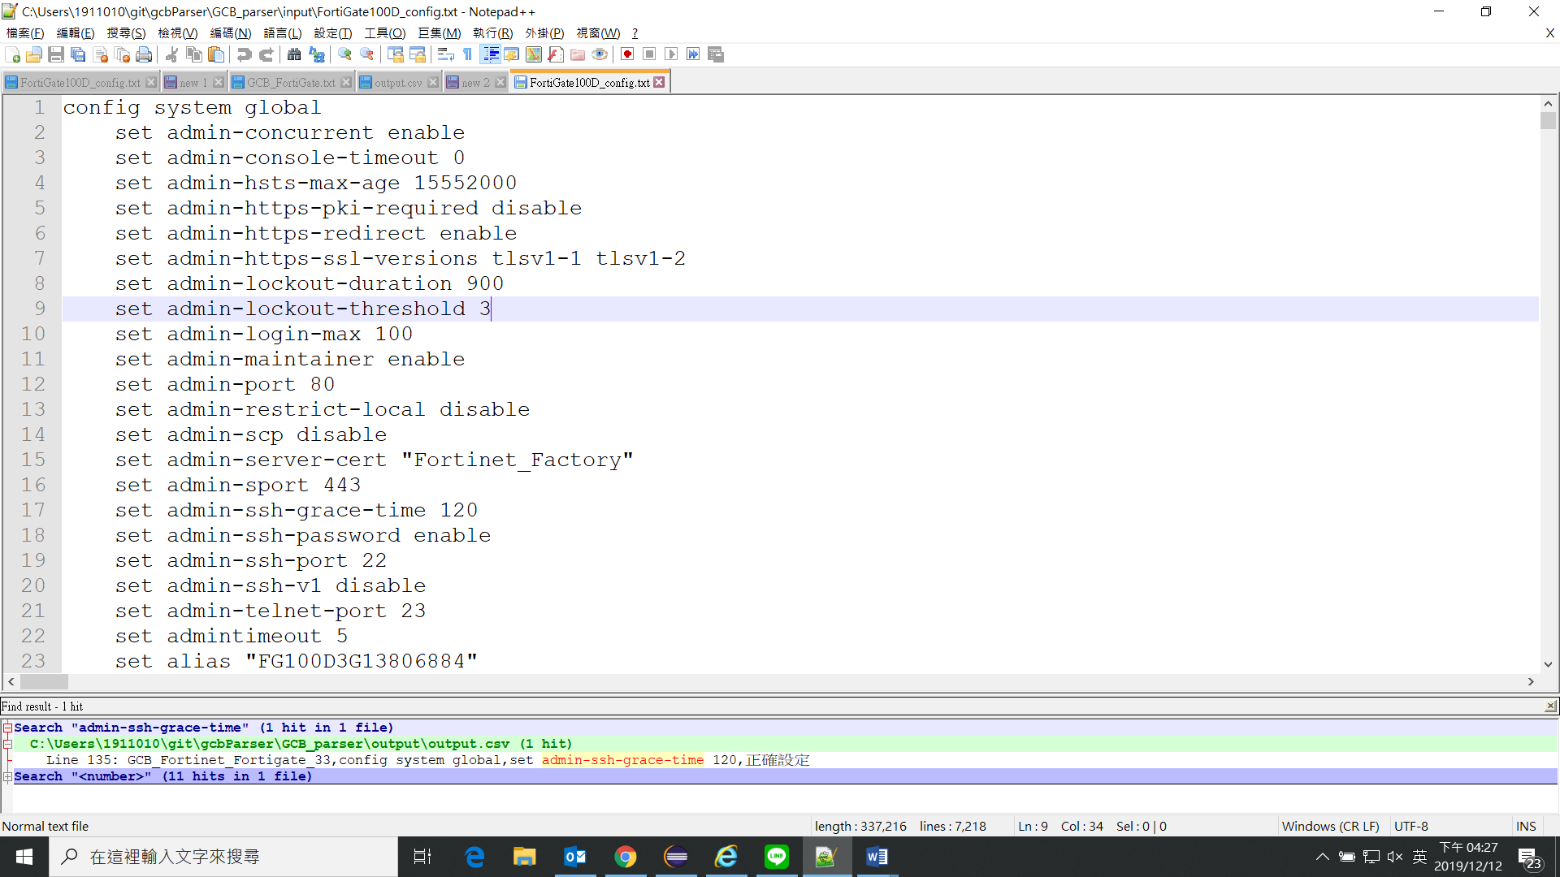Figure 3：設備組態檔範例

1. **GCB規則檔案**

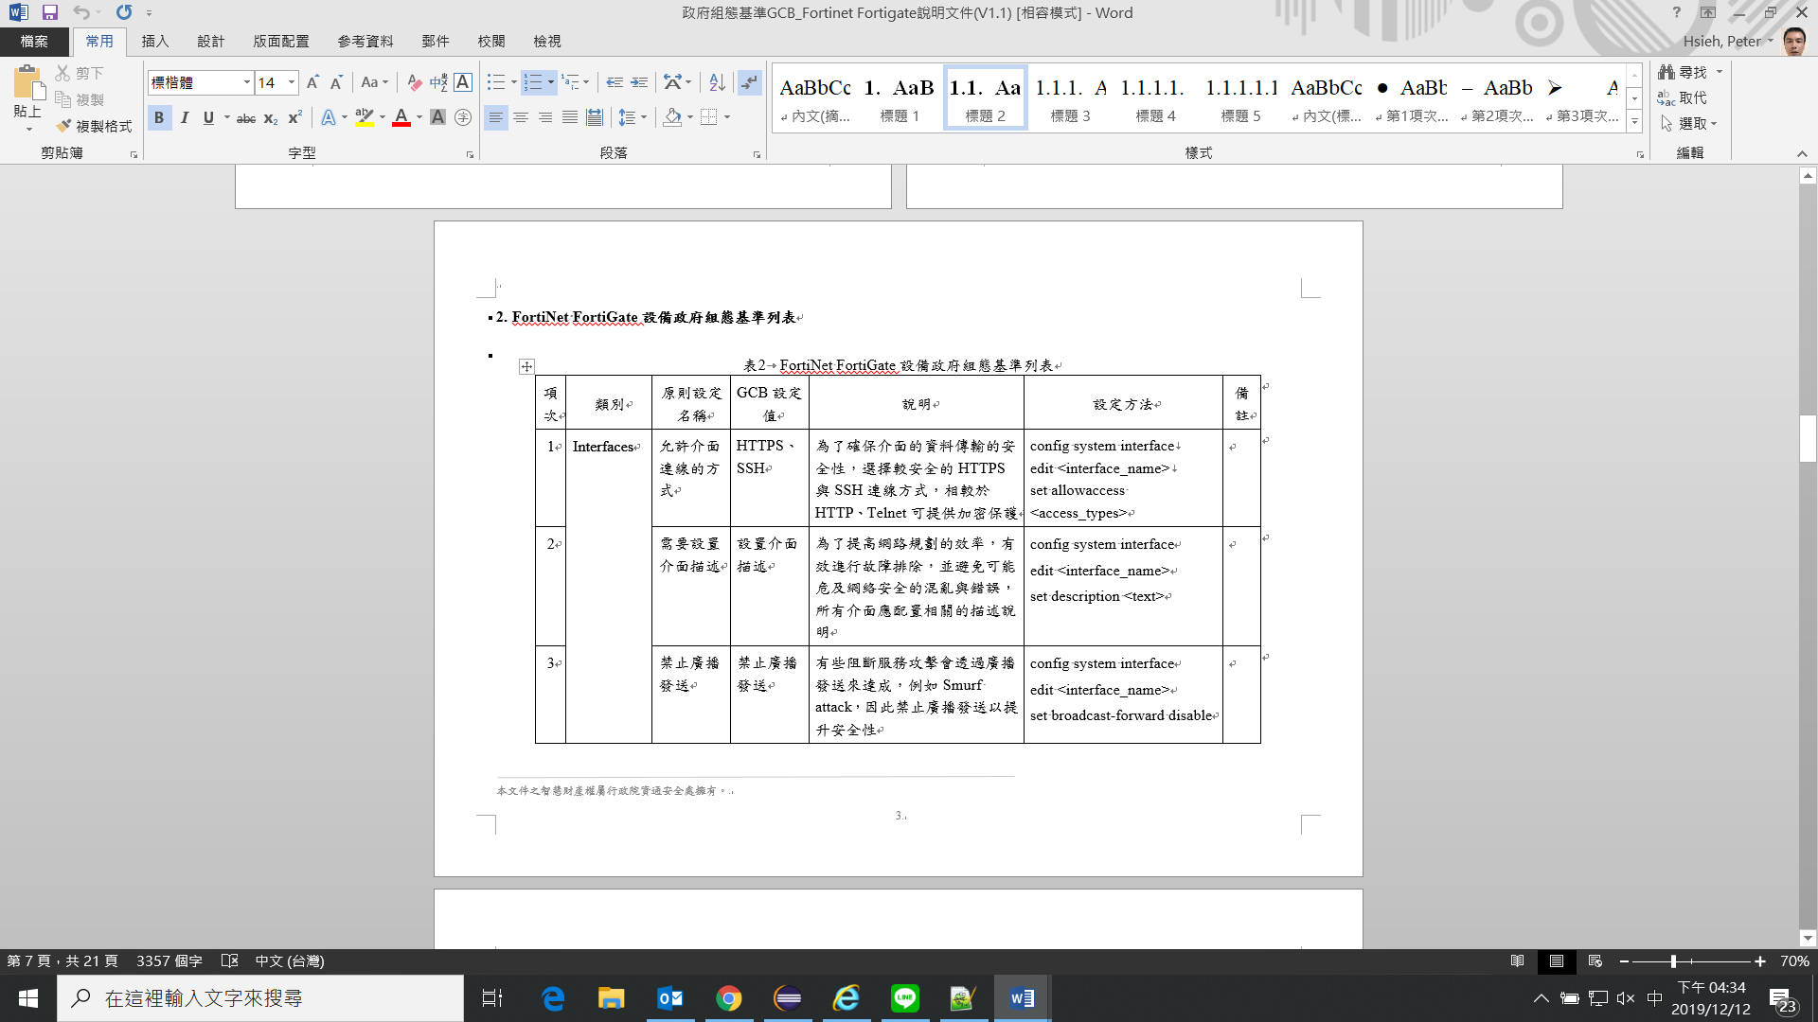此檔案將GCB規範轉化為程式可讀格式，GCB規範可參考技服中心所頒佈文件，範例為Figure 4

Figure 4：GCB規範範例

第一條規範為***config system interface，edit <interface_name>，set allowaccess <access_types>***，箭頭括號(<>)內可為任意文字，但不可空白，此規範轉化以下規則***config system interface，edit <interface_name>，set allowaccess <access_types>，***檢測程式方可讀取規則後進行檢測。再以第三條規範為例，***config system interface，edit <interface_name>，set broadcast-forward disable***，此規範重點為必須設定disable，若為其他設定(例如enable)均視為錯誤設定，所以在規則內需以引號(“)設定，故第三條規則應為***config system interface，edit <interface_name>，set broadcast-forward “disable”***。下表為規範與規則之對照表節錄：

|  |  |  |
| --- | --- | --- |
| **項次** | **規範** | **規則** |
| GCB 1 | config system interface  edit <interface_name>  set allowaccess <access_types> | config system interface  edit <interface_name>  set allowaccess <access_types> |
| GCB 3 | config system interface  edit <interface_name>  set broadcast-forward disable | config system interface  edit <interface_name>  set broadcast-forward “disable” |

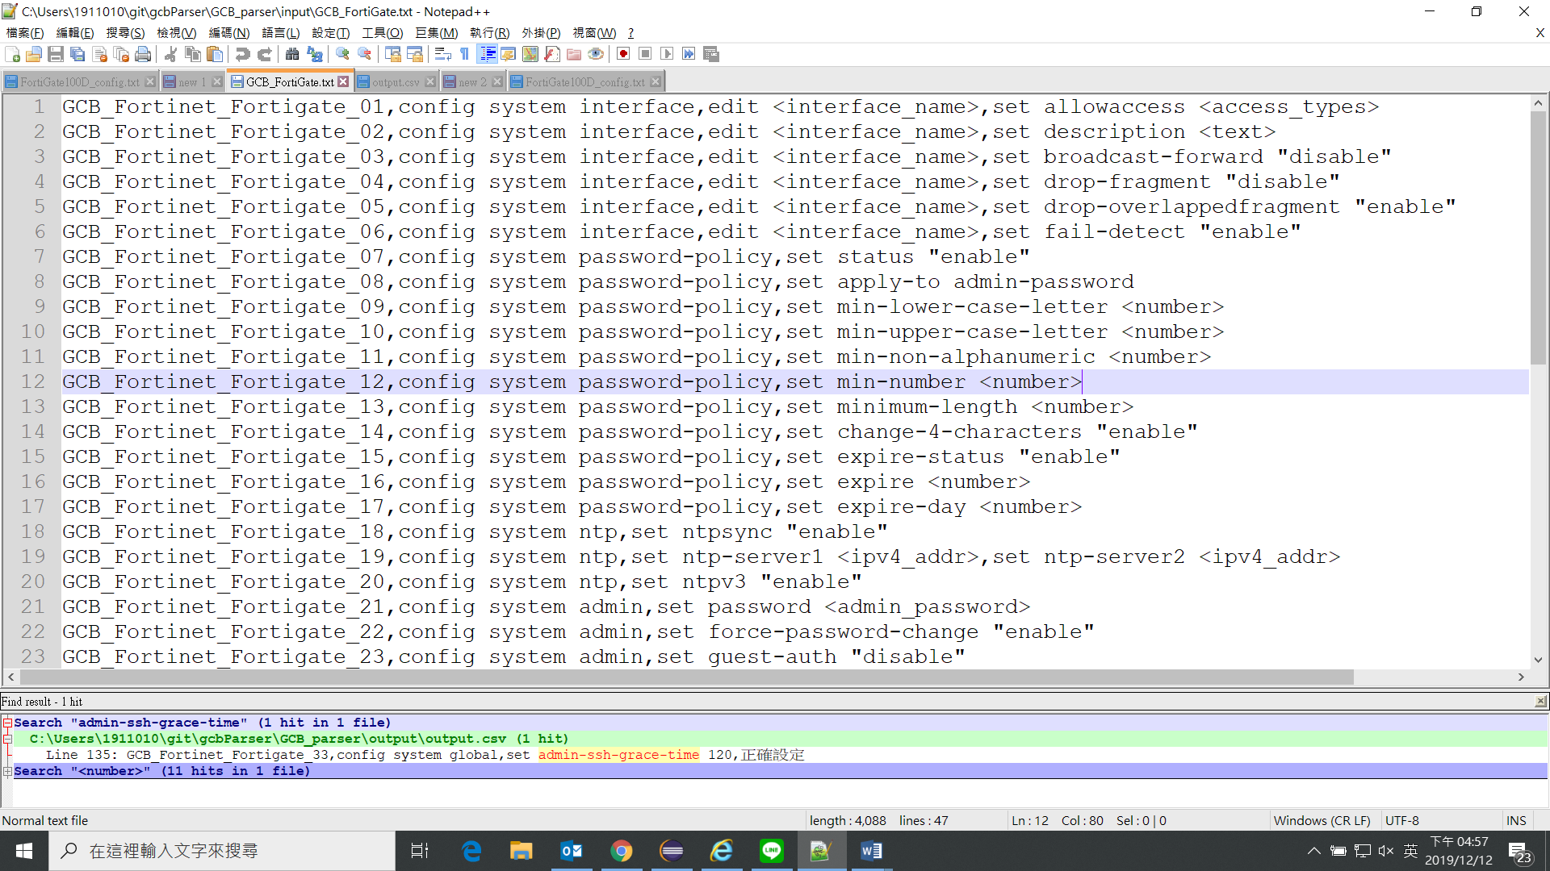GCB規則檔案內記錄由GCB規範所轉化的規則，每一行分為2部分，前半部為GCB編號，後半部為該規範之轉化規則

Figure 5：GCB規則檔案

|  |  |  |
| --- | --- | --- |
|  | **規則前半** | **規則後半部** |
| **說明** | GCB之編號，格式為  GCB_[廠牌]_[型號]_[編號] | 對組態之要求 |
| **範例** | GCB_Fortinet_Fortigate_18 | config system ntp,set ntpsync "enable" |

1. **輸出結果**

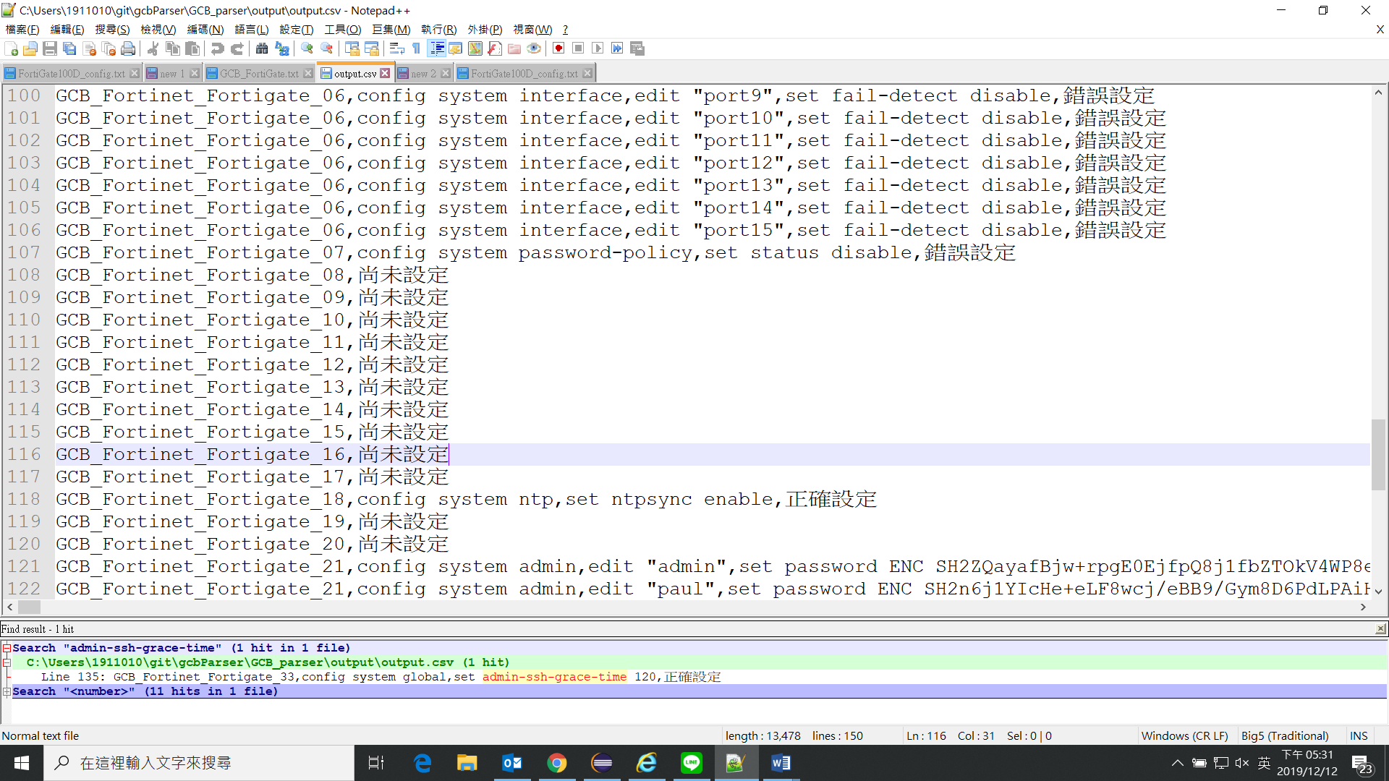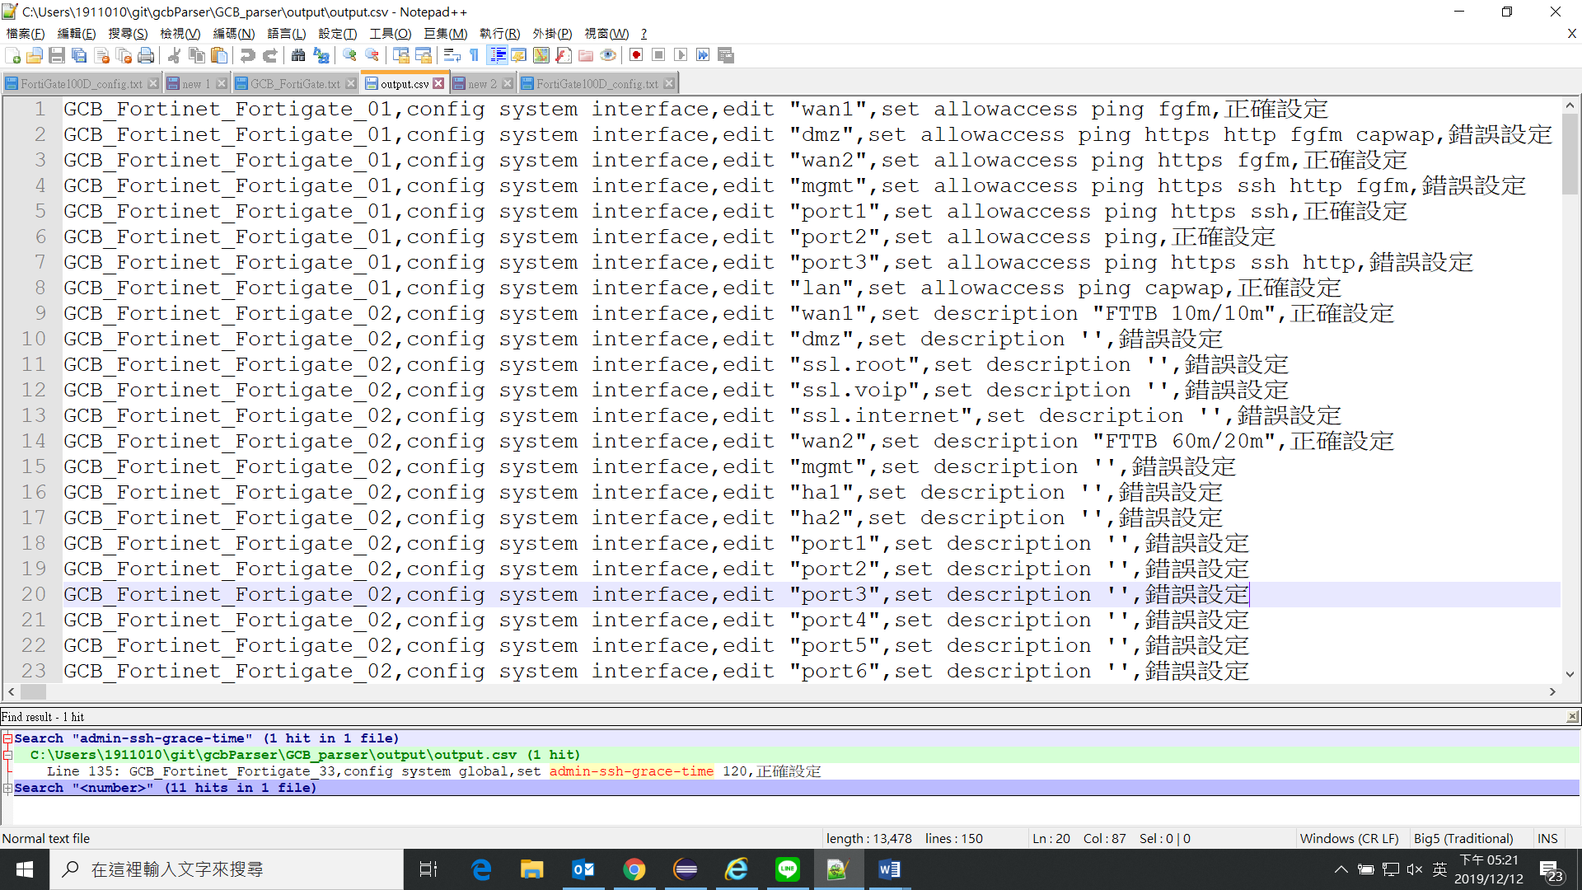輸出結果檔案記錄檢測結果，每行記錄規則之編號，組態內設定與檢測結果。以GCB 1規則為例，若set allowaccess之協定出現http或telnet等明碼協定則為錯誤設定，因此Figure 6第2行的檢測結果為錯誤設定。另外GCB 2要求set description之後不可為空字串，所以第10行為錯誤設定。

Figure ：輸出結果-含尚未設定

Figure 6：輸出結果

另外，需額外考慮GCB規範要求設定，但組態檔案中卻未出現之情形，例如Figure 7第108行為例，組態檔案內沒有符合GCB 8(config system password-policy,set apply-to admin-password)的設定，因此顯示結果為尚未設定。設備管理員可據此進行正確設定。

附錄

|  |  |  |
| --- | --- | --- |
| **項次** | **規範** | **規則** |
| GCB 1 | config system interface  edit <interface_name>  set allowaccess <access_types> | config system interface  edit <interface_name>  set allowaccess <access_types> |
| GCB 2 | config system interface  edit <interface_name>  set description <text> | config system interface,edit <interface_name>,set description <text> |
| GCB 3 | config system interface  edit <interface_name>  set broadcast-forward disable | config system interface  edit <interface_name>  set broadcast-forward “disable” |
| GCB 4 | config system interface  edit <interface_name>  set drop-fragment enable | config system interface  edit <interface_name>  set drop-fragment "disable" |
| GCB 5 | config system interface  edit <interface_name>  set drop-overlappedfragment enable | config system interface edit <interface_name> set drop-overlappedfragment "enable" |
| GCB 6 | config system interface  edit <interface_name>  set fail-detect enable | config system interface edit <interface_name> set fail-detect "enable" |
| GCB 7 | config system password-policy  set status enable | config system password-policy set status "enable" |
| GCB 8 | config system password-policy  set apply-to admin-password | config system password-policy set apply-to admin-password |
| GCB 9 | config system password-policy  set min-lower-case-letter 1 | config system password-policy set min-lower-case-letter <number> |
| GCB 10 | config system password-policy  set min-upper-case-letter 1 | config system password-policy set min-upper-case-letter <number> |
| GCB 11 | config system password-policy  set min-non-alphanumeric 1 | config system password-policy set min-non-alphanumeric <number> |
| GCB 12 | config system password-policy  set min-number 1 | config system password-policy set min-number <number> |
| GCB 13 | config system password-policy  set minimum-length 12 | config system password-policy set minimum-length <number> |
| GCB 14 | config system password-policy  set change-4-characters enable | config system password-policy set change-4-characters "enable" |
| GCB 15 | config system password-policy  set expire-status enable | config system password-policy set expire-status "enable" |
| GCB 16 | config system password-policy  set expire 90 | config system password-policy set expire <number> |
| GCB 17 | config system password-policy  set expire-day 14 | config system password-policy set expire-day <number> |
| GCB 18 | config system ntp  set ntpsync enable | config system ntp set ntpsync "enable" |
| GCB 19 | config system ntp  set ntp-server1 <ipv4_addr>  set ntp-server2 <ipv4_addr> | config system ntp set ntp-server1 <ipv4_addr> set ntp-server2 <ipv4_addr> |
| GCB 20 | config system ntp  set ntpv3 enable | config system ntp set ntpv3 "enable" |
| GCB 21 | config system admin  set password <admin_password> | config system admin set password <admin_password> |
| GCB 22 | config system admin  set force-password-change enable | config system admin set force-password-change "enable" |
| GCB 23 | config system admin  set guest-auth disable | config system admin set guest-auth "disable" |
| GCB 24 | config system admin  set allow-remove-adminsession disable | config system admin set allow-remove-adminsession "disable" |
| GCB 25 | config system auto-install  set auto-install-config disable | config system auto-install set auto-install-config "disable" |
| GCB 26 | config system auto-install  set auto-install-image enable disable | config system auto-install set auto-install-image "disable" |
| GCB 27 | config system global  set admin-https-ssl-versions tlsv1-0 tlsv1-1 tlsv1-2 | config system global set admin-https-ssl-versions <tlsv1-0 tlsv1-1 tlsv1-2> |
| GCB 28 | config system global  set admin-https-redirect enable | config system global set admin-https-redirect "enable" |
| GCB 29 | config system global  set admin-lockout-threshold 3 | config system global set admin-lockout-threshold <number> |
| GCB 30 | config system global  set admin-lockout-duration 900 | config system global set admin-lockout-duration <number> |
| GCB 31 | config system global  set hostname <unithostname> | config system global set hostname <unithostname> |
| GCB 32 | config system global  set fds-statistics disable | config system global set fds-statistics "disable" |
| GCB 33 | config system global  set admin-ssh-grace-time 900 | config system global set admin-ssh-grace-time <number> |
| GCB 34 | config system global  set admin-login-max 1 | config system global set admin-login-max <number> |
| GCB 35 | config system global  set admin-reset-button disable | config system global set admin-reset-button "disable" |
| GCB 36 | config system global  set cfg-save manual | config system global set cfg-save manual |
| GCB 37 | config system snmp user  edit <username>  set set security-level auth-priv | config system snmp user edit <username> set set security-level auth-priv |
| GCB 38 | config system snmp user  edit <username>  set priv-proto aes256 | config system snmp user edit <username> set priv-proto aes256 |
| GCB 39 | config system snmp user  edit <username>  set auth-proto sha | config system snmp user edit <username> set auth-proto sha |
| GCB 40 | config system snmp user  edit <username>  set query-port <port_int> | config system snmp user edit <username> set query-port <port_int> |
| GCB 41 | config system snmp community  edit <index Num>  set name <community_name> | config system snmp community edit <index Num> set name <community_name> |
| GCB 42 | config system snmp community  set query-v1-status disable | config system snmp community set query-v1-status "disable" |
| GCB 43 | config system snmp community  edit <index Num>  set query-v1-prot <port num> | config system snmp community edit <index Num> set query-v1-prot <port num> |
| GCB 44 | config system snmp community  set query-v2c-status disable | config system snmp community set query-v2c-status "disable" |
| GCB 45 | config system snmp community  edit <index Num>  set query-v2c-prot <port num> | config system snmp community edit <index Num> set query-v2c-prot <port num> |
| GCB 46 | config log setting  set log-invalid-packet enable | config log setting set log-invalid-packet "enable" |
| GCB 47 | config log setting  set user-anonymize disable | config log setting set user-anonymize "disable" |