- 对于消息的处理， 是采用轮询批量处理的， 不是一条消息处理一次的，这样是不能完全理解整个对话的含义。
- 不需要正则抽取， 紧急度检测和 RAG 检索， 先要能够对这一批消息进行一个分组， 然后进行意图识别。
因为你在没有意图识别的情况下， 进行 RAG 检索， 有可能回复的就是根据 RAG 里面的内容回答的一些 general 的问题，然后你就把问题结束了。存在： intent_type` 被知识库结果污染。
比如客户问“帮我取消订单”，这本质是 `action_execution`。
如果知识库里正好有“取消订单流程说明”，模型可能被诱导成 `auto_reply`，这在业务上就危险。
- 分组和意图识别的逻辑如下， 抽取聊天室里面的消息，如 80 条。 直接调用大语言模型进行分组和意图识别。 对于每一个分组， 调用 LLM进行意图识别， 有意图的 messages， 产生 task 和task draft。 参数完整的 task draft， 直接产生 task， 参数不完整的 ， 产生 task draft。 对每一个 task draft， 进行会话管理， 因为 这个 task draft 里面的参数可能不完整， 对完整的 task draft， 直接产生 task，对没有完整参数的 task draft， 在聊天室里面提问， 让客户提供相应信息， 然后， 再下一次轮询的时候， 拿着新消息+所有的 task draft， 再进行一轮分组， 意图识别， 从新产生 task和 task draft。
争取的流程应该是这样的：

Process Description

Stage 1 — Message ingestion
Each polling cycle pulls a fresh batch of messages (~80) from the WeChat Public Account archive and merges them with all currently active task drafts before processing begins.

Stage 2 — Intent grouping (LLM call ①)
All messages are sent to the LLM in a single call. The model segments them semantically into intent groups, regardless of which user sent them. Each group is classified as one of three types: action_execution (requires a system action), auto_reply (a question that can be answered directly), or ignore (chit-chat, irrelevant content). auto_reply groups proceed to RAG-augmented response generation immediately — intent is confirmed first, so the knowledge base cannot contaminate the classification. ignore groups are discarded.

Stage 3 — Per-user split + action sub-type identification (LLM call ②)
action_execution groups are split back to the user dimension — each user gets their own independent processing context. The LLM is then called a second time to identify the specific action sub-type: cancel_order, refund, change_address, etc. If the sub-type cannot be determined from the conversation, a task draft is created immediately and the user is asked to clarify.

Stage 4 — Slot filling (LLM call ③)
Once the sub-type is confirmed, the corresponding slot schema is loaded from static configuration. The LLM performs incremental slot filling: it receives the schema definition, the current draft's already-filled slots, and the new messages — and fills only the null slots, never overwriting confirmed values.

Stage 5 — Task / task draft generation
If all required slots are filled, a Task is generated and passed to the downstream dispatcher. If required slots are still missing, a task draft is created or updated, poll_count is set to 0, and the user is asked for the missing information.

Stage 6 — Task draft lifecycle management
On every subsequent polling cycle, each active draft increments its poll_count by 1. The system attempts to fill remaining slots using new messages. If successful, the draft is promoted to a Task. If poll_count reaches 3 with slots still missing, the draft is marked deactive and the user is notified that their request has been cancelled due to missing information.
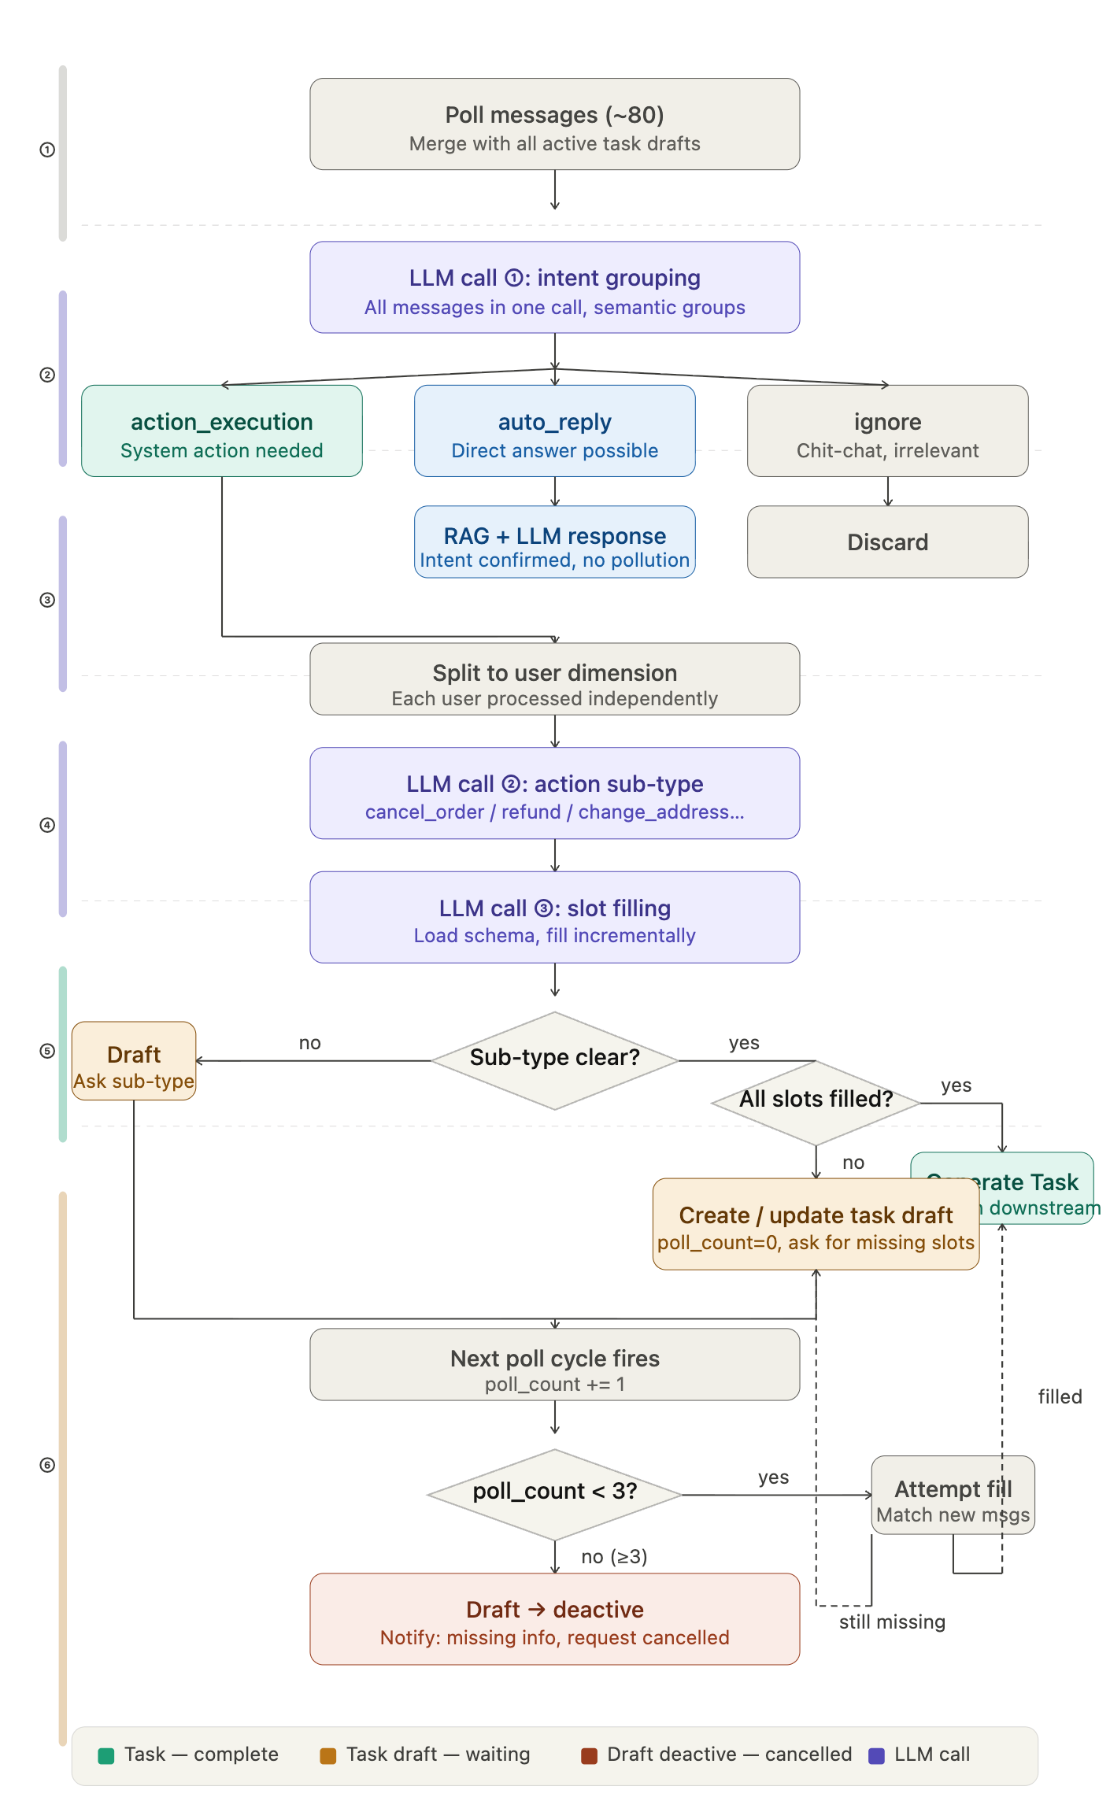
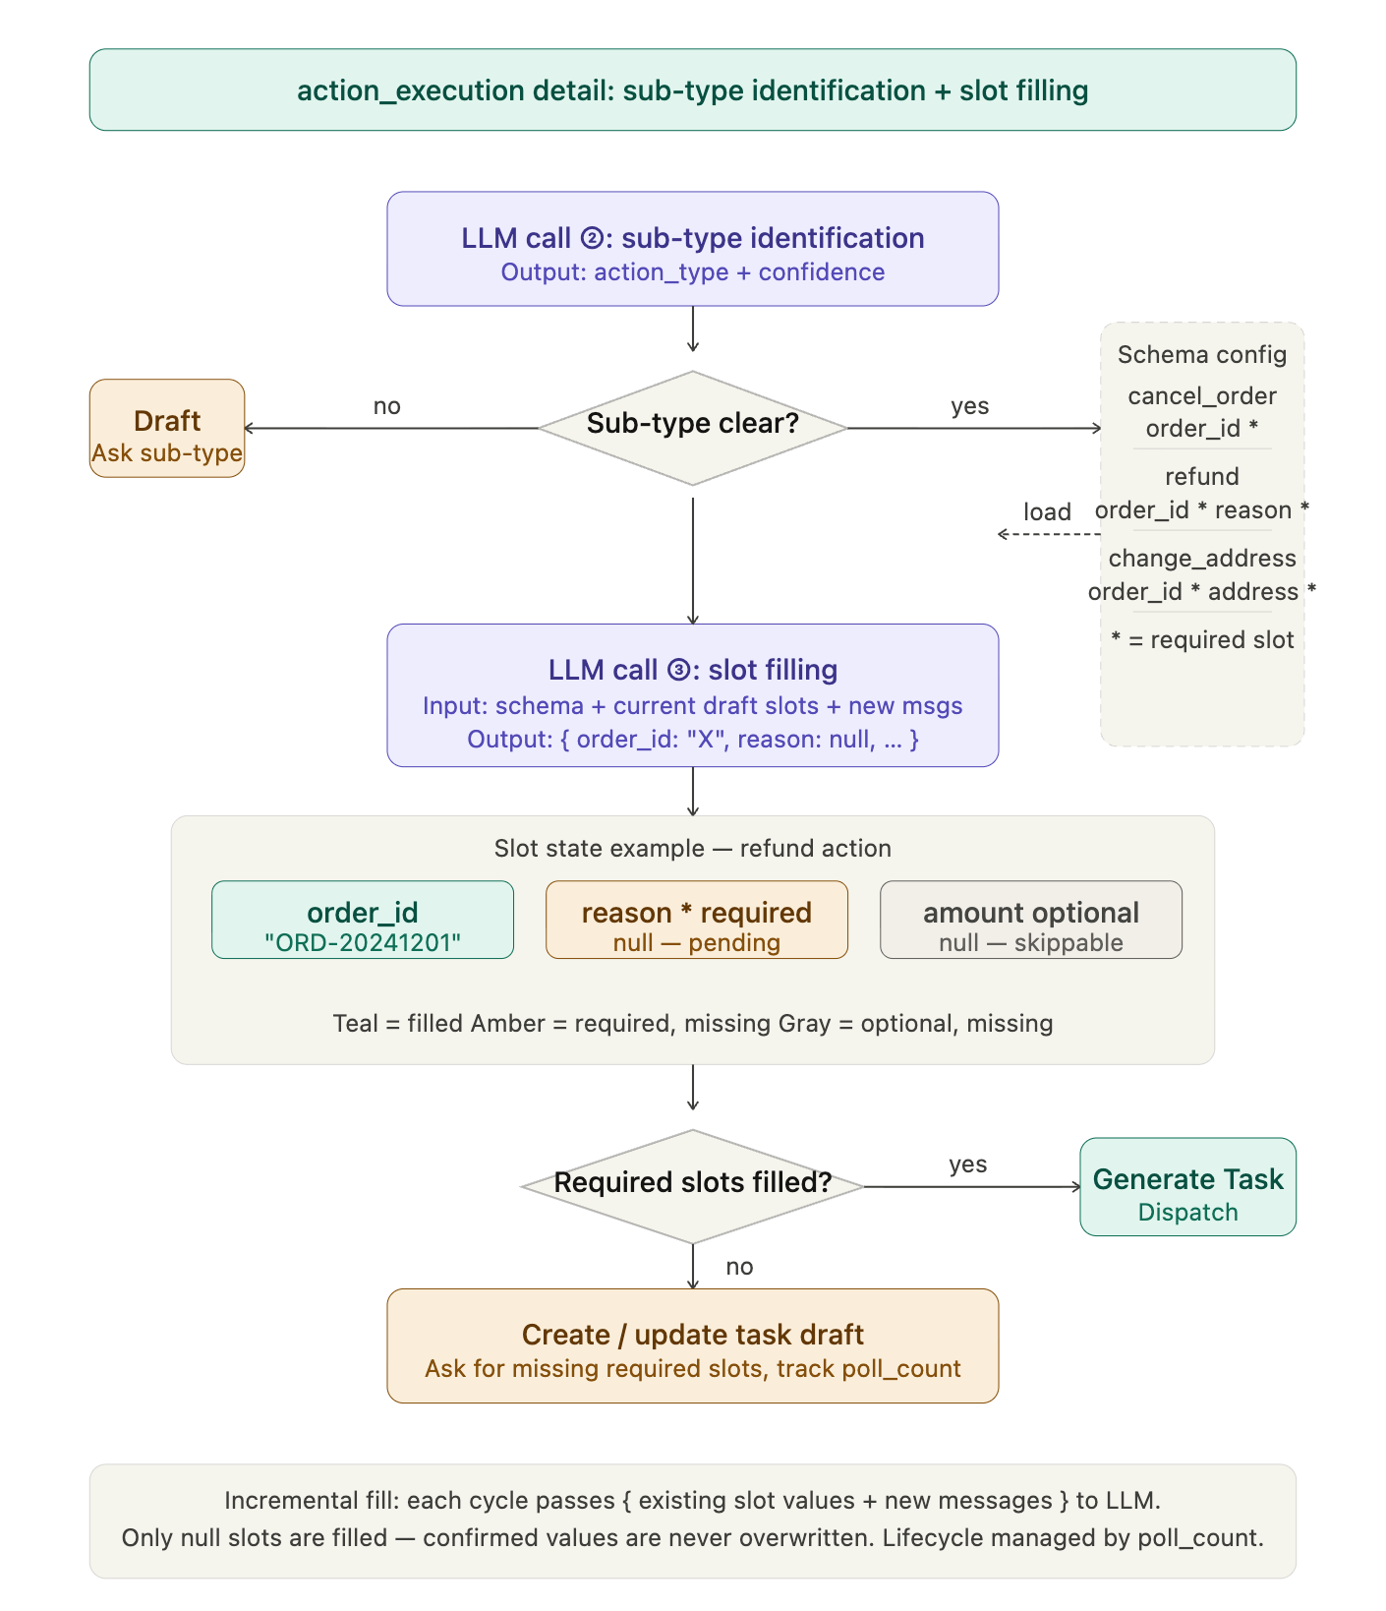

The three LLM calls have completely independent responsibilities: call ① does semantic grouping across all messages at once, call ② identifies the specific action sub-type per user, and call ③ performs schema-driven slot extraction. Their prompts never overlap, which is what prevents intent classification from being polluted by slot-filling context. Also the LLM models are different.
The slot schema is static configuration, not open-ended LLM reasoning. The model's job in call ③ is only to find values from the conversation and place them into pre-defined slots — the schema decides which slots exist and which are required.
Incremental filling is the key to multi-turn completion. Each poll carries already-confirmed slot values alongside new messages, so the LLM only touches null entries. This prevents a noisy new message from overwriting a slot the user already confirmed two turns ago.

Detailed Logic Breakdown
Understood. Your goal is to keep the architecture clean while leveraging "multiple calls to inexpensive models" to balance cost and accuracy.
Given the unique nature of group messages (one person asking, multiple people answering, and multi-task concurrency), I have redesigned the full workflow—from message polling to task generation—for you. The core philosophy of this process is: "Aggregate context first, then cascade through filters, and finally produce structured output."

Customer Service Bot: End-to-End Design (From Messages to Task Blocks)

Stage 1: Ingestion & Pre-processing (Buffer)
- Polling: Pull a batch of messages from the Official Account archive interface.
- Contextual Anchoring:
  - Group messages by RoomID (Group ID).
  - Core Action: Force-tag every message with [Timestamp][SenderID][MessageType].
  - Reasoning: The LLM must know who is speaking to process the logic of "multi-user discussions."

Stage 2: State Retrieval
- Query Active Drafts: Retrieve all ACTIVE task drafts for the specific RoomID from the database or Redis.
- Contextual Splicing: Combine the "new message batch" with the "active draft status" of the group. If a group has multiple drafts (e.g., User A is processing a return while User B asks about shipping), both are carried into the next stage.

Stage 3: Task Sorting (LLM Call ① - Fast Model)
Use the cheapest model (e.g., GPT-4o-mini, Llama 3 8B) to perform simple "multiple-choice" logic.
- Input: Recent group chat text + List of active tasks.
- Task: 1. Noise Filtering: Which messages are just meaningless chatter (Ignore)? 2. Attribution/Association: Is the new message a follow-up to "Existing Draft A," or does it initiate "New Task B"?
- Output: A streamlined list mapping specific messages to Task IDs (or flagged as New).

Stage 4: Intent & Slot Extraction (LLM Call ② - Core Model)
If you are prioritizing cost, use a cheap model here; if you prioritize task success rate, use a slightly more capable model.
- Input: Relevant message fragments for a specific task (New or Existing) + The Schema definition for that task.
- Task: 1. Intent Confirmation: Confirm the specific action (e.g., cancel_order). 2. Slot Extraction: Extract slot information in JSON format. 3. Conflict Checking: If User C replies with a tracking number for User B, the LLM must judge whether to accept this information based on context.
- Output: Structured Incremental Slots.

Stage 5: Logic Validation & Decision Making (Task Assembler - Pure Code Execution)
This step does not call an LLM. It is handled by backend logic (Python/Go) to ensure 100% accuracy.
- Slot Validation: Compare extracted data against the static Schema.
  - Scenario A (Full): All slots are filled.
  - Scenario B (Incomplete): Slots are missing; record which fields are still empty.
- Decision:
  - If Full: Change status to READY, generate the Task Block, and send it to the downstream Agent.
  - If Incomplete: Keep status as DRAFT and generate a suggested "clarification prompt" for the user.

Stage 6: Lifecycle Management
- TTL (Time To Live) Check: Do not rely on polling counts; use absolute time. If a draft receives no new messages for 10 minutes, mark it as EXPIRED.
- Deduplication & Updates: Update the draft status in the database and prepare for the next polling round.

Specific Problems This Design Solves:
- Regarding "Cheap Models":
  - The process is split into Sorting (Call 1) and Extraction (Call 2).
  - Call 1 handles large blocks of text (80+ messages) using the cheapest model because it only performs classification.
  - Call 2 only processes the few messages relevant to the task. Even if the model is slightly more expensive, the total Token count remains very low.
- Regarding "Multi-user Group Chats":
  - Through the Attribution in Stage 3, we transform chaotic group chats back into an orderly "Task Stream."
  - The prompt explicitly states: If the sender is neither the task initiator nor customer service, slot information provided by them should be treated with caution.
- Regarding "Process Complexity":
  - This is a standard Pipe-and-Filter architecture. While it looks like many steps, each step has a singular responsibility, making it very easy to debug. You will know exactly whether the model failed to identify intent or the code failed to validate a slot.

