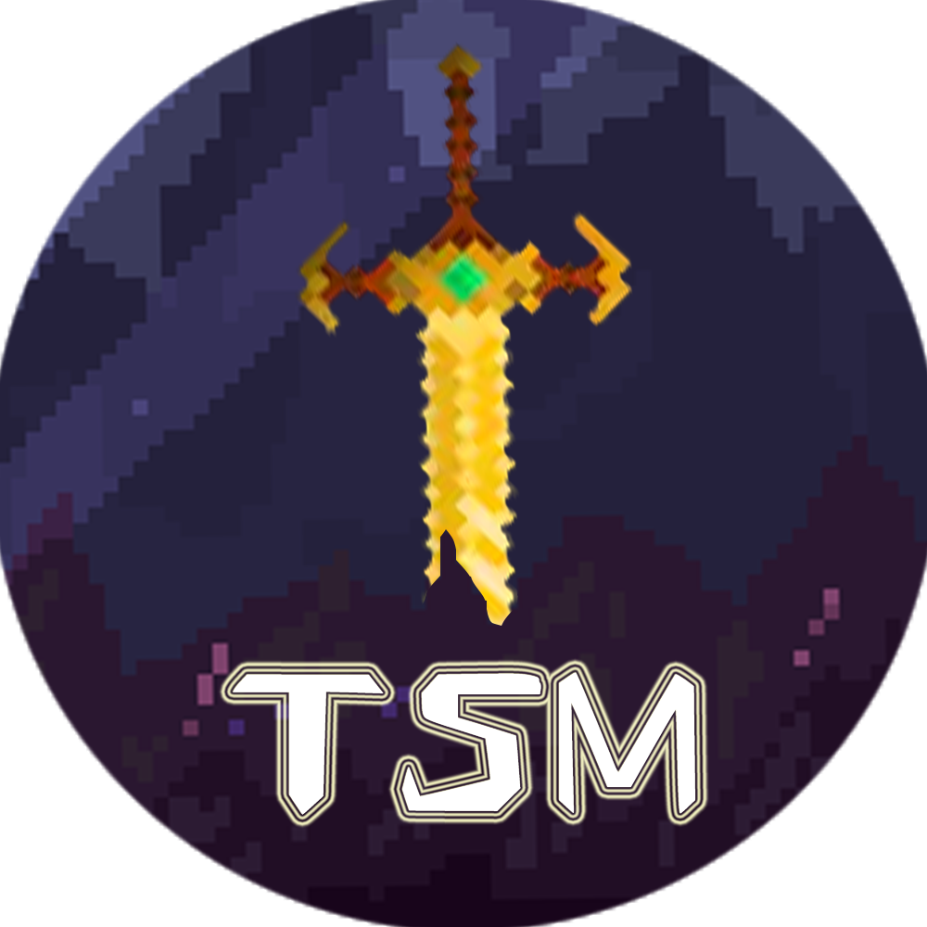

Logo

Main Menu

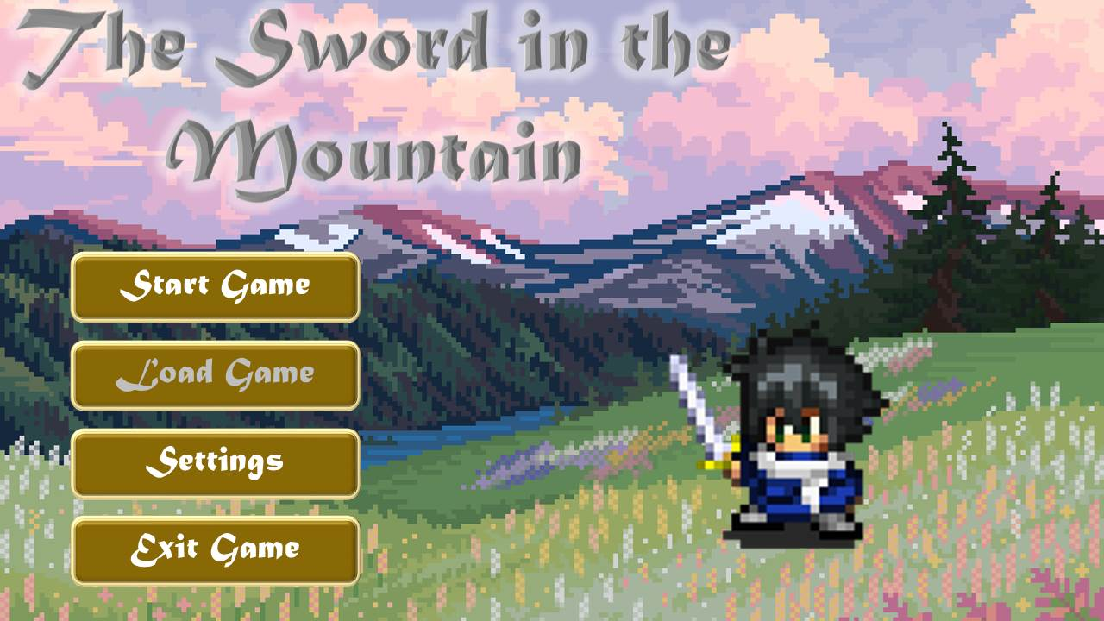

Screenshots

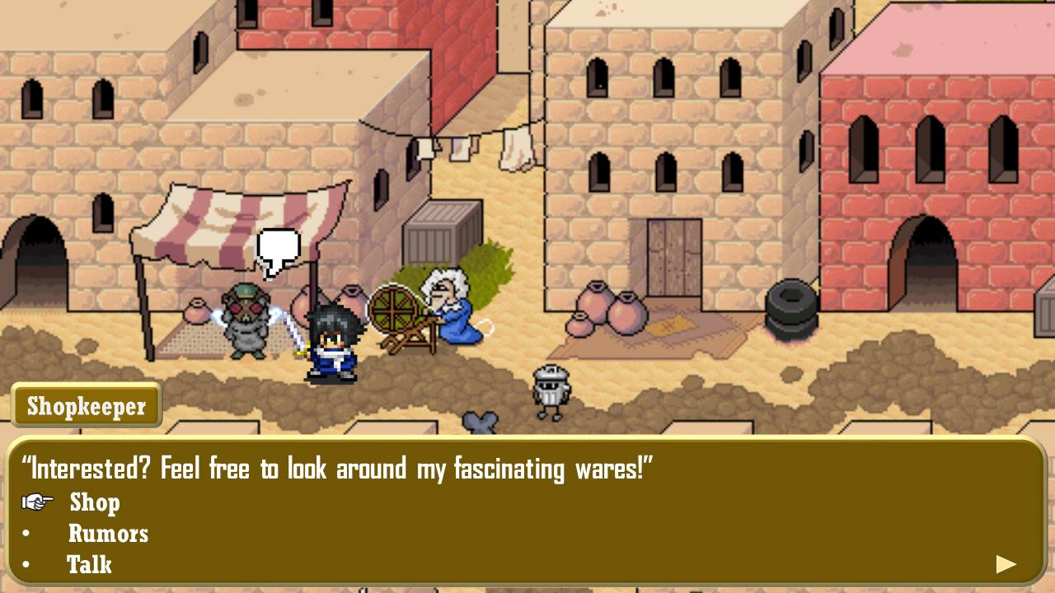

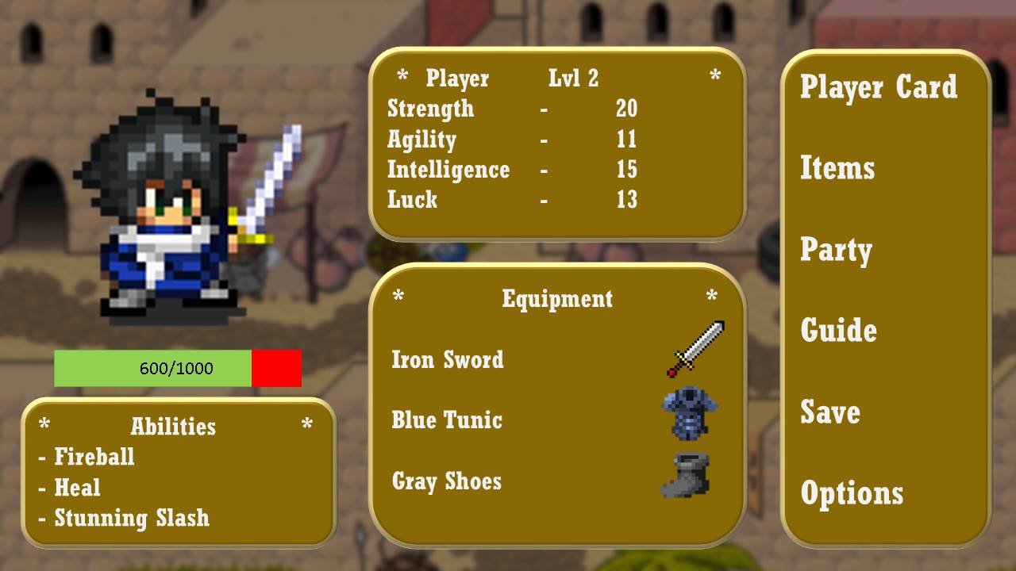

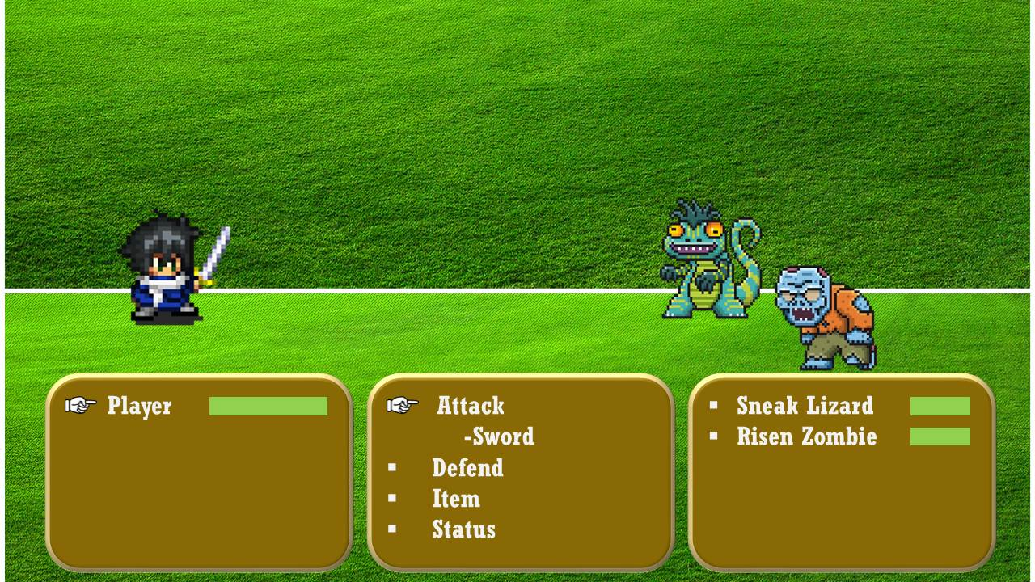

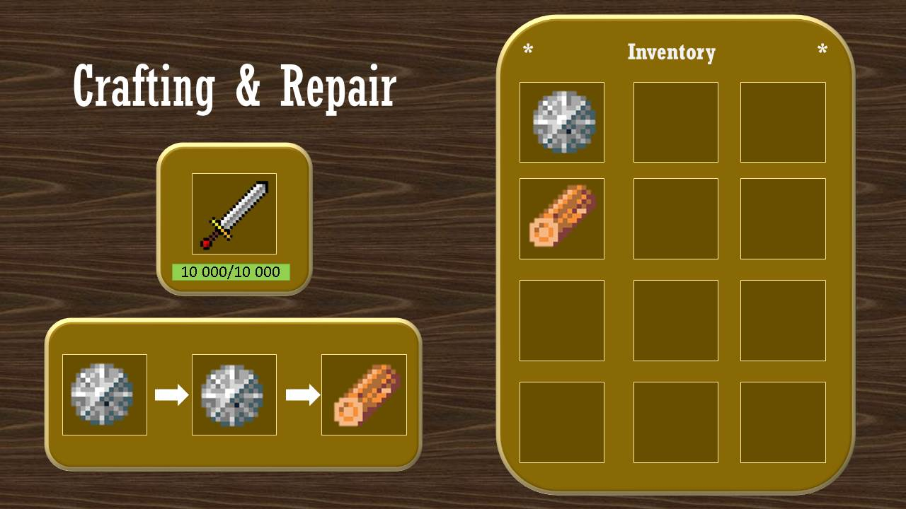

**Title:** The Sword in the Mountain

* The title correlates to the story of a legendary sword hidden in the cave of a mountain that is wedged in stone and can only be wielded out by a worthy warrior that is pure of heart.

**Genre:** Fantasy

* The game’s setting is a fantasy world that is set in the old medieval-like era where magic and fictional creatures exist.

**Gameplay:** Turn-based, role-playing game

* The gameplay pays homage to the old RPGs where the player and enemies take turns to attack, defend, use items or magic.
* The game is an RPG meaning that the player gets to decide what the character’s role in the story is. They will get options on dialogue, decisions that will affect the story, almost like the player is actually who they are controlling.

**Story:**

* The game’s story starts from a little peaceful village in the Dragon Kingdom, where a young hero (that is named by the player) is dreaming to become a great King Knight, the greatest hero in the world, as no one in their village has successfully become a King Knight he aspires to be the first from their village to become one, as it will improve the lives of his family and his village and will give him the ability to protect everyone that he loves and bring peace to the world.

He starts training to become the greatest King Knight that he can be, but later finds out that the road ahead isn’t going to be easy, along with his new friends from the same batch of knights, they set out to become the greatest knights that they can be, and compete to become the next King Knight.

But one day as the young knight and his fellow trainees, the current King Knight visits his batch of knights and personally asks for the young hero (you) as it seems that their Elder Knights, the wise sages and advisers of the Knights has foretold a prophecy of a boy, a boy that will save the world from the pending doom that is the embodiment of all Evil, the strongest demon to ever walk in the face of the Earth…Omega, whose name means the “end of all” and it is the young hero’s destiny to defeat that evil with the sword that was wielded by the First King Knight, the legendary Sword of Beginnings, which can only be wielded by young knight, as he is… the next **Alpha Knight**, the hope that will give the world a bright Beginning from the incoming End of all things

**Players/Target Market:** For everyone that is aged 13 and above

* The game’s target market are teens, since this is the age where they engage in fiction and wonder about fantasy-based games with good storyline and simple but fun game mechanics.