Kinematics and Dynamics of Mechatronic Systems

3rd laboratory task
Piotr Bury , Maciej Paczocha
Determine a Homogeneous Transformation matrix 1
Determining the constants and random values of joint coordinates in the ranges 1
Draw both paths on the 2nd figure 3
1st path: Generating motion path for each joint 4
2nd path: Generating motion path for each joint 6

Determine a Homogeneous Transformation matrix
clear all; clc
% declaration of symbols
syms th1 d1 th2 a3 th4 d5 q1 q2 q3
% Determination of a symbolic form of HT matrices – application of mA function
A1=mA(th1,d1,0,sym(pi/2));
A2=mA(th2,0,0,0);
A3=mA(0,0,a3,0);
A4=mA(th4,0,0,sym(pi/2));
A5=mA(sym(pi/2),d5,0,0);
%
% multiplication of matrices to obtain HTM
T01=A1;
T05=A1*A2*A3*A4*A5;

Determining the constants and random values of joint coordinates in the ranges
input constants
d1_input = 0.4;
d5_input = 0.15;
% Drawing the workspace on the 1st figure
figure(1);
hold on
for th1_input=-pi/2:pi/18:pi/2
for th2_input=-pi/4:pi/8:pi/4
for a3_input=0.2:0.1:0.6
for th4_input=-pi/2:pi/4:pi/2
T05_r=subs(T05,{th1,d1,th2,a3,th4,d5},{th1_input,d1_input, th2_input, a3_input, th4_input, d5_input});
P_r = [T05_r(1,4); T05_r(2,4); T05_r(3,4)];
plot3(P_r(1,1),P_r(2,1),P_r(3,1),'.')
end
end
end
end
%
% Determine the paths
%Determine the 1st path
x1=[0.39 0.39 0.29 0.23 0.21 0.19 0.17 0.15 0.14 0.12];
y1=[0.46 0.44 0.40 0.30 0.20 0.10 -0.10 -0.2 -0.3 -0.3];
z1=[0.03 0.29 0.43 0.43 0.37 0.37 0.35 0.18 0.15 0.02];
path1=[x1; y1; z1];
%Determine the 2nd path
x2=[0.00 0.00 0.00 0.14 0.24 0.24 0.32 0.27 0.03 0.00];
y2=[0.45 0.45 0.38 0.35 0.24 0.00 -0.2 -0.27 -0.42 -0.53];
z2=[-0.05 0.24 0.57 0.78 0.70 0.60 0.4 0.3 0.2 -0.13];
path2=[x2; y2; z2];
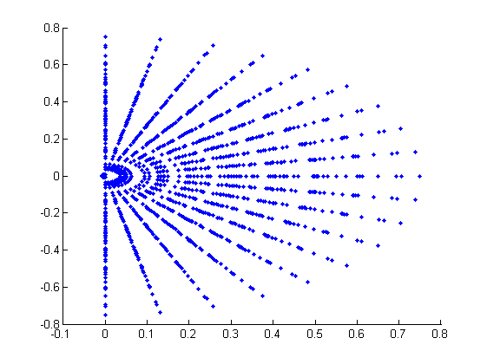

Draw both paths on the 2nd figure
hold on
plot3(x1,y1,z1,'--r')
%hold on
plot3(x2,y2,z2,'--g')
grid on
xlabel('X')
ylabel('Y')
zlabel('Z')
hold off
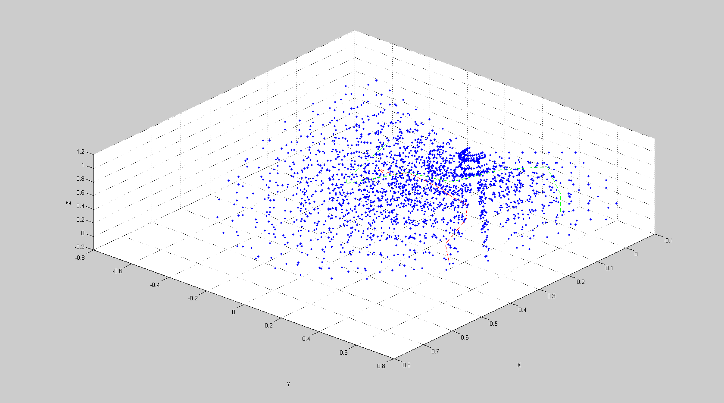

1st path: Generating motion path for each joint
%Placeholder for cartesian coordinates gathering
JointCoordinates1 = zeros(10,4);
Drawing motion path for each joint
figure(2)
hold on
grid on
xlabel('X')
ylabel('Y')
zlabel('Z')
plot3(x1,y1,z1,'--r');
for i=1:10
joint4=path1(:,i);
%calculation of q1,q2,q3,q4 with inverse kinematics
th1_inverse=atan2(joint4(2,1),joint4(1,1));
th2_inverse=atan2((joint4(3,1)-d1_input),sqrt(joint4(1,1)^2+joint4(2,1)^2));
a3_inverse= sqrt(joint4(1,1)^2+joint4(2,1)^2+(joint4(3,1)-d1_input)^2);
th4_inverse = pi/4-(pi/2)*rand; %not possible to select specific range for q4, so that it will be generated randomly
%determining the matrix for points belonging to path
T01_real=subs(T01,{th1,d1},{th1_inverse,d1_input});
T05_real=subs(T05,{th1,d1,th2,a3,th4,d5},{th1_inverse,d1_input, th2_inverse, a3_inverse, th4_inverse, d5_input});
Pw = [T05_real(1,3);T05_real(2,3);T05_real(3,3)]*d5_input;
joint3=joint4-Pw;
joint1=[T01_real(1,4); T01_real(2,4); T01_real(3,4)];
pts34=[joint4'; joint3'];
pts13=[joint3'; joint1'];
pts01=[joint1'; [0 0 0]];
line(pts34(:,1), pts34(:,2),pts34(:,3));
line(pts13(:,1), pts13(:,2),pts13(:,3));
line(pts01(:,1), pts01(:,2),pts01(:,3));
end
CartesianCoordinates1=path1';
hold off
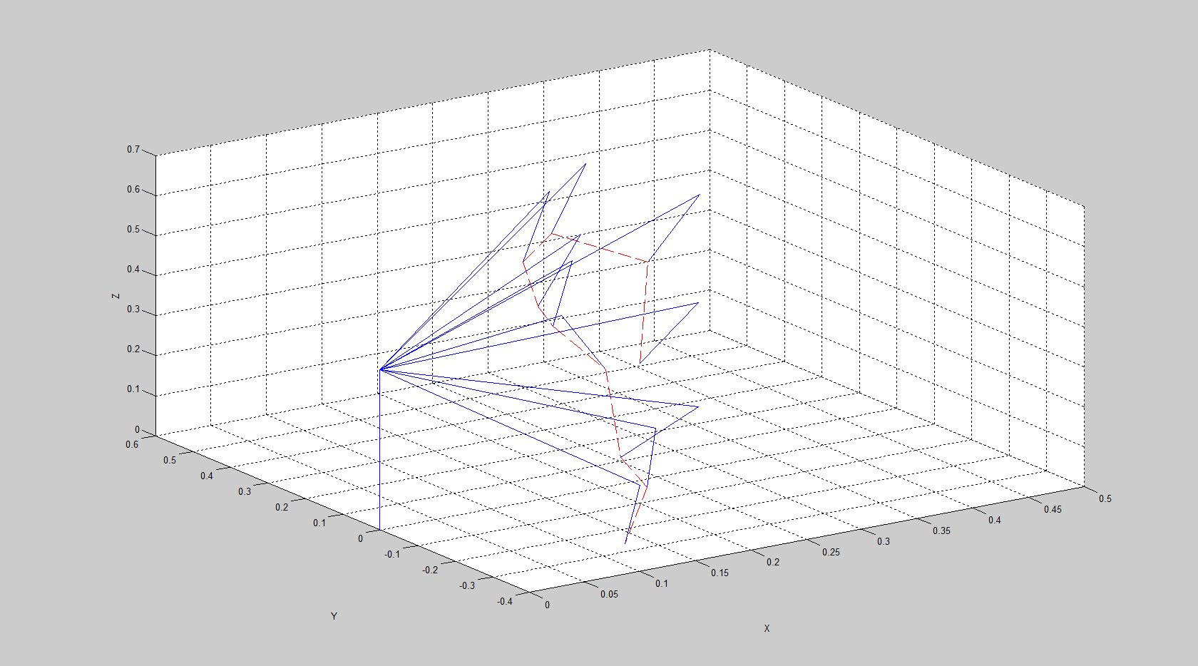
Cartesian coordinates table:
 | X | Y | Z
1 | 0,39 | 0,46 | 0,03
2 | 0,39 | 0,44 | 0,29
3 | 0,29 | 0,4 | 0,43
4 | 0,23 | 0,3 | 0,43
5 | 0,21 | 0,2 | 0,37
6 | 0,19 | 0,1 | 0,37
7 | 0,17 | -0,1 | 0,35
8 | 0,15 | -0,2 | 0,18
9 | 0,14 | -0,3 | 0,15
10 | 0,12 | -0,3 | 0,02

Joint coordinates table:
 | Theta1 | Theta2 | A3 | Theta4
1 | 0,867566 | -0,5503 | 0,707531 | 0,696327
2 | 0,845566 | -0,18495 | 0,598164 | -0,03438
3 | 0,943488 | 0,060646 | 0,494975 | 0,257848
4 | 0,916714 | 0,079195 | 0,37921 | 0,509458
5 | 0,761013 | -0,10308 | 0,291548 | 0,457185
6 | 0,484478 | -0,13883 | 0,216795 | -0,63641
7 | -0,53172 | -0,24828 | 0,20347 | -0,2755
8 | -0,9273 | -0,72165 | 0,333017 | 0,04953
9 | -1,13417 | -0,64679 | 0,414849 | -0,64738
10 | -1,19029 | -0,86613 | 0,498799 | 0,622017

2nd path: Generating motion path for each joint
%Placeholder for cartesian coordinates gathering
JointCoordinates2 = zeros(10,4);
Drawing motion path for each joint
figure(3)
hold on
grid on
xlabel('X')
ylabel('Y')
zlabel('Z')
plot3(x2,y2,z2,'--g');
for i=1:10
joint4=path2(:,i);
%calculation of q1,q2,q3,q4 with inverse kinematics
th1_inverse=atan2(joint4(2,1),joint4(1,1));
th2_inverse=atan2((joint4(3,1)-d1_input),sqrt(joint4(1,1)^2+joint4(2,1)^2));
a3_inverse= sqrt(joint4(1,1)^2+joint4(2,1)^2+(joint4(3,1)-d1_input)^2);
th4_inverse = pi/4-(pi/2)*rand; %not possible to select specific range for q4, so that it will be generated randomly
%determining the matrix for points belonging to path
T01_real=subs(T01,{th1,d1},{th1_inverse,d1_input});
T05_real=subs(T05,{th1,d1,th2,a3,th4,d5},{th1_inverse,d1_input, th2_inverse, a3_inverse, th4_inverse, d5_input});
Pw = [T05_real(1,3);T05_real(2,3);T05_real(3,3)]*d5_input;
joint3=joint4-Pw;
joint1=[T01_real(1,4); T01_real(2,4); T01_real(3,4)];
pts34=[joint4'; joint3'];
pts13=[joint3'; joint1'];
pts01=[joint1'; [0 0 0]];
line(pts34(:,1), pts34(:,2),pts34(:,3));
line(pts13(:,1), pts13(:,2),pts13(:,3));
line(pts01(:,1), pts01(:,2),pts01(:,3));
JointCoordinates2(i,1)=th1_inverse;JointCoordinates2(i,2)=th2_inverse;JointCoordinates2(i,3)=a3_inverse;JointCoordinates2(i,4)=th4_inverse; %gather joint coordinates
end
CartesianCoordinates2 = path2'; %inversing the path to easier gathering to table
hold off
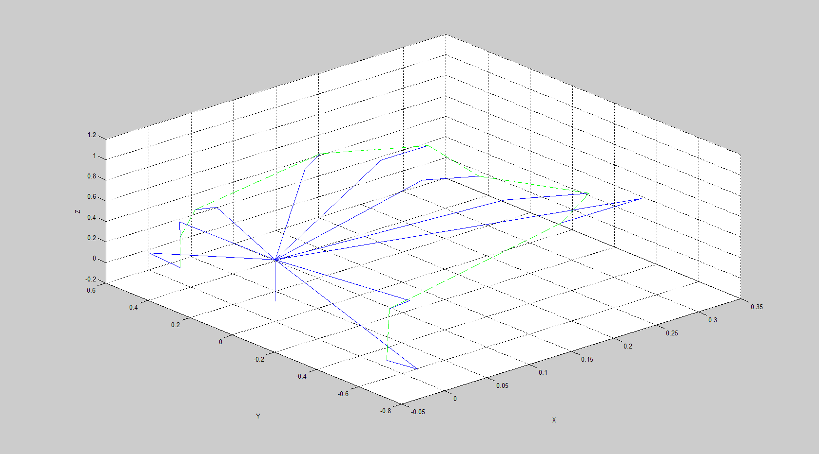
Cartesian coordinates table:
 | X | Y | Z
1 | 0 | 0,45 | -0,05
2 | 0 | 0,45 | 0,24
3 | 0 | 0,38 | 0,57
4 | 0,14 | 0,35 | 0,78
5 | 0,24 | 0,24 | 0,7
6 | 0,24 | 0 | 0,6
7 | 0,32 | -0,2 | 0,4
8 | 0,27 | -0,27 | 0,3
9 | 0,03 | -0,42 | 0,2
10 | 0 | -0,53 | -0,13

Joint coordinates table:
 | Theta1 | Theta2 | A3 | Theta4
1 | 1,570796 | -0,7854 | 0,636396 | -0,32503
2 | 1,570796 | -0,34162 | 0,477598 | -0,7846
3 | 1,570796 | 0,420663 | 0,416293 | 0,333245
4 | 1,19029 | 0,789412 | 0,535257 | 0,134268
5 | 0,785398 | 0,723839 | 0,45299 | 0,055229
6 | 0 | 0,694738 | 0,31241 | -0,41462
7 | -0,5586 | 0 | 0,377359 | -0,49983
8 | -0,7854 | -0,25614 | 0,394715 | 0,627971
9 | -1,49949 | -0,44343 | 0,466154 | 0,505613
10 | -1,5708 | -0,7854 | 0,749533 | 0,220485

