Kinematics and Dynamics of Mechatronic Systems
4th laboratory task
Piotr Bury , Maciej Paczocha

For vectors of joint variables Q1, Q2, … QN corresponding to the prepared motion paths plan the spline joint trajectory of the type 5-(5)-5.
%planning of 10 segment polynomial spline joint trajectories
%corresponding to the assumed path
Q1=[1.570796 1.570796 1.570796 1.19029 0.785398 0 -0.5586 -0.7854 -1.49949 -1.5708];
Q2=[-0.7854 -0.34162 0.420663 0.789412 0.723839 0.694738 0 -0.25614 -0.44343 -0.7854];
Q3=[0.636396 0.477598 0.416293 0.535257 0.45299 0.31241 0.377359 0.394715 0.466154 0.749533];
Q4=[-0.32503 -0.7846 0.333245 0.134268 0.055229 -0.41462 -0.49983 0.627971 0.505613 0.220485];
% setting the duration time of each trajectory segment (in seconds)
T=[0.2,0.1,0.1,0.1,0.1,0.1,0.1,0.1,0.2];
% setting values of initial and final joint velocity as well as
% the initial and final joint acceleration (usually they are set to 0s)
V=[0 0];A=[0 0];
% planning of the initial trajectory of type 555 (evaluation of the
% coefficients)
y1=fun_path(Q1,T,V,A);
y2=fun_path(Q2,T,V,A);
y3=fun_path(Q3,T,V,A);
y4=fun_path(Q4,T,V,A);
% setting the time axis resolution
dt=0.01;
% calculate joint displacements, velocities and accelerations for 3 joints
wb1=waitbar(0,'calculate joint displacement');
[q1,v1,aa1,tt,ti]=fun_graph(y1,T,dt,'r');
i=1;waitbar(i/3,wb1)
[q2,v2,aa2,tt,ti]=fun_graph(y2,T,dt,'b');
i=2;waitbar(i/3,wb1)
[q3,v3,aa3,tt,ti]=fun_graph(y3,T,dt,'g');
i=3;waitbar(i/3,wb1)
[q4,v4,aa4,tt,ti]=fun_graph(y4,T,dt,'g');
i=4;waitbar(i/3,wb1)
close(wb1);

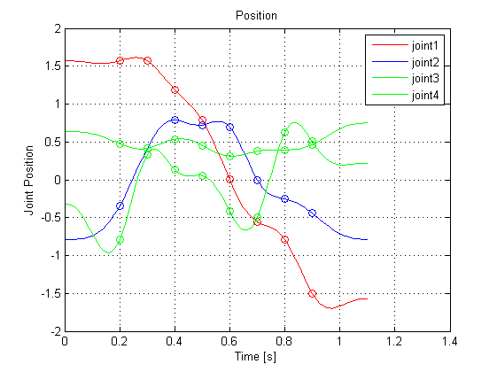

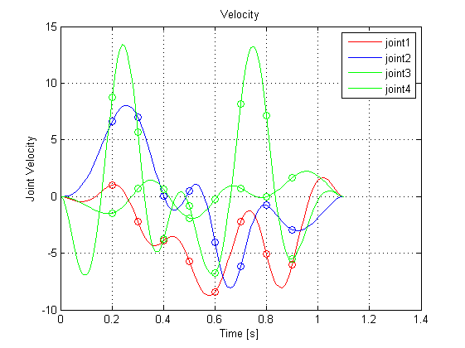
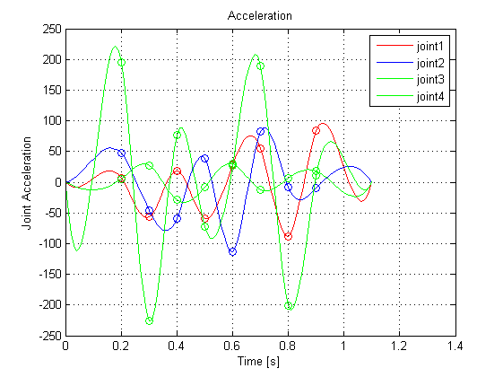

Evaluate, present graphically and assess the resultant Cartesian path and the broken line resulting from composition of Q1, Q2, … QN vectors for the both paths
syms th1 d2 th3 th4 a2 a3
% calculate displacement in 3D - formulas
XX=cos(th1)*(a2+a3*cos(th3));
YY=sin(th1)*(a2+a3*cos(th3));
ZZ=d2-a3*sin(th3);
% calculate the 3D path
X=double(subs(XX,{th1,d2,th3,th4,a2,a3},{q1,q2,q3,q4,0.1,0.5}));
Y=double(subs(YY,{th1,d2,th3,th4,a2,a3},{q1,q2,q3,q4,0.1,0.5}));
Z=double(subs(ZZ,{th1,d2,th3,th4,a2,a3},{q1,q2,q3,q4,0.1,0.5}));
% calculate the 3D broken line
XQ=double(subs(XX,{th1,d2,th3,th4,a2,a3},{Q1,Q2,Q3,q4,0.1,0.5}));
YQ=double(subs(YY,{th1,d2,th3,th4,a2,a3},{Q1,Q2,Q3,q4,0.1,0.5}));
ZQ=double(subs(ZZ,{th1,d2,th3,th4,a2,a3},{Q1,Q2,Q3,q4,0.1,0.5}));
%Draw the paths
figure(4)
plot3(X',Y',Z','--g');
figure(5)
plot3(XQ,YQ,ZQ,'--r');
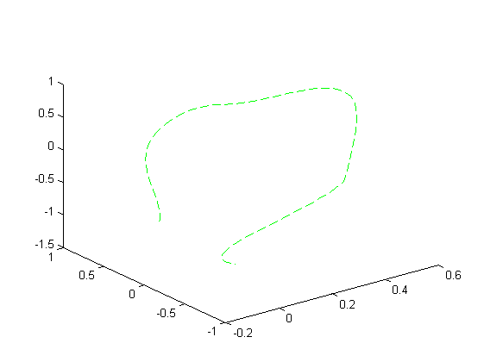
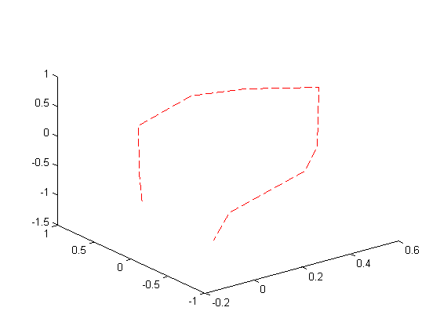
%Concatenating coodinate vectors to form data for both paths
Path3D=[X,Y,Z];
BrokenLine3D=[XQ',YQ',ZQ'];
Path3DLength = sum( sqrt( sum( diff(Path3D,1,1).^2 ,2)) ,1)
BrokenLine3DLength = sum( sqrt( sum( diff(BrokenLine3D,1,1).^2 ,2)) ,1)
Path3DLength =
4.5189
BrokenLine3DLength =
4.3293

