**CALLA LILLY FLOWERS**

1. Name: Ivory Grace

Category: Anniversary

Image:

Price: $340,

Description: " Pure, elegant ivory blooms symbolize grace, poise, and serene beauty, capturing hearts with their delicate elegance.

1. Name: Angelic Aura

Category: Get Well Soon

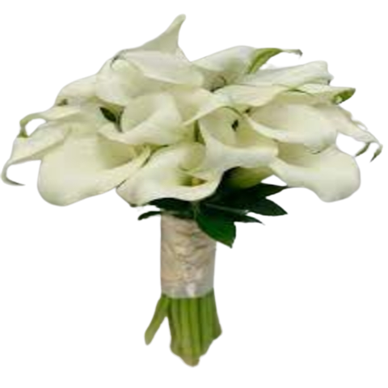Image:

Price: $90,

Description: " These blooms radiate an ethereal presence, embodying purity and grace, with an otherworldly charm.

1. Name: Blushy Beauty

Category: House Warming

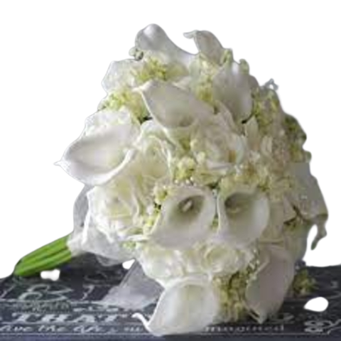Image:

Price: $195,

Description: " Delicate and blushing in color, these blooms exude a soft and charming beauty that captivates.

1. Name: Regal Radiance

Category: Sympathy

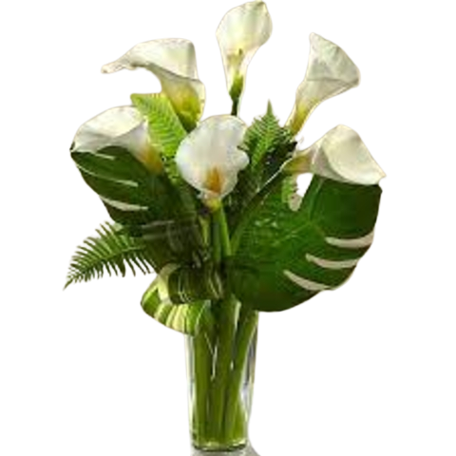Image:

Price: $195,

Description: " Exuding regal charm and radiance, these blooms capture the essence of majesty and elegance.

1. Name: Elegant Embrace

Category: Valentine

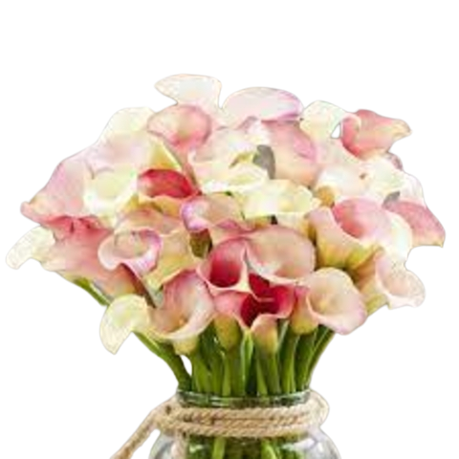Image:

Price: $195,

Description:" These flowers signify an elegant and profound embrace, capturing hearts with their graceful beauty. "

1. Name: Graceful Guardian

Category: House Warming

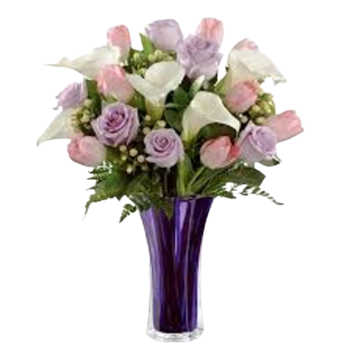Image:

Price: $195,

Description:" These blooms stand as a graceful guardian, symbolizing protection, guidance, and unwavering presence. "

1. Name: Velvet Dreams

Category: Love And Romance

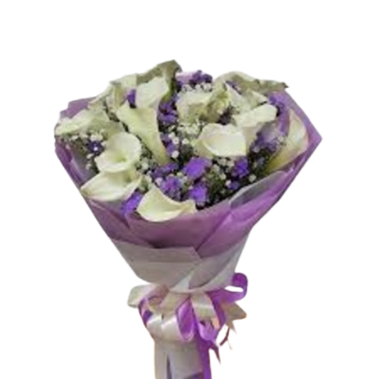Image:

Price: $195,

Description:" With a velvety allure, these blooms evoke a dreamy, luxurious charm and elegance. "

1. Name: Starlight Serenade

Category: Mothers Day

Image:

Price: $195,

Description:" Resembling the serenade of starlight, these flowers bring a gentle, celestial radiance and beauty. "

1. Name: Opulent Orchid

Category: Sympathy

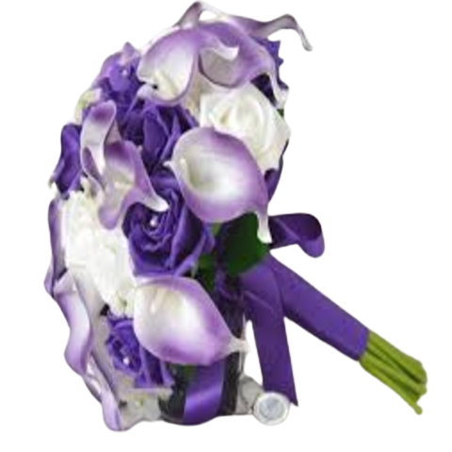Image:

Price: $195,

Description:" These orchids exude opulence and luxury, symbolizing wealth and sophistication in their lavish beauty."

1. Name: Ethereal Elegance

Category: Valentine

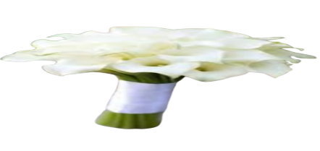Image:

Price: $195,

Description:" Delicate and ethereal, these blooms embody an airy and elegant charm, captivating with grace and beauty. "