CARNATION FLOWER

1. Name: Rosy Radiance

Category: Anniversary

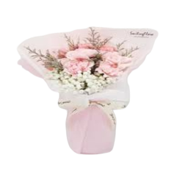Image:

Price: $250

Description: Elegant, vibrant roses emanate inner light that warms the heart, capturing attention with their radiance.

1. Name: Coral Crush

Category: Get Well Soon

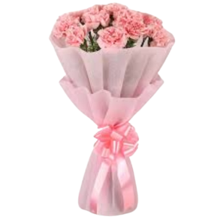Image:

Price: $490

Description: Bold and vibrant, these flowers exhibit a passion and vibrancy that cannot be ignored.

1. Name: Ivory Elegance

Category: House Warming

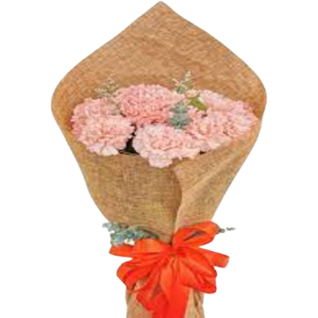Image:

Price: $195

Description: Pure and elegant, these ivory blooms embody grace and sophistication with a timeless elegance.

1. Name: Golden Glimmer

Category: Sympathy

Image:

Price: $195

Description: These blooms shine with a golden glimmer, symbolizing elegance, wealth, and beauty with their radiance.

1. Name: Dreamy DewDrops

Category: Anniversary

Image:

Price: $195

Description: Passionate and vibrant, these blooms express a strong and irresistible attraction, captivating all who see them.

1. Name: Daisy Delight

Category: Wedding

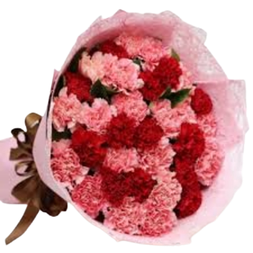Image:

Price: $195

Description: These daisies bring delight with their bright and cheerful blooms, spreading happiness and joy.

1. Name: Rosebud Romance

Category: Anniversary

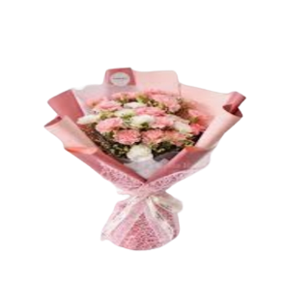Image:

Price: $195

Description: Symbolizing the beginning of love, these rosebuds capture the tender and enchanting moments of romance.

1. Name: Carnation Radiance

Category: Birthday

Image:

Price: $195

Description: These blooms cascade like carnations, radiating vibrancy and exuberance in their captivating display.

1. Name: Delicate Dancer

Category: Get Well Soon

Image:

Price: $195

Description Like a graceful dancer, these blooms exude an airy and elegant charm, captivating with every move.

1. Name: Carnation Charm

Category: Graduation

Image:

Price: $195

Description: Carnations that convey charm and attraction, offering a delightful and alluring presence in any setting.