GEMINI FLOWER

1. Name: Sparkling Gemini

Category: Anniversary

Image:

Price: $300

Description: Unique and captivating, these flowers showcase a duality that sparkles with an enchanting, distinct charm.

1. Name: Rainbow Gem

Category: Birthday

Image:

Price: $220

Description: These flowers are like precious gems, with their colorful hues that shine and captivate all.

1. Name: Blooming Bliss

Category: Graduation

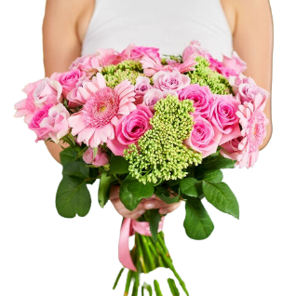Image:

Price: $195

Description: Celebrate academic accomplishments with these blooms that exude a sense of joy and fulfillment.

1. Name: Meadow Marvel

Category: Love and Romance

Image:

Price: $195

Description: Blooms that evoke the wonder of a beautiful meadow, capturing the marvel of the beauty of nature.

1. Name: Pastel Petals

Category: Mother’s Day

Image:

Price: $195

Description: Soft and soothing pastel blooms create a gentle atmosphere of beauty and tenderness.

1. Name: Floral Fantasy

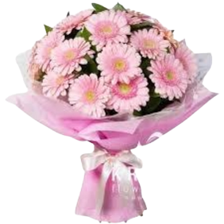Category: Wedding

Image:

Price: $195

Description: A fantasy brought to life, these blooms create an enchanting world of beauty and splendor.

1. Name: Garden Jewel

Category: Mother’s Day

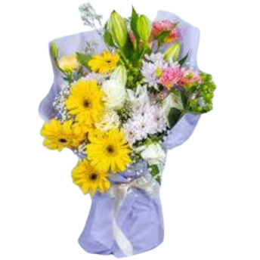Image:

Price: $195

Description: Like a precious jewel in the garden, these blooms symbolize beauty and richness in nature's splendor.

1. Name: Wildflower Wonder

Category: Sympathy

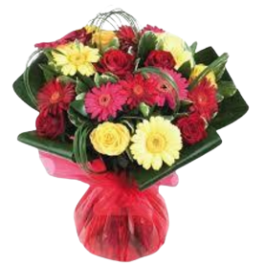Image:

Price: $195

Description: These wildflowers bring wonder, embodying the charm and untamed beauty of the wilderness.

1. Name: Dreamy Daises

Category: Wedding

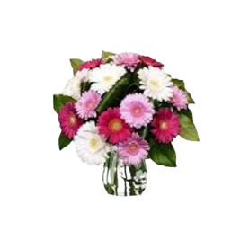Image:

Price: $195

Description: Delicate and dreamy, these daisies create an enchanting atmosphere with their soft and cheerful presence.

1. Name: Sunset Splendor

Category: Valentine

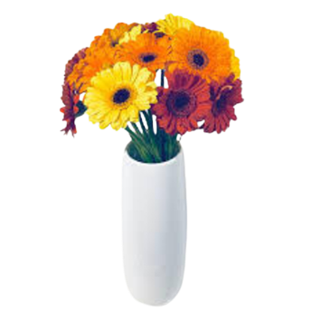Image:

Price: $195

Description: Resembling the splendor of a vibrant sunset, these flowers bring a breathtaking and colorful display.