HYDRANGEAS FLOWER

1. Name: Lavenger Love

Category: Anniversary

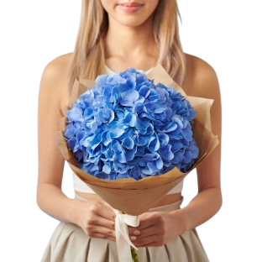Image:

Price: $110

Description: Tranquil lavender blooms symbolize deep affection, emanating serenity and representing a tranquil, profound love.

1. Name: Gentle Giant

Category: Get Well Soon

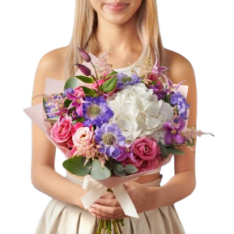Image:

Price: $470

Description: Tranquil lavender blooms symbolize deep affection, emanating serenity and representing a tranquil, profound love.

1. Name: Ocean Dream

Category: House Warming

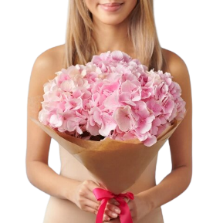Image:

Price: $195

Description: These flowers evoke the dreamy tranquility of the ocean, inspiring visions of serene coastal beauty.

1. Name: Majestic Mauve

Category: Sympathy

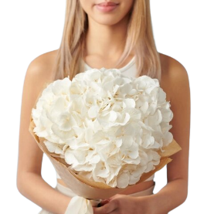Image:

Price: $195

Description: Mauve-hued blooms that exude majesty, capturing attention with their regal and captivating beauty.

1. Name: Violet Velvet

Category: Valentine

Image:

Price: $195

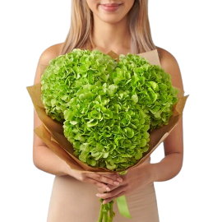Description: Bold and vibrant, these blooms capture a sense of passion and attraction that cannot be ignored.

1. Name: Heavenly Hydrangeas

Category: House Warming

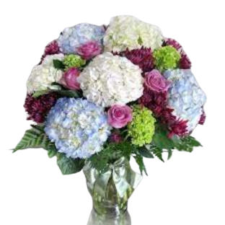Image:

Price: $195

Description: Bold and vibrant, these blooms capture a sense of passion and attraction that cannot be ignored.

1. Name: Blue Skies Beauty

Category: Love and Romance

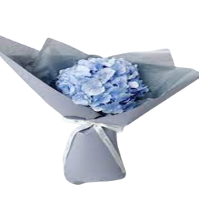Image:

Price: $195

Description: Bold and vibrant, these blooms capture a sense of passion and attraction that cannot be ignored.

1. Name: Hydrangeas Haven

Category: Sympathy

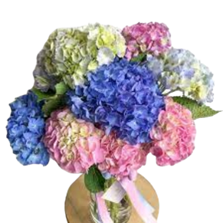Image:

Price: $195

Description: Bold and vibrant, these blooms capture a sense of passion and attraction that cannot be ignored.

1. Name: Sunny Side Blooms

Category: Sympathy

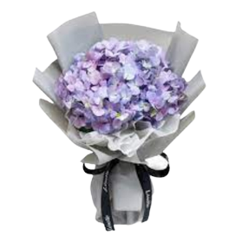Image:

Price: $195

Description: Bold and vibrant, these blooms capture a sense of passion and attraction that cannot be ignored

1. Name: Floral Fantasy

Category: Valentine

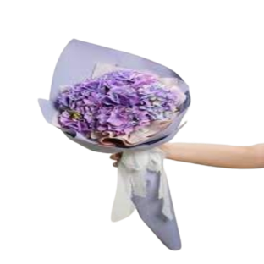Image:

Price: $195

Description: Bold and vibrant, these blooms capture a sense of passion and attraction that cannot be ignored.