LISIANTHUS FLOWER

1. Name: Gentle Grace

Category: Anniversary

Image:

Price: $150

Description: Flowers embodying calm and elegance, captivating all with gentle charm, bringing a sense of poise.

1. Name: Secrete Grace

Category: Birthday

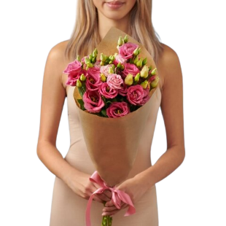Image:

Price: $195

Description: Enigmatic and captivating, these blooms symbolize the hidden beauty and wonders of a secluded garden.

1. Name: Romantic Ruffles

Category: House Warming

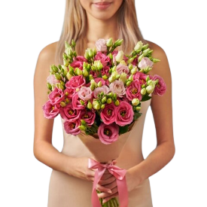Image:

Price: $195

Description: Blooms with ruffled petals that exude an air of romance, capturing hearts with their charm.

1. Name: Starry Sapphire

Category: Sympathy

Image:

Price: $195

Description: These blooms capture the deep blue allure of sapphires, symbolizing the elegance of starry nights.

1. Name: Precious Petals

Category: Valentine

Image:

Price: $195

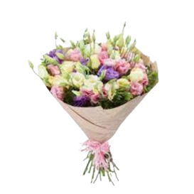Description: Delicate and precious, these petals embody love, gratitude, and admiration within their exquisite beauty.

1. Name: Vintage Velvet

Category: Anniversary

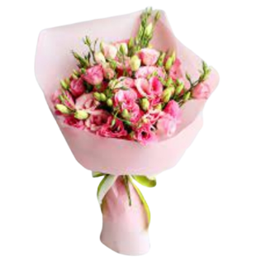Image:

Price: $195

Description: These blooms exude the timeless elegance of vintage velvet, symbolizing luxury and sophistication.

1. Name: Orchid Odyssey

Category: Birthday

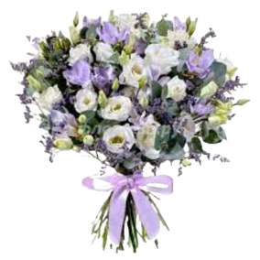Image:

Price: $195

Description: Like a captivating journey, these orchids invite you to explore their unique and exotic beauty.

1. Name: Periwinkle Princess

Category: Get Well Soon

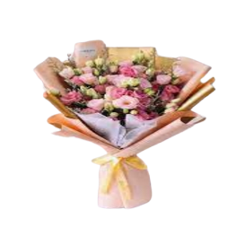Image:

Price: $195

Description: Delicate and regal in periwinkle hues, these blooms embody a sense of royal beauty.

1. Name: Whispering Bells

Category: Graduation

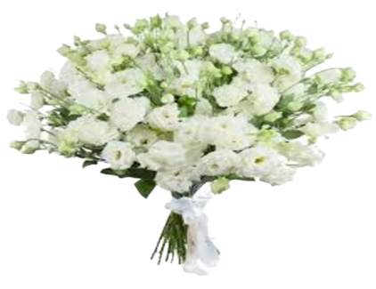Image:

Price: $195

Description: With a gentle whisper, these bell-shaped blooms convey a tranquil and serene atmosphere.

1. Name: Lush Lisianthus

Category: Graduation

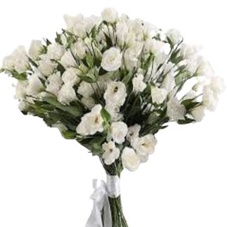Image:

Price: $195

Description: These lisianthus blooms are lush and opulent, representing richness and elegance in their abundance.