ROSE FLOWERS

1. Name: Crimson Charm

Category: Anniversary

Image:

Price: $240

Description: Deep red hues evoke desire, love, and unending fascination in every captivating crimson petal.

1. Name: Heavenly Rose

Category: Birthday

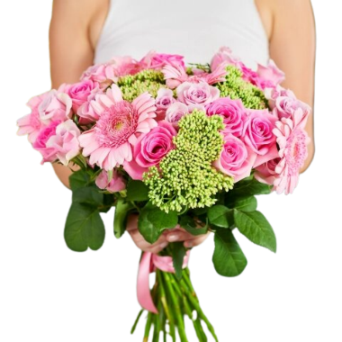Image:

Price: $100

Description: Roses that reflect a divine beauty, exuding an aura of heavenly grace and serenity.

1. Name: Ruby Success

Category: Graduation

Image:

Price: $100

Description: Symbolizing passion and success, these blooms capture the essence of a remarkable achievement.

1. Name: Pink Passion

Category:

Image:

Price: $195

Description: Radiating affection and passion, these pink blooms symbolize love in its most affectionate form.

1. Name: Sun Kissed Rose

Category: Mother’s Day

Image:

Price: $195

Description: Deep crimson blooms exude an irresistible charm, symbolizing love, desire, and fascination.

1. Name: Graceful Grace

Category: Wedding

Image:

Price: $195

Description: A double dose of grace, these blooms represent elegance and charm in their graceful presence.

1. Name: Midnight Rose

Category: Anniversary

Image:

Price: $195

Description: Evoking the mystery of midnight, these roses symbolize deep passion and romance in their allure.

1. Name: Amour Amethyst

Category: Birthday

Image:

Price: $195

Description: These blooms exude the romantic allure of amethyst, symbolizing deep love and passion in each petal.

1. Name: Enchanting Essence

Category: Get well Soon

Image:

Price: $195

Description: Symbolizing passion and success, these blooms capture the essence of a remarkable achievement.