SPRAY ROSES FLOWER

1. Name: Fragrant Breeze

Category: Anniversary

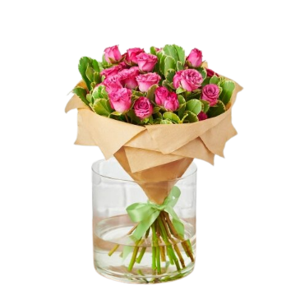Image:

Price: $280

Description: Gentle, soothing aroma flows from these flowers, bringing a refreshing, tranquil natural breeze.

1. Name: Royal Ruffles

Category: Birthday

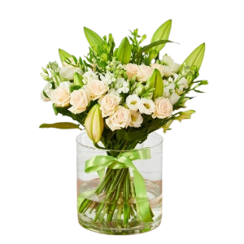Image:

Price: $200

Description: Regal and elegant, these flowers display ruffled petals that exude a sense of majesty and grandeur.

1. Name: Golden Success

Category: Graduation

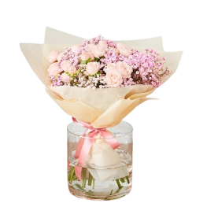Image:

Price: $195

Description: These blooms radiate the brilliance of success, akin to a golden achievement that shines brightly.

1. Name: Fragrant Breeze

Category: Love and Romance

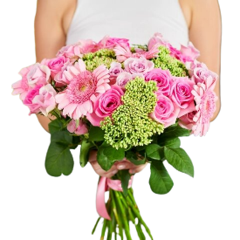Image:

Price: $195

Description: A gentle spray of blooms that conveys sweetness and tenderness, creating an atmosphere of affection

1. Name: Whispering Winds

Category: Mother’s Day

Image:

Price: $195

Description: Like the gentle whispers of the wind, these blooms convey tranquility and serenity to the soul.

1. Name: Blossom Cascade

Category: Wedding

Image:

Price: $195

Description: Like a cascade of blossoms, these flowers create a stunning and enchanting visual display.

1. Name: Lavender Lace

Category: Get well Soon

Image:

Price: $195

Delicate and lavender-hued, these blooms are like lace, symbolizing grace and elegance in their charm.

1. Name: Sunset Spritz

Category: Graduation

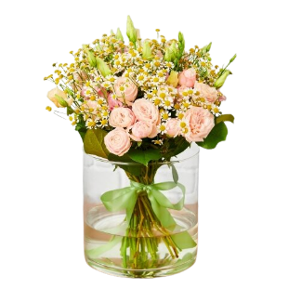Image:

Price: $195

Description: Resembling the warm colors of a sunset, these flowers bring a splash of vibrant radiance.

1. Name: Coral Cascade

Category: Anniversary

Image:

Price: $195

Description: These blooms cascade like coral, radiating vibrancy and exuberance in their captivating display

1. Name: Enchanted Elixir

Category: Love and Romance

Image:

Price: $195

Description: With an enchanted elixir-like allure, these flowers captivate with an otherworldly charm and beauty