TULIP FLOWERS

1. Name: Coral Charm

Category: Anniversary

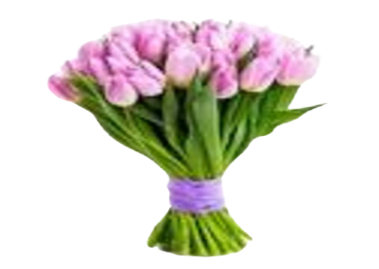Image:

Price: $240

Description: Soft, joyful blooms exuding warmth through their coral-colored petals, bringing a sense of happiness.

1. Name: Tulip Timeless

Category: Birthday

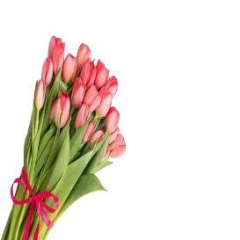Image:

Price: $140

Description: Timeless and beloved, tulips symbolize undying love, making them perfect for expressing affection.

1. Name: Perfection

Category: Graduation

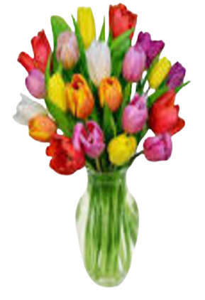Image:

Price: $195

Description: These flowers embody excellence and the pursuit of perfection, making them a fitting gift for graduates.

1. Name: Blushing Beauty

Category: Love and Romance

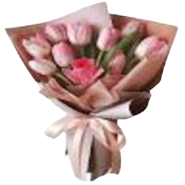Image:

Price: $195

Description: Delicate and blushing in color, these blooms exude a soft and charming beauty that captivates.

1. Name: Spring Symphony

Category: Mother’s Day

Image:

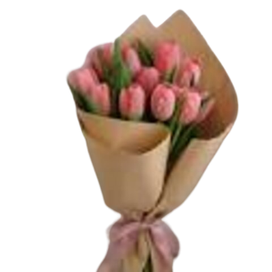Price: $195

Description: A floral symphony celebrating the beauty and rejuvenation of spring, bringing harmony to nature.

1. Name: Apricot Dream

Category: Wedding

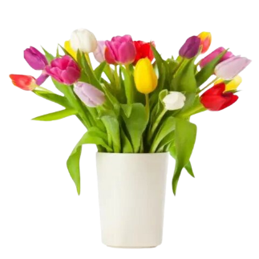Image:

Price: $195

Description: Blooms with the soft, dreamy hues of apricot, bringing a sense of warmth and beauty.

1. Name: Snowflake Serenity

Category: House Warming

Image:

Price: $195

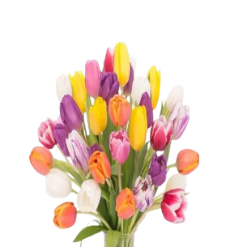Description: Like delicate snowflakes, these blooms bring an atmosphere of serene and tranquil beauty

1. Name: Enchanted Emerald

Category: Love and Romance

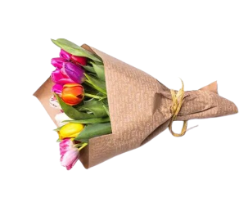Image:

Price: $195

Description: With their enchanting emerald hues, these flowers exude a mystical and captivating allure

1. Name: Ocean Blue

Category: Mother’s Day

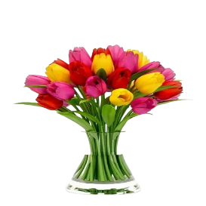Image:

Price: $195

Description: Capturing the essence of the deep blue ocean, these blooms evoke a sense of serenity and tranquility.

1. Name: Glows

Category: Sympathy

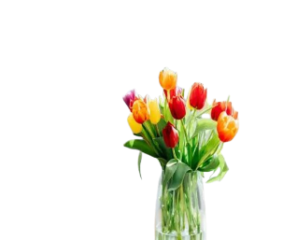Image:

Price: $195

Description: These blooms radiate with a golden glow, symbolizing elegance, wealth, and beauty in their radiant charm.