**Simulácie vo virtuálnej realite s využitím gamifikácie za účelom vzdelávania a prípravných kurzov**

*(Simulations in virtual reality using gamification in purposes of education and training courses)*

**1. Úvod //abstrakt**

*(Abstract)*

**2. Pojem gamifikácia**

*(Gamification)*

**3. Virtuálna realita a simulácie**

*(Virtual reality and simulations)*

1. **Využitie vo vzdelávaní a prípravných kurzoch**

**4. Použitia gamifikácie v simuláciách**

*(Uses of gamification in simulations)*

**5. Zoznam oblastí, kde sa simulácie využívajú na edukačné účely**

*(List of areas where simulations are used in education and training purposes)*

1. Zdravotníctvo
2. Armáda
3. Autoškola
4. Pilotovanie
5. ostatné

**6. Motivácia štatistikami a levelmi**

*(Motivations with statistics and levels)*

**7. Zhodnotenie**

*(Evaluation)*

**1. ÚVOD - Abstract //brief summary**

Short introduction and description of the article – sum up points few words and present the main object/purpose of the article

**2. Pojem gamifikácia**

**3. Využitie v simuláciách**

**VR in games – link with simulations in education and training**

How VR games work (very briefly) and how they can be represented as ‚games‘ but used as an education and training purposes.

**3. Riešenia výskumníkov**

**Mentions of researchers involved in this topic and the problems discussed + current situation in world**

Introduce publishers, researchers and known projects and problems.

**6. Motivácia štatistikami a levelmi**

**5. Prečo použiť gamifikácie vo VR simuláciach**

**REASONS to use VR games more in the future and WHERE to use them correctly (prob. before conclusion)**

Find supportive reasons in other articles and quotations and give my own opinion about the topic (has to be marked that it is mine – bcs of unprofessionality.

**6. Využitie prostriedkov gamifikácie na vzdelávanie**

**Zoznam Exact list of items that I want to write about in my article + their advantages, disadvantage + their mutual summarization**

1. Army trainings (preparations before entering actual conditions) [2. main]
2. Healthcare and other medical similarities [1. main]
3. Virtual reality exposure therapy [minor]
4. 3D modeling and architecture [minor]
5. Airplane and car simulators [minor]

**IMPORTANT NOTICES**

* My theory and arguments must be supported by expert researches
* All quotations and references must be mentioned
* I am not researching, I am just gathering information that someone has researched before – my opinions means basically nothing if not supported
* I have to use everything that is required in the article.

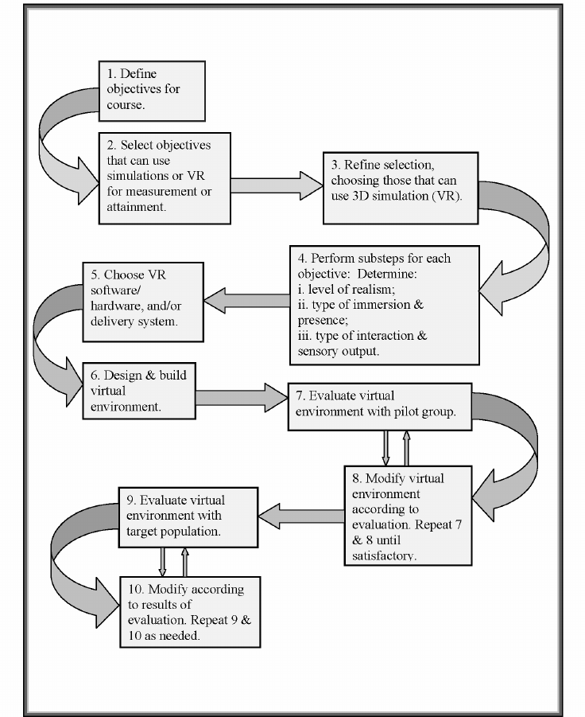Model for determining when to use virtual reality in education and training courses. Copyright 1997. 2009 by Veronica Sexauer Pantelidis.