**Future of SIMULATIONS (as games) IN VIRTUAL REALITY**

*Article structure:*

* **Abstract //brief summary**

Short introduction and description of the article – sum up points few words and present the main object/purpose of the article

* **VR in games – link with simulations in education and training**

How VR games work (very briefly) and how they can be represented as ‚games‘ but used as an education and training purposes.

* **Mentions of researchers involved in this topic and the problems discussed + current situation in world**

Introduce publishers, researchers and known projects and problems.

* **REASONS to use VR games more in the future and WHERE to use them correctly (prob. before conclusion)**

Find supportive reasons in other articles and quotations and give my own opinion about the topic (has to be marked that it is mine – bcs of unprofessionality.

* **Exact list of items that I want to write about in my article + their advantages, disadvantage + their mutual summarization**

1. Army trainings (preparations before entering actual conditions) [2. main]
2. Healthcare and other medical similarities [1. main]
3. Virtual reality exposure therapy [minor]
4. 3D modeling and architecture [minor]
5. Airplane and car simulators [minor]

**IMPORTANT NOTICES**

* My theory and arguments must be supported by expert researches
* All quotations and references must be mentioned
* I am not researching, I am just gathering information that someone has researched before – my opinions means basically nothing if not supported
* I have to use everything that is required in the article.

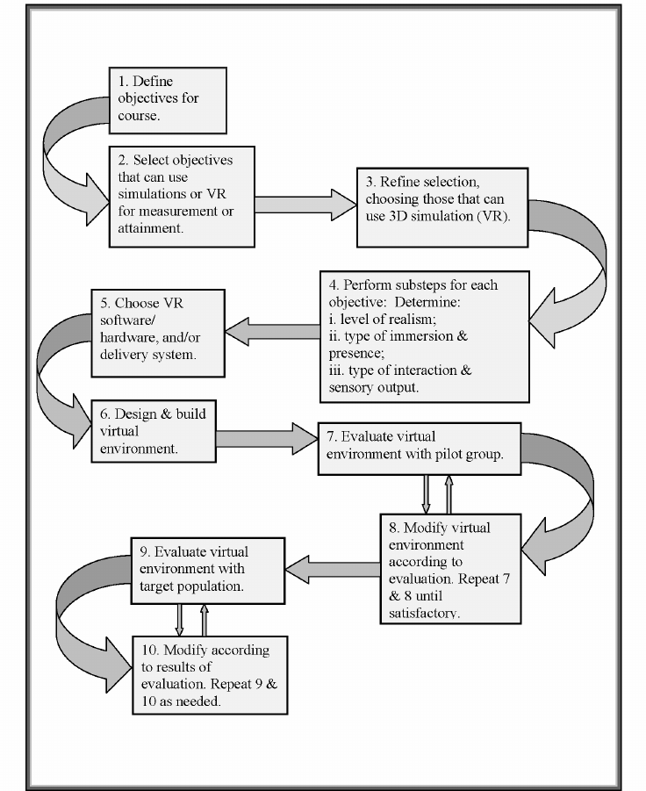Model for determining when to use virtual reality in education and training courses. Copyright 1997. 2009 by Veronica Sexauer Pantelidis.