Rogue-Like Game

Game Design Document

CONTENTS

Description Of Game

Screen Mockups

Extending The Game

Description Of Game

Rogue-Like Game is a clone of the 2D game Angband. In particular, it takes from Angband the movement and combat mechanics, but omits some other aspects of the game. The player will be able to move within the play space using the left, right, up, and down arrow keys while being able to interact with objects within the playspace.

The game will be composed of multiple levels, with enemies perpetually spawning as the player moves throughout the level. Each destroyed enemy will earn the player score points, with the aim of the game being to reach the maximum score before the player’s inevitable destruction occurs. Enemies will also shoot projectiles, that the player will have to avoid.

Key features:

- Player will be able to move left, right, up and down within the game space.

- Player actions will be reflected in animation of the character

- Enemies will randomly spawn in any level

- Upon destruction, enemies and player will animate

- Sound will be generated by the following events:

  - player collision with boundaries of the playspace

  - player death
  - enemy death

  - player buys/picks up object

- Background music will also play during the game

- The player will have a health bar, and will be able to absorb X enemy shots before dying

Components:
UI:
- Character Generation
- Gameplay Layout
  - Map
  - HUD (HP)
- Character Status Sheet
- Help Menu
- Win Screen
- Death Screen
- List

Stores of State:
- Character
- Map
- Creature
- Objects
Controllers:
789
456 ➔ Movement/Targeting
123

“m” use magic
More commands : http://www.zangband.org/Docs/Commands.aspx

Procedures:

- Character Death
- Monster Death
  - Character LevelUp
- New Level
  - Make rooms
  - Make corridors
  - Place objects/monsters
- Pick up object//use object//equip object//drop object
- Attack
- Line of Sight // Light
- Save Game//Load Game

Content:
- Races
- Classes
- Monsters
- Items
- Terrain Features
- Magic

Game Logic:

Controller {
If Character {loadGame
Else {newCharacter

loadGame {
printMap
printHud
waitForPlayerInput

onPlayerInput{
inputBuffer{
doCommand{

makeMap (context){
new map[x,y]
makeRooms{
makeCorridors{
addMonsters{
addTreasure{

}

Screen Mockups

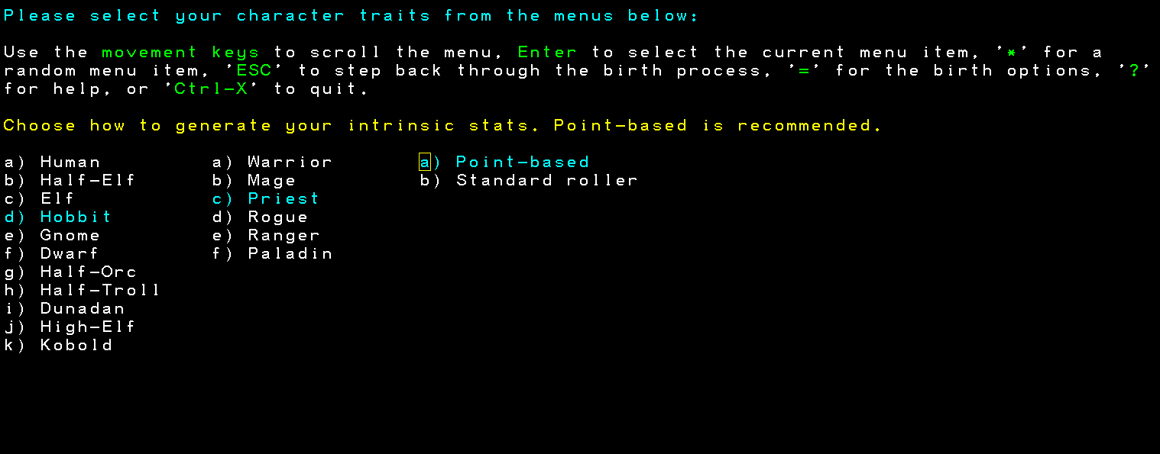
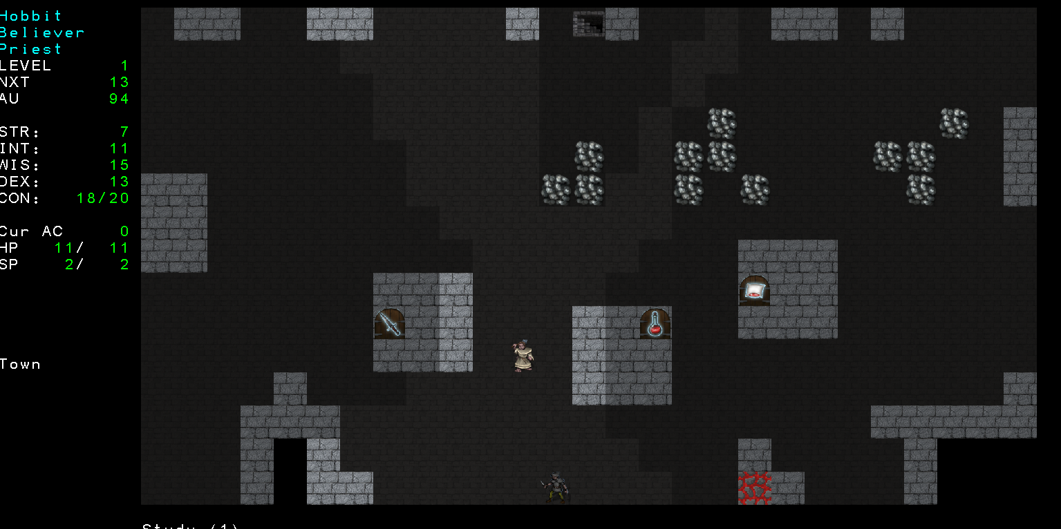

Extending The Game

Some ideas:

- Multiple enemy types – also enemies spawned could become progressively harder to beat.

- Multiple player types – different races, abilities, fighting styles, etc.
- Procedural level design.
- Power Ups for the player.
- Loot drops by the enemies (health bonus, rare items, etc.)

