Peterson Metayer

Module 04 Handling Division & Conversion Exceptions [Individual Project]

**Output**

**1:**

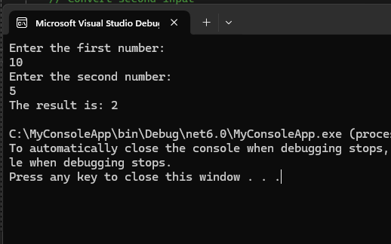

**2:**

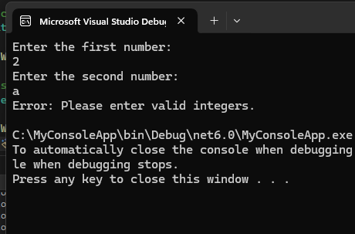

**3:**

