**Design Solution**

|  |
| --- |
| PT Tech |
| AVG Software Solution |
| [Project A.V.G] |

|  |
| --- |
| [Peter Tran]  12-20-2020  [Version 1.1] |

Contents

A. Introduction 3

A.1. Purpose Statement 3

A.2. Overview of the Problem 3

A.3. Goals and Objectives 3

A.4. Prerequisites 3

A.5. Scope 4

A.6. Environment 4

B. Requirements 5

B.1. Business Requirements 5

B.2. User Requirements 5

B.3. Functional Requirements 6

B.4. Nonfunctional Requirements 6

C. Software Development Methodology 7

C.1. Advantages of the waterfall method 7

C.2. Disadvantages of the waterfall method 7

C.3. Advantages of {a different method} 7

C.4. Disadvantages of {a different method} 7

C.5. Best suited 7

D. Design 8

D.1. Storyboard or Flowchart 8

D.2. UML Diagram 9

E. Testing 10

E.1. Testing Type (change name to fit your needs) 10

E.1.1. Soft Deletes (Test) 10

E.1.2. Search For Item (Test) 11

E.1.3. Purchase Item (Test) 12

F. Sources 14

# Introduction

The American Video Game Company needs a new customer relationship management system, as their current/projected growth far exceeded their expectation. They are currently accepting proposals for the development of this C.R.M. The purpose of this system is to build and improve profitability, customer relationships, and the overall efficiency of their team. We will discuss our proposed solution below and how we will address the key business requirements; both functional and non-functional.

# A.1. PUrpose Statement

The purpose of this document is to provide our recommendation and design for the customer relationship management system. It will address the needs of A.V.G as well as critical business requirements to sustain and further scale the A.V.G Company in the future.

# A.2. Overview of THE PROBLEM

A.V.G requires a new solution for managing all aspects of their C.R.M. Their sales have increased by 42% in the last 2 years. As a result, they have outgrown their current solution, and are unable to efficiently manage/track their sales, activities, and contracts. This new system will better track and increase productivity of their team.

# A.3. Goals and Objectives

We will develop a new C.R.M. that will best optimize existing business procedures to its furthest extent; we will implement proper permission and roles of each user while maintaining security. In addition, this newly developed system should be able to sustain current needs and the ability to scale in the future. On top this, it must be developed in a reasonable amount of time while maintaining optimal performance.

All in all, the overall goals and objectives includes:

Security

Developed by a specified deadline

Performance

Usability

# A.4. Prerequisites

|  |  |  |  |
| --- | --- | --- | --- |
| Number | Prerequisite | Description | Completion Date |
| 100 | N/A | Reiterate and address key business requirements. | 12/20/2020 |
| 200 | 100 | Get approval for agreed upon deadline. | 1/23/2020 |
| 300 | 100 | Develop budget and get it approved by project sponsor. | 2/21/2020 |
| 400 | N/A | Collaborate and discuss about regulatory, security requirements, and system design for C.R.M. | 4/22/2020 |

# A.5. Scope

The proposed solution will cover many technical details, as well as overall architecture and design of the system. It will also address software compatibility, security, and usability of the product. It will further reiterate the main business and user requirements; both functional and non-functional. In addition, we will include testing and validations of three main features of the C.R.M.: search functionality, purchase of items, and soft deletes. The proposal will not address any operating system or browser not specified below. Additionally, it will not cover issues with scalability as we will be using Heroku, a platform that allows for virtually unlimited scaling. Furthermore, we will not discuss about networking, setup, or maintenance of server, as it will also be handled by Heroku.

# A.6. Environment

Operating System and Browser Support

* Latest Chrome and Chromium
* Latest Firefox
* I.E 9 and above
* Safari 6.0
* Mobile and tablet
* iOS7 Safari
* iOS7 Third Party Browsers (Chrome and Firefox)
* Android 4.0 Chrome

Infrastructure

* Cloud hosting environment: Heroku which allows developers to develop, run, and operate application entirely on the cloud. (PAAS)
* Database: Heroku Postgres (Managed database service provided by Heroku)
* Development Language/Framework: Ruby/Ruby on Rails

# Requirements

American Video Game has outgrown their existing tools for customer relation management. This is due to a high growth in their business. Within the last two years, they have grown by 42% and is projected to grow even more. They have requested for a new C.R.M. that is more efficient and does not cause to many changes to their existing business process. In addition, the C.R.M must be able to handle soft deletes, hard deletes, price calculation, inventory management, scalability, etc. More information will be provided about how we are going to handle these requirements below.

* Soft Deletes of Data
* Performance & Scalability
* Version control, auditing, and rollbacks
* Order Management of items sold
* Forecasting of sales and Revenue
* Hosting

# Business Requirements

Version Control:

The C.R.M must adhere to correct guidelines for change management and version control. Version control allows us to track software changes and roll back if needed. In addition, it allows us to enhance security by being able to perform audits. All developers and employees working on this project must follow our change management procedures. They must log every change with documentation onto our private GitHub repository.

# User Requirements

Hosting

This C.R.M. will be used by a multitude of users and devices. Due to this reason, it must be compatible with all the operating systems and browsers listed in the environment section above. We will fully test the C.R.M software on all the operating system and browsers we mention in the documentation. As a fail-safe, if a user uses our software on an incompatible environment, a JavaScript popup will appear with a list of compatible browsers and O.S.

Performance and Scalability

American Video Game has 2000 employees who will access the software regularly. At any point in time, there can be 500 employees who will use the C.R.M simultaneously. The software must be able to handle this amount of traffic at a satisfactory speed. In addition, it must be able to scale as A.V.G is still growing. Due to these reasons, we will put an emphasis on designing our database and optimizing code with appropriate algorithms. Also, since the software will be hosted on Heroku scalability will not be an issue. Heroku will allow us to scale as demand for resource increases.

# Functional Requirements

Soft Deletes

A.V.G requires that the C.R.M be able to implement soft deletes. This is a way of deleting data from our user interface but not out database. We plan to implement this feature by adding an additional column called “deleted” on any table that requires it. When the user clicks “deleted” instead of deleting the data, we will set the “deleted” column to true. After this, we will recompile and query data for data where “deleted” is false.

Forecast of Sales and Revenue

For the C.R.M to meet its requirement, it must implement a feature to forecast sales and revenue. In addition, it must convert currency and predict profitability. This allows for the A.V.G, to manage their budget and expectation. Our team plans to use an A.P.I.(FutureMargin) that can predict and automate all the functionalities listed above. We chose to outsource this feature rather than building it, as there is an existing solution that can handle this perfectly. We can then use that free time to focus on more important matters.

Order Management of Items

A.V.G requires a system that will be able to turn a price quote into an order and finalizing a sale. This system must also have a self-service portal where the user can handle returns, track orders, and purchase/repurchase items. This will require a custom solution. Due to this, we will be building it from the ground up. Our developers and designers will work together to implement all the features listed above. Regarding taking payments, we will provide options to use PayPal or our very own payment gateway.

# NonFunctional Requirements

The C.R.M. not only have to perform at optimal level, but it must also be intuitive as well. The interface will be user friendly and follow guidelines for best practice. We plan on making it intuitive by performing a series of usability testing on the interface. 50 participants will be asked to use our product as we collect data on their level of satisfaction. We are also planning to hire a lawyer to help us design a system that adhere to current laws and regulations. The lawyer will look at issues such as payment, customer information, licensing, and ownership rights.

# SOFTWARE DEVELOPMENT METHODOLOGY

American Video Game has selected the waterfall software development methodology for this project. The waterfall model takes a linear approach to project management, where every step has a beginning and end. It uses a sequential model where each phase of project management must be completed before the next phase can start. After thorough research, A.V.G has concluded that this linear process works best.

# Advantages of the waterfall method

The waterfall methodology takes the whole process of project development and break it into separate parts. Due to this rigid and predictable design flow, major decisions can be planned thoroughly. In addition, developers and team members have a clear understand of what the end goal is. They can gauge the level of commitment needed and plan the appropriate number of resources required for completion. There will be no ambiguous requirements, making this process simple and easy to understand.

# disAdvantages of the waterfall method

The waterfall methodology might be a classic in the software development life cycle, it is not without its imperfection. It follows a rigid and structured process which will be a hinderance if A.V.G wanted to implement new requirements and additional features for the project. Due to this, another disadvantage would be the cost of time. The concept stage must be thoroughly addressed because once testing starts, it will be difficult to revert or change a feature.

# Advantages of THE AGILE METHOD

The Agile methodology makes software development a continuous process. It does not have the rigid structure that the waterfall model has but make software development an ongoing process. Ideas and solutions can evolve as better ones are found. This allows for decisions and planning to be done throughout the entire project. Members will not have to be committed to an undesired solution as they can stop and reassess the best course of action forward.

# disAdvantages of THE AGILE METHOD

The benefit of the agile model can also lead to its downfall. It allows for software revisions to happen in real time. This makes it difficult to measure the progression of the project as time goes by. In addition, more time and resources are required because there is no fixed product, as modifications can happen. This can lead to scope creep and an increase in the technical debt for the project.

# best SUITED

The waterfall model works best for the project because A.V.G has a clear list of requirements needed and milestones that needs to be reached. The company is growing very fast and will need the product as soon as possible. Due to this time constraint, tasks for the completion of the project will have to be done sequentially. The scope of the proposed work is simple, and the success of the project relies on earliest completions of the deliverables. Due to these reasons, we concluded that the waterfall model works best for the success of the project.

# Design

American Video Games requires a C.R.M due to the high growth volume their company is experiencing. This solution will allow A.V.G to track and create reports and contracts for their business. In addition, an intuitive dashboard must be created for customer and item management. User experience, performance, and scalability is of major concern and should be a prioritize.

# Flowchart

This flowchart will show the process of how a customer can place an order. It will walk through the various steps needed to be done before an order is successfully completed.

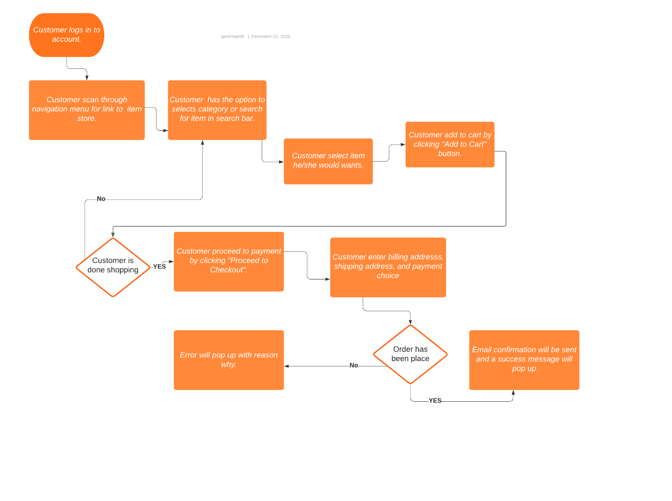

# UML Diagram For Order Management

Below is the database design for A.V.G. order management system. A **User** can place many **Orders**. An **Order** belongs to one **User**. An **Order** can have many **OrderItems**. An **Order** has one and one **trackingID**.

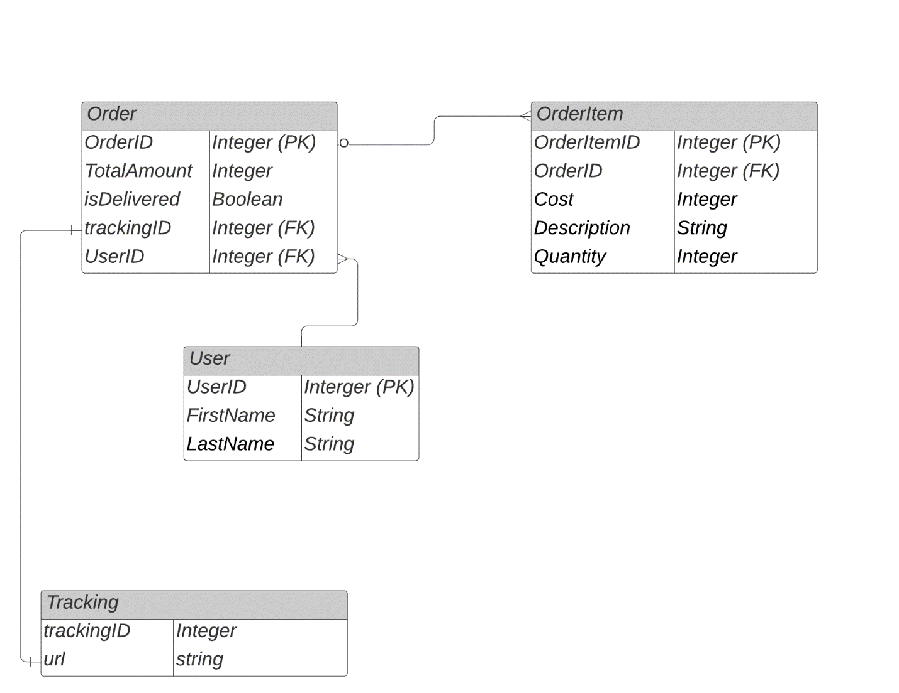

# Testing

This section will summarize how we plan to test the functionality of our customer relationship management system. The objective of the proposed tests will be to address features and processes, maintain data integrity, and create an optimal user experience. Below will a list of overall requirements we will be testing.

* Soft Deletes
* Search for items
* Purchase Item

# Testing Type (Functional)

The following test will be to see if our developed C.R.M. implements soft deletes. We will test this feature by deleting a user. Our C.R.M. wants to keep information on all users even if a user delete their account.

# Soft Deletes

## Soft Deletes of User

|  |
| --- |
| Requirement to be tested  We will test the soft delete requirement for user. |
| Preconditions: Conditions that must be present before test case can successfully run   1. Database must be implemented and verify that data flow is working correctly. 2. User table must have a Boolean column called isDeleted 3. isDeleted column must be set to false initially on every user 4. CREATE, READ, UPDATE, & DELETE(CRUD) functionality is proven to work on user table. 5. GUI Interface relating to these CRUD actions are up and running. |
| Steps: The steps the tester must execute to test the feature.   1. A new user (Paul) creates an account. 2. Paul logs in to account. 3. Paul clicks on settings and navigate down to delete account. 4. When Paul confirm deletion, User table will set isDeleted to TRUE in database. 5. Paul will then be sent to a new page that says his account is deleted. 6. Developer will than query User table searching for Paul account where isDeleted is TRUE. 7. Developer will confirm that Paul’s data is still in User table. |
| Expected results:  Expected results will be that the information of a deleted account will still be in the database. We also expect that the deleted account table entry has its isDeleted column set to TRUE. |
| Pass/Fail: Mark whether the test case passed or failed. The results can be compiled and used to determine if the application is ready for delivery/release.  Test Run 1: User (Paul) deactivates account. Paul’s data is still in database when querying User table. (PASS) |

# Search For Item

## Search For Item

|  |
| --- |
| Requirement to be tested  We will test that search functionality of our CRM by querying the Item table. |
| Preconditions: Conditions that must be present before test case can successfully run   1. Database must be created and working properly. 2. Item table must be created with the following columns: ID, Name, Description, Cost, & Quantity. 3. GUI interface must be completed and working properly to search for items. 4. Successful implementation of SQL command with proper parameters to find the item specified. |
| Steps: The steps the tester must execute to test the feature.   1. Import or verify that the Item table is populated with the proper data. 2. (GUI)Use the search bar located on the top of the C.R.M. and enter the item’s name. 3. Open data log and make sure that the correct parameters are being pass from the search bar. 4. Verify that the SQL statement to query for item is correct. 5. (GUI) Make sure that item page is populated if item exist. 6. If item does not show up, verify that it does not exist in database. |
| Expected results:  We expect the search bar to return a page, with information about the item, if the item exists. |
| Pass/Fail: Mark whether the test case passed or failed. The results can be compiled and used to determine if the application is ready for delivery/release.  Test Run 1: Search for A.V.G hats in search bar and was sent to a page with a list of A.V.G. hats.  (PASS) |

# Purchase Item

## Purchase Item

|  |
| --- |
| Requirement to be tested  Make sure that an item can be purchased in the order management module. |
| Preconditions: Conditions that must be present before test case can successfully run   1. Database is created successfully and proven to work. 2. Order, OrderItem, Tracking, Item, & User table are all created with correct primary key/foreign key associations. 3. Payment feature is implemented and is working successfully. 4. (GUI)Payment Interface is created to purchase order. |
| Steps: The steps the tester must execute to test the feature.   1. Populate database with test data. 2. (GUI)Log in as a test user. 3. (GUI) Find an item and add it to cart 4. (GUI) Click the proceed to checkout button 5. (GUI) Enter test credit card information and confirm order. 6. Confirm that payment is received in payment gateway system. 7. Confirm that Item table gets updated with correct quantity. 8. Confirm that a new record of Order, OrderItem, & Tracking is created with the proper associations. |
| Expected results: Expected results and any side effects such as updating a database, writing to a file, etc.  Expected results is that the payment gateway system receives the correct payment amount. In addition, OrderItem, Order, & Tracking is updated with correct associations. This will allow the system to know which order a user have. |
| Pass/Fail: Mark whether the test case passed or failed. The results can be compiled and used to determine if the application is ready for delivery/release.  Payment was successfully received in payment gateway. All associated tables were updated with correct Primary Key/Foreign Key associations.  (PASS) |