**EKITI STATE UNIVERSITY**

**IN AFFLIATED WITH**

**EMMANUEL ALAYANDE COLLEGE OF EDUCATION**

**P.M.B. 1010, OYO, OYO STATE.**

**ASSIGNMENT ON:**

**RUNNING ALL SAMPLE PROGRAMM IN OUR NOTE.**

**OGUNJIDE OLUWAPELUMI COMFORT**

**EKSU/OYO/18/0487**

**COMPUTER SCIENCE**

**COURSE CODE:**

**CSC 201**

**COURSE TITLE:**

**SCIENTIFIC PROGRAMMING LANGUAGE**

**LEVEL:**

**200 LEVEL**

**LECTURER IN CHARGE:**

**MR ADEDOKUN T.A.**

1. 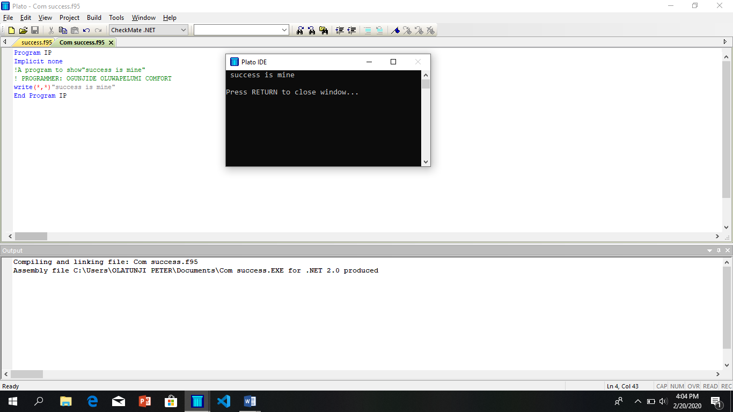**Write A FORTRAN Program print “success is mine”**
2. 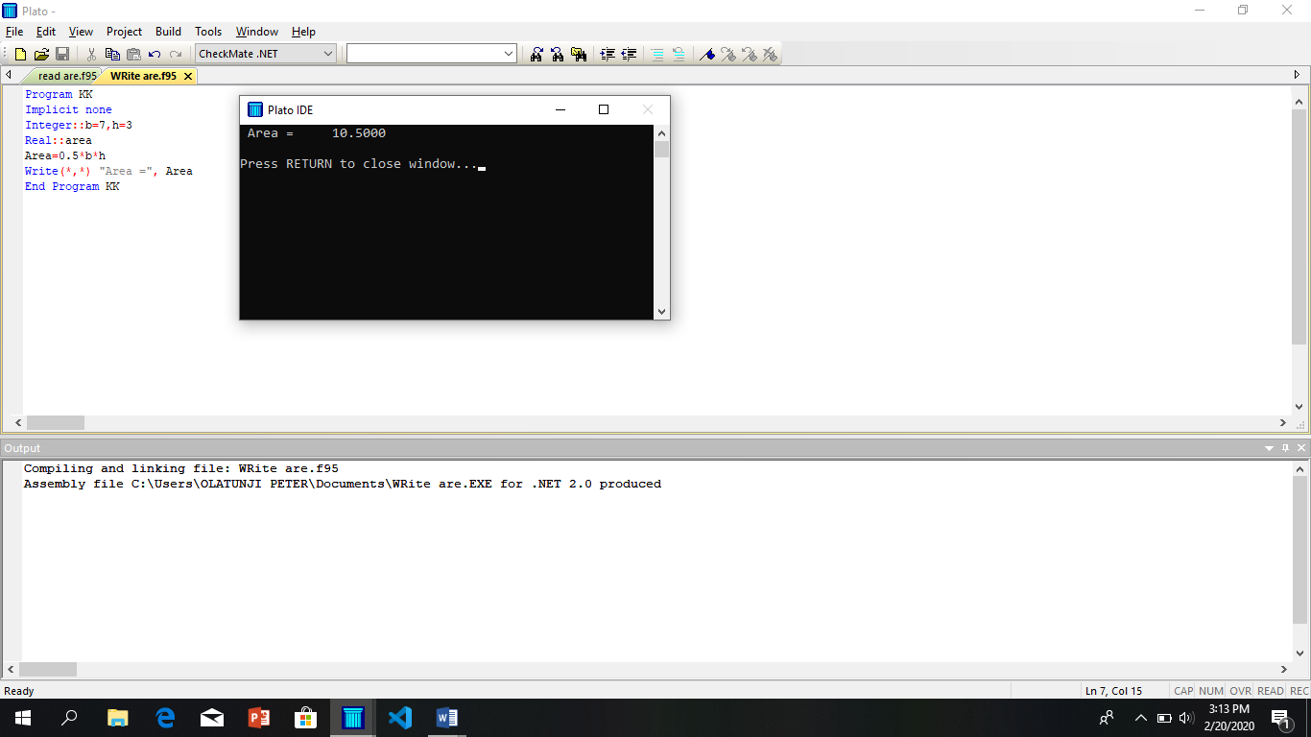**Write a FORTRAN Program find the Area of a Triangle.**
3. **Write a FORTRAN Program to compute Area and Circumference of a triangle using READ Statement**

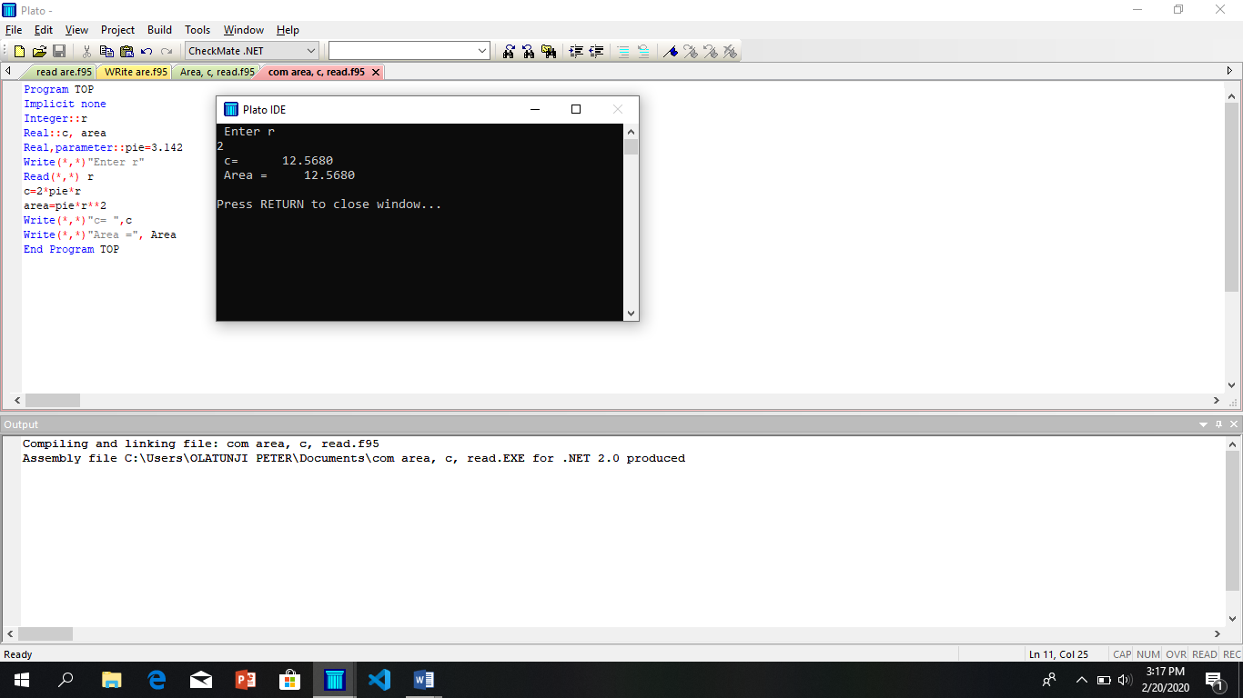

1. **Write a FORTRAN Program to find the Area and Circumference of a triamgle.**

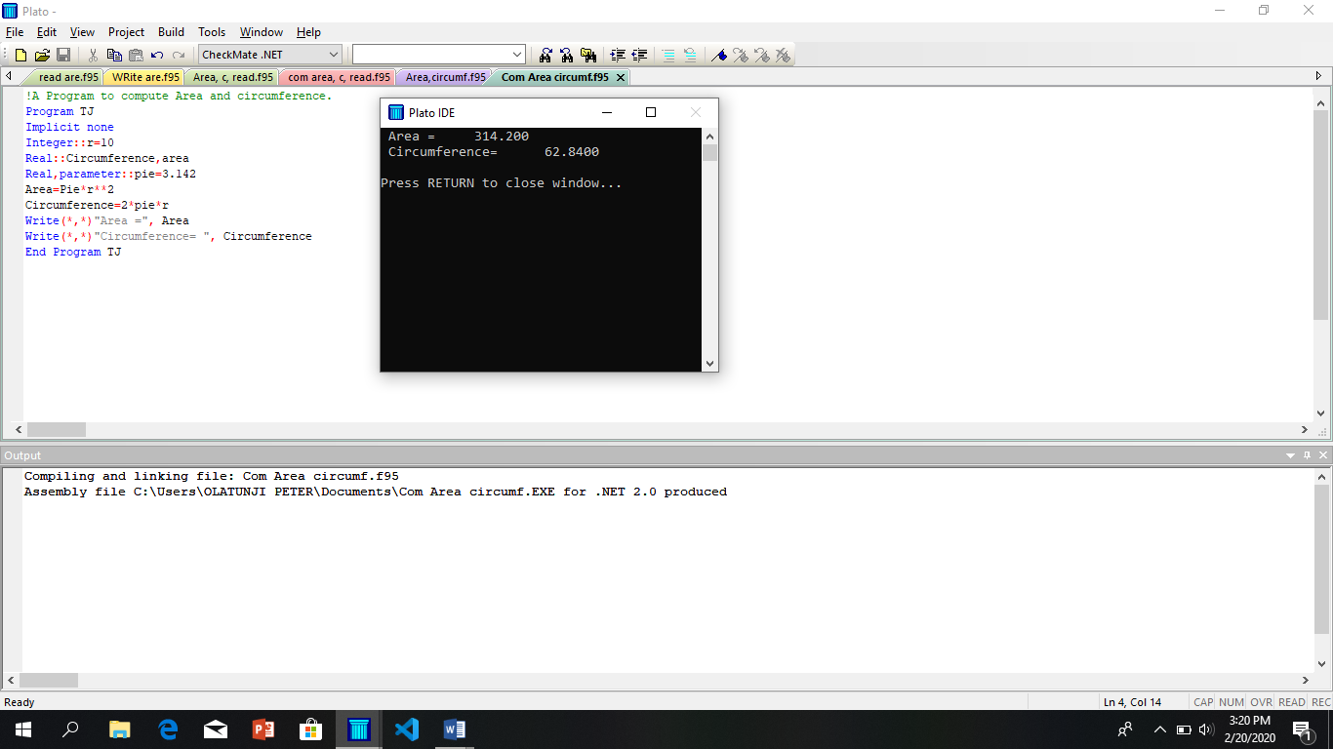

1. 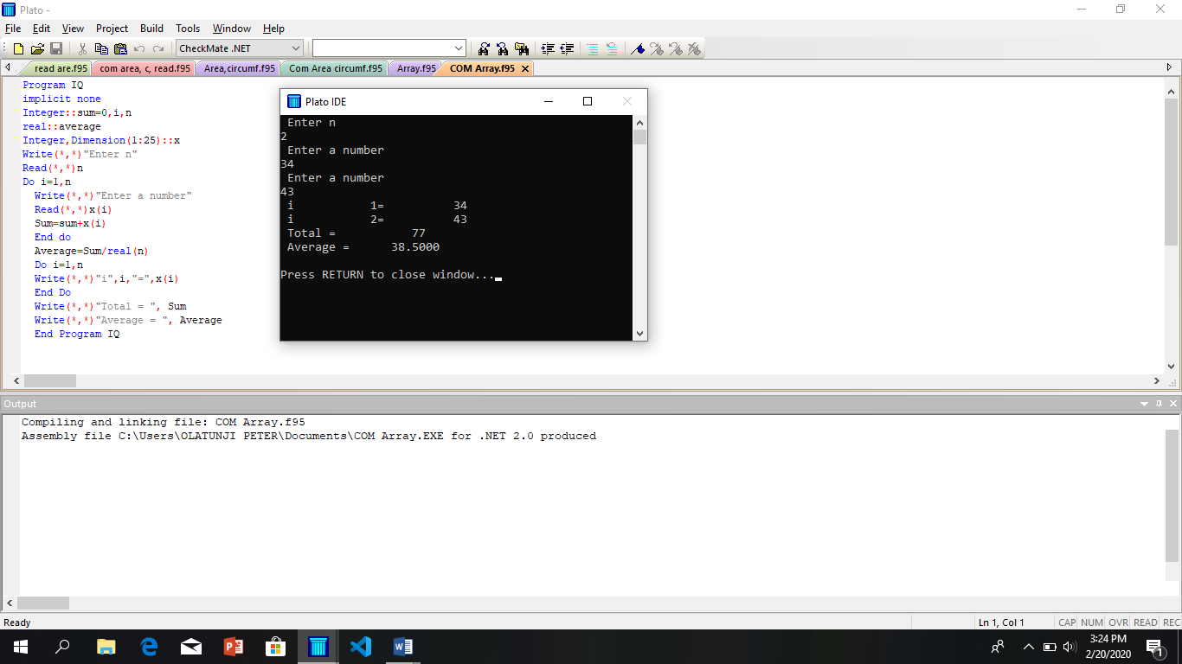**Write a FORTRAN to determine the average of n number where i = 1,2,3,4…n , where average = ∑ x i, i=1,2,3,…n, where n = 25**
2. 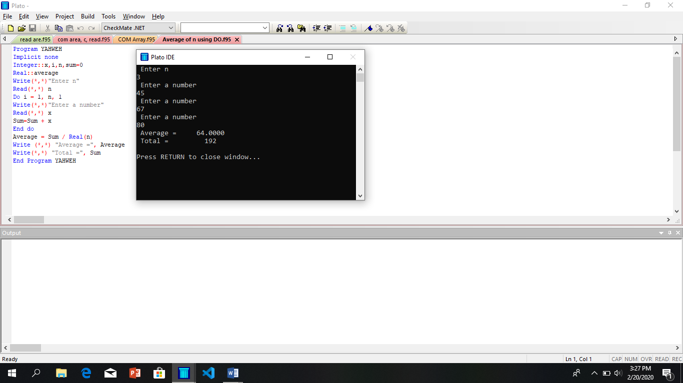**Write a Program to calculate the average of n integer number using DO Statement .**
3. **Write a Program to average number of N using DO WHILE Statement where average = ∑ x i, i=1,2,3,…n.**

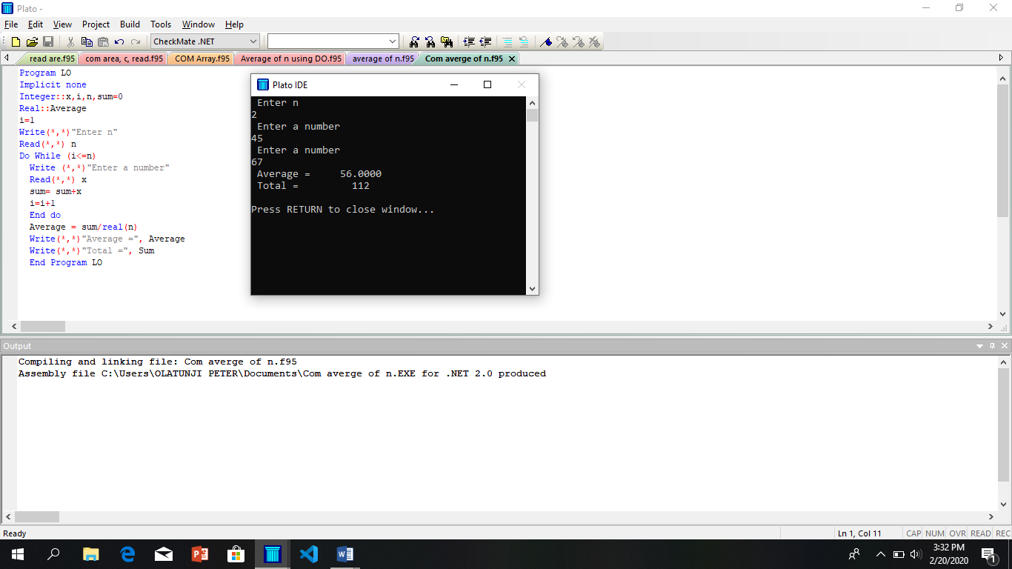 **n**

1. **Write a Program to find the average n real number, where average = ∑ x i, i=1,2,3,…n.**

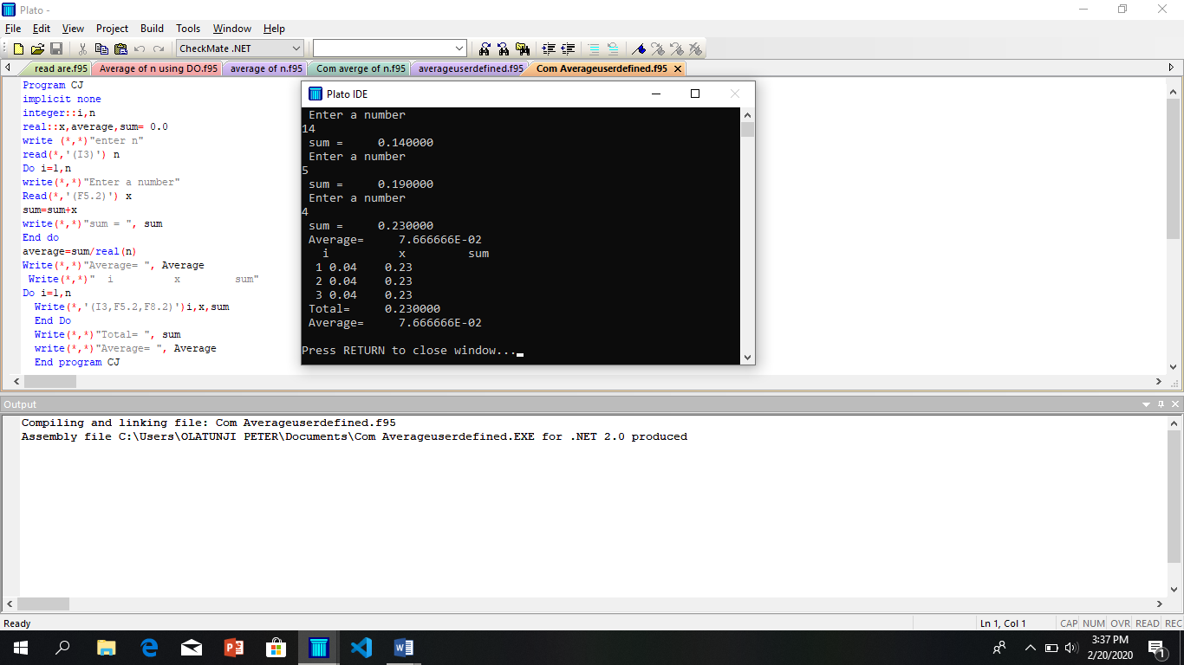 **n**

1. 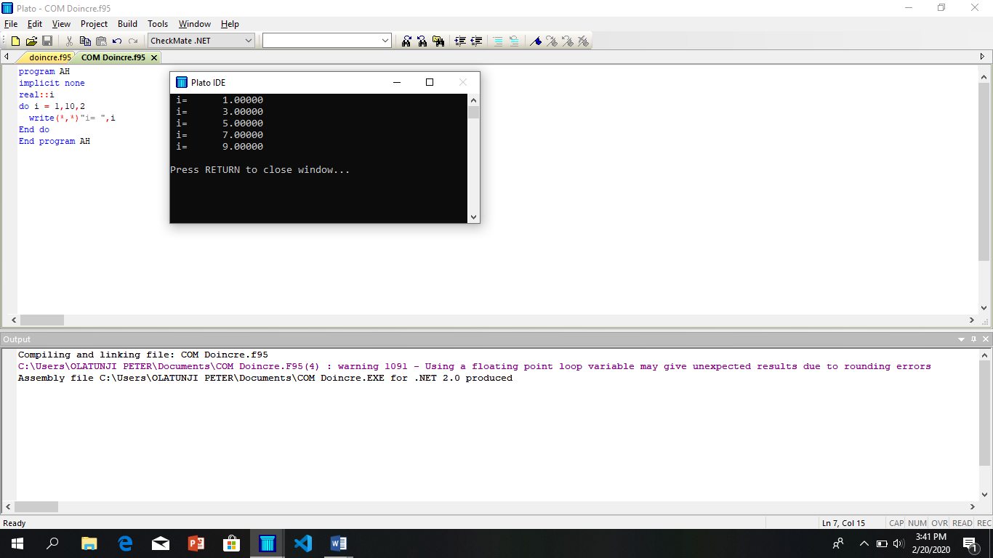 **Write a FORTRAN Program to determine the number of repetition being performed using DO Statement.**
2. **Write a Program to display n numbers, where n = 20 using DO-WHILE.**

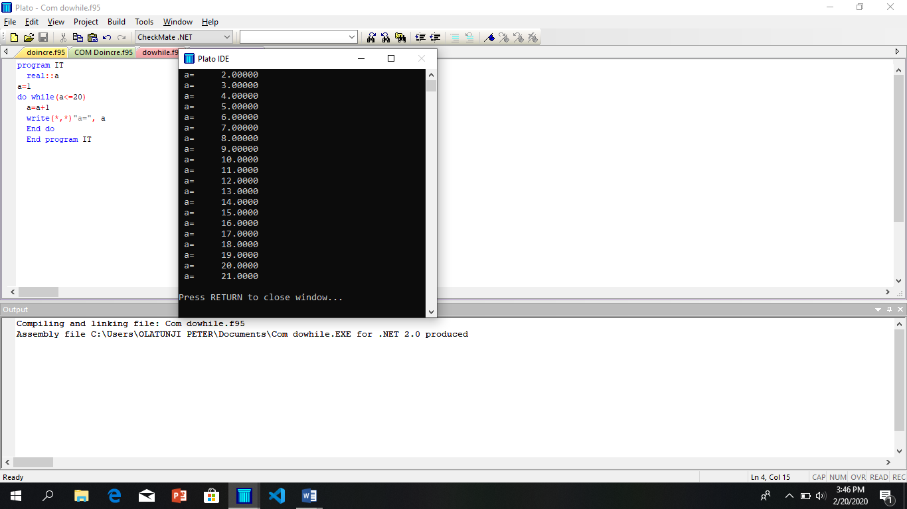

1. 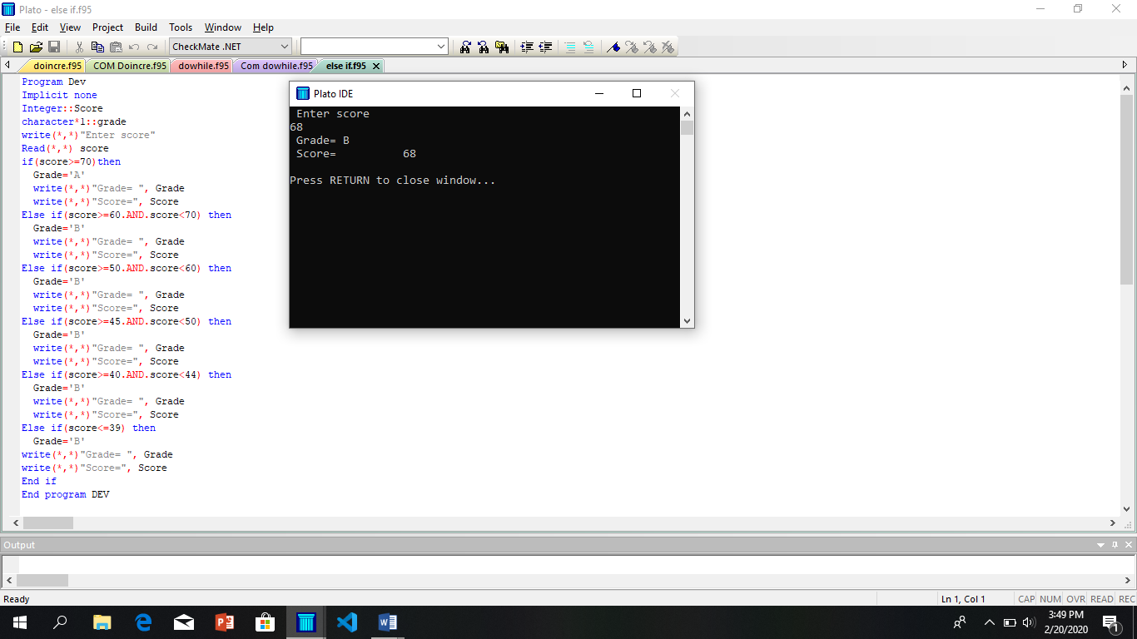**Write a Program to determine the appropriate grade using IF-THEN-ELSEIF-ELSE Structur**
2. **Write a FORTRAN Program to find Area of a Trapezium, where area = ½ (a+b)h by using user defined specifications.**

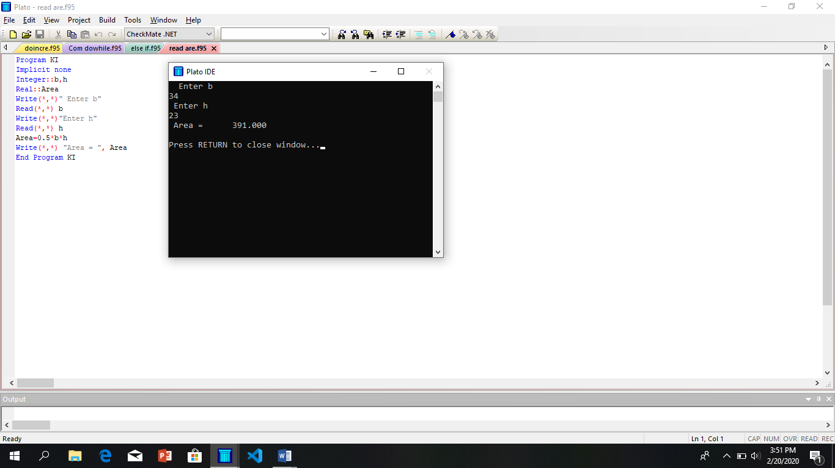

1. 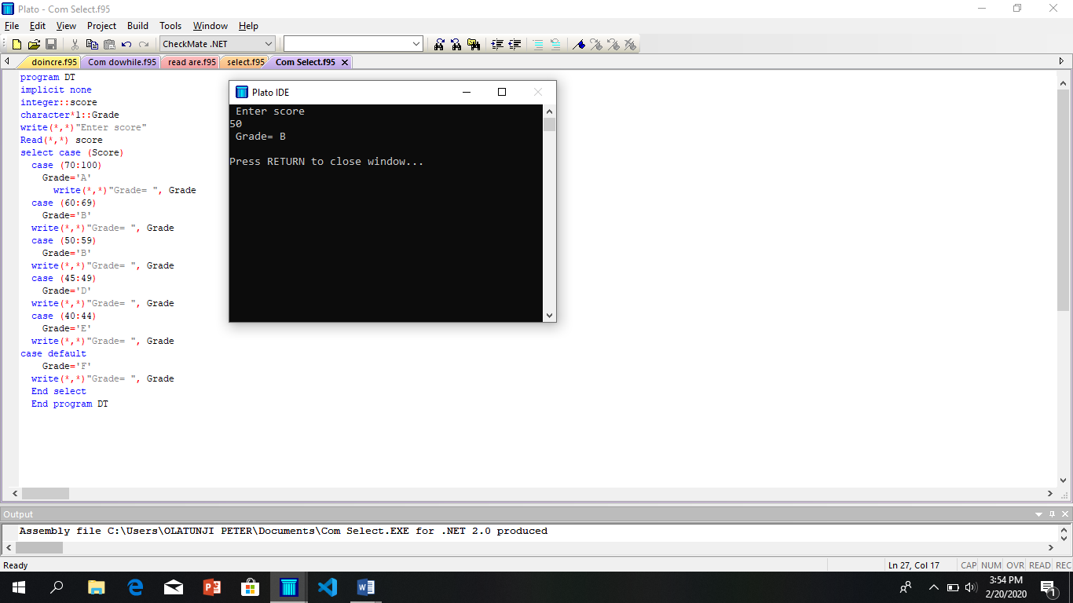 **Write a FORTRAN Program t0 determine the appropriate grade using SELECT CASE.**
2. 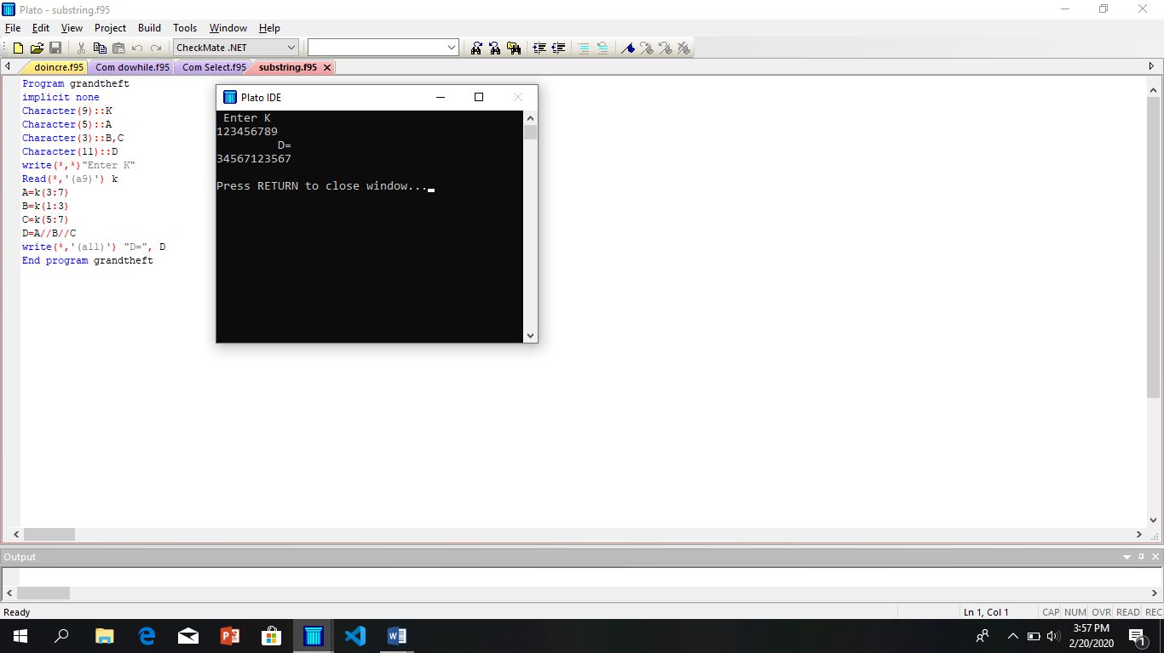 **Write a FORTRAN Program to concatenate A,B,C where A,B and C are substrings of K, where K = 123456789.**
3. 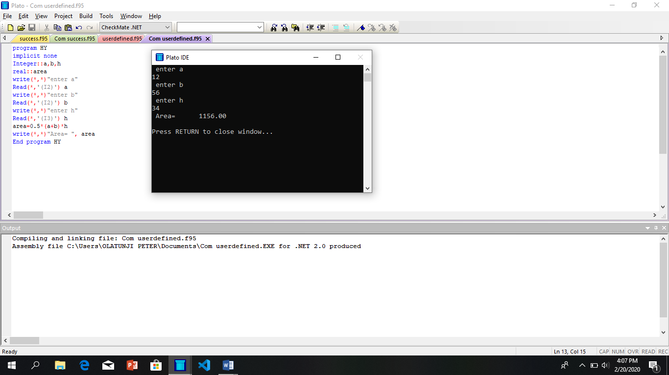 **Write a FORTRAN Program to find Area of a Trapezium, where area = ½ (a+b)h by using user defined specifications.**
4. 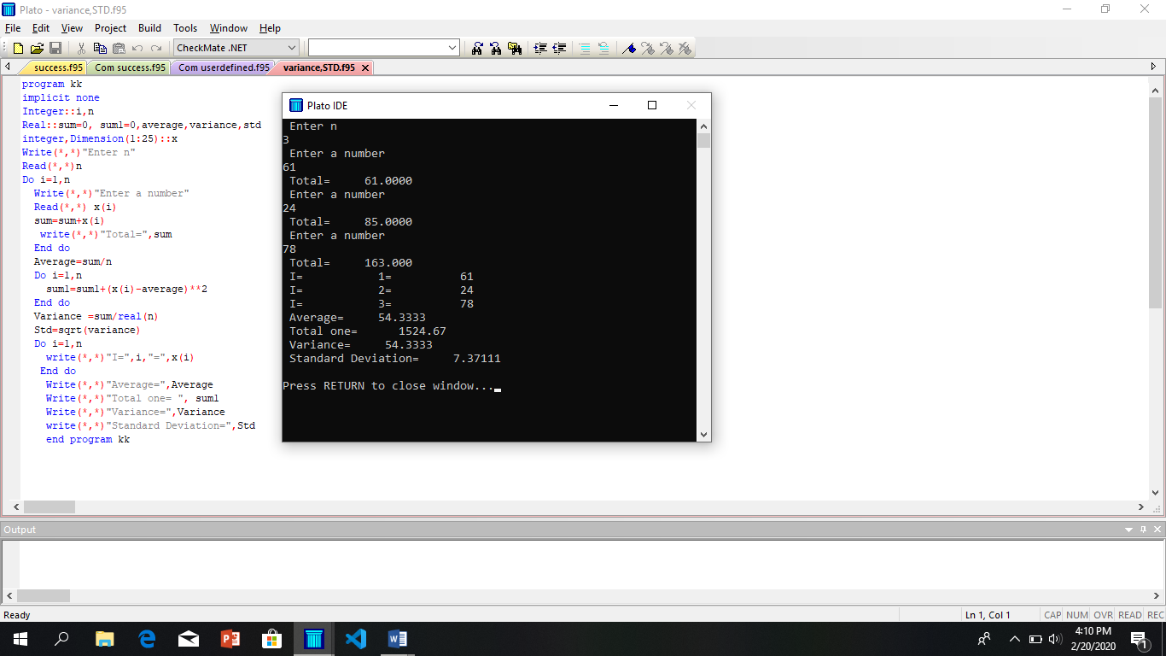 **Write a FORTRAN Program to compute average Variance and the Standard Deviation of n decimal numbers where Variance = 2 ,STD = , Average = n - 1**
5. 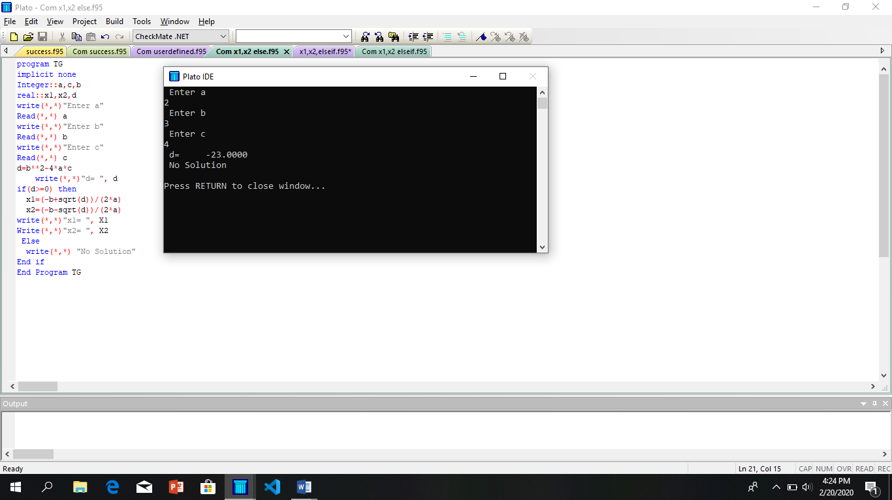**Write A FORTRAN Program to find the Root of the Quadratic Equation using IF-THEN-ELSE Structure.**
6. 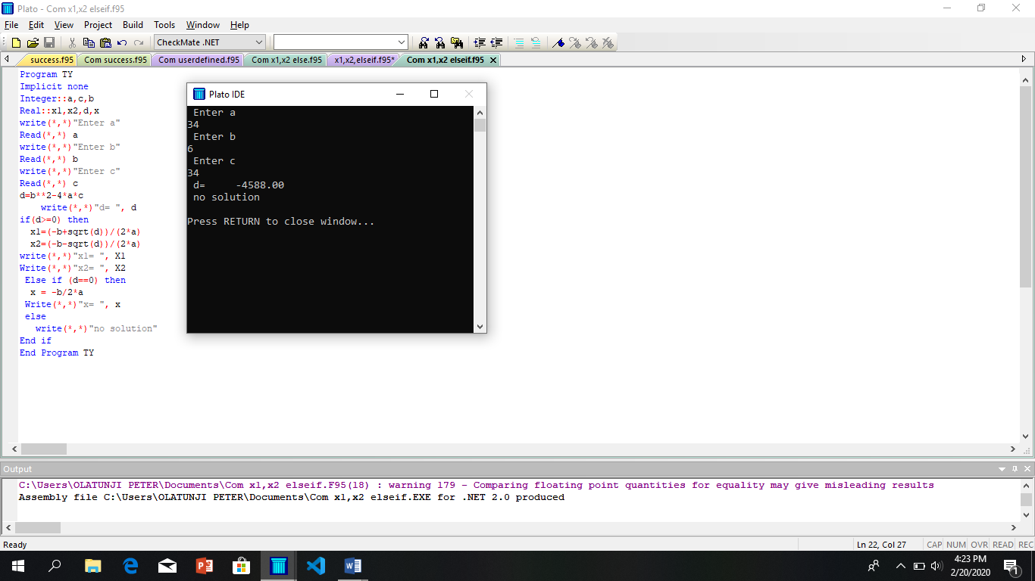 **Write a FORTRAN Program to find the Root of the Quadratic Equation using IF-THEN-ELSEIF-ELSE Structure.**
7. 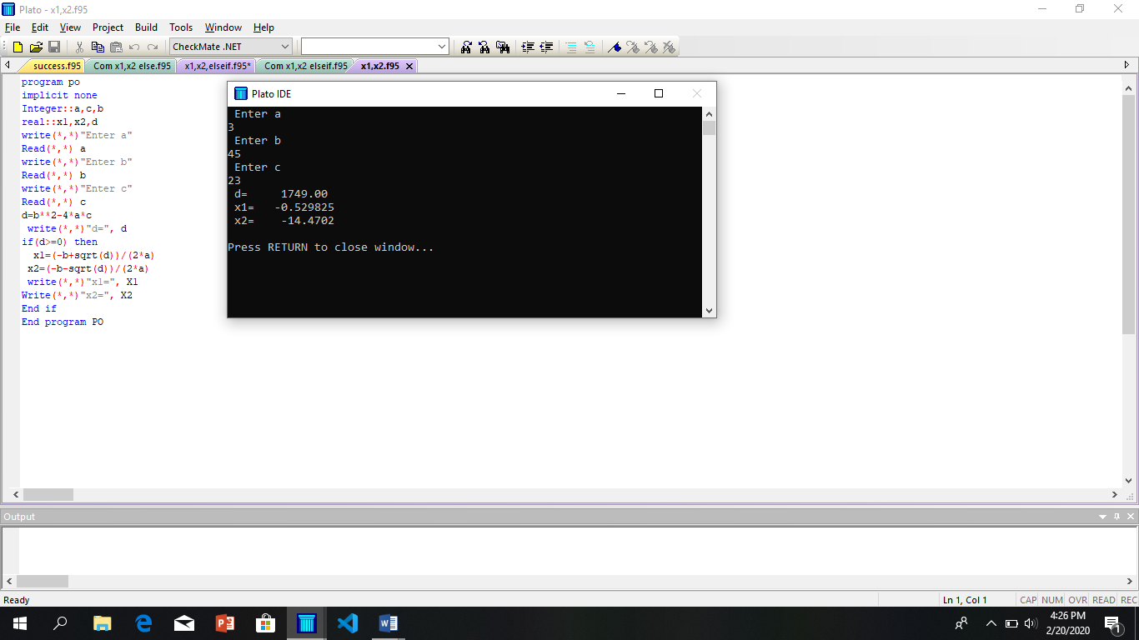**Write a FORTRAN Program to find the Root of the Quadratic Equation using IF-THEN Structure.**