**Read the instructions below carefully before starting coding.**

Students are ONLY allowed to use:

* Materials on their computer (including JDK 1.8, NetBeans, Window explorer, zip tools, Browser, PEA, SQLServer, Webserver Tomcat ).
* Using the account( username=sa, password=12345) to connect to the SQLServer

Follow the steps below to complete PE:

1. Create a folder to save given projects, e.g., PRJ301_StudentID (1). Download given materials to (1).
2. Write code according to the requirements in the exam.
3. DO NOT delete or create a Java file with the same name as the given files.
4. DO NOT EDIT the file DBUtils.java. This file is used to connect to the database
5. Using the MVC2 model with MainController
6. Students are provided with a PE project. And it is mandatory to use the provided project to complete your PE.

If at least one of the above requirements is not followed, the exam will get **ZERO**.

**Resource**: You are supported the materials. They include:

1. The Java web project is named “PE_PRJ301” and contains some files (.java,.html,…):

* The class DBUtils.java is used to make a connection to the database.
* Some classes *DAO are used to access the database.
* Some classes *DTO are used to create basic objects.
* Some classes in the package “pe.controllers” handle requests, then forward the results to one of several different JSP pages.

1. The file “database.sql” is used to create a database.

**Database**: You must run codes in the given file “database.sql” to create the database [EmployeeManagement] and use it in the practical exam.

The **Account** table

|  |  |  |
| --- | --- | --- |
| **Field name** | **Datatype** | **Note** |
| Id | int | identity primary key |
| Email | varchar(50) | not null |
| FullName | nvarchar(50) | not null |
| RoleId | char(2) | not null |
| Password | varchar(20) | not null |

The **Employee** table

|  |  |  |
| --- | --- | --- |
| **Field name** | **Datatype** | **Note** |
| Id | int | identity primary key |
| FullName | nvarchar(50) | not null |
| Dob | datetime | not null |
| Salary | float | not null |

**Requirements**:

Create a Java web application to manage employees. The application has the following functions:

# The login function:

## On the login.jsp page, the user enters their email and password. The system will check if the email and password are correct, then grant access permission and go to employees.jsp page as shown below. **( 1.0 point)**

## If not, the system will show the ”Incorrect email or password” message on the login.jsp page. **( 0.5 points)**

## The employees.jsp page shows the welcome message in the format “Welcome <the full name of the login user>”. **(0.5 points)**

## The employees.jsp page shows the employee list in table format. **(2.0 points)**

## The employees.jsp page has the logout function. After logout, redirect to the login.jsp page. **(1.0 point)**

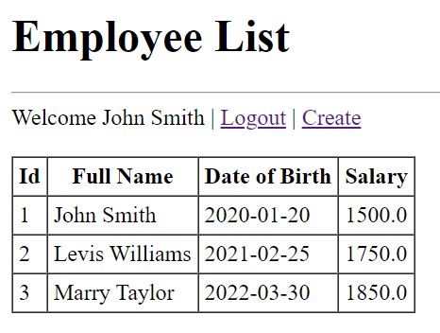

# The adding employee function:

## There is the Create link on the employees.jsp page. If the user has the admin role (RoleId = “AM”), the Create link will take the user to go to the create.jsp page allows adding a new employee **(1.0 point)**; otherwise, it will take the user to go to the login.jsp page. **(0.5 points)**

## Data must validate as below before insert into the database and show corresponding errors if validation is not satisfied: **(1.5 points)**

* All fields cannot be left blank.
* The full name length must be between 3 and 50 characters.
* The exam date field must be a valid date in the yyyy-MM-dd format.
* The score field must be between 0 and 10 and can have one digit in the decimal part.

## On the create.jsp page, adding a new employee to the database. After successfully inserting data, redirect to the employees.jsp page again to see the results. **(2.0 points)**

The End