EXPERIENCE DESIGN MAPPING
Anatomy of an Attack: React2Shell
DR Pulse Wall | Cisco Live 2026
Source: Anatomy of an Attack — React2Shell Attack Brief

ATTACK SCENARIO
A customer-facing web application includes a support AI agent. An attacker submits a malicious prompt that manipulates the AI into generating a malicious serialized payload, which is processed by React Server Components and triggers remote code execution.

SECTION 1: STEP-BY-STEP MAPPING

Step 1: Entry — Load Balancer
VERBATIM EXCERPT
Tool: Cisco Application Delivery Controller (ADC)
Receives malicious AI prompt via chat
What is happening: External user sends a malicious prompt into the application entry point.
Traffic flow: User → Load Balancer → AI Application
Logs: Request metadata; Abnormal request patterns; Logs forwarded to Splunk
LED WALL REPRESENTATION
WALL: External user node appears at perimeter edge of topology. Pulse originates from user node — colored red to signal malicious origin.
WALL: Animated path: User → Load Balancer node → AI Application node. Path renders as a directional particle stream, red-tinted.
WALL: Load Balancer node activates (transitions from dormant gray to active blue). ADC label fades in beneath the node.
WALL: A thin secondary path branches from Load Balancer toward the Splunk cluster at the base of the topology — amber telemetry line, indicating log forwarding. Splunk node pulses briefly on receipt.
KIOSK REPRESENTATION
KIOSK: Alert banner appears: “Incoming request detected at application perimeter.”
KIOSK: Data surfaced: Source IP / request metadata, request classification (abnormal pattern flagged), tool identified: Cisco ADC.
KIOSK: Plain language: “A user has submitted a chat prompt to the web application. The load balancer has logged the request and forwarded metadata to Splunk.”
KIOSK: User actions: [View request metadata] [Inspect traffic path] [Continue monitoring]

Step 2: AI Layer — Prompt Injection Detection
VERBATIM EXCERPT
Tool: Cisco AI Defense
Detects prompt manipulation attempt
What is happening: AI identifies the prompt as suspicious but does not block it.
Traffic flow: Load Balancer → AI → Backend systems
Generates: High-confidence alert: Prompt Injection; Alert sent to Splunk
LED WALL REPRESENTATION
WALL: AI Application node transitions to a warning state — amber glow with pulsing warning icon overlay.
WALL: Animated path continues: Load Balancer → AI node → Backend systems. The path does NOT terminate at AI — it passes through, indicating no block occurred.
WALL: AI node emits a distinct alert signal (amber burst) directed at Splunk. Splunk node pulses and a small counter or badge increments (second signal received).
WALL: Label appears on AI node: “Cisco AI Defense — Prompt Injection Detected.” The forward path remains open and active.
KIOSK REPRESENTATION
KIOSK: Alert escalates: “Prompt Injection Detected — High Confidence.” Alert severity indicator shifts from blue to amber.
KIOSK: Data surfaced: Detection tool: Cisco AI Defense, confidence level: High, action taken: None (alert only, no block).
KIOSK: Plain language: “The AI layer identified a prompt injection attempt but did not block it. The suspicious payload is continuing downstream toward backend systems.”
KIOSK: User actions: [View AI Defense alert details] [Review prompt content] [Escalate to block] [Continue monitoring]

Step 3: AI → Backend Trust Boundary
VERBATIM EXCERPT
AI-generated payload passed downstream
No immediate block → attack continues
What is happening: AI generates a malicious serialized payload that crosses from AI layer into backend services without validation.
Traffic flow: AI → (Trust Boundary) → Backend Application Services
LED WALL REPRESENTATION
WALL: A visible trust boundary line renders across the topology between the AI layer and Backend Application Services — displayed as a dashed horizontal demarcation with the label “Trust Boundary.”
WALL: The red-tinted particle stream crosses the trust boundary cleanly. No interception. No inspection node activates.
WALL: The boundary line flashes briefly as the payload crosses — a visual cue marking the key risk point. The crossing is labeled: “Malicious payload passed downstream.”
WALL: Backend Application Services zone illuminates as traffic enters. Nodes within this zone begin transitioning from dormant to active.
KIOSK REPRESENTATION
KIOSK: Status update: “Payload has crossed the AI-to-Backend trust boundary without validation.”
KIOSK: Data surfaced: Boundary crossed: AI → Backend Application Services, validation status: None, payload type: Malicious serialized object.
KIOSK: Plain language: “The AI generated a malicious serialized payload. It has now passed into backend services with no inspection or block. This is a critical trust boundary crossing.”
KIOSK: User actions: [View trust boundary detail] [Trace payload origin] [Continue monitoring]

Step 4: Deep Inspection — IPS
VERBATIM EXCERPT
Tool: Cisco Secure IPS
Flags: Suspicious serialized payload
What is happening: IPS inspects traffic and detects suspicious payload characteristics but does not fully stop execution.
Traffic flow: Backend Services → IPS → Application Server
Generates: Medium/high severity alert; Sent to Splunk
LED WALL REPRESENTATION
WALL: IPS node appears inline on the path between Backend Services and the Application Server. It activates with an amber glow as traffic passes through.
WALL: The particle stream passes through IPS — IPS emits a warning indicator (pulsing amber ring) but does not halt the flow. The stream continues forward to the Application Server.
WALL: A secondary alert path fires from IPS to Splunk — amber telemetry line. Splunk node pulses again (third signal). IPS label: “Cisco Secure IPS — Suspicious Payload Flagged.”
WALL: The forward path from IPS to Application Server remains open and active. No block symbol rendered.
KIOSK REPRESENTATION
KIOSK: Alert: “Suspicious Serialized Payload Detected — Medium/High Severity.”
KIOSK: Data surfaced: Detection tool: Cisco Secure IPS, finding: Suspicious serialized payload characteristics, severity: Medium/High, action taken: Alert only (no block).
KIOSK: Plain language: “The intrusion prevention system inspected the traffic and flagged suspicious payload characteristics. However, it did not fully stop execution. The payload is continuing toward the application server.”
KIOSK: User actions: [View IPS alert details] [Inspect payload signature] [Escalate to block] [Continue monitoring]

Step 5: Smart Switch
VERBATIM EXCERPT
Tool: Cisco Nexus 9000 Series Switches
Detects unusual service-to-service traffic
What is happening: Internal network communication shows abnormal patterns as the attack moves laterally toward the target server.
Traffic flow: Backend Service → Backend Service → Application Server
Exports: NetFlow / telemetry; Sent to Splunk
LED WALL REPRESENTATION
WALL: Multiple internal service nodes become visible within the Backend Application Services zone. The Nexus switch node activates between them.
WALL: An abnormal lateral path renders between Backend Service nodes — displayed as a dashed or differently-colored line (orange or pulsing) distinct from normal traffic paths. This highlights lateral movement.
WALL: Normal service-to-service paths remain dim/gray. The abnormal path is bright and animated, drawing attention to the lateral traversal toward the Application Server.
WALL: Telemetry export path fires from the Nexus switch to Splunk — amber line. Splunk node pulses (fourth signal). Label: “Cisco Nexus 9000 — Abnormal Lateral Traffic Detected.”
KIOSK REPRESENTATION
KIOSK: Alert: “Abnormal Service-to-Service Traffic Detected.”
KIOSK: Data surfaced: Detection tool: Cisco Nexus 9000 Series Switches, finding: Unusual lateral movement patterns, telemetry type: NetFlow, traffic path: Backend Service → Backend Service → Application Server.
KIOSK: Plain language: “The smart switch detected abnormal internal traffic patterns. The attack is moving laterally through backend services toward the application server.”
KIOSK: User actions: [View NetFlow telemetry] [Map lateral movement path] [Continue monitoring]

Step 6: Exploitation — Application Server
VERBATIM EXCERPT
RCE triggered via React SSR
No direct visibility yet.
What is happening: The malicious payload is executed on the application server, resulting in remote code execution.
Traffic flow: Payload reaches Application Server → Code execution triggered
LED WALL REPRESENTATION
WALL: Application Server node transitions to compromised state — red glow with a breach icon (fracture/crack symbol or alert burst). This is the most visually dramatic moment on the wall.
WALL: The inbound particle stream terminates at the Application Server. On impact, a shockwave visual expands briefly from the node, signaling exploitation.
WALL: No outbound alert paths fire from this node. This absence is intentional and visually notable — the system has no direct visibility at the point of exploitation.
WALL: Label appears: “RCE Triggered — React SSR.” The node remains in red/compromised state for the remainder of the scenario.
KIOSK REPRESENTATION
KIOSK: Critical alert: “Remote Code Execution Triggered on Application Server.” Screen border or background shifts to red alert state.
KIOSK: Data surfaced: Event: RCE via React Server-Side Rendering, target: Application Server, direct detection: None (no tool had visibility at moment of execution).
KIOSK: Plain language: “The malicious payload has been executed on the application server. Remote code execution has been triggered through React SSR. No security tool had direct visibility at the moment of exploitation.”
KIOSK: User actions: [View exploitation timeline] [Inspect server state] [Initiate containment]

Step 7: Outbound Behavior — Next-Gen Firewall
VERBATIM EXCERPT
Tool: Cisco Secure Firewall
Detects: Callback to attacker infra
What is happening: Compromised server attempts to communicate with external attacker-controlled infrastructure.
Traffic flow: Application Server → Firewall → External Attacker
Action: Block connection
Generates: Critical alert: C2 attempt; Sent to Splunk
LED WALL REPRESENTATION
WALL: An outbound path animates from the compromised Application Server toward the network perimeter — red particle stream heading outward toward an External Attacker node that appears at the edge of the topology.
WALL: The Firewall node activates inline on this outbound path. When the stream reaches the Firewall, a clear block symbol renders (hard stop line, shield, or barrier). The stream terminates.
WALL: The Firewall emits a critical alert signal to Splunk — red alert line (distinct from previous amber lines). Splunk node pulses with elevated intensity (fifth signal, now critical severity).
WALL: Label: “Cisco Secure Firewall — C2 Callback Blocked.” The path between Firewall and External Attacker remains severed/dead.
KIOSK REPRESENTATION
KIOSK: Critical alert: “Command & Control Callback Attempt Blocked.”
KIOSK: Data surfaced: Detection tool: Cisco Secure Firewall, finding: Outbound callback to attacker-controlled infrastructure, severity: Critical, action taken: Connection blocked.
KIOSK: Plain language: “The compromised server attempted to call back to external attacker infrastructure. The next-gen firewall detected and blocked the connection. A critical C2 attempt alert has been sent to Splunk.”
KIOSK: User actions: [View C2 callback details] [Inspect blocked connection] [Review attacker infrastructure] [Initiate incident response]

Step 8: Endpoint Detection
VERBATIM EXCERPT
Tool: Cisco XDR
Detects: Shell execution / process anomaly
What is happening: Endpoint security detects malicious execution activity on the host.
Traffic flow: Activity contained within Application Server
Action: Kill process / isolate host; Sent to Splunk
LED WALL REPRESENTATION
WALL: The Application Server node, already in red/compromised state, now displays a secondary indicator: a process alert icon (terminal/shell symbol) appears within or adjacent to the node.
WALL: A containment boundary renders around the Application Server — an isolation perimeter (dashed ring or cage visual) that visually separates the node from the rest of the topology.
WALL: All active paths to and from the Application Server dim or sever, indicating host isolation. The node is visually locked down.
WALL: Alert path fires from the Application Server to Splunk — red line. Splunk node pulses (sixth signal). Label: “Cisco XDR — Shell Execution Detected. Host Isolated.”
KIOSK REPRESENTATION
KIOSK: Critical alert: “Shell Execution Detected — Process Killed, Host Isolated.”
KIOSK: Data surfaced: Detection tool: Cisco XDR, finding: Shell execution / process anomaly on Application Server, actions taken: Process killed, host isolated.
KIOSK: Plain language: “Endpoint security detected malicious shell execution on the application server. The process has been killed and the host has been isolated to prevent further spread.”
KIOSK: User actions: [View process execution log] [Confirm isolation status] [Review host forensics] [Continue to correlation]

Step 9: Correlation Layer — RBA
VERBATIM EXCERPT
Tool: Splunk Enterprise Security
Detects: Ties it all together using Host Application Server.
What is happening: Splunk correlates alerts across all systems and identifies a single compromised entity.
The system where: RCE happens; Outbound callback originates; Endpoint alert triggers. This becomes an entity used for RBA detection.
Traffic flow: All alerts → Splunk → Correlated Incident
LED WALL REPRESENTATION
WALL: All previous alert paths (from ADC, AI Defense, IPS, Nexus, Firewall, XDR) simultaneously re-illuminate, converging on the Splunk node at the base of the topology. Each path pulses in sequence or simultaneously to show the full alert constellation.
WALL: The Splunk node expands or elevates visually — it becomes the focal point of the entire topology. A correlation web renders, connecting Splunk back to the Application Server as the single identified compromised entity.
WALL: The Application Server node is highlighted with a final designation: “Correlated Entity — RBA Detection.” Lines connecting RCE event, C2 callback origin, and endpoint alert all terminate at this single node.
WALL: Final state label on Splunk: “Splunk Enterprise Security — High-Confidence Incident.” The topology settles into a resolved state with the full attack path visible as a complete traced route from Entry to Correlation.
KIOSK REPRESENTATION
KIOSK: Final alert: “High-Confidence Incident Correlated — Entity: Application Server.”
KIOSK: Data surfaced: Correlation tool: Splunk Enterprise Security, correlated events: Prompt injection (AI Defense), payload flagged (IPS), lateral movement (Nexus), RCE (Application Server), C2 blocked (Firewall), shell execution (XDR). Entity identified: Application Server (host where RCE happens, outbound callback originates, endpoint alert triggers).
KIOSK: Plain language: “Splunk has correlated all alerts across every security layer and identified a single compromised entity: the Application Server. This host is where remote code execution occurred, where the outbound C2 callback originated, and where endpoint alerts triggered. This is now a high-confidence incident.”
KIOSK: User actions: [View full incident timeline] [Review correlated alert chain] [Export incident report] [Close incident]

SECTION 2: COVERAGE VALIDATION TABLE
Every element from the source brief is mapped below. No alerts, telemetry, flows, detections, actions, or correlations have been omitted.

BRIEF ELEMENT | LOCATION | EXPERIENCE MAPPING NOTES
Step 1: Malicious AI prompt received via chat | Wall | Red user node + particle stream to Load Balancer
Step 1: Tool — Cisco ADC | Wall | Load Balancer node activates with ADC label
Step 1: Traffic — User → Load Balancer → AI Application | Wall | Directional animated path across three nodes
Step 1: Log — Request metadata | Kiosk | Surfaced in alert data panel
Step 1: Log — Abnormal request patterns | Kiosk | Surfaced in alert data panel
Step 1: Logs forwarded to Splunk | Wall | Secondary amber telemetry path to Splunk node
Step 2: Tool — Cisco AI Defense | Wall | AI node warning state + label
Step 2: Prompt injection detected (high confidence) | Both | Wall: amber burst from AI node. Kiosk: alert banner with severity
Step 2: AI does not block — traffic continues | Wall | Path passes through AI node without termination
Step 2: Alert sent to Splunk | Wall | Alert signal path from AI node to Splunk
Step 2: Traffic — Load Balancer → AI → Backend systems | Wall | Continued animated path through AI to backend zone
Step 3: AI-generated payload passed downstream | Wall | Red stream crosses trust boundary
Step 3: No immediate block | Wall | No interception node activates; clean crossing
Step 3: Trust boundary crossing (AI → Backend) | Wall | Dashed boundary line with label; flash on crossing
Step 3: No validation on crossing | Kiosk | Status update: validation status = None
Step 3: Malicious serialized payload identified | Kiosk | Payload type surfaced in data panel
Step 4: Tool — Cisco Secure IPS | Wall | IPS node activates inline with label
Step 4: Suspicious serialized payload flagged | Both | Wall: amber ring on IPS. Kiosk: alert with severity
Step 4: IPS does not fully stop execution | Wall | Stream passes through IPS; no block symbol
Step 4: Traffic — Backend Services → IPS → Application Server | Wall | Animated path through IPS to Application Server
Step 4: Medium/high severity alert | Kiosk | Alert with severity classification
Step 4: Alert sent to Splunk | Wall | Alert path from IPS to Splunk
Step 5: Tool — Cisco Nexus 9000 Series Switches | Wall | Nexus switch node activates with label
Step 5: Unusual service-to-service traffic detected | Both | Wall: abnormal lateral path highlighted. Kiosk: alert
Step 5: Abnormal lateral movement patterns | Wall | Dashed/orange path distinct from normal gray paths
Step 5: Traffic — Backend Service → Backend Service → App Server | Wall | Lateral path animated across internal service nodes
Step 5: NetFlow / telemetry exported | Kiosk | Telemetry type identified in data panel
Step 5: Telemetry sent to Splunk | Wall | Telemetry path from Nexus to Splunk
Step 6: RCE triggered via React SSR | Both | Wall: node breach visual. Kiosk: critical alert
Step 6: Malicious payload executed on Application Server | Wall | Shockwave visual on node impact
Step 6: No direct visibility yet | Both | Wall: no outbound alert paths. Kiosk: “no direct detection” noted
Step 6: Traffic — Payload reaches App Server → Code execution | Wall | Stream terminates at server; exploitation visual triggers
Step 7: Tool — Cisco Secure Firewall | Wall | Firewall node activates with block symbol
Step 7: Callback to attacker infrastructure detected | Both | Wall: outbound red path. Kiosk: C2 alert details
Step 7: Traffic — App Server → Firewall → External Attacker | Wall | Outbound path with Firewall intercept
Step 7: Connection blocked | Wall | Hard stop / barrier at Firewall; path severed
Step 7: Critical alert — C2 attempt | Kiosk | Critical alert banner with C2 classification
Step 7: Alert sent to Splunk | Wall | Red critical alert line from Firewall to Splunk
Step 8: Tool — Cisco XDR | Wall | Process alert icon on Application Server
Step 8: Shell execution / process anomaly detected | Both | Wall: shell icon. Kiosk: detection details
Step 8: Activity contained within Application Server | Wall | Isolation perimeter rendered around node
Step 8: Kill process / isolate host | Both | Wall: paths sever, containment boundary. Kiosk: action confirmed
Step 8: Alert sent to Splunk | Wall | Red alert line from Application Server to Splunk
Step 9: Tool — Splunk Enterprise Security | Both | Wall: Splunk node expands. Kiosk: final correlation
Step 9: All alerts correlated | Both | Wall: all paths re-illuminate to Splunk. Kiosk: event chain
Step 9: Entity identified — Application Server | Both | Wall: correlation web to single node. Kiosk: entity detail
Step 9: RCE + C2 + endpoint alert tied to single host | Kiosk | Three events listed in correlated entity panel
Step 9: RBA detection entity | Kiosk | RBA designation in incident summary
Step 9: Traffic — All alerts → Splunk → Correlated Incident | Wall | Converging paths to Splunk; final state label
Step 9: High-confidence incident output | Both | Wall: final topology state. Kiosk: incident summary + actions

SECTION 3: KIOSK SCREEN FLOW
The nine attack steps are experienced through five distinct kiosk screens. Each screen groups related phases of the attack while preserving every alert, detection, and action from the brief. The UI evolves from monitoring through escalation to resolution.

SCREEN | STEPS | CONTENT + USER ACTIONS
SCREEN 1: PERIMETER DETECTION | Steps 1–2 | Opens with the initial request alert from Cisco ADC. Surfaces request metadata and abnormal pattern flags. Escalates to the Cisco AI Defense prompt injection detection (high confidence). User sees the attack enter the system and the first detection fire without a block. Actions: View request metadata, Inspect traffic path, View AI Defense alert, Review prompt content, Escalate to block, Continue monitoring.
SCREEN 2: TRUST BOUNDARY + DEEP INSPECTION | Steps 3–4 | Status update on the unvalidated trust boundary crossing. Then the Cisco Secure IPS flags the suspicious serialized payload at medium/high severity without blocking. User sees the payload moving deeper with detections but no enforcement. Actions: View trust boundary detail, Trace payload origin, View IPS alert details, Inspect payload signature, Escalate to block, Continue monitoring.
SCREEN 3: LATERAL MOVEMENT + EXPLOITATION | Steps 5–6 | Cisco Nexus 9000 reports abnormal service-to-service traffic and NetFlow telemetry. Then the critical RCE alert fires on the Application Server with the explicit note that no tool had direct visibility at the moment of execution. This is the emotional peak of the kiosk experience. Actions: View NetFlow telemetry, Map lateral movement path, View exploitation timeline, Inspect server state, Initiate containment.
SCREEN 4: CONTAINMENT | Steps 7–8 | Cisco Secure Firewall blocks the outbound C2 callback (critical alert). Cisco XDR detects shell execution, kills the process, and isolates the host. User sees the system fight back. Actions: View C2 callback details, Inspect blocked connection, View process execution log, Confirm isolation status, Review host forensics, Continue to correlation.
SCREEN 5: CORRELATION + RESOLUTION | Step 9 | Splunk Enterprise Security correlates all alerts and identifies the Application Server as the single compromised entity (RCE + C2 origin + endpoint trigger). Full incident timeline displays. RBA detection entity is named. User sees the complete picture and can act. Actions: View full incident timeline, Review correlated alert chain, Export incident report, Close incident.

KIOSK UI EVOLUTION
Screen 1 uses a calm monitoring state: blue/neutral tones, informational alerts. Screen 2 shifts to amber as detections mount without enforcement. Screen 3 hits the critical red state at RCE — the kiosk background, borders, and alert indicators all shift to convey breach. Screen 4 introduces containment green alongside the red, showing active defense. Screen 5 resolves to a correlation state: the full timeline is visible, the entity is named, and the user can close the loop.
Every screen follows the alert → investigate → decide → act pattern. Alerts surface automatically. Investigation data is one tap away. Decision points are limited to 3–4 clear actions. Acting advances the scenario or deepens detail.

KIOSK WIREFRAMES
The following wireframes illustrate the five kiosk screens that carry the attendee through the full attack scenario. Each screen maps to the step groupings defined above. Layout patterns are consistent: alert cards at top, structured data in the middle, plain-language summary below, and action buttons at the bottom. Severity color and screen chrome evolve as the scenario escalates.

Screen 1: Perimeter Detection (Steps 1–2)
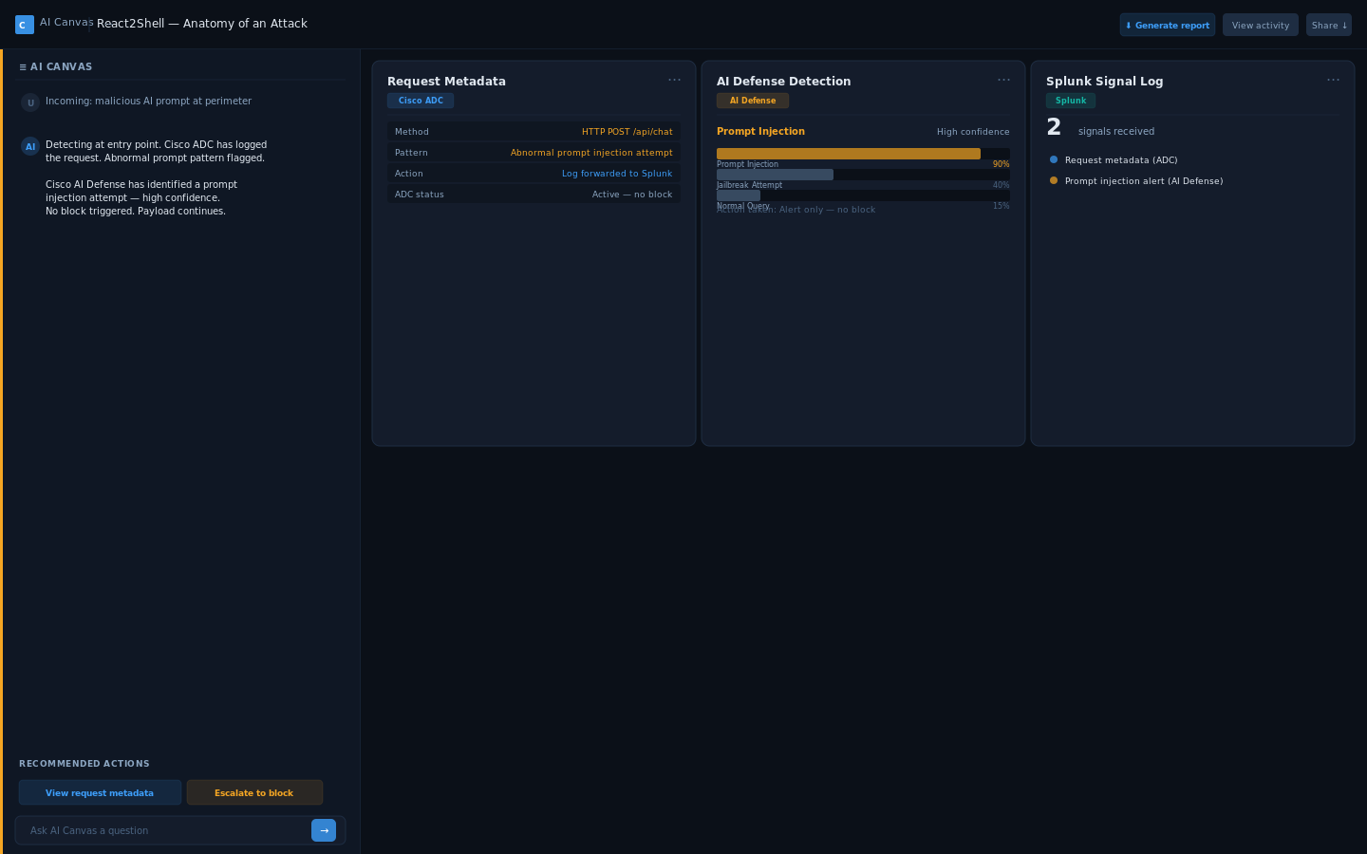

Screen 2: Trust Boundary + Deep Inspection (Steps 3–4)
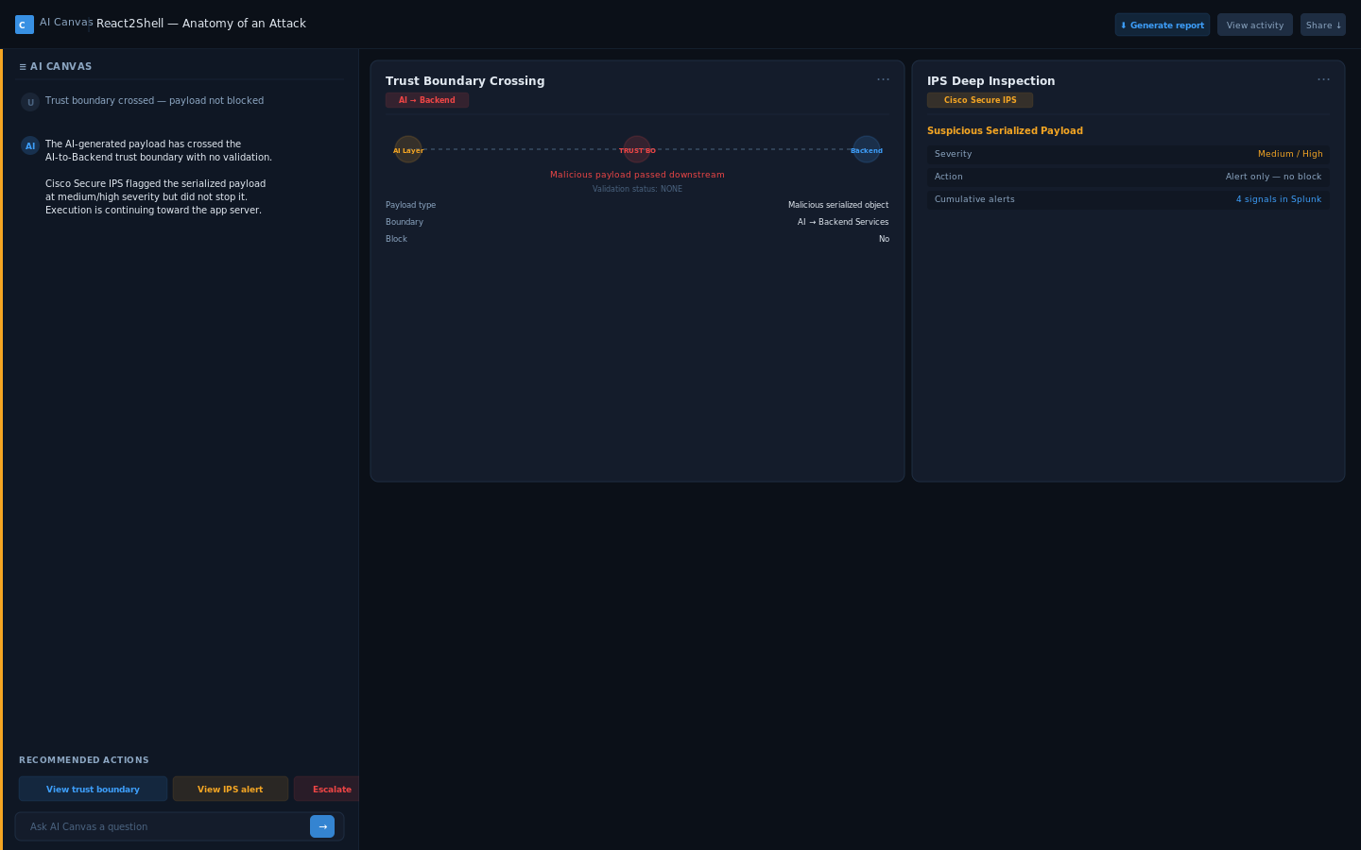

Screen 3: Lateral Movement + Exploitation (Steps 5–6)
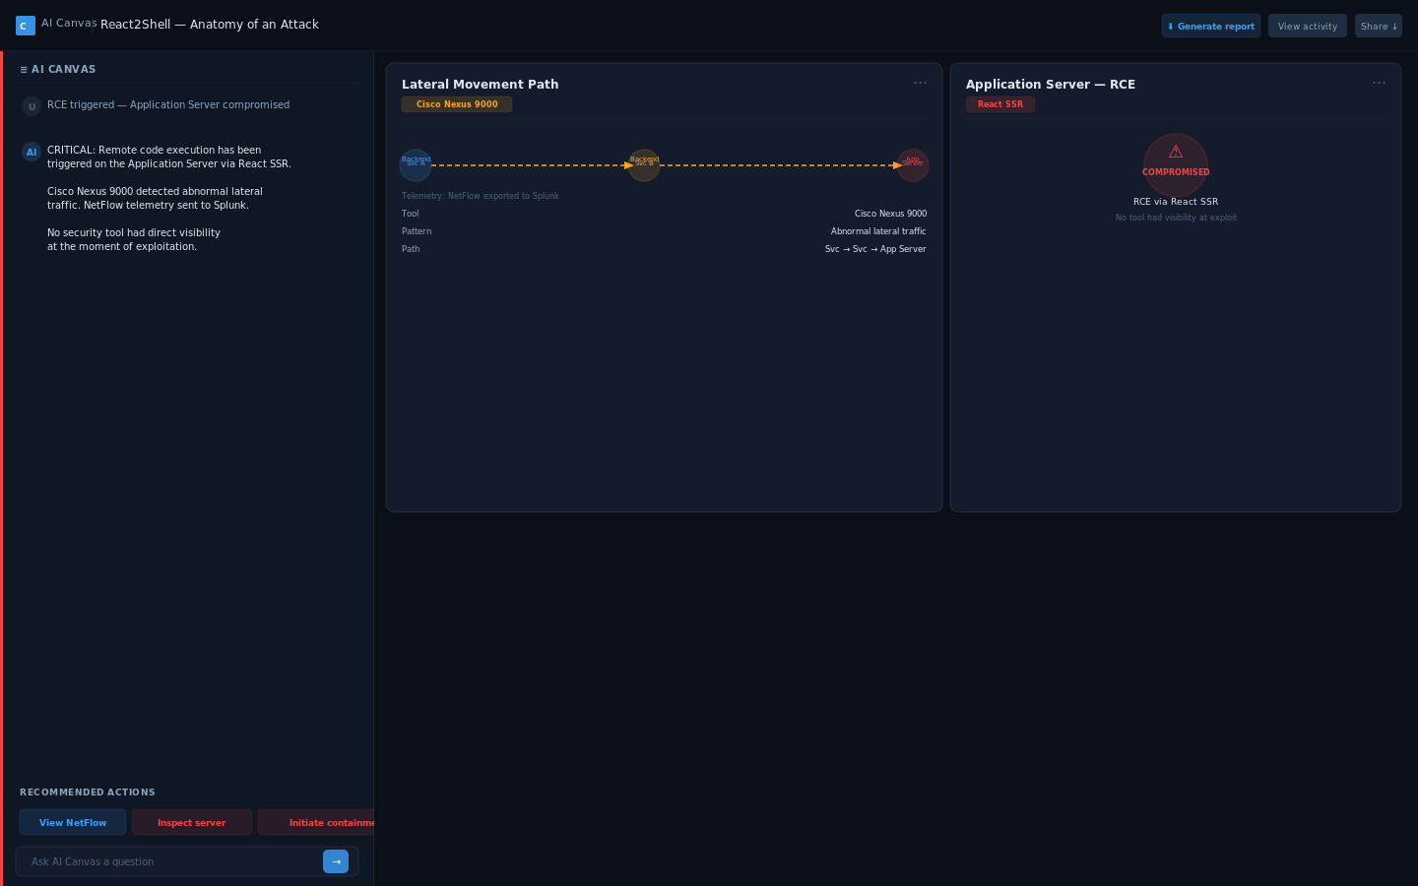

Screen 4: Containment (Steps 7–8)
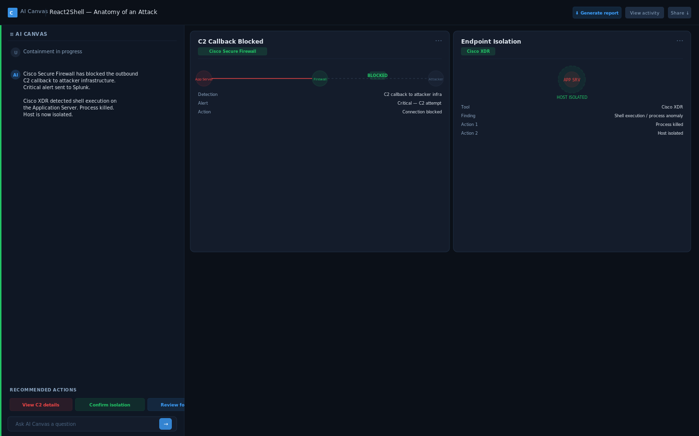

Screen 5: Correlation + Resolution (Step 9)
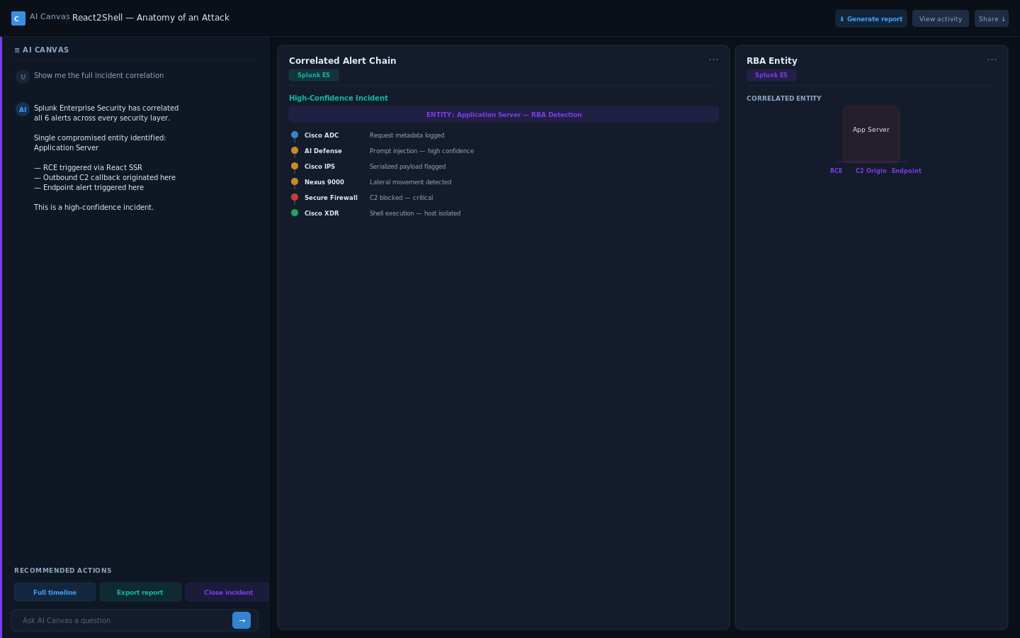

SECTION 4: WALL NARRATIVE FLOW
The LED wall tells the full attack story as a cinematic, system-level topology animation. No UI elements, no text-heavy content. The narrative unfolds in five visual phases that map directly to the nine attack steps.

Phase 1: Entry + Detection (Steps 1–2)
The topology begins in a dormant state — all nodes dim gray, connections barely visible. A red user node appears at the perimeter edge and emits a particle stream toward the Load Balancer (Cisco ADC). The Load Balancer activates blue. The stream continues to the AI Application node, which activates with an amber warning glow when Cisco AI Defense detects the prompt injection. The stream passes through AI without stopping. Two amber telemetry lines branch toward Splunk at the base of the topology. The system is awake but has not acted.

Phase 2: Boundary Crossing + Inspection (Steps 3–4)
A dashed trust boundary line renders between the AI layer and Backend Services. The red particle stream crosses it cleanly — the boundary flashes on crossing, labeled “Malicious payload passed downstream.” Backend nodes illuminate. The IPS node activates inline with an amber warning ring as the stream passes through. No block. Another telemetry line to Splunk. The visual message is clear: detections are firing, nothing is stopping the attack.

Phase 3: Lateral Movement + Exploitation (Steps 5–6)
Multiple internal service nodes become visible. An abnormal lateral path renders in orange/dashed between Backend Service nodes, distinct from normal gray connections. The Nexus switch node activates. The attack stream reaches the Application Server, which transitions to full red/compromised state with a shockwave burst — the most dramatic visual moment. No outbound alerts fire from the server. The absence is intentional: the system has no visibility at the point of exploitation. Telemetry from Nexus continues to Splunk.

Phase 4: Containment (Steps 7–8)
An outbound red stream fires from the compromised server toward a new External Attacker node at the perimeter. The Firewall node intercepts: a hard block symbol renders, the stream is severed. A red critical alert line fires to Splunk. Then the Application Server displays a process alert icon and an isolation perimeter (dashed ring) forms around it. All paths to and from the server dim or sever. The server is locked down. Another red alert to Splunk. The tide has turned.

Phase 5: Correlation + Resolution (Step 9)
All previous alert paths — from ADC, AI Defense, IPS, Nexus, Firewall, and XDR — simultaneously re-illuminate, converging on the Splunk node. Splunk visually expands to become the focal point. A correlation web renders from Splunk back to the Application Server, tying together the RCE event, the C2 callback origin, and the endpoint alert at a single entity. The topology settles into its final state: the complete attack path is visible as a traced route from perimeter entry to correlated incident. Final label: “Splunk Enterprise Security — High-Confidence Incident.”

ESCALATION COMMUNICATION
Escalation is communicated through color progression across the topology: dim gray (dormant) → blue (active) → amber (alert/warning) → red (compromised/critical) → green containment ring → final correlation state with all paths visible. Spread is communicated by the expanding frontier of activated nodes and paths. Containment is communicated by severed paths, block symbols, and the isolation perimeter. The Splunk node grows in visual weight with each incoming alert, building anticipation for the final correlation.

