Xtract - Data Cube

Now, consider the following table. It consists of 5 columns viz., Region, Product, Salesman, Quantity and Discount which are self explanatory. This is a HMG grid which contains many rows.
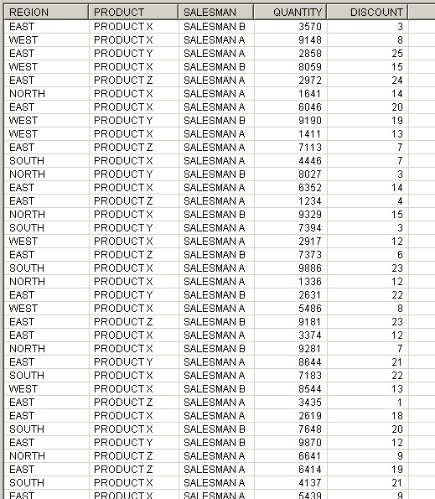
To make this data to be useful and to take managerial decisions, we may have to answer some of the questions as like:
1. What are all the regions, products, who are all the sales people.
2. What is the total quantity sold
3. What is the total number of transactions salesman-wise/product-wise/region-wise
4. What is the total quantity sold region-wise, product-wise, salesman-wise, region-product-wise, so on and so forth in various combination
5. What is the maximum/minimum discount allowed in total, region-wise, product-wise, salesman-wise and in various combination
Now, this is actually seeing the data in various perspectives or in 3 Dimensional!
These things are possible now with my small utility.
Rathinagiri

