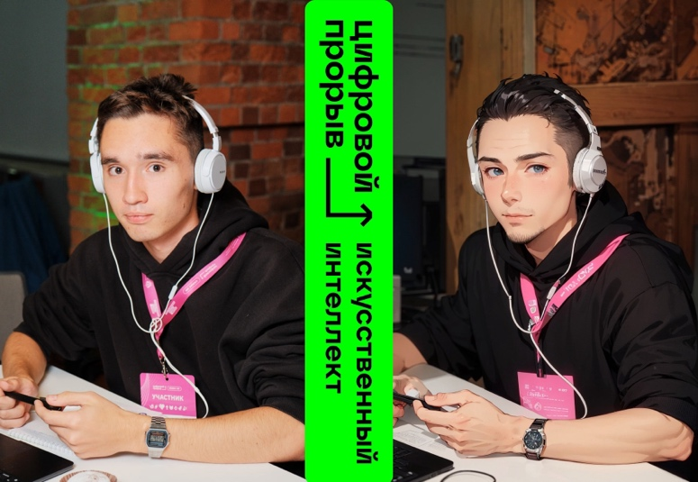**Zaznobin Petr**

*Date of birth:* 02.08.2004

*Age:* 19 лет

*Tel.:* 89867497926

*Email:* [pitzaznobin@gmail.com](mailto:pitzaznobin@gmail.com)

*GitHub:* <https://github.com/Petr-Zaznobin>

C*ity of residence:* N.Novgorod

*Place of study:* Lobachevsky NNSU  
*Faculty:* ITMM

*Specialty: Applied Mathematics and Informatics*

*Course: 2*

About me:

* Graduated from high school with a gold medal,
* Participant of Sirius «Большие вызовы» educational program,
* ICPC 2021 participant (initial stage),
* Participant of the All-Russian hackathon «Цифровой прорыв 2023. Сезон ИИ»,
* Worked at an online school as a tutor for a math course,
* Wrote an article on habr (<https://habr.com/ru/articles/757626/>),
* Currently reading the yandex handbook on ML and taking a course from yandex on ml and algorithms.

Proficiency in the following technologies and skills:

* Pandas basics (learned to analyze data when working with ML)
* Matpotlib basics (used to analyze data when working with ML).
* YOLOv8
* Know the basics of OOP
* Know the basics of ML
* Worked with CV and NLP (at hackathon)
* Linux command line basics
* C++ basics
* Have knowledge of algorithms
* Have knowledge of linear algebra
* Have knowledge of matanalysis
* Know the basics of working with Git

Soft skills:

* Curiosity
* Perseverance
* Ability to work in a team
* Desire to gain new knowledge
* Purposefulness
* Stress resistance
* Flexibility of mind

Language Knowledge:

* English (B1)
* Russian (native)