**FROM SOFIA AIRPORT TO CITY CENTER**

Sofia Airport is the largest airport in Bulgaria and is only 20 minutes away by metro from the city center. Sofia Airport has two terminals – T1 and T2. Sofia Airport provides direct free-of-charge transportation between the two terminal buildings.

The vehicles are marked as SHUTTLE BUSES and operate 24/7 as follow:

On Terminal 1 – Terminal 2 – Terminal 1 route: from 08:00 a.m. to 08:00 p.m. the bus runs at every 30 min. From 08:00 p.m. to 08:00 a.m. on the route Terminal 1 – Terminal 2 – Terminal 1: at every 40 min.

SOFIA AIRPORT METRO STATION

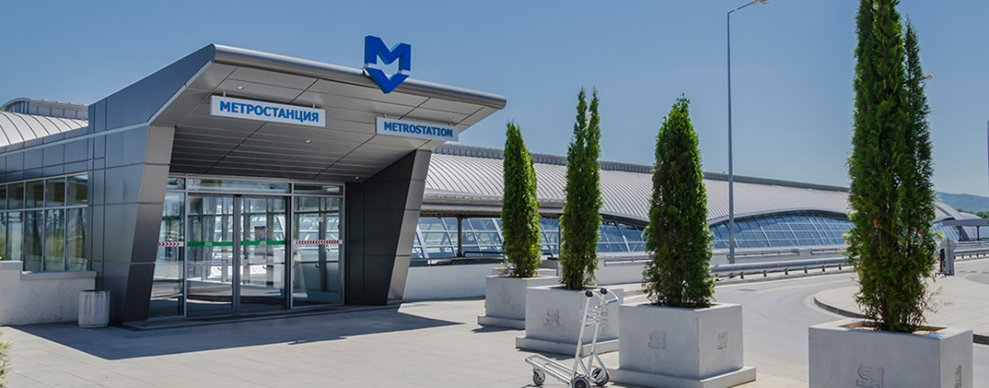

**SOFIA AIRPORT METRO STATION** is located in the eastern part of **Terminal 2**. You can reach it by following ***the blue markings*** on the floor of the public area of Terminal 2. M4 Line of Sofia Metro connects Sofia Airport with the city center – at Sofia University Metro Station and at Serdika Metro Station. The trip takes about 30 minutes. By changing lines at Serdika Metro Station you can go to **Sofia Central Bus Station** and **Sofia Central Railway Station**. The metro trains from and to the airport run from 5:30 to 24:00 on weekdays and holidays. There are travel cards vending machines at Sofia Airport Metro Station. You can use Bulgarian banknotes or coins or a bank card to purchase a travel card. You can use your bank card directly as a travel card. This is the best option. It costs 1.60 BGN. The single-trip travel card for the metro has to be ***validated at the validators* *at the entrance to the metro stations.***

Each travel card can be used up to 30 minutes after being purchased. A single travel card for metro you can buy also from the metro cash-desks located next to the metro's entrance. You should keep your travel card till the end of the trip.

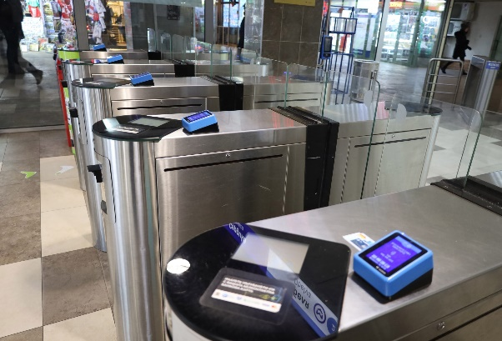

The following passes can also be bought at the metro cash-desks: a daily pass for all lines of the public transport – 4 BGN (not for night transport); an electronic card issued for ten metro single trips – 12 BGN.

**BUS LINES No E84, No E184, No 384**

**Bus line No E84** runs from Sofia city center – bus stop Gen. Gurko Str. (bus stop No 1903), to Sofia Airport Terminal 2. From Terminal 2 it runs to Sofia Airport Terminal 1 and then back to Sofia city center.

**Bus line No E184** runs from Sofia city center - bus stop Gen. Gurko Str. (bus stop No 1903), to Sofia Airport Terminal 1. From Terminal 1 it runs to Terminal 2 and then back to Sofia city center.

Both bus lines operate under an all-day timetable. The exact times, including the first and last buses, are published at www.sofiatraffic.bg/en/transport/schedules. It takes around 45 minutes to reach the airport from the city center by both bus lines.

The single-trip travel card for the buses, trams and trolleys costs 1.60 BGN and has to be ***validated at the validators* *at the entrance to the metro stations.***

**TAXI from the airport to city center**

When you land at Sofia Airport, a taxi ride to the city center of Sofia is one of the available options. A taxi ride from Sofia Airport to the city center takes 20 minutes with a fare ranging from 15 to 30 BGN. The official taxi provider for Sofia Airport is *“Yellow”* taxi. The taxis are situated right next to the western exit of the airport. Be aware of unlicensed taxi drivers. Taxi drivers only accept Bulgarian Levs, so it's a good idea to have the local currency on hand. Keep in mind that not all taxi drivers may speak English fluently, leading to potential communication hurdles.

**FROM SOFIA CENTRAL BUS STATION TO CITY CENTER**

Sofia Central Bus Station and Serdika Bus Station are the two Sofia’s principal bus gateways. Both are located next to the Central Railway Station making train-to-bus connections easy. Sofia Central Bus Station is located at 100 Maria Louisa Blvd. It can be reached by Sofia Metro Line 2 (*Central Railway Station metro station*); by trams №: 1,3,6,7 and by buses №: 85,213,305,404,413.

Sofia Metro connects Sofia Central Bus Station with the center of the city – Serdika metro Station. The trip takes about 5 minutes. Passengers can change metro lines at Serdika metro station and travel direct to Sofia University or Sofia Airport Terminal 2.

**USEFUL TRAVEL TIPS**

**Currency & Exchange rate**

Bulgarian currency is called “Bulgarian lev” (plural “Bulgarian leva”). **1.95 BGN = 1 EUR**

If you need to some money in CASH is better to use ATMs rather than “Currency exchange bureau”. We recommend ATMs attached to a bank as they are more secure and will offer a better exchange rate. In any case if you must exchange money, we suggest the option to go to the nearest shopping mall and search for *“Tavex”* exchange currency: <https://tavex.bg/en/contacts/>.

**Metro MAP**

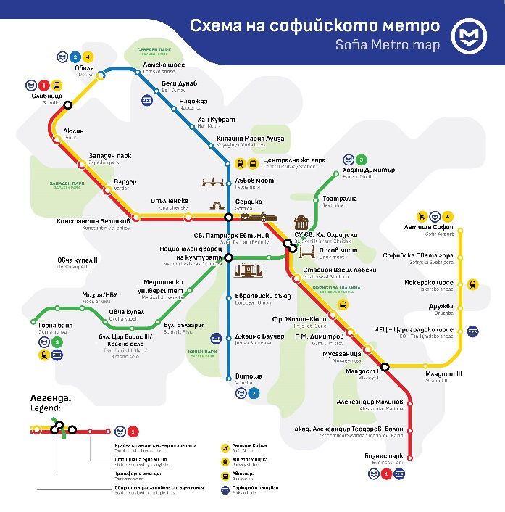

Click on the map to open the scheme in Google maps. (Ctrl+Click to follow the link).

**Electric Outlets**

Bulgaria uses type F outlets (also works with C and E) and the standard voltage is 230 volts. If your country has a standard voltage between 220-240 (like the UK and rest of Europe) you can use your electric appliances without a voltage converter.

**Current Local Time**

Eastern European Time (EET)

Time zone in Sofia (UTC/GMT+2)

**Weather and temperature in Sofia**

Sofia in March shows a temperature shift, moving from an average high of a cold 5.6°C in February to a fresh 10.6°C. Throughout March, Sofia registers a consistent average low-temperature of 0.8°C. In March it is raining for about 10 days, with typically 38mm of accumulated precipitation.

**Free Wi-Fi Internet Areas in Sofia**

It is easily accessible and available everywhere. Free wi-fi areas could be found in most public areas such as the Central Railway Station, Central Bus Station, Sofia Airport, Central Covered Market – Halite. Same goes for all hotels, shopping malls, most metro stations and even some of the parks such as South Park (Yuzhen park), Zaimov Park, Doctor’s Garden.

You can also expect that most of the cafes, restaurants and bars would have free wi-fi. Sometimes you might have to ask for a password at the counter but generally it’s free. You just have to bring your own device. Unlike other countries, it’s relatively easy here to find free internet.

**NB! FREE WI-FI** at Sofia University main building hosting the **AdriaArray workshop.**

**Museum of Paleontology and Historical Geology** (5th floor, North Wing of Sofia University)

Info [HERE](https://gpff.gea.uni-sofia.bg/facilities/museum/).

**Museum of Mineralogy, Petrology and Mineral Resources** (5th floor, South Wing of Sofia University)

Info [HERE](https://www.uni-sofia.bg/index.php/eng/the_university/other_structures/museums2/museum_of_mineralogy_petrology_and_mineral_resources).