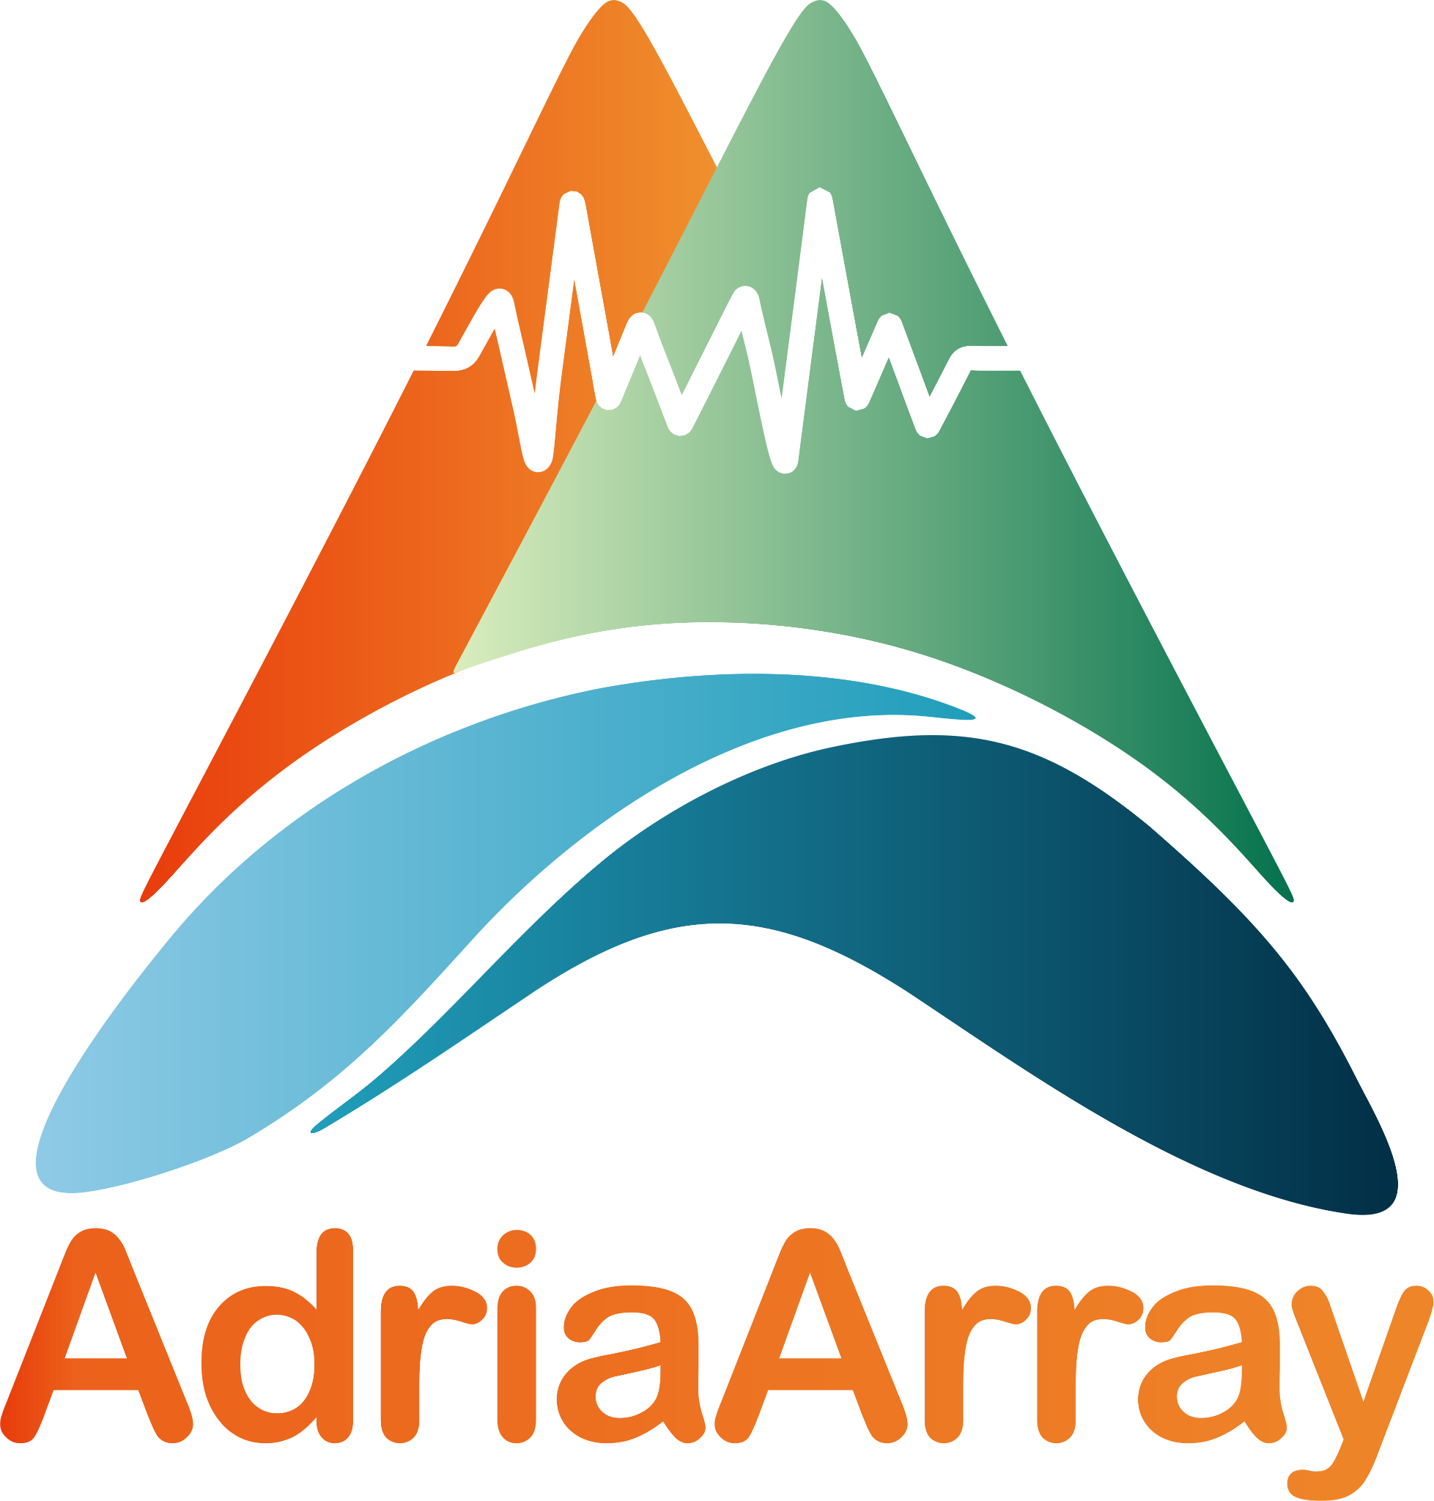
AdriaArray Workshop Sofia 2024
venue: main building (Rectorat) of the Sofia University “St. Kliment Ohridski”,
Tzar Osvoboditel Blvd. 15, Sofia, Bulgaria, March 12-15, 2024

The workshop is locally organized by
the Department of Meteorology and Geophysics, Faculty of Physics, Sofia University,
by
the National Institute of Geophysics, Geodesy and Geography, Bulgarian Academy of Sciences
and by
the Bulgarian Geophysical Society

Organizing committee:
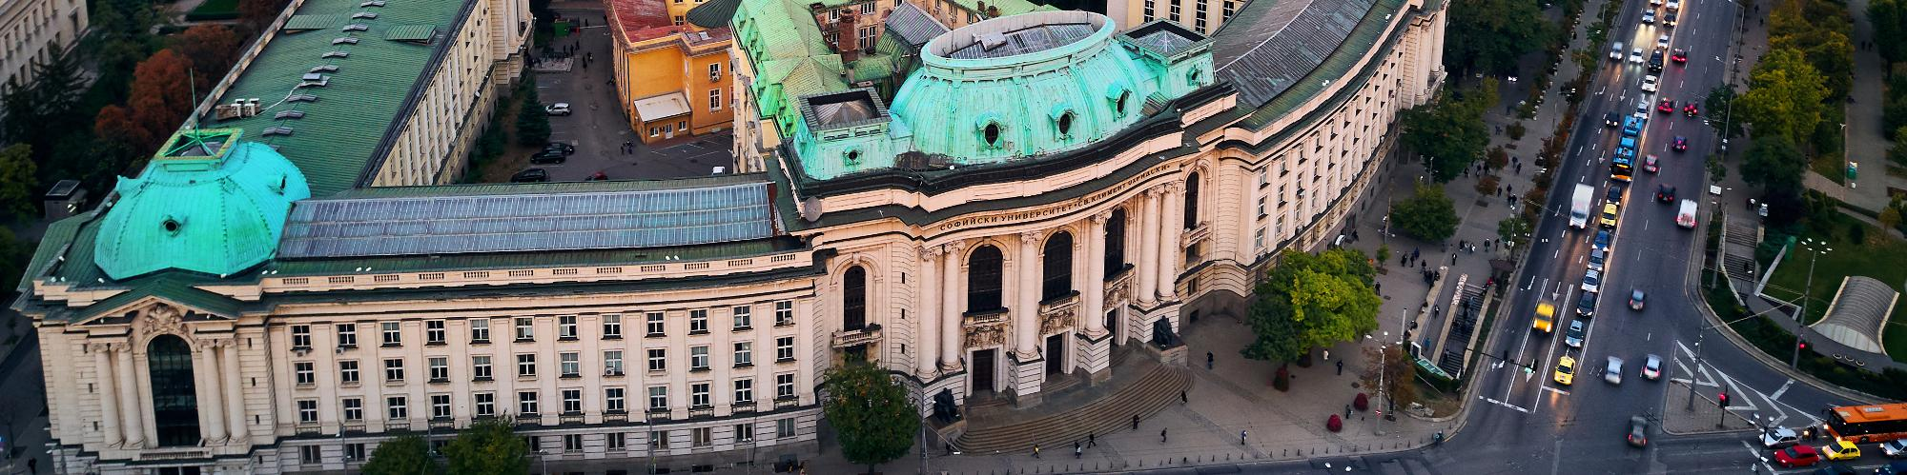
Gergana Georgieva, Lili Dimitrova, Lyuba Dimova, Petr Kolínský & Thomas Meier
program version: February 21, 9:00 CET
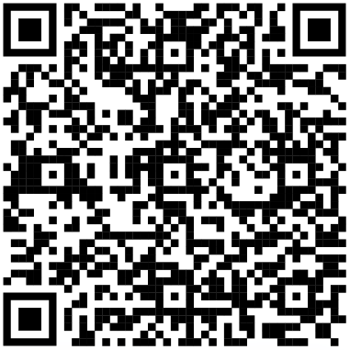
AdriaArray webpage https://orfeus.readthedocs.io/en/latest/adria_array_main.html

The workshop is supported by:
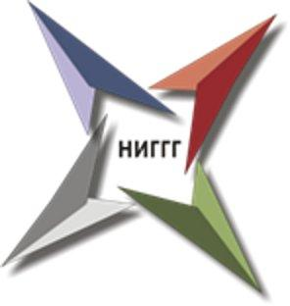
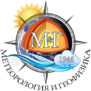
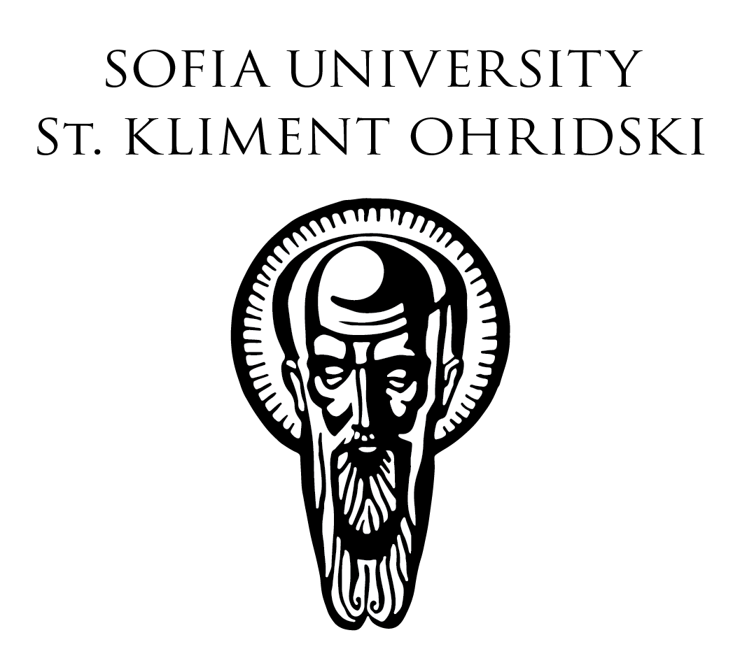
﻿



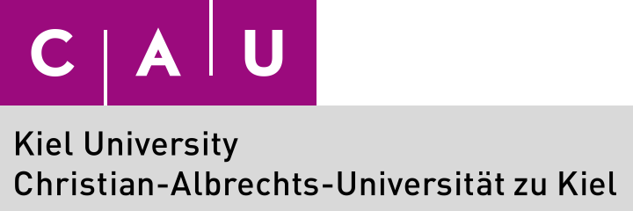

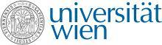
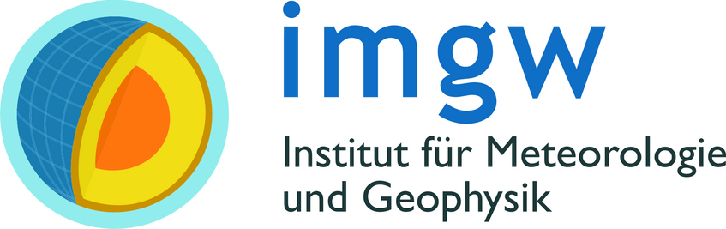

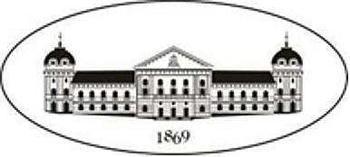

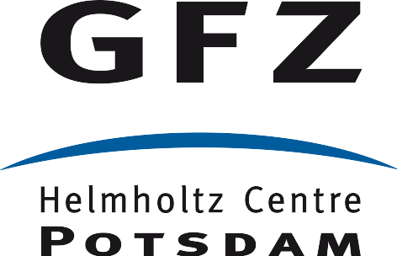
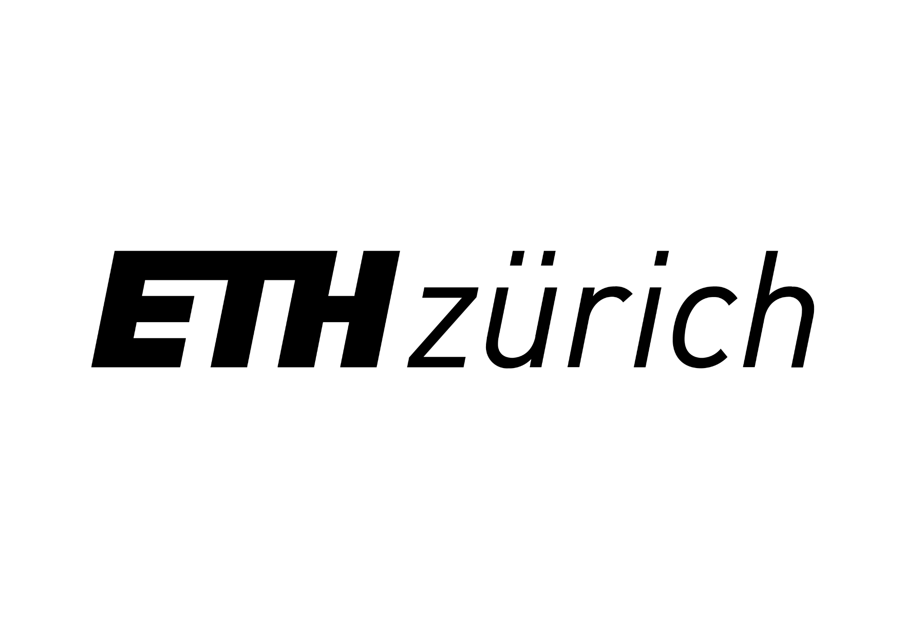
Poster presentations:
Poster Specifications: Maximum size: 100 cm x 90 cm (portrait orientation)
Lightning Talk: In addition to the poster presentation, each participant will have the opportunity to deliver a 1-minute lightning talk to accompany his/her poster. This brief presentation (1 slide) will allow you to provide a concise overview of your research, findings, and key points to fellow participants and attendees.
Poster Printing: Please note that there will be no printing facilities provided by the organizers at the venue.
Submission Deadline: We kindly request all participants to submit their 1-min lightning talk files before 10 March 2024. This will allow us sufficient time to organize the poster session and ensure a seamless experience for all attendees. Send your files in .ppt or .pptx to lyuba_dimova@phys.uni-sofia.bg.
Transport information and useful tips:
From Sofia Airport to City Center. Sofia Airport is the largest airport in Bulgaria and is only 20 minutes away by metro from the city center. Sofia Airport has two terminals – T1 and T2. Sofia Airport provides direct free-of-charge transportation between the two terminal buildings. The vehicles are marked as SHUTTLE BUSES and operate 24/7 as follows: On Terminal 1 – Terminal 2 – Terminal 1 route: from 08:00 a.m. to 08:00 p.m. the bus runs at every 30 min. From 08:00 p.m. to 08:00 a.m. on the route Terminal 1 – Terminal 2 – Terminal 1: at every 40 min. SOFIA AIRPORT METRO STATION is located in the eastern part of Terminal 2. You can reach it by following the blue markings on the floor of the public area of Terminal 2. M4 Line of Sofia Metro connects Sofia Airport with the city center – at Sofia University Metro Station and at Serdika Metro Station. The trip takes about 30 minutes. By changing lines at Serdika Metro Station you can go to Sofia Central Bus Station and Sofia Central Railway Station. There are travel cards vending machines at Sofia Airport Metro Station. You can use Bulgarian banknotes or coins or a credit card to purchase a travel card. The best option is to pay by your credit card before entering the platforms. It costs 1.60 BGN. The single-trip travel card for the metro has to be validated at the validators at the entrance to the metro stations. Each travel card can be used up to 30 minutes after being purchased.
Bus Lines No E84, No E184. Bus line No E84 runs from Sofia Airport Terminal 2 to Terminal 1 and then to Sofia city center – bus stop Sofia University (bus stop No 1700). Bus line No E184 runs from Sofia Airport Terminal 1 to Terminal 2 and then to Sofia city center – bus stop Sofia University (bus stop No 1700). It takes around 45 minutes to reach the city center from the airport by both bus lines. The single-trip travel card for the buses, trams and trolleys costs 1.60 BGN and has to be validated at the validators at the entrance to the metro stations.
TAXI from the airport to the city center. A taxi ride from Sofia Airport to the city center takes 20 minutes with a fare ranging from 20 to 30 BGN. The official taxi provider for Sofia Airport is “Yellow” taxi. The taxis are situated right next to the western exit of the airport. Be aware of unlicensed taxi drivers. Taxi drivers only accept Bulgarian Levs, so it's a good idea to have the local currency on hand. Keep in mind that not all taxi drivers may speak English fluently, leading to potential communication hurdles.
From Sofia Central Bus Station to City Center. Sofia Central Bus Station and Serdika Bus Station are the two Sofia’s principal bus gateways. Both are located next to the Central Railway Station making train-to-bus connections easy. Sofia Central Bus Station is located at 100 Maria Louisa Blvd. It can be reached by Sofia Metro Line 2 (Central Railway Station metro station); by trams №: 1,3,6,7 and by buses №: 85,213,305,404,413. Sofia Metro connects Sofia Central Bus Station with the center of the city – Serdika metro Station. The trip takes about 5 minutes. Passengers can change metro lines at Serdika metro station and travel directly to Sofia University or Sofia Airport Terminal 2.
Currency & Exchange rate. Bulgarian currency is called “Bulgarian lev” (plural “Bulgarian leva”). 1.95 BGN = 1 EUR. If you need some money in CASH it is better to use ATMs rather than “Currency exchange bureau”. We recommend ATMs attached to a bank as they are more secure and will offer a better exchange rate.
Current Local Time. Eastern European Time (EET). Time zone in Sofia (UTC/GMT+2)
FREE WI-FI at Sofia University main building hosting the AdriaArray workshop.
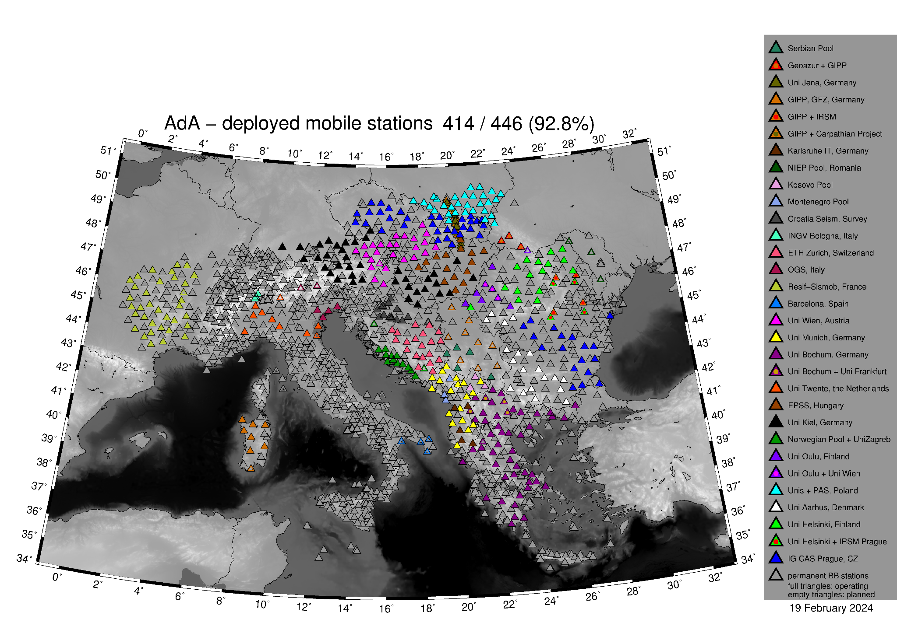
Tuesday, March 12 | overview of the program by sessions
09:00 - 10:30 | Welcome and introduction
11:00 - 12:30 | Plenary session 1 – Tectonics of the region
14:00 - 15:30 | Plenary session 2 – Local networks and seismicity
16:00 - 16:45 | Plenary session 2 – Local networks and seismicity - continued
16:45 - 17:30 | Poster advertisement
17:30 - 18:30 | Poster session

Wednesday, March 13
09:00 - 10:30 | Plenary session 3: Passive seismic imaging
11:00 - 12:30 | Plenary session 3: Passive seismic imaging - continued
14:00 - 15:30 | Break-out session 1: Engineering seismology | Break-out session 2: Data availability and quality
16:00 - 17:30 | Break-out session 3: Ambient noise | Break-out session 4: Body wave tomography
17:30 - 18:30 | Meeting of Early Career Scientists | Poster session

Thursday, March 14
09:00 - 10:30 | Plenary session 4: GNSS and geodynamics
11:00 - 12:30 | Break-out session 5: Surface wave tomography | Break-out session 6: Receiver functions
14:00 - 15:30 | Break-out session 7: Shear-wave splitting | Break-out session 8: Seismicity and source parameters
16:00 - 17:30 | Break-out session 9: Vrancea | Break-out session 10: Linking geophysical observables and geodynamics
17:30 - 18:30 | Meeting on Communication and Outreach | Poster session

Friday, March 15
09:00 - 10:00 | Steering Committee meeting | Visit of the Museum of Palaeontology and of the Museum of Mineralogy
10:30 - 12:00 | Plenary discussion 5: final discussion

Time | session / talk detailed program |  |  | Room
Tuesday, March 12
08:30 - 09:00 | Registration (pick-up badges and information sheets) |  |  | in front of Aula
09:00 - 10:30 | Welcome and introduction convener: Gergana Georgieva |  |  | Aula
09:00 - 09:30 | Welcome addresses:
 | Galin Tsokov, Minister of Education and Science of Bulgaria
 | Georgi Valchev, Rektor of Sofia University
 | Nikolay Miloshev, Director of the National Institute of Geophysics, Geodesy and Geography, Bulgarian Academy of Sciences
 | Thomas Meier, AdriaArray Seismology Group
09:30 - 9:50 | Petr Kolínský: Status of the AdriaArray Seismic Network
09:50 - 10:10 | Neven Georgiev: Tectonics of the Balkan
10:10 - 10:30 | Thomas Meier, Claudia Piromallo, Sergei Lebedev & Stephane Rondenay: AdriaArray: research questions and methodological challenges
10:30 - 11:00 | Group photo / coffee break
11:00 - 12:30 | Plenary session 1 – Tectonics of the region convener: Stanislaw Mazur & Thomas Meier |  |  | Aula
11:00 - 11:15 | Eline Le Breton: Plate reconstructions of the Adriatic Plate
11:15 - 11:30 | Mark Handy: Connection of Dinaric-Hellenic bending and seismicity to mantle structure
11:30 - 11:45 | Jan Pleuger: The evolution of the Dinaric-Hellenic slab as inferred from surface geology
11:45 - 12:00 | Dimcho Solakov: Seismicity and seismic hazard for Bulgaria
12:00 - 12:15 | László Fodor: How precise determination of earthquake epicenters can help neotectonic study: a case study from Hungary
12:15 - 12:30 | George Kaviris: The contribution of the AdriaArray stations to the monitoring of the recent Euboea sequences
12:30 - 14:00 | Lunch break
14:00 - 15:30 | Plenary session 2 – Local networks and seismicity conveners: Gesa Petersen & Petr Kolínský |  |  | Aula
14:00 - 14:15 | Christos Evangelidis: EIDA@AdriaArray: Updates on distributing data from local and temporary networks
14:15 - 14:30 | Liudmyla Farfuliak: Initial Steps of Ukrainian Seismic Network Modernization
14:30 - 14:45 | Bálint Süle: AdriaArray in Hungary: the broadband seismic network and its characteristics
14:45 - 15:00 | Djordje Sušić: Seismological Network of Serbia
15:00 - 15:15 | Stojan Babić: Local and AdriaArray network in Republic of Srpska
15:15 - 15:30 | Merjema Genjac-Zukić: Seismic network in the Federation of BiH
15:30 - 16:00 | Coffee break
16:00 - 16:45 | Plenary session 2 - Local networks and seismicity - continued conveners: Gesa Petersen & Petr Kolínský |  |  | Aula
16:00 - 16:15 | Hans Agurto-Detzel: The ANTICS large-N deployment in Albania: lessons from the installation and first results on seismicity
16:15 - 16:30 | Liliya Dimitrova: Bulgarian seismic network and AdA initiative
16:30 - 16:45 | Andrea Pio Ferreri: OTRIONS seismic network after ten years of operation: the new seismic catalog
16:45 - 17:30 | Poster (slide)show convener: Lyuba Dimova |  |  | Aula
16:45 - 17:30 | Introducing each poster by 1 slide with 1 minute talk
17:30 - 18:30 | Poster session |  |  | Main foyer
18:30 | End of the program for Tuesday

Wednesday, March 13
09:00 - 10:30 | Plenary session 3: Passive seismic imaging conveners: Gergana Georgieva & Matthew Agius |  |  | Aula
09:00 - 09:15 | Irene Menichelli: Implications of Adria continental double-sided subduction on the geodynamics of the central Mediterranean
09:15 - 09:30 | Andreas Rietbrock: AI enhanced LET of the Greater Alpine region
09:30 - 09:45 | Gergana Georgieva: Earth structure beneath Bulgaria from receiver functions
09:45 - 10:00 | Dániel Kalmár: Receiver function analysis in the Pannonian basin and wider region: from the crust to the upper mantle
10:00 - 10:15 | Stanislaw Mazur: Crustal structure and tectonic models of the Western Carpathians, based on deep seismics and potential field data
10:15 - 10:30 | Silvia Pondrelli: Seismic Anisotropy Studies in the AdriaArray region: an Overview
10:30 - 11:00 | Coffee break
11:00 - 12:30 | Plenary session 3: Passive seismic imaging - continued conveners: Gergana Georgieva & Matthew Agius |  |  | Aula
11:00 - 11:15 | Ayoub Kaviani: Investigation of pattern of mantle flow and deformation beneath different tectonic settings: examples from the Zagros collision zone, Oman (obduction), Namibia (plume-lithosphere interaction), and Kamchatka subduction zone
11:15 - 11:30 | Sébastien Chevrot: Helmholtz tomography of Western Europe
11:30 - 11:45 | Laura Petrescu: A new ambient noise shear wave velocity model of the Eastern European lithosphere
11:45 - 12:00 | Thomas Meier: Crustal and upper mantle 3D Vs structure of the Pannonian Region from joint earthquake and ambient noise Rayleigh wave tomography
12:00 - 12:15 | Henrique Berger Roisenberg: Surface-wave attenuation and phase-velocity maps using the AlpArray seismic network: implications for crustal heterogeneity
12:15 - 12:30 | Felix Borleanu: Seismic attenuation of orogens and sedimentary basins in the Pannonian-Carpathian Region using noise and earthquake data
12:30 - 14:00 | Lunch break
14:00 - 15:30 | Break-out session 1: Engineering Seismology | Hall 1 | Break-out session 2: Data availability and quality | Aula
 | conveners: Iva Dasović & Costas Papazachos |  | conveners: Felix Eckel, Cristian Neagoe & Petr Kolínský
15:30 - 16:00 | Coffee break
16:00 - 17:30 | Break-out session 3: Ambient noise | Hall 1 | Break-out session 4: Body wave tomography | Aula
 | conveners: Irene Molinari, Anne Obermann, Laura Petrescu & Richard Kramer |  | conveners: Claudia Piromallo & Pasquale De Gori
17:30 - 18:30 | Meeting of Early Career Scientists | Hall 1 | Poster session | Main foyer
 | conveners: Richard Kramer, Felix Eckel & Johannes Stampa
18:30 | End of the program for Wednesday

Thursday, March 14
09:00 - 10:30 | Plenary session 4: GNSS and geodynamics conveners: Marcel Thielmann & Thomas Meier |  |  | Aula
09:00 - 09:15 | Keranka Vassileva: An overview of the studies of the Earth's crust movements on the territory of Bulgaria and the Balkan Peninsula with GNSS
09:15 - 09:30 | Lyubka Pashova: GPS/GNSS stations and networks in Bulgaria and their use for geodynamic research
09:30 - 09:45 | Marcel Thielmann: The Geophysical Model Generator: a tool to unify and interpret geophysical datasets
09:45 - 10:00 | Enrico Serpelloni: Vertical velocities and horizontal strain-rates in the Euro-Mediterranean region
10:00 - 10:15 | Ivone Jiménez-Munt: The lithosphere and upper mantle of Adria margins from integrated geophysical-geochemical modeling
10:15 - 10:30 | Thorsten Nagel: Searching for the crust in the MTZ
10:30 - 11:00 | Coffee break
11:00 - 12:30 | Break-out session 5: Surface wave tomography | Hall 1 | Break-out session 6: Receiver functions | Aula
 | conveners: Sébastien Chevrot, Laura Petrescu & Thomas Meier |  | conveners: Gergana Georgieva & Stéphane Rondenay
12:30 - 14:00 | Lunch break
14:00 - 15:30 | Break-out session 7: Shear-wave splitting | Hall 1 | Break-out session 8: Seismicity and source parameters | Aula
 | convener: Silvia Pondrelli |  | conveners: Gesa Petersen & Efthimios Sokos
15:30 - 16:00 | Coffee break
16:00 - 17:30 | Break-out session 9: Vrancea | Hall 1 | Break-out session 10: Linking geophysical observables and geodynamics | Aula
 | conveners: Renata Lukešová & Felix Borleanu |  | conveners: Marcel Thielmann, Thorsten Nagel & Thomas Meier
17:30 - 18:30 | Meeting on communication and outreach | Hall 1 | Poster session | Main foyer
 | conveners: Petr Kolínský & Thomas Meier
18:30 | End of the program for Thursday

Friday, March 15
09:00 - 10:00 | Meeting of the AdriaArray Steering Committee  SC members + ECS representative | Aula | Visit of the Museum of Paleontology and of the Museum of Mineralogy | Main foyer
10:00 - 10:30 | Coffee break
10:30 - 12:00 | Plenary session 5 – discussion conveners: Thomas Meier & Petr Kolínský |  |  | Aula
10:30 - 11:00 | Outcome of Break-out sessions and Working Group meetings (1-slide summary)
11:00 - 12:00 | Discussion of next steps and next meetings
12:00 | End, goodbye

The list of talks which are to be assigned to the breakout sessions by the respective conveners follows below. Additional presentations may be solicited by conveners of the break-out sessions. Please, contact the conveners of the break-out session directly in case you are interested to give a short presentation at one of the break-out sessions.
talk # | Author & title
 | Felix Eckel: Data Quality Checks of AdriaArray
 | Luděk Vecsey: Data + metadata tests
 | Petr Kolínský: Summarizing the results of data quality tests
 | Angela Sarao': Focal mechanisms catalog of earthquakes occurring in the southeastern Alps area from 1928 to 2023
 | Edmond Dushi: Real time regional moment tensor analysis in Albania
 | Milen Tsekov: On some statistical properties of Bulgarian seismicity
 | Irene Menichelli: Toward a machine learning based workflow for Regional Phase Identification
 | Laura Petrescu: Shear wave splitting analysis and multi-layer inversions in the AdriaArray region
 | Luděk Vecsey: A new method to measure seismic anisotropy of the upper mantle directly from the width and orientation of the particle motion of shear waves
 | Renata Lukešová: First results from analysis of AdriaArray station within local experiment - Vrancea
 | Marc Sosson: tba

Poster presentations (in the main foyer, displayed all 4 days):

poster # | Author & title
 | Amr El-Sharkawy - Anisotropic phase velocity tomography beneath Adria from earthquakes
 | Amra Krehić - Seismic network in the Federation of BiH
 | Anila Xhahysa - Macroseismic database impact in the seismic hazard of Albania
 | Anton Ivanov - Analysis of sea level data at Varna tide gauge
 | Bernd Schurr - The 2019 Mw6.4 Durres, Albania earthquake – anatomy of a thrust fault from high-resolution aftershock relocations
 | Cristian Neagoe - AdriaArray Status at NIEP - National Institute for Earth Physics
 | Damiano Pesaresi - OGS 2Y AdA seismic network installation and data acquisition
 | Dmitry Storchak - ISC data products for Adria region
 | Dogan Kalafat - Development of Kandilli Observatory and Earthquake Research Institute Seismic Network
 | Dragana Chernih - tba
 | Francesca Di Luccio - The role of salt tectonics in the occurrence of the 2021 Central Adriatic seismic sequence (presented by … tba)
 | Frederik Tilmann - The ANTICS large-N deployment
 | Genny Giacomuzzi - Accretion style and deep fluids in continental orogenic evolution
 | Gesa Petersen - Investigating microseismic swarms and clusters in the Eastern Alps
 | Hana Kampfová Exnerová - Mapping the Moho in the Bohemian Massif and the Western Carpathians with P-receiver functions
 | Irene Molinari - AdriaArray in Italy, installations and data quality
 | Iva Dasović - The Berkovići (BIH) M_{L} = 6.0 earthquake sequence of 22 April 2022 – seismological and seismotectonic analyses
 | Jasmina Najdovska - tba
 | Johannes Stampa - Data retrievability tests
 | Josip Stipčević - Crustal structure of the Dinarides (presented by … tba)
 | Jovan Dedić - Montenegro seismic network and installation of Z6 temporary network in Montenegro
 | Judith Confal - Splitting intensity: Examples from local and regional anisotropy tomographic images
 | Julia Rewers - tba
 | Katerina Drogreshka - tba
 | Kévin Delage - tba
 | Laura Scognamiglio - A preliminary study of the off-shore seismic source of the November 2022 Mw 5.5 offshore Adriatic (Italy) earthquake
 | Lucia Fojtíková - Seismic Activity and the event Oct 9th, 2023, M5.0 in Slovakia in the context of the AdraArray
 | Luděk Vecsey - A new method to measure seismic anisotropy of the upper mantle directly from the width and orientation of the particle motion of shear waves (talk possible)
 | Marcel Paffrath - tba
 | Maria Grazia - Accurate focal depth analysis using sP depth phase in the Adriatic region
 | Matthew Agius - tba
 | Mila Atanasova-Zlatareva - Study of co-seismic deformations of the earth's crust for the territory of the Balkan Peninsula based on satellite data (presented by H. Nikolov)
 | Natasa Kaludjerović - Tectonic stress regime and IHMS GNSS network of Montenegro
36. | Petya Trifonova - Moho discontinuity, Curie point depths, and temperature distribution inside the Earth crust in Bulgaria
 | Piotr Środa - tba
 | Reneta Raykova - Seismic Network of Sofia University
 | Richard Kramer - Inferring water resources from ambient seismic noise using regional seismic networks
 | Stephen Monna - Uppermost Mantle Structure in the Central Mediterranean Region From P and S Receiver Functions
 | Tahira Nicole - Ambient noise autocorrelations
 | Tanishka Soni - Unraveling the collisional history of the Western Carpathians through deep geophysical sounding
 | Todor Zhelyazov - Simulation of the dynamic response of base-isolated structures
 | Tommi Vuorinen - Detecting local-to-regional seismicity using template matching with relatively dense seismic networks
 | Yongki Andita Aiman - Mantle Transition Zone (MTZ) beneath the contiguous US revealed by ambient noise cross-correlations

The AdriaArray workshop is supported by the following institutions:
BAS - Bulgarian Academy of Sciences (https://www.bas.bg/?lang=en)
BGS - Bulgarian Geophysical Society (https://www.bggs.eu/index.html)
Department of Meteorology and Geophysics, Sofia University "St. Kliment Ohridski" (https://mg.phys.uni-sofia.bg/index_en.html)
ETH Zurich - Eidgenössische Technische Hochschule Zürich (https://ethz.ch/en.html)
Helmholtz-Centre Potsdam - GFZ German Research Centre for Geosciences (https://www.gfz-potsdam.de/en/)
ILP - International Lithosphere Program, Task Force 4 Continental lithosphere broadscale investigation (CoLiBrI) (https://wp.unil.ch/orog3ny/research/colibri/)
Institute of Geophysics of the Czech Academy of Sciences (https://www.ig.cas.cz/en/)
IMGW - Institut für Meteorologie und Geophysik, Universität Wien (https://img.univie.ac.at/en/about-us/)
INGV - Istituto Nazionale di Geofisica e Vulcanologia (https://www.ingv.it/en/home)
Kiel University - Christian-Albrechts-Universität zu Kiel (CAU) https://www.uni-kiel.de/en/
NIGGG - National Institute of Geophysics, Geodesy and Geography, BAS (http://www.niggg.bas.bg/en/)
ORFEUS - Observatories and Research Facilities for European Seismology (http://orfeus-eu.org/)
Sofia University "St. Kliment Ohridski" (https://uni-sofia.bg/index.php/eng)

