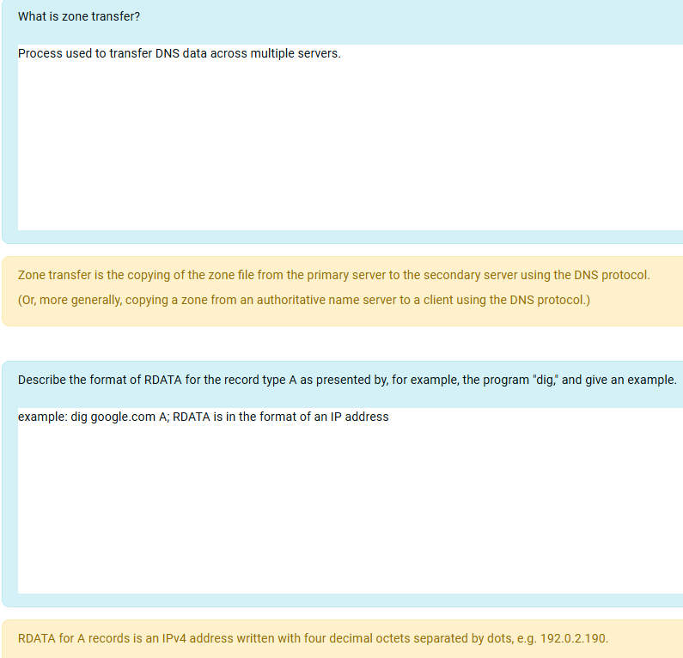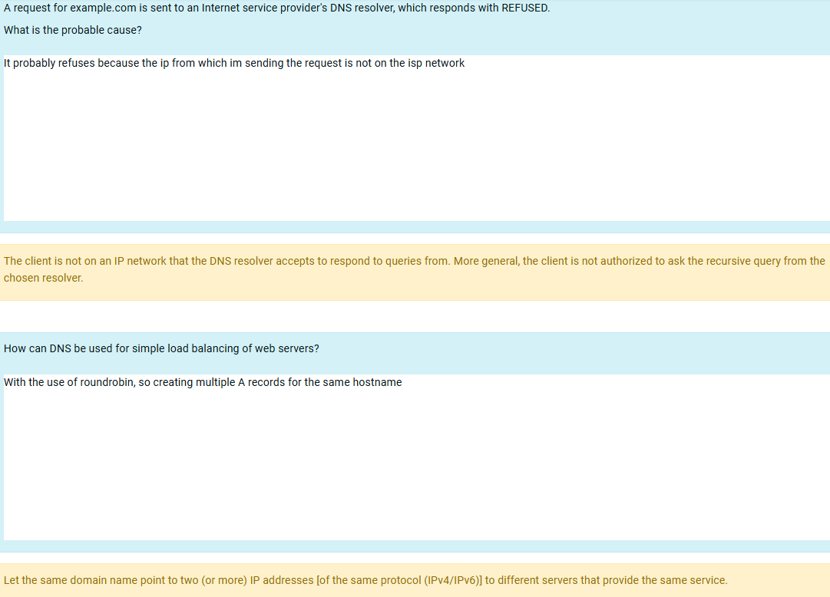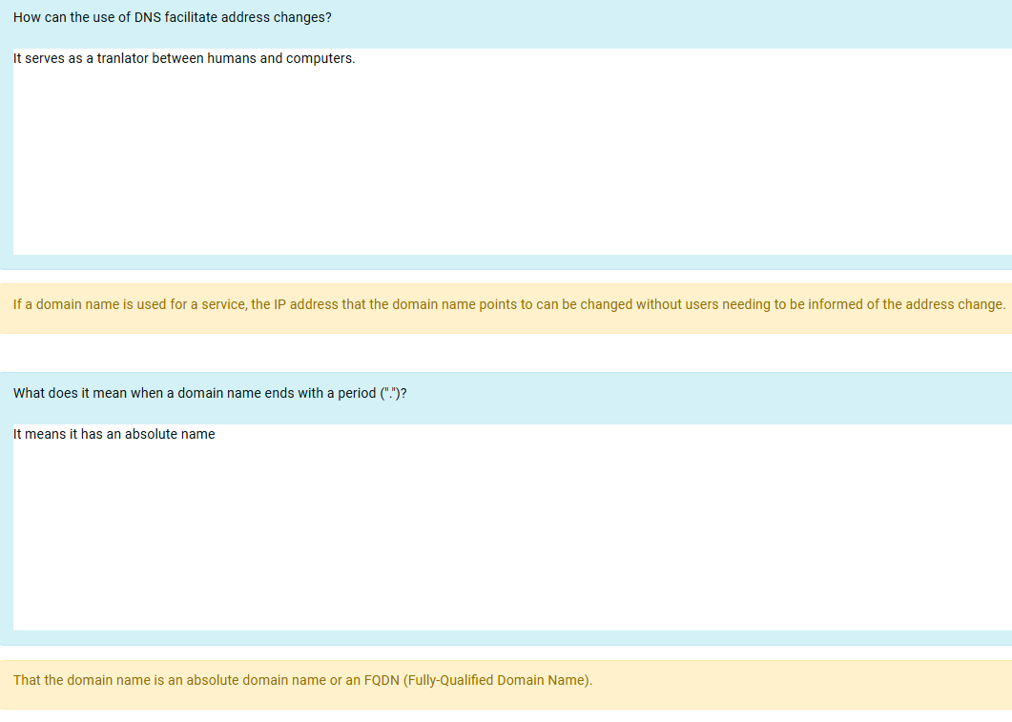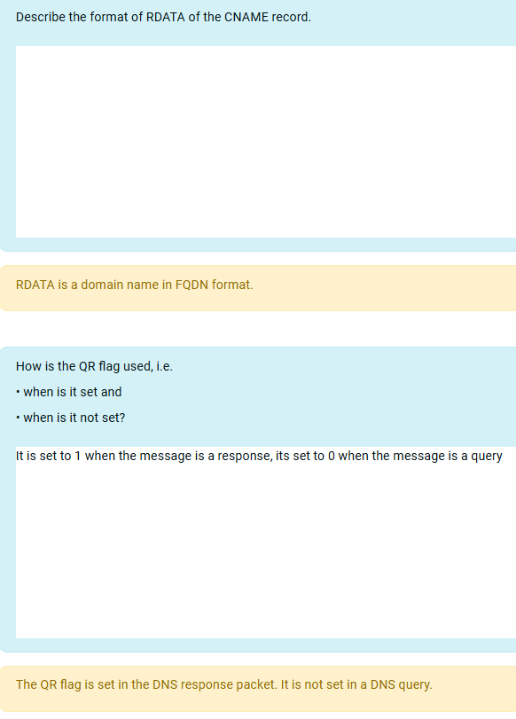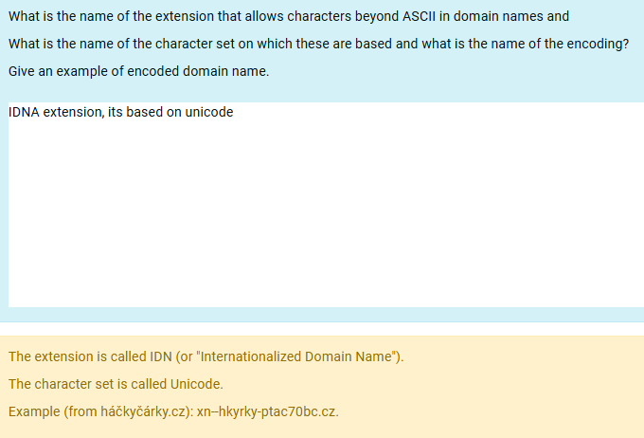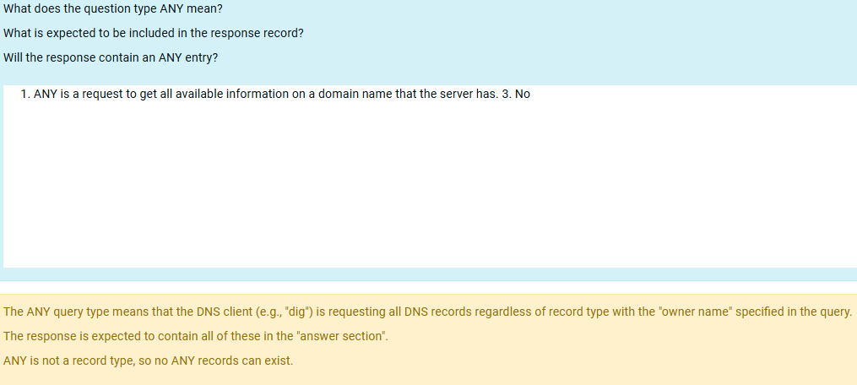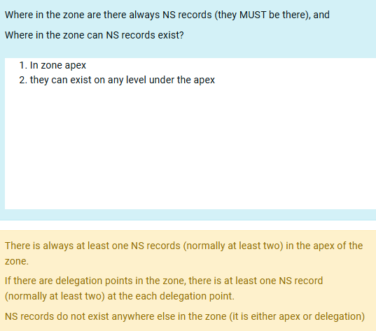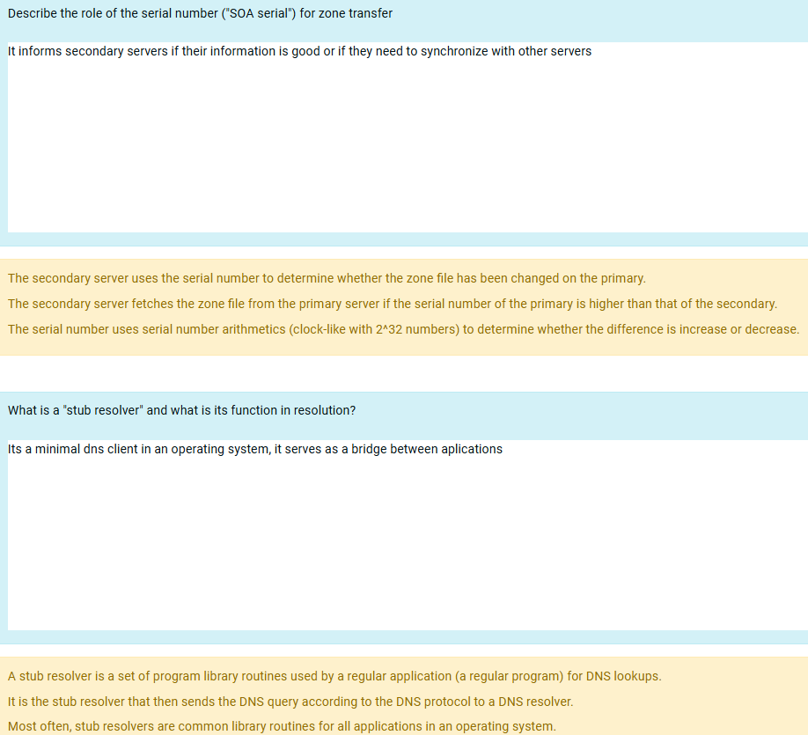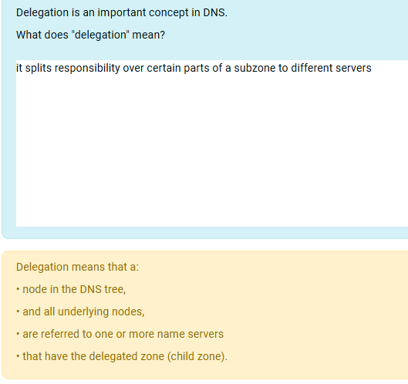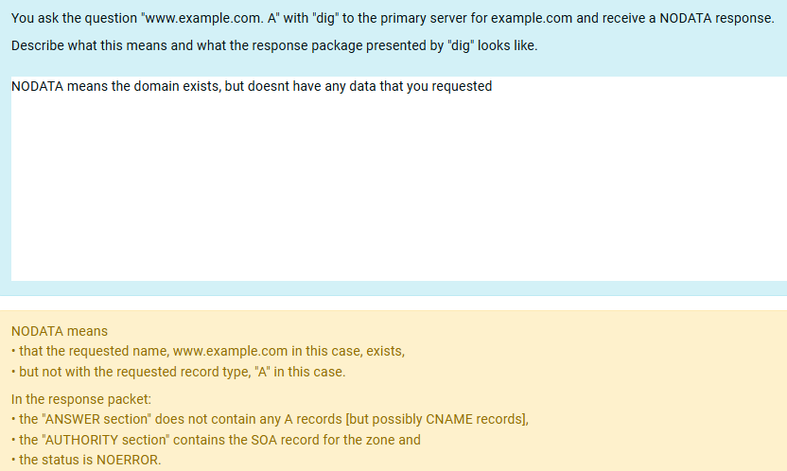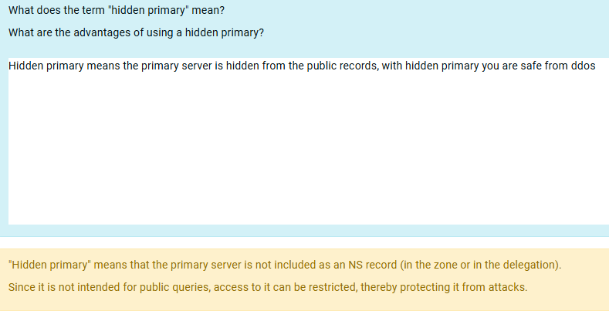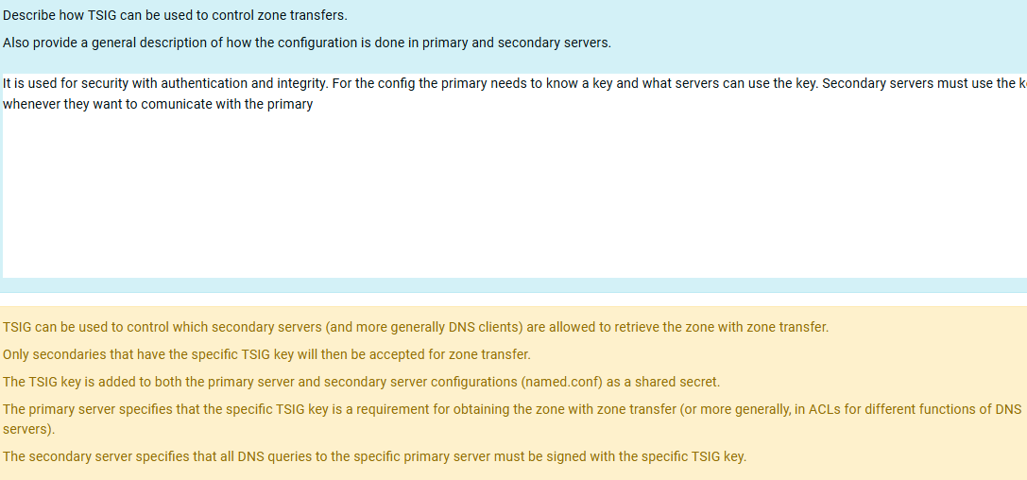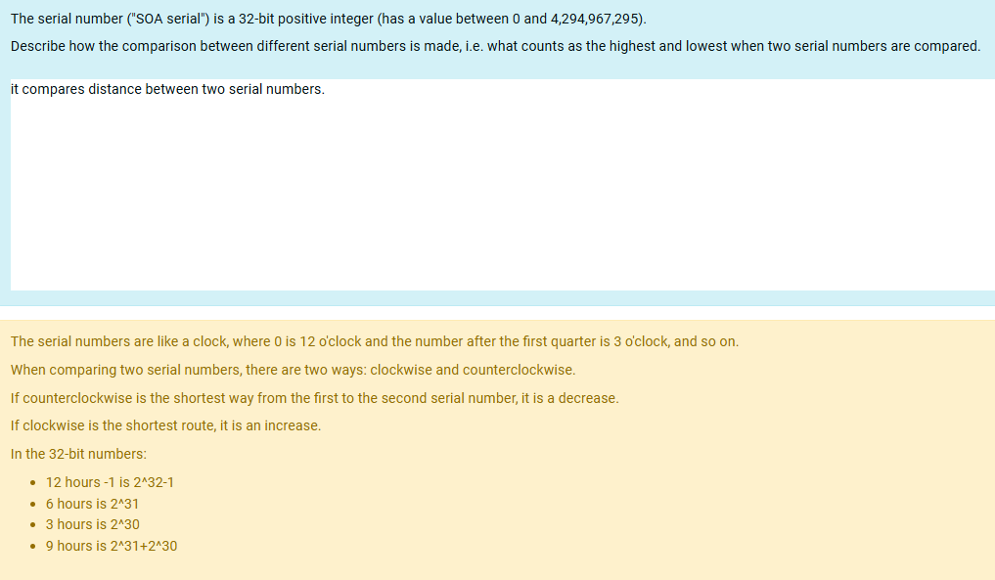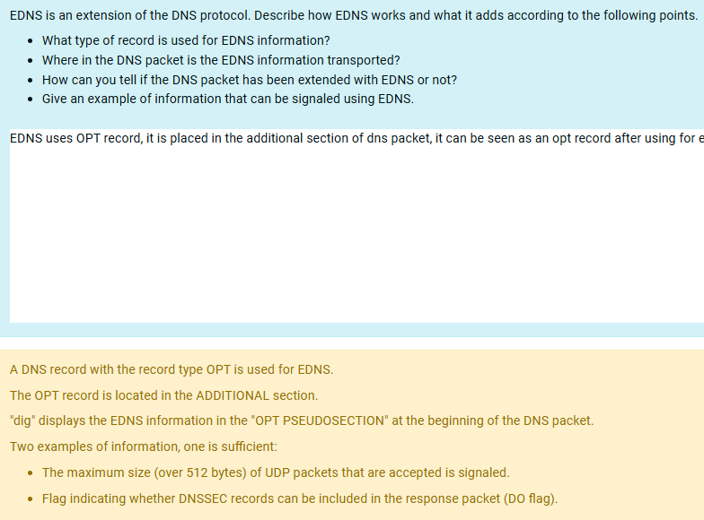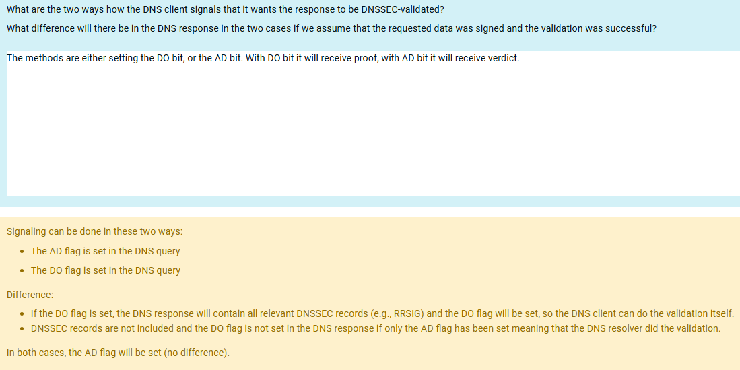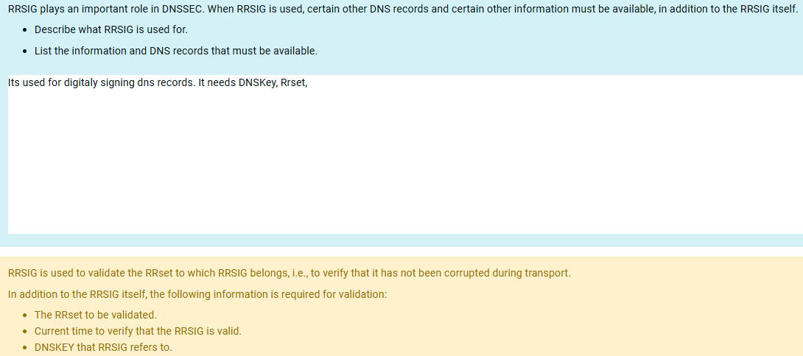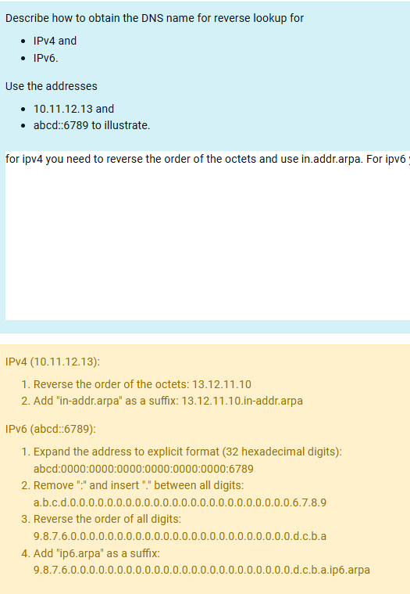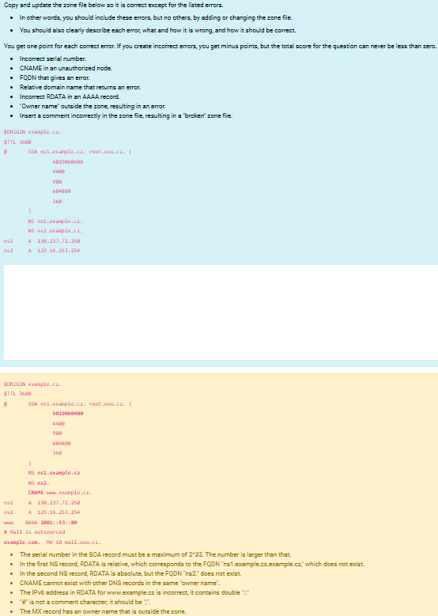What is zone transfer?
Text odpovědi Úloha 1
Process used to transfer DNS data across multiple servers.
Reakce
Zone transfer is the copying of the zone file from the primary server to the secondary server using the DNS protocol.
(Or, more generally, copying a zone from an authoritative name server to a client using the DNS protocol.)
Úloha 2
Hotovo
Počet bodů z 1,00
Úloha s vlaječkou
Text úlohy
Describe the format of RDATA for the record type A as presented by, for example, the program "dig," and give an example.
Text odpovědi Úloha 2
example: dig google.com A; RDATA is in the format of an IP address
Reakce
RDATA for A records is an IPv4 address written with four decimal octets separated by dots, e.g. 192.0.2.190.
Úloha 3
Hotovo
Počet bodů z 1,00
Úloha s vlaječkou
Text úlohy
A request for example.com is sent to an Internet service provider's DNS resolver, which responds with REFUSED.
What is the probable cause?
Text odpovědi Úloha 3
It probably refuses because the ip from which im sending the request is not on the isp network
Reakce
The client is not on an IP network that the DNS resolver accepts to respond to queries from. More general, the client is not authorized to ask the recursive query from the chosen resolver.
Úloha 4
Hotovo
Počet bodů z 1,00
Úloha s vlaječkou
Text úlohy
How can DNS be used for simple load balancing of web servers?
Text odpovědi Úloha 4
With the use of roundrobin, so creating multiple A records for the same hostname
Reakce
Let the same domain name point to two (or more) IP addresses [of the same protocol (IPv4/IPv6)] to different servers that provide the same service.
Úloha 5
Hotovo
Počet bodů z 1,00
Úloha s vlaječkou
Text úlohy
How can the use of DNS facilitate address changes?
Text odpovědi Úloha 5
It serves as a tranlator between humans and computers.
Reakce
If a domain name is used for a service, the IP address that the domain name points to can be changed without users needing to be informed of the address change.
Úloha 6
Hotovo
Počet bodů z 1,00
Úloha s vlaječkou
Text úlohy
What does it mean when a domain name ends with a period (".")?
Text odpovědi Úloha 6
It means it has an absolute name
Reakce
That the domain name is an absolute domain name or an FQDN (Fully-Qualified Domain Name).
Úloha 7
Nezodpovězeno
Počet bodů z 1,00
Úloha s vlaječkou
Text úlohy
Describe the format of RDATA of the CNAME record.
Text odpovědi Úloha 7
Reakce
RDATA is a domain name in FQDN format.
Úloha 8
Hotovo
Počet bodů z 1,00
Úloha s vlaječkou
Text úlohy
How is the QR flag used, i.e.
• when is it set and
• when is it not set?
Text odpovědi Úloha 8
It is set to 1 when the message is a response, its set to 0 when the message is a query
Reakce
The QR flag is set in the DNS response packet. It is not set in a DNS query.
Úloha 9
Hotovo
Počet bodů z 2,00
Úloha s vlaječkou
Text úlohy
What is the name of the extension that allows characters beyond ASCII in domain names and
What is the name of the character set on which these are based and what is the name of the encoding?
Give an example of encoded domain name.
Text odpovědi Úloha 9
IDNA extension, its based on unicode
Reakce
The extension is called IDN (or "Internationalized Domain Name").
The character set is called Unicode.
Example (from háčkyčárky.cz): xn--hkyrky-ptac70bc.cz.
Úloha 10
Hotovo
Počet bodů z 2,00
Úloha s vlaječkou
Text úlohy
What does the question type ANY mean?
What is expected to be included in the response record?
Will the response contain an ANY entry?
Text odpovědi Úloha 10
- ANY is a request to get all available information on a domain name that the server has. 3. No
Reakce
The ANY query type means that the DNS client (e.g., "dig") is requesting all DNS records regardless of record type with the "owner name" specified in the query.
The response is expected to contain all of these in the "answer section".
ANY is not a record type, so no ANY records can exist.
Úloha 11
Hotovo
Počet bodů z 2,00
Úloha s vlaječkou
Text úlohy
Where in the zone are there always NS records (they MUST be there), and
Where in the zone can NS records exist?
Text odpovědi Úloha 11
- In zone apex
- they can exist on any level under the apex
Reakce
There is always at least one NS records (normally at least two) in the apex of the
zone.
If there are delegation points in the zone, there is at least one NS record
(normally at least two) at the each delegation point.
NS records do not exist anywhere else in the zone (it is either apex or delegation)
Úloha 12
Hotovo
Počet bodů z 2,00
Úloha s vlaječkou
Text úlohy
Describe the role of the serial number ("SOA serial") for zone transfer
Text odpovědi Úloha 12
It informs secondary servers if their information is good or if they need to synchronize with other servers
Reakce
The secondary server uses the serial number to determine whether the zone file has been changed on the primary.
The secondary server fetches the zone file from the primary server if the serial number of the primary is higher than that of the secondary.
The serial number uses serial number arithmetics (clock-like with 2^32 numbers) to determine whether the difference is increase or decrease.
Úloha 13
Hotovo
Počet bodů z 2,00
Úloha s vlaječkou
Text úlohy
What is a "stub resolver" and what is its function in resolution?
Text odpovědi Úloha 13
Its a minimal dns client in an operating system, it serves as a bridge between aplications
Reakce
A stub resolver is a set of program library routines used by a regular application (a regular program) for DNS lookups.
It is the stub resolver that then sends the DNS query according to the DNS protocol to a DNS resolver.
Most often, stub resolvers are common library routines for all applications in an operating system.
Úloha 14
Hotovo
Počet bodů z 2,00
Úloha s vlaječkou
Text úlohy
Delegation is an important concept in DNS.
What does "delegation" mean?
Text odpovědi Úloha 14
it splits responsibility over certain parts of a subzone to different servers
Reakce
Delegation means that a:
• node in the DNS tree,
• and all underlying nodes,
• are referred to one or more name servers
• that have the delegated zone (child zone).
Úloha 15
Hotovo
Počet bodů z 2,00
Úloha s vlaječkou
Text úlohy
You ask the question "www.example.com. A" with "dig" to the primary server for example.com and receive a NODATA response.
Describe what this means and what the response package presented by "dig" looks like.
Text odpovědi Úloha 15
NODATA means the domain exists, but doesnt have any data that you requested
Reakce
NODATA means
• that the requested name, www.example.com in this case, exists,
• but not with the requested record type, "A" in this case.
In the response packet:
• the "ANSWER section" does not contain any A records [but possibly CNAME records],
• the "AUTHORITY section" contains the SOA record for the zone and
• the status is NOERROR.
Úloha 16
Hotovo
Počet bodů z 2,00
Úloha s vlaječkou
Text úlohy
What does the term "hidden primary" mean?
What are the advantages of using a hidden primary?
Text odpovědi Úloha 16
Hidden primary means the primary server is hidden from the public records, with hidden primary you are safe from ddos
Reakce
"Hidden primary" means that the primary server is not included as an NS record (in the zone or in the delegation).
Since it is not intended for public queries, access to it can be restricted, thereby protecting it from attacks.
Úloha 17
Hotovo
Počet bodů z 3,00
Úloha s vlaječkou
Text úlohy
Describe how TSIG can be used to control zone transfers.
Also provide a general description of how the configuration is done in primary and secondary servers.
Text odpovědi Úloha 17
It is used for security with authentication and integrity. For the config the primary needs to know a key and what servers can use the key. Secondary servers must use the key whenever they want to comunicate with the primary
Reakce
TSIG can be used to control which secondary servers (and more generally DNS clients) are allowed to retrieve the zone with zone transfer.
Only secondaries that have the specific TSIG key will then be accepted for zone transfer.
The TSIG key is added to both the primary server and secondary server configurations (named.conf) as a shared secret.
The primary server specifies that the specific TSIG key is a requirement for obtaining the zone with zone transfer (or more generally, in ACLs for different functions of DNS servers).
The secondary server specifies that all DNS queries to the specific primary server must be signed with the specific TSIG key.
Úloha 18
Hotovo
Počet bodů z 3,00
Úloha s vlaječkou
Text úlohy
The serial number ("SOA serial") is a 32-bit positive integer (has a value between 0 and 4,294,967,295).
Describe how the comparison between different serial numbers is made, i.e. what counts as the highest and lowest when two serial numbers are compared.
Text odpovědi Úloha 18
it compares distance between two serial numbers.
Reakce
The serial numbers are like a clock, where 0 is 12 o'clock and the number after the first quarter is 3 o'clock, and so on.
When comparing two serial numbers, there are two ways: clockwise and counterclockwise.
If counterclockwise is the shortest way from the first to the second serial number, it is a decrease.
If clockwise is the shortest route, it is an increase.
In the 32-bit numbers:
- 12 hours -1 is 2^32-1
- 6 hours is 2^31
- 3 hours is 2^30
- 9 hours is 2^31+2^30
Úloha 19
Hotovo
Počet bodů z 3,00
Úloha s vlaječkou
Text úlohy
EDNS is an extension of the DNS protocol. Describe how EDNS works and what it adds according to the following points.
- What type of record is used for EDNS information?
- Where in the DNS packet is the EDNS information transported?
- How can you tell if the DNS packet has been extended with EDNS or not?
- Give an example of information that can be signaled using EDNS.
Text odpovědi Úloha 19
EDNS uses OPT record, it is placed in the additional section of dns packet, it can be seen as an opt record after using for example dig, EDNS can be used to signal UDP
Reakce
A DNS record with the record type OPT is used for EDNS.
The OPT record is located in the ADDITIONAL section.
"dig" displays the EDNS information in the "OPT PSEUDOSECTION" at the beginning of the DNS packet.
Two examples of information, one is sufficient:
- The maximum size (over 512 bytes) of UDP packets that are accepted is signaled.
- Flag indicating whether DNSSEC records can be included in the response packet (DO flag).
Úloha 20
Hotovo
Počet bodů z 3,00
Úloha s vlaječkou
Text úlohy
What are the two ways how the DNS client signals that it wants the response to be DNSSEC-validated?
What difference will there be in the DNS response in the two cases if we assume that the requested data was signed and the validation was successful?
Text odpovědi Úloha 20
The methods are either setting the DO bit, or the AD bit. With DO bit it will receive proof, with AD bit it will receive verdict.
Reakce
Signaling can be done in these two ways:
- The AD flag is set in the DNS query
- The DO flag is set in the DNS query
Difference:
- If the DO flag is set, the DNS response will contain all relevant DNSSEC records (e.g., RRSIG) and the DO flag will be set, so the DNS client can do the validation itself.
- DNSSEC records are not included and the DO flag is not set in the DNS response if only the AD flag has been set meaning that the DNS resolver did the validation.
In both cases, the AD flag will be set (no difference).
Úloha 21
Hotovo
Počet bodů z 3,00
Úloha s vlaječkou
Text úlohy
RRSIG plays an important role in DNSSEC. When RRSIG is used, certain other DNS records and certain other information must be available, in addition to the RRSIG itself.
- Describe what RRSIG is used for.
- List the information and DNS records that must be available.
Text odpovědi Úloha 21
Its used for digitaly signing dns records. It needs DNSKey, Rrset,
Reakce
RRSIG is used to validate the RRset to which RRSIG belongs, i.e., to verify that it has not been corrupted during transport.
In addition to the RRSIG itself, the following information is required for validation:
- The RRset to be validated.
- Current time to verify that the RRSIG is valid.
- DNSKEY that RRSIG refers to.
Úloha 22
Hotovo
Počet bodů z 4,00
Úloha s vlaječkou
Text úlohy
Describe how to obtain the DNS name for reverse lookup for
- IPv4 and
- IPv6.
Use the addresses
- 10.11.12.13 and
- abcd::6789 to illustrate.
Text odpovědi Úloha 22
for ipv4 you need to reverse the order of the octets and use in.addr.arpa. For ipv6 you must extend the address and separate it, then use ip6.arpa
Reakce
IPv4 (10.11.12.13):
- Reverse the order of the octets: 13.12.11.10
- Add "in-addr.arpa" as a suffix: 13.12.11.10.in-addr.arpa
IPv6 (abcd::6789):
- Expand the address to explicit format (32 hexadecimal digits):
abcd:0000:0000:0000:0000:0000:0000:6789
- Remove ":" and insert "." between all digits:
a.b.c.d.0.0.0.0.0.0.0.0.0.0.0.0.0.0.0.0.0.0.0.0.0.0.0.0.6.7.8.9
- Reverse the order of all digits:
9.8.7.6.0.0.0.0.0.0.0.0.0.0.0.0.0.0.0.0.0.0.0.0.0.0.0.0.d.c.b.a
- Add "ip6.arpa" as a suffix:
9.8.7.6.0.0.0.0.0.0.0.0.0.0.0.0.0.0.0.0.0.0.0.0.0.0.0.0.d.c.b.a.ip6.arpa
Úloha 23
Nezodpovězeno
Počet bodů z 7,00
Úloha s vlaječkou
Text úlohy
Copy and update the zone file below so it is correct except for the listed errors.
- In other words, you should include these errors, but no others, by adding or changing the zone file.
- You should also clearly describe each error, what and how it is wrong, and how it should be correct.
You get one point for each correct error. If you create incorrect errors, you get minus points, but the total score for the question can never be less than zero.
- Incorrect serial number.
- CNAME in an unauthorized node.
- FQDN that gives an error.
- Relative domain name that returns an error.
- Incorrect RDATA in an AAAA record.
- "Owner name" outside the zone, resulting in an error.
- Insert a comment incorrectly in the zone file, resulting in a "broken" zone file.
$ORIGIN example.cz.
$TTL 3600
@ SOA ns1.example.cz. root.osu.cz. (
4019060400
4400
900
604800
360
)
NS ns1.example.cz.
NS ns2.example.cz.
ns1 A 130.237.72.250
ns2 A 129.16.253.254
Text odpovědi Úloha 23
Reakce
$ORIGIN example.cz.
$TTL 3600
@ SOA ns1.example.cz. root.osu.cz. (
5019060400
4400
900
604800
360
)
NS ns1.example.cz
NS ns2.
CNAME www.example.cz.
ns1 A 130.237.72.250
ns2 A 129.16.253.254
www AAAA 2001::53::80
# Mail is outsourced
example.com. MX 10 mail.osu.cz.
- The serial number in the SOA record must be a maximum of 2^32. The number is larger than that.
- In the first NS record, RDATA is relative, which corresponds to the FQDN "ns1.example.cz.example.cz," which does not exist.
- In the second NS record, RDATA is absolute, but the FQDN "ns2." does not exist.
- CNAME cannot exist with other DNS records in the same "owner name".
- The IPv6 address in RDATA for www.example.cz is incorrect, it contains double "::"
- "#" is not a comment character; it should be ";".
- The MX record has an owner name that is outside the zone.
Úloha 24
Nezodpovězeno
Počet bodů z 7,00
Úloha s vlaječkou
Text úlohy
DNS questions were sent to three name servers using the "dig" program, and the three DNS responses are shown below.
- The query packets were identical except for possible differences in query type.
- Compare the responses and identify differences and similarities.
- You can assume that the servers and zones are correctly configured and that nothing has changed in the zone between responses.
- You can disregard the timestamps.
What conclusions can be drawn about the name servers and how they are configured?
Justify your conclusions by pointing out similarities and differences in the response packages.
Which differences between the DNS responses are not relevant for drawing conclusions about the name servers? Justify your answer.
;; ->>HEADER<<- opcode: QUERY, status: NOERROR, id: 13412
;; flags: qr aa rd; QUERY: 1, ANSWER: 1, AUTHORITY: 0, ADDITIONAL: 1
;; OPT PSEUDOSECTION:
; EDNS: version: 0, flags:; udp: 1232
;; QUESTION SECTION:
;kth.se. IN A
;; ANSWER SECTION:
kth.se. 7200 IN A 130.237.28.40
;; Query time: 57 msec
;; SERVER: 129.16.253.252#53(129.16.253.252)
;; WHEN: Wed Jun 07 10:27:59 CEST 2023
;; MSG SIZE rcvd: 51
;; ->>HEADER<<- opcode: QUERY, status: NOERROR, id: 31097
;; flags: qr rd ra ad; QUERY: 1, ANSWER: 1, AUTHORITY: 0, ADDITIONAL: 1
;; OPT PSEUDOSECTION:
; EDNS: version: 0, flags:; udp: 3072
;; QUESTION SECTION:
;kth.se. IN A
;; ANSWER SECTION:
kth.se. 4571 IN A 130.237.28.40
;; Query time: 54 msec
;; SERVER: 10.30.7.2#53(10.30.7.2)
;; WHEN: Wed Jun 07 10:28:28 CEST 2023
;; MSG SIZE rcvd: 51
;; ->>HEADER<<- opcode: QUERY, status: NOERROR, id: 632
;; flags: qr rd ra; QUERY: 1, ANSWER: 1, AUTHORITY: 0, ADDITIONAL: 1
;; OPT PSEUDOSECTION:
; EDNS: version: 0, flags:; udp: 1232
;; QUESTION SECTION:
;kth.se. IN AAAA
;; ANSWER SECTION:
kth.se. 7193 IN AAAA 2001:6b0:1:11c2::82ed:1c28
;; Query time: 54 msec
;; SERVER: 63.33.59.206#53(63.33.59.206)
;; WHEN: Wed Jun 07 09:06:15 UTC 2023
;; MSG SIZE rcvd: 51
Text odpovědi Úloha 24
Reakce
Analysis:
; flags: qr aa rd; QUERY: 1, ANSWER: 1, AUTHORITY: 0, ADDITIONAL: 1 (...)
;; ANSWER SECTION:
kth.se. 7200 IN A 130.237.28.40
;; flags: qr rd ra ad; QUERY: 1, ANSWER: 1, AUTHORITY: 0, ADDITIONAL: 1 (...)
;; ANSWER SECTION:
kth.se. 4571 IN A 130.237.28.40
;; flags: qr rd ra; QUERY: 1, ANSWER: 1, AUTHORITY: 0, ADDITIONAL: 1
(...)
;; ANSWER SECTION:
kth.se. 7193 IN AAAA 2001:6b0:1:11c2::82ed:1c28
- Server 129.16.253.252 is an authoritative server for the zone that includes kth.se because the AA flag is set.
- It is not a resolver for the querier because the RA flag is not set.
- Server 10.30.7.2 is a resolver (the RA flag is set) and
- provides a non-authoritative answer (the AA flag is not set).
- In addition, it is a DNSSEC-validating resolver (the AD flag is set).
- The server 63.33.59.206 is also a resolver (the RA flag is set) and
- also provides a non-authoritative response (the AA flag is not set).
- However, it is not a validating resolver because the AD flag is not set.
Since the zone is obviously signed, we can assume that 129.16.253.252 also supports DNSSEC.
Differences in message ID are not relevant. It automatically differs for each query.
The difference in record type (A versus AAAA) is controlled by the query and is not a property of the name server.
The name servers advertise different maximum UDP sizes in EDNS. Two servers advertise 1232 bytes and one advertises 3072 bytes. This is controlled by the configuration of the name servers.
The differences in TTL between the two name servers that responded to the A query are not unexpected, as the authoritative response has a longer TTL, and the resolver's TTL had time to decrease when the query was made. This is an effect of one being an authoritative server and the other a resolver.

