NestZModels

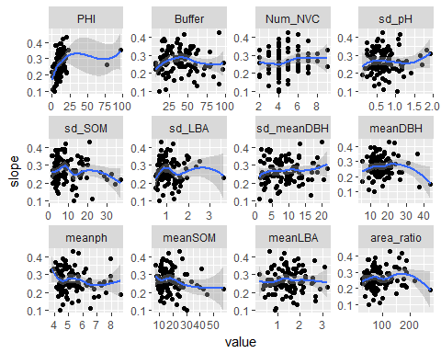

## corrs  
## PHI 0.38  
## Num_NVC 0.21  
## meanph 0.21  
## Buffer 0.20  
## meanSOM 0.19  
## sd_SOM 0.16  
## sd_LBA 0.16  
## meanDBH 0.16  
## area_ratio 0.16  
## sd_meanDBH 0.14  
## meanLBA 0.14  
## sd_pH 0.12

The two varibles with the lowest correlation coefficients (dcor distance correlation) to slope are meanLBA and sd pH,(Corr = 0.14,0.12)

The outliers in PHI, area_ratio and sd_SOM make it had to see the reponse of slope to these variable. Initially I removed some outliers, but the distribution of some variables, eg sd_SOM was very right skew, therefore decided to look at log fit instead.

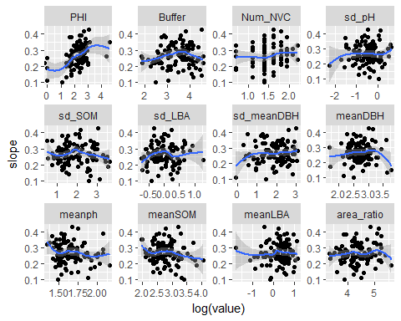

## slopecor  
## PHI 0.42  
## Buffer 0.21  
## Num_NVC 0.20  
## meanph 0.20  
## meanSOM 0.18  
## area_ratio 0.16  
## sd_SOM 0.15  
## sd_LBA 0.15  
## sd_meanDBH 0.15  
## meanDBH 0.15  
## meanLBA 0.15  
## sd_pH 0.12

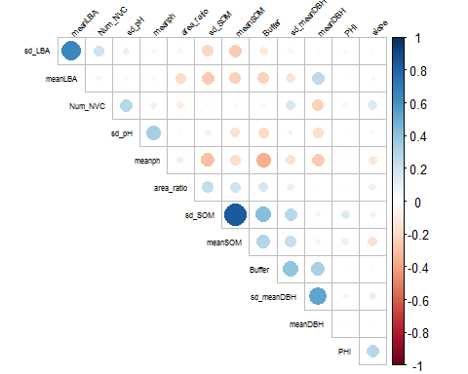

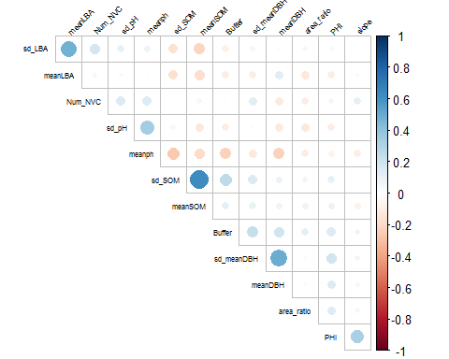

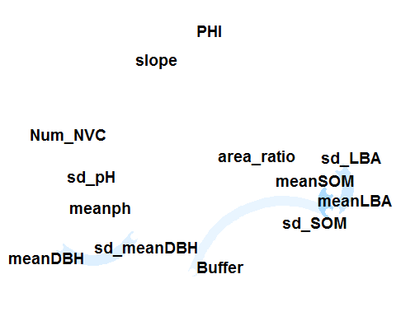 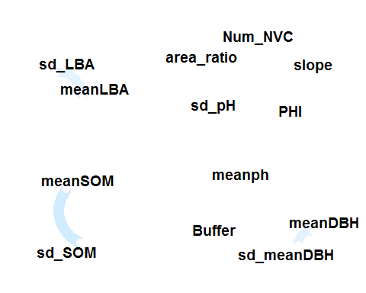 using either pearson or kendal correlations (even having removed outliers which migh influence the pearson correlation) there are correlations above 0.4 between the means and sd. Splitting the data into two groups to separate these variables might give a less correlated set of variables.

# Splitting the data into sd and means

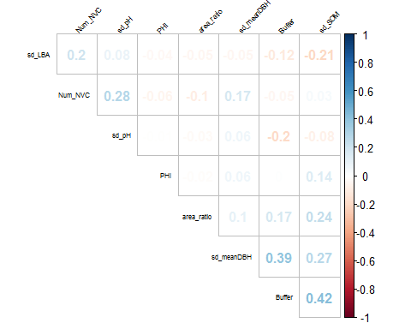 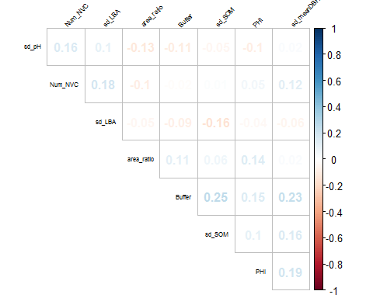 The oearson method shows correaltion between sbuffer, and sd of SOM and meandbh. The kendall does not show any correlations above 0.25. This may be due to the outliers in SOM and mean DBH which are influencing the pearson calculation.

## slopecor  
## PHI 0.42  
## Buffer 0.21  
## Num_NVC 0.20  
## area_ratio 0.16  
## sd_SOM 0.15  
## sd_LBA 0.15  
## sd_meanDBH 0.15  
## sd_pH 0.12

## slopecor  
## PHI 0.42  
## Buffer 0.21  
## Num_NVC 0.20  
## meanph 0.20  
## meanSOM 0.18  
## area_ratio 0.16  
## meanDBH 0.15  
## meanLBA 0.15

Both sets show a correlation (distance using dcor) of 0.42 with PHI with the remaning correlations between the vars and slope being very similar. The selection of variables could all potnetialy have an effect on richness. This model analysis is lookin at the slope of the SAC from the ln/ln lme model. This model can be thought of as an “averaging” effect of the alpha diversity of each plot in the site. The effect of any environmental variables on the slope at this scale should therefore be small compared to the effect of the increasing area

# Models

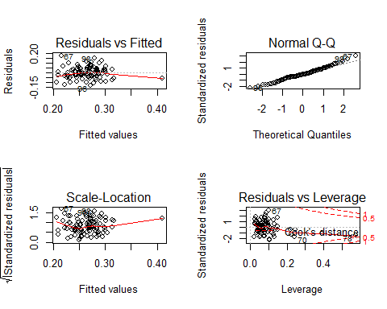

There is slight lack of linerity in the residuals plot due to one outlier. The residuals do not apear to deviate substantially from normality. Site 23 (point 78) appears to be influential - this is the outlier in PHI

## $`242`  
##   
## Call:  
## lm(formula = slope ~ area_ratio + meanph + meanSOM + Num_NVC +   
## PHI + 1, data = data, na.action = "na.fail")  
##   
## Coefficients:  
## (Intercept) area_ratio meanph meanSOM Num_NVC   
## 0.2854521 0.0001995 -0.0121737 -0.0018080 0.0079558   
## PHI   
## 0.0017081   
##   
##   
## $`241`  
##   
## Call:  
## lm(formula = slope ~ meanph + meanSOM + Num_NVC + PHI + 1, data = data,   
## na.action = "na.fail")  
##   
## Coefficients:  
## (Intercept) meanph meanSOM Num_NVC PHI   
## 0.306006 -0.012730 -0.001613 0.007396 0.001679   
##   
##   
## attr(,"rank")  
## function (x)   
## do.call("rank", list(x))  
## <environment: 0x0000000016585ca0>  
## attr(,"rank")attr(,"call")  
## AICc(x)  
## attr(,"rank")attr(,"class")  
## [1] "function" "rankFunction"  
## attr(,"beta")  
## [1] "none"

## Global model call: lm(formula = slope ~ ., data = data, na.action = "na.fail")  
## ---  
## Model selection table   
## (Int) are_rat Bff mnp mSO Num_NVC PHI df  
## 242 0.2855 0.0001995 -0.01217 -0.001808 0.007956 0.001708 7  
## 241 0.3060 -0.01273 -0.001613 0.007396 0.001679 6  
## 177 0.3385 -0.01185 -0.001637 0.001618 5  
## 178 0.3226 0.0001748 -0.01131 -0.001810 0.001639 6  
## 226 0.2183 0.0002161 -0.001569 0.007372 0.001668 6  
## 243 0.2995 9.982e-05 -0.01204 -0.001671 0.007424 0.001681 7  
## logLik AICc delta weight  
## 242 146.079 -277.0 0.00 0.286  
## 241 144.872 -276.9 0.11 0.271  
## 177 143.072 -275.5 1.45 0.138  
## 178 143.971 -275.1 1.91 0.110  
## 226 143.904 -274.9 2.05 0.103  
## 243 144.933 -274.7 2.29 0.091  
## Models ranked by AICc(x)

The “best” two models use number NVC, meanpH, meanSOM, PHI and either do or do not include area_ratio. We expect meanSOM to effect pH, and that pH effects richness, with greatest richness occurring around neutral pH - so I am not sure why we would also include meanpHas well as meanSOM. We are looking at slope of SAC across nests, not R of the nests, but the greater the slope, the greater the richness of the nest.

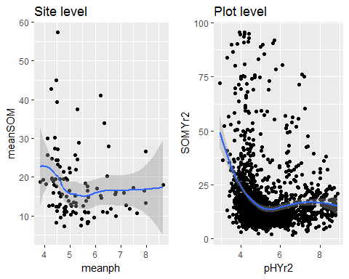

The plots suggest that in these sites meanSOM is not strongly correlated with meanpH at Site level, but at plot level there is a negative correlation below pH5, However, there is a lot of scatter.

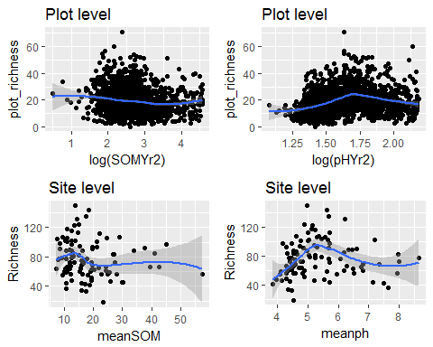 The richness at site and plot level does not have a strong linear correlation with pH, there is the expected unimodal peak, which is stronger at site level. This would suggest that pH is s strong influencing factor on richness, and thereby z, but its effect is not linear. Therefore the coefficient of the linear term in the model could be expected to be small and less signiicant than a non-linear term.

The richness as site or plot level does not appear to correlate strongly with SOM, and its effect on the slope would therefore be small

These plots suggest that meanpH would be a bettter term for predictung richness and therefore slope, but that it should be non-linear.