DOCUMENTATION

ASSIGNMENT 1

STUDENT NAME: Petra Lînaru
GROUP:30644

CONTENTS

1. Assignment Objective 3
2. Problem Analysis 3
3. Conceptual architecture of the distributed system 3
4. Implementation technologies 3
5. UML Deployment Diagram 3
6. Build and execution considerations 3

Assignment Objective
The assignment's goal is to develop a web platform that simplifies energy consumption management by installing intelligent energy metering devices. The application accommodates two user categories: clients and administrators. Administrators have the authority to execute CRUD (Create-Read-Update-Delete) actions on both users and energy metering devices, as well as manage their associations. Clients, on the other hand, are allowed to view the devices associated with their accounts.

Problem Analysis
The functional requirements specify the essential capabilities of the Energy Management System, including user authentication, role-based access control, and the ability for administrators and clients to perform CRUD operations on users and devices, as well as user-device mappings.

- User Authentication and Redirection:
  - Users log in and are automatically redirected to the page corresponding to their role.
- Administrator/Manager Role:
  - Admins can perform CRUD operations on user accounts.
  - Admins can perform CRUD operations on smart energy metering devices.
  - Admins can create mappings between users and devices.
- User/Client Role:
  - Clients can view a list of their associated devices on their user dashboard.
- Role-Based Access Control:
  - Users of one role cannot access the pages corresponding to other roles, preventing unauthorized access through URL manipulation.

Non-functional requirements encompass aspects such as system performance, security, and scalability. These requirements ensure that the Energy Management System operates efficiently and securely.
- Microservices:
- User Management Microservice
- Device Management Microservice
- Security:
- Implement user authentication mechanisms (cookies, session management, etc.) to enforce access control and safeguard administrator pages.

Conceptual architecture of the distributed system

- Backend/ Microservices:
The Energy Management System comprises two microservices: one for users and another for devices. The Users Microservice utilizes an "AppUser" entity that extends "IdentityUser." It relies on an Entity Framework Core DbContext, UserManager, and IdentityManager to perform various user-related operations. The user data, along with the IdentityUser tables, are stored in a SQL Server database. The Users Microservice is further divided into two parts: user authentication and user data operations. This segregation is achieved by organizing the HTTP methods into two controllers, one for "/authenticate" and one for "/AppUser." Additionally, the backend handles redirection by storing a "redirectURL" in the response sent to the frontend. This URL is saved in the browser's local storage, along with the user's role and user token, ensuring that unauthorized users cannot access restricted data.

The Device Microservice focuses on managing device instances. Each user can own multiple devices, and each device is associated with a device type. Consequently, three distinct databases are maintained in SQL Server. The Device Microservice accesses the database using a DbContext and exposes endpoints through the DeviceController. Furthermore, relationships between device instances are established using foreign keys in SQL Server. A key feature is the synchronization between the user database and the user clone database. When changes like device creation or deletion occur in one database, they are propagated to the other, ensuring data consistency.
The use of request/response classes (equivalent to data transfer objects) in both microservices ensures that only necessary data is exposed.

- Frontend:
The frontend of the Energy Management System is developed using React, organized into components and dialogs. Components contain .jsx files for main pages, including admin, user, and user_profile (accessible by administrators to view registered users and their devices). Dialogs are used to create and update cases, enhancing the user experience and ensuring smooth interaction with the system.

The technology stack includes React for the frontend, C# with .NET Web API for the backend, ASP.NET Core Identity for role management within the Users Microservice, .NET authentication and authorization based on bearer tokens, SQL Server for database management, and Docker for deployment. This combination of technologies supports the development of a robust and secure Energy Management System.

Implementation technologies
The Energy Management System utilizes a range of technologies for its various components:
- Frontend: The user interface is developed using React.
- Backend: The backend services are implemented in C# with .NET Web API.
- Role Management: Role management for users is achieved using ASP.NET Core Identity.
- Authentication & Authorization: .NET-based authentication and authorization are implemented based on Bearer tokens for secure access control.
- Database: SQL Server is used for data storage and management.
- Deployment: Docker is employed for containerization and deployment of the system, ensuring a scalable and efficient deployment process.

UML Deployment Diagram
The Energy Management System is deployed using Docker containers. The deployment setup includes two microservices: one for managing devices and the other for users, as well as a React frontend.
Devices Microservice Deployment: The "emsbackend" service, responsible for device management, is exposed on port 9090, providing a RESTful API to interact with device instances. The environment is configured for development, and ASP.NET Core is set to listen on port 80. This service depends on the "db2" service, which is an SQL Server container based on the SQL Server image. The SQL Server container is named "SQLServer3" and exposes port 1435 for database connectivity.
Users Microservice Deployment: The "emsbackend" service for user management follows a similar deployment pattern. It is exposing the RESTful API on port 8080. It is also configured for development and depends on the "db" service. The "db" service uses the same official SQL Server image, and is named "SQLServer2." It exposes port 1434 for database connections.
React Frontend Deployment: In addition to the microservices, there is a React frontend deployed in a separate container. While the configuration details of this deployment are not included in the provided Docker Compose file, the React frontend container runs on port 3000. This frontend interacts with the microservices to provide a user-friendly interface for the Energy Management System.
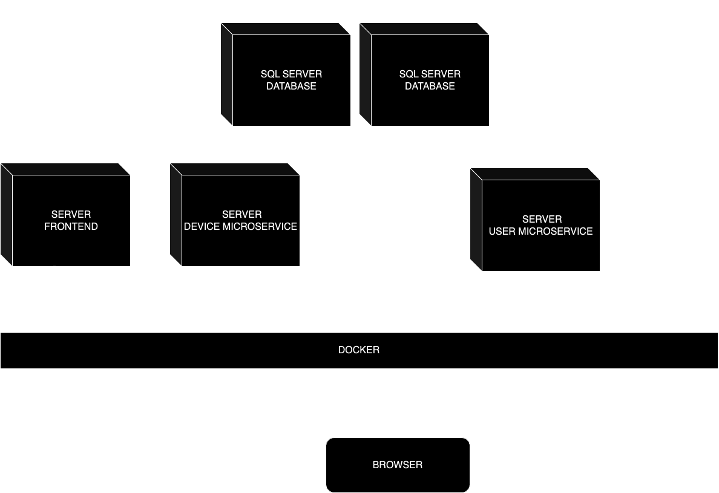

Build and execution considerations

In the emsbackend_users folder run the following commands:
docker-compose build
dotnet ef database update
docker-compose up
In the emsbackend_devices folder run the following commands:
docker-compose build
dotnet ef database update
docker-compose up
In the emsfrontend folder run the following commands:
docker build -t reactimage .
docker run -p 3000:3000 reactimage

