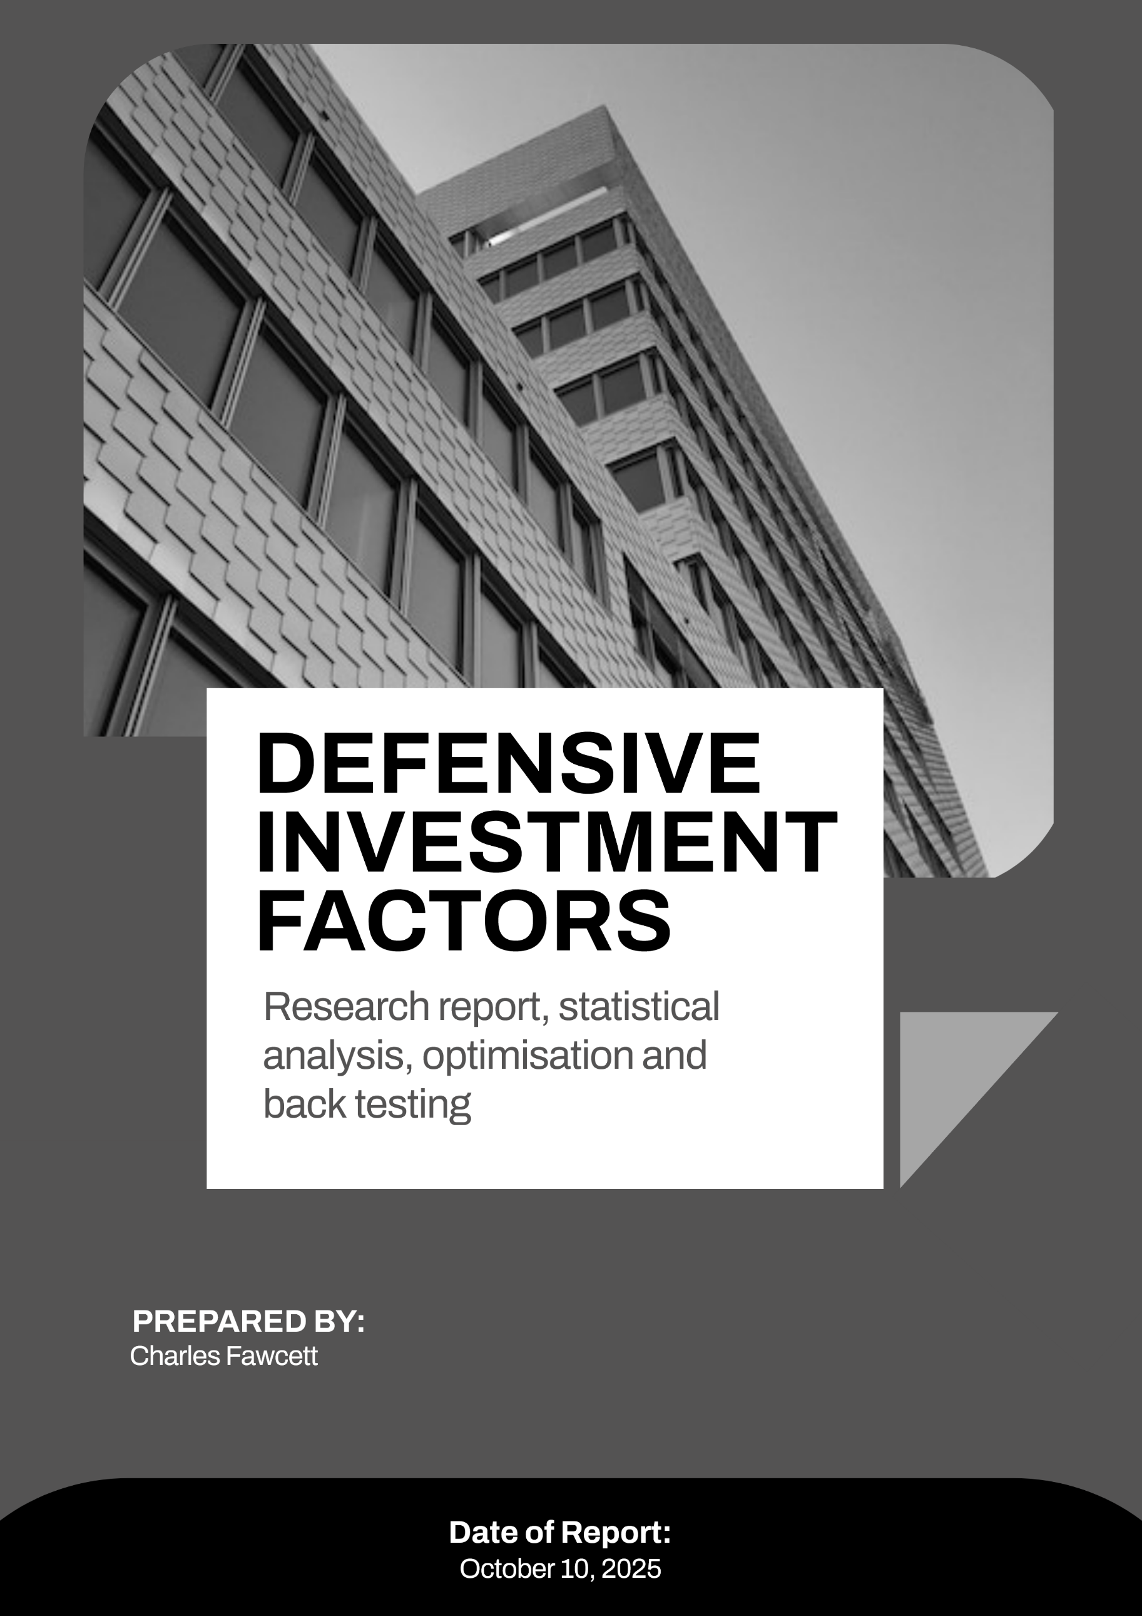

Table of Contents
1. Predictive Power of Investment Factors 3
2. Effect of Macroeconomic Environment 4
3. Back testing Results 5
4. Rebalancing Frequency Optimisation 6
5. Optimal Factor Combination 7
6. Machine Learning Factor Investing Approach 8
References 9
Appendix A 10

1. Predictive Power of Investment Factors

Low Volatility

Profit

Safety

Still haven’t check that bracket issue in the statistics section of the code!
Nice factor investing research:
file:///C:/Users/cfawc/Downloads/AQRJPMQuant23FactFictionandFactorInvesting.pdf
factor combining MSCI:
https://www.msci.com/documents/10199/ff891dc6-61ac-9d77-1f39-aeb0113a767d
S&P global factor combining
https://www.spglobal.com/spdji/en/documents/research/research-the-merits-and-methods-of-multi-factor-investing.pdf

2. Effect of Macroeconomic Environment

3. Back testing Results

4. Rebalancing Frequency Optimisation

5. Optimal Factor Combination

Want to do this:
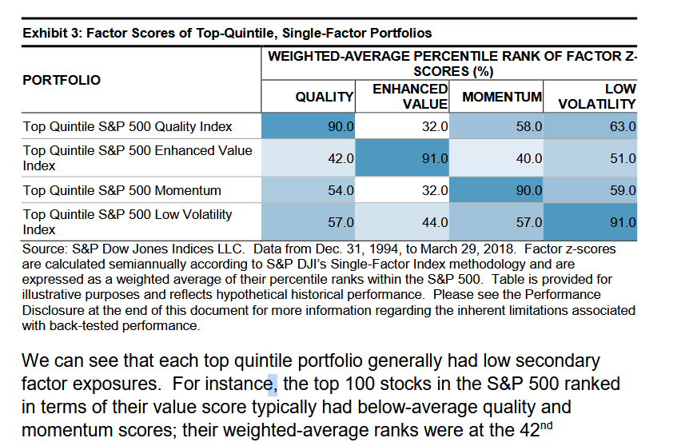

Then show dilution from investing in multiple single factors separately

6. Machine Learning Factor Investing Approach

References

Appendix A

