**Disaster Recovery with IBM Cloud Virtual Servers**

PROBLEM STATEMENT

Safeguard business operations with IBM Cloud Virtual Servers. Create a disaster recovery plan for an on-premises virtual machine, ensuring continuity in unforeseen events. Test and validate the recovery process to guarantee minimal downtime. Become the guardian of business continuity, securing the future of your organization!

DEVELOPMENT

The project is done using IBM Cloud Foundry with **“Custom Migrations and Disaster Recovery as a Service”**. 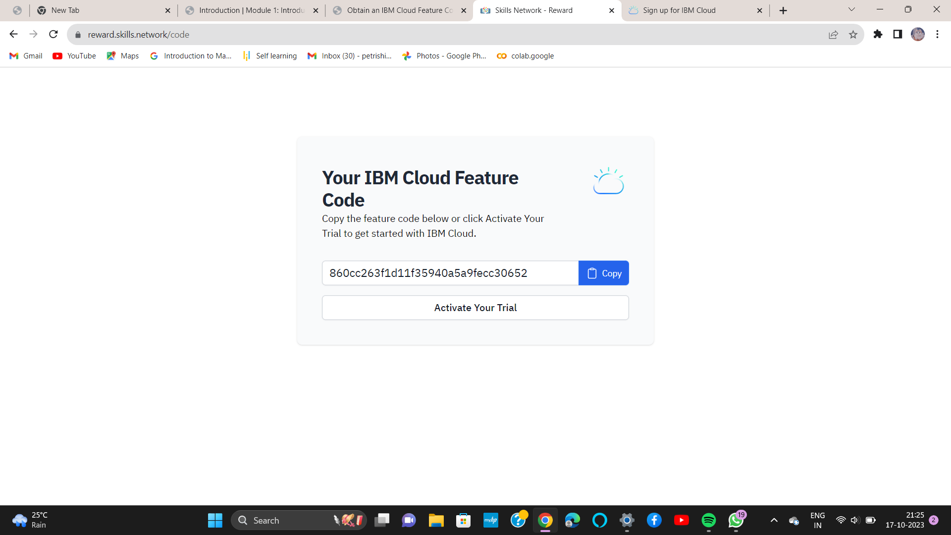

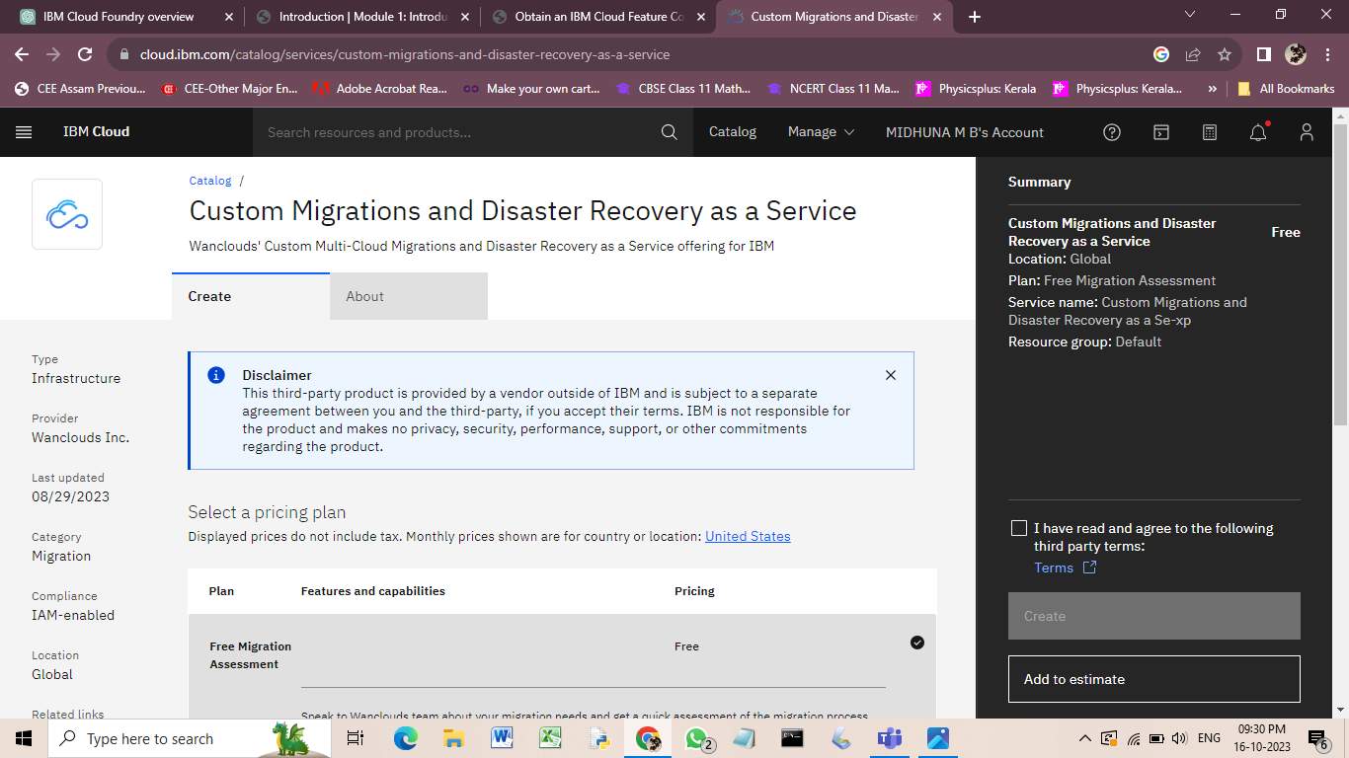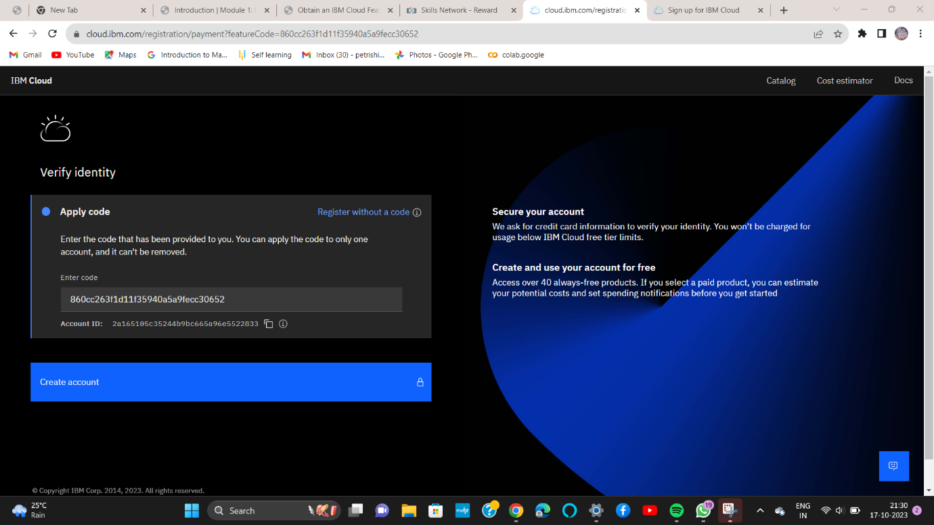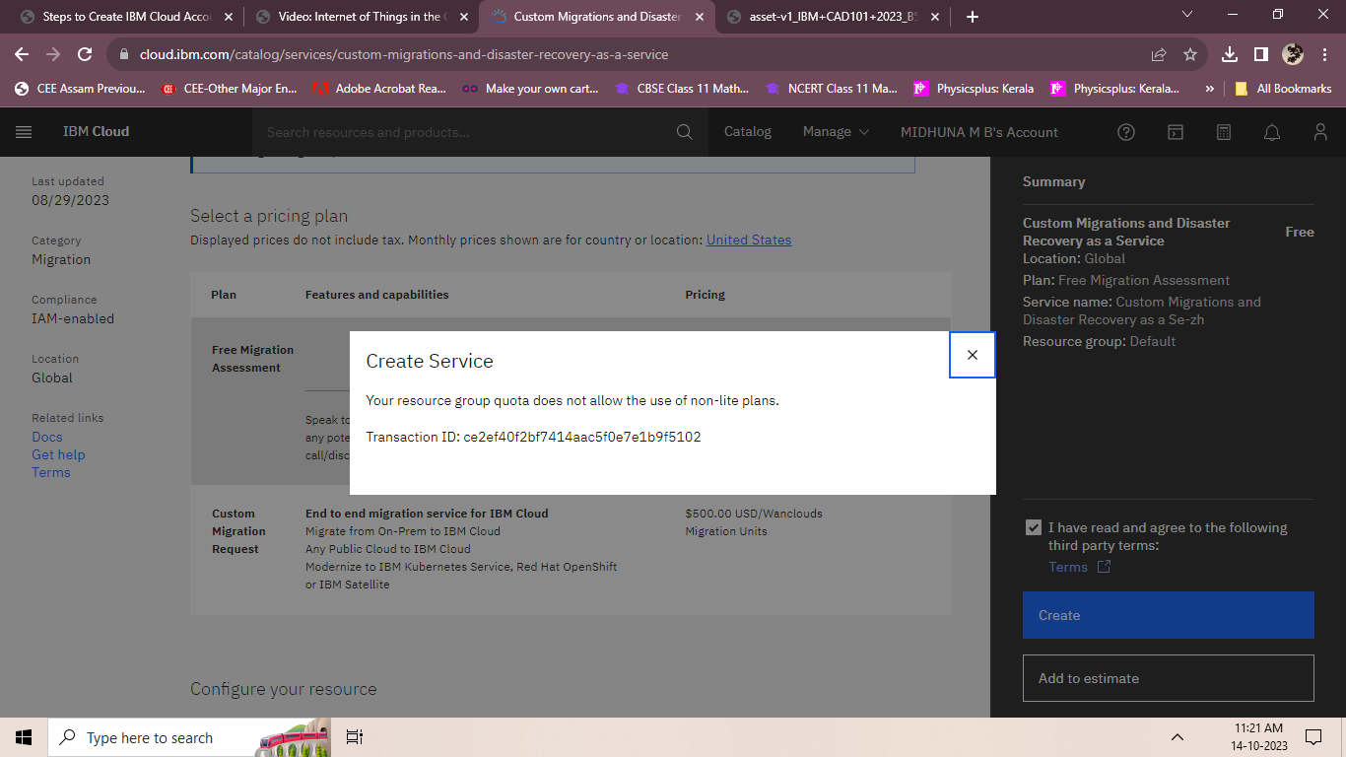

**Disaster Recovery Strategy**

It is a plan that helps protect your important applications and data in case of unexpected events.

* + Identify important data
  + Choose a backup solution
  + Set up replication
  + Test the plan regularly
  + Document and train the team