Kushnir Petro  Junior Web Developer  Mail: kallebloomckwist@gmail.com  Phone: (066) 452-82-16  Skype: beatles.m1ck_jagg.er  Address: St. Vyhovskoho, Lviv  Linkedin:https://ua.linkedin.com/in/petro-kushnir-541764120 |  |  | 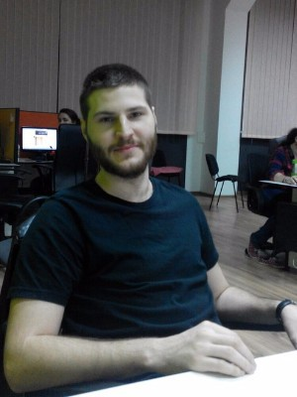
Overview
- Able to work in rapidly-changing environment.
- Management skills.
- I’ve been doing repairs and tuning of computer equipment.
- I’m self-motivated, quick learner, passionate about my work. I have good communication skills and love working in a team.

Skills | Languages / Technologies  - CSS  - HTML  - JavaScript  - Bootstrap  Platforms  - MS Windows  - Mac OS X | Tools  - Corel Draw  - MS Office  AutoCAD
Professional Skills | Softserve university certificate  HTML5 App Development Fundamentals (HTML5/CSS3/JavaScript)  Series AA №4675/2016  Web projects:  http://petrokushnir.github.io/website/index.html  http://petrokushnir.github.io/pixelant/
Education | Master Degree in Nanotechnologies and Information Measuring and Specialized Computer System  Sevastopol National University of Nuclear Energy and Industry, Sevastopol, Ukraine
Languages
English –Intermediate
Ukrainian - Native
Russian - Fluent
Experience | 10.06.2012-20.08.2012  Scheme designer “Zakarpatoblenerho” Uzhgorod company  21.09.2014-01.05.2016  Support Agent “ZoomSupport” Lviv company  01.05.2016-present  Senior Support Agent “ZoomSupport” Lviv company
Hobbies | Sports  Reading  Music

