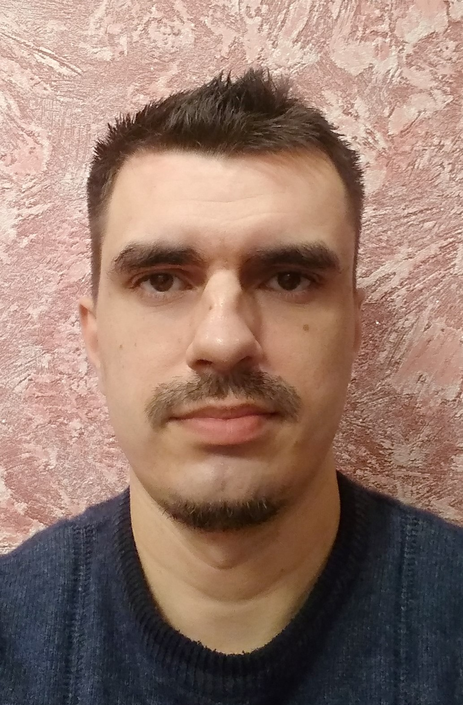
Petro Pliuta (Петро Плюта)
DevOps

Contacts
- +38(098)029-49-38 (also in viber, telegram)
- pet.pluta@gmail.com
- Rivne, Ukraine

Experience
- 2018-2020. ISP billing software framework Splynx. System administrator (responsible person for testing infrastructure, PR reviewer, QA automation, tester, technical support engineer, technical writer).
- 2016-2018. Internet services provider UarNet. Technical support engineer.
- 2015-2016. Internet services provider Lagidcom. Technical support engineer.
- before 2015. Driver, seller, head of the warehouse, etc

Skills
- Jenkins, pipelines, Groovy
- Docker, Dockerhub
- Git, Github, Bitbucket
- Ansible
- Bash scripting

- Proxmox VE
- Mikrotik, RouterOS
- Switching, routing, OpenVPN, PPTP, iptables, PON, etc
- MySQL, SQLite

- HTML, CSS, JavaScript, React.js
- Python, Django framework

- Codeception framework, Automated testing, Selenium testing

- Jira, slack, mattermost
- Technical writer

Education
- 2016-2018. C++. https://rivne.itstep.org/programmer
- 2018. Mikrotik MTCNA (1812NA7449)
- 2019-2020. Python web developer. https://rivne.itstep.org/python
Course work - https://github.com/PetroPliuta/billing

Languages
- English – upper-intermediate (reading, writing – good; listening, speaking – bad)
- Russian
- Ukrainian – native speaker )

Links
- Linkedin - https://www.linkedin.com/in/petro-pliuta-1580421ba/
- Github - https://github.com/PetroPliuta/
- Dockerhub - https://hub.docker.com/u/pliuta/
- CV in DOC format - pliuta_devops.doc

