Project1

Task 1

- I downloaded PCAP file (Assignment1.pcap)
- I downloaded and opened Wireshark on my computer
- I imported pcap1_1 file into Wireshark

Task 2

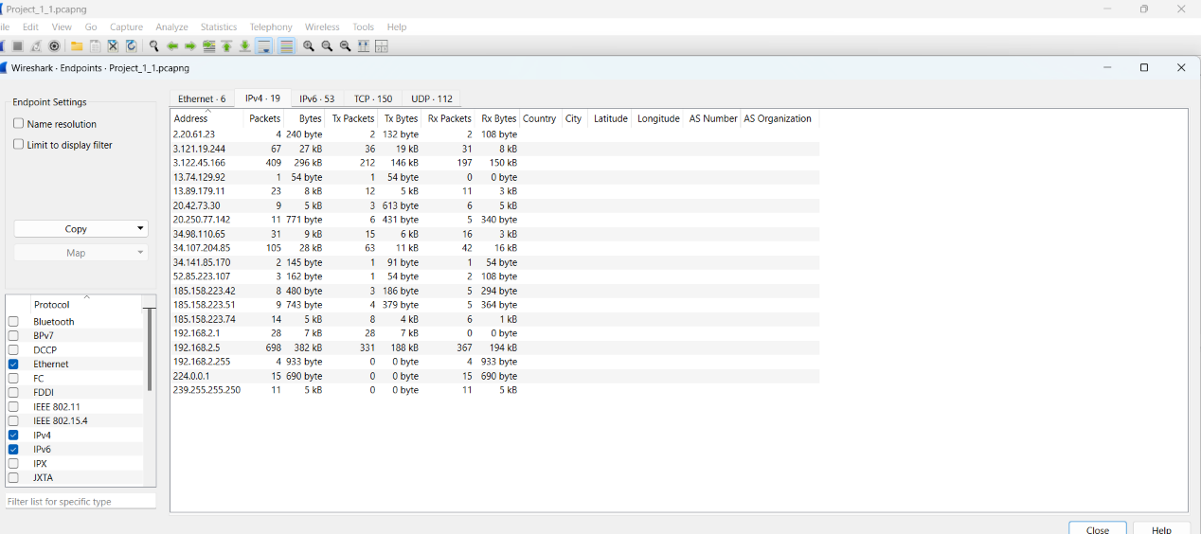

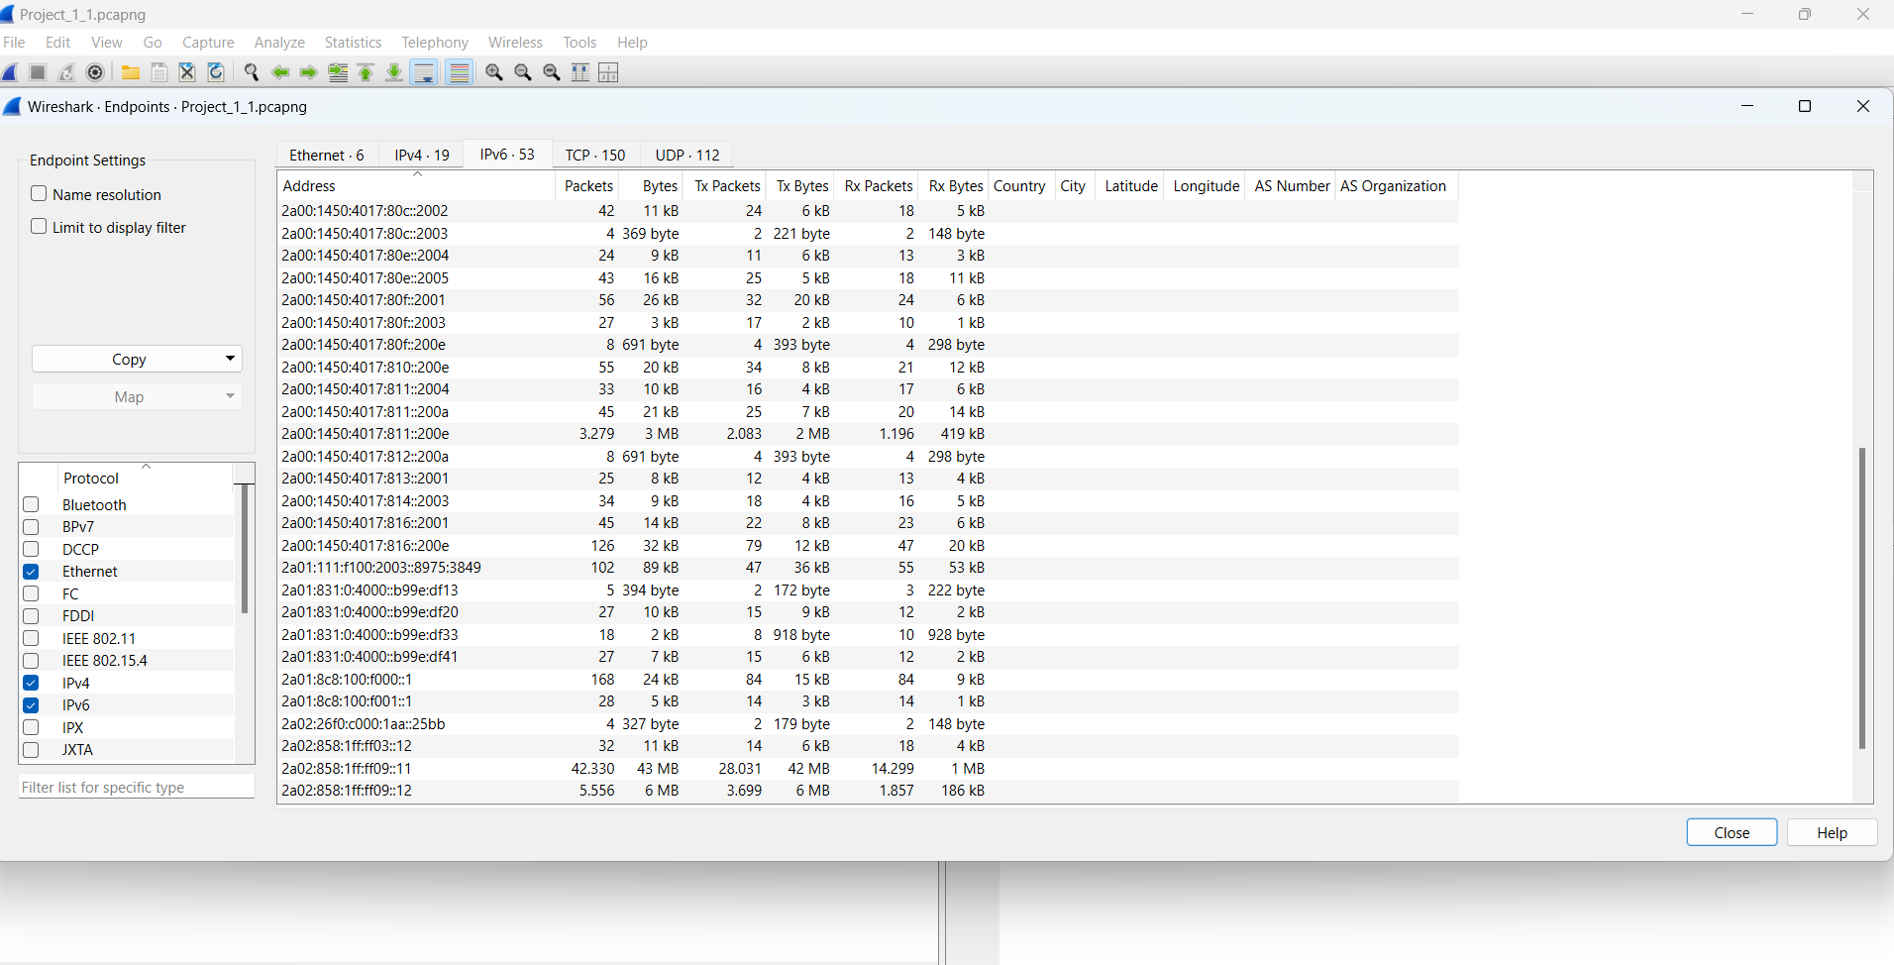

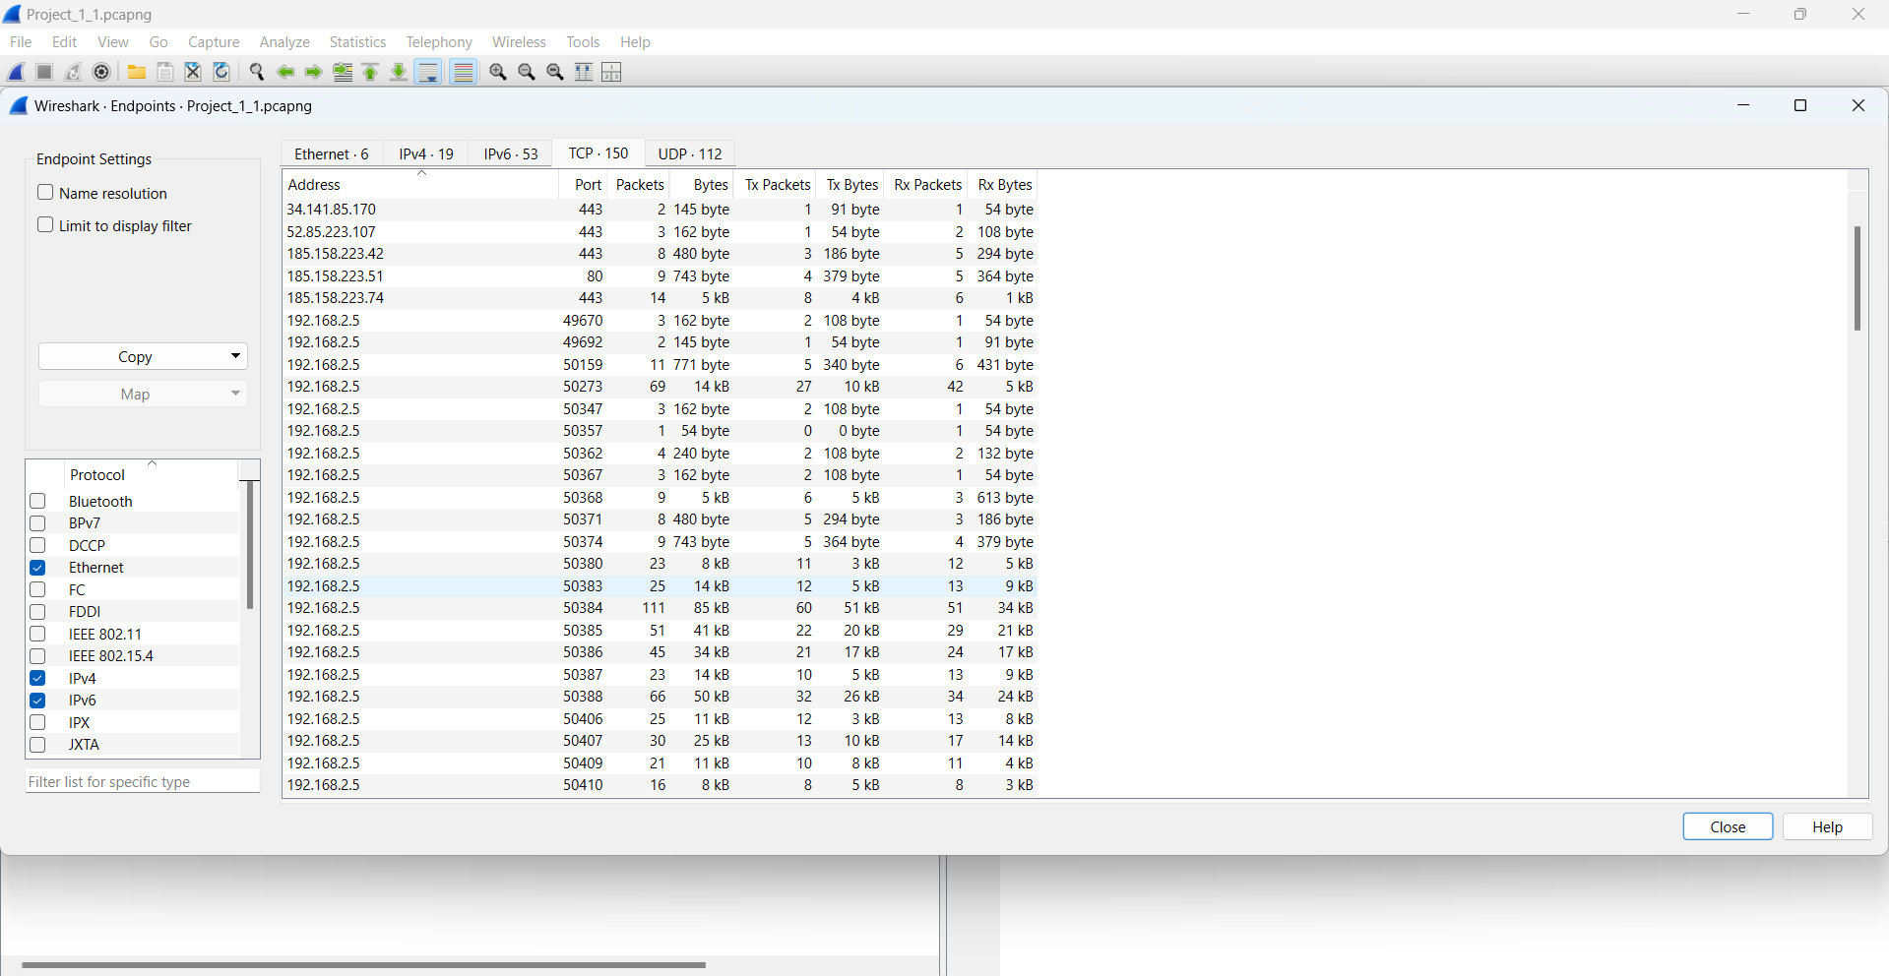

- In order to find them out I clicked on Statistics > Endpoints
- The protocols I used are Ethernet , IPv4 , IPv6 , TCP , UDP

Task 3

- I imported project1_2
- There are 6001 packets

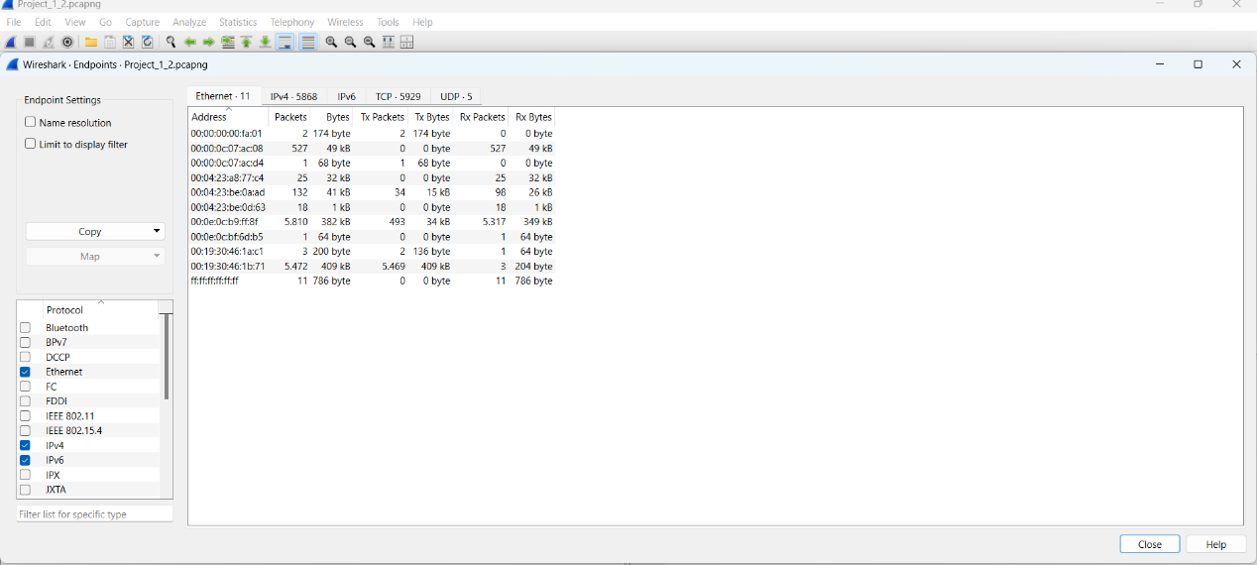
There are 11 host addresses
- In the top IP conversation, there are 17 packets

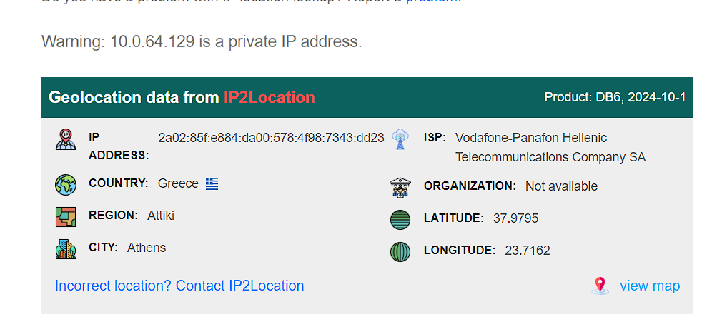

Packet 19

- TTL (Time to Live): 123
- Source address: host -212-252-19-85 , destination address: 10.0.64.129

Packet 34
- Source address: host -212-252-19-92 , destination address: 10.0.64.129 . They have the same ID in virtual Lan (301)
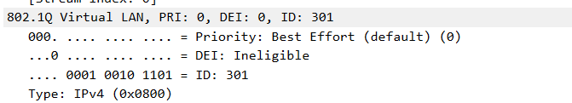
- All IP TTL does not change in the packets coming from 212.252.0.0/16
- All the ID IP s are the same ( 10.0.64.29) , using the same protocol TCP
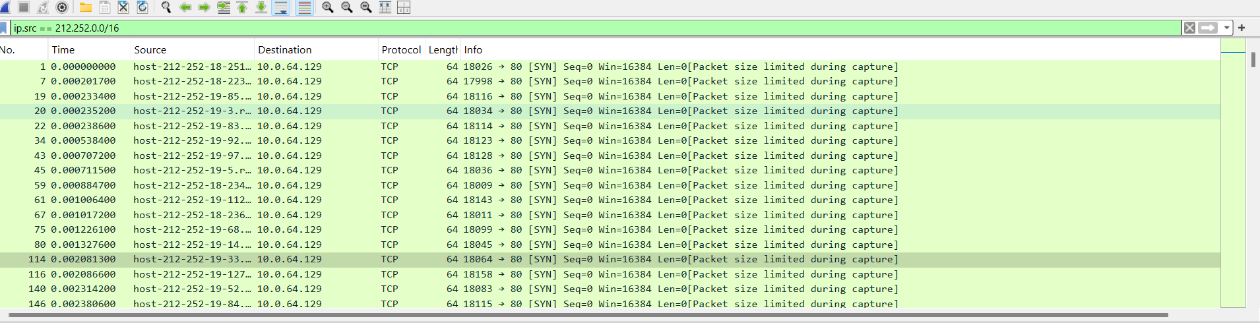

- I believe that the risk of spoofing is greatly increased, because all these packets have the same Time To Live (TTL) , they have the same IP destination address and they use the same protocol

Investigating Suspect Attack
- I imported the project1_3 into Wireshark
- There are only 9 packets and I observe that the packet 3 and packet 8 have the same source and destination address ( src: 192.168.4.31 and dst: 192.168.4.1)
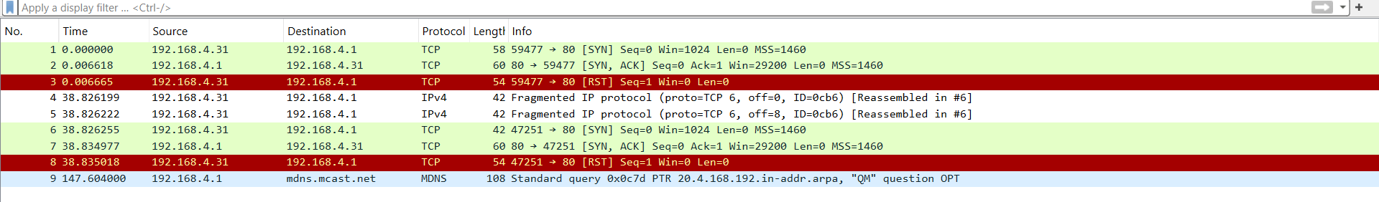
- They have the same length and the same IP fragmentation
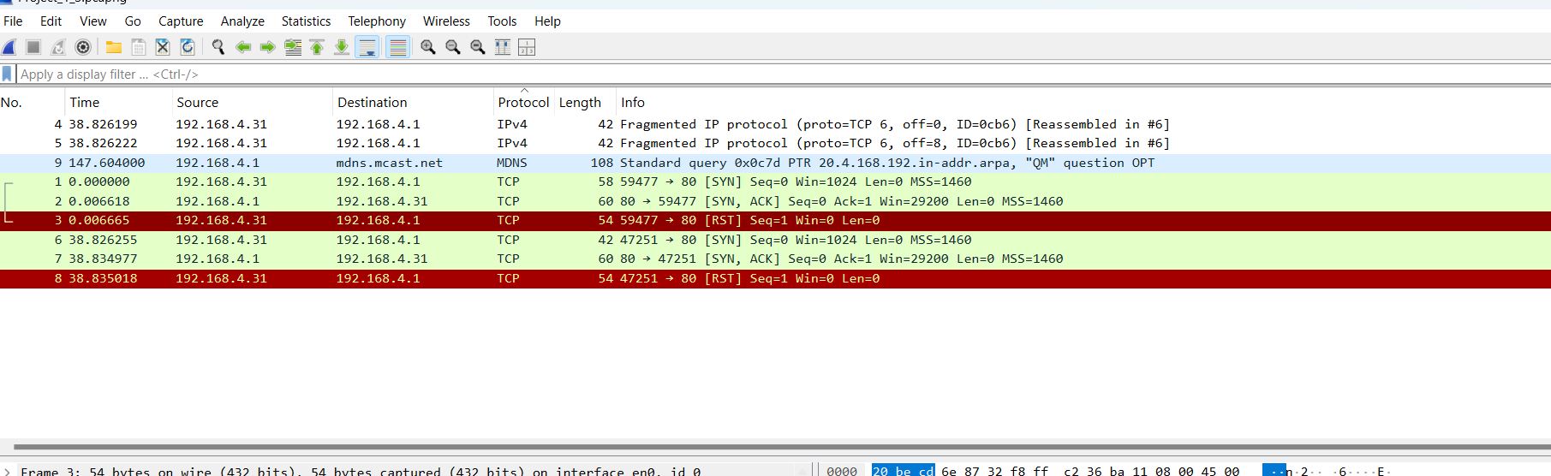

Reconnaissance with Kali Linux

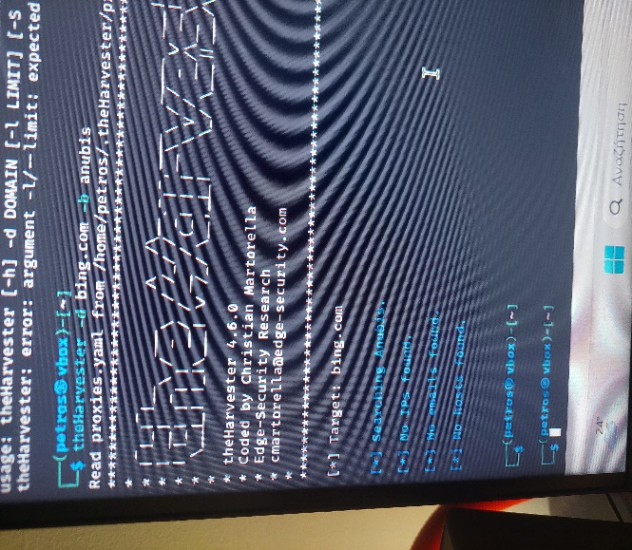
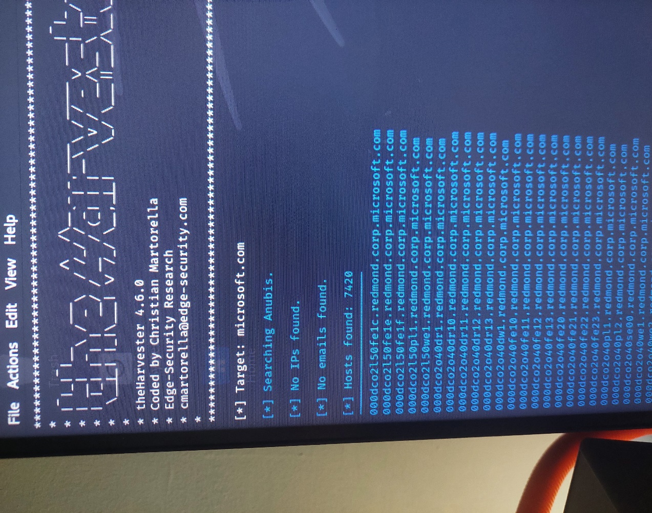

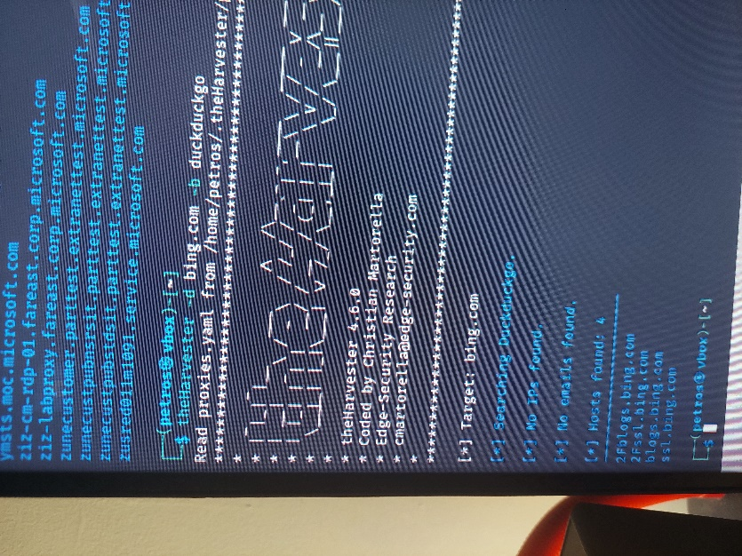
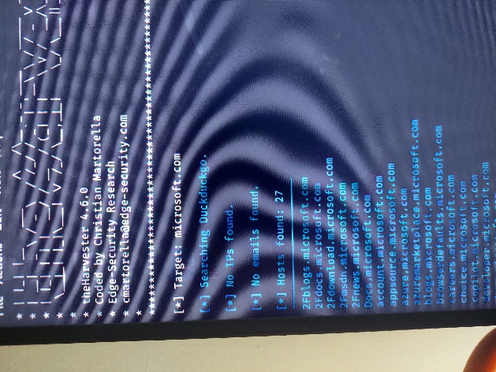

- As you can see there are no hosts in bing.com through Anubis, while there are 7420 in Microsoft.com
- There are 4 hosts in bing.com through DuckDuckGo, while there are 27 in Microsoft.com

