Equipment – objašnjenje

1. Server <https://www.worldstream.com/en/dedicated-servers/configure/19?chassis=20&cpu=23&memory=1536&location=1&uplink=15&ddosShield=3&storage=12&remoteFeature=1> (Dell PowerEdge R630 SFF)
2. <https://servermall.eu/config/dell-r730-16SFF/>
3. Windows Server Datacenter 2019 / cena 6155e je za 16 jezgara – ne ide po cpu, nego po jezgrima
4. Ovo su kul serveri - <https://www.hpe.com/us/en/compute.html> - server DL500
5. Лиценца - Autodesk Product Design & Manufacturing Collection (AutoCad, Inventor, Fusion360) – 2855 po coveku po godini – 1 osoba na etf, 2 u firmi, eth za sad ne dobija – i treba nam za 1 godinu samo
6. <https://www.dell.com/en-uk/work/shop/nvidia-tesla-v100s-32-gb-260w-double-wide-passive-full-height-gpu-customer-install/apd/490-bfrt/graphic-video-cards#tabs_section> – skupa tesla v100 cena

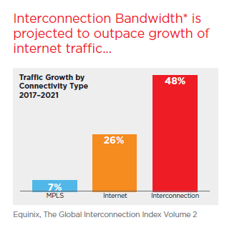 zato eqinix nam treba, jer je bas pricao o healthcare

Testing - <https://www.inflectra.com/Purchase/SpiraPlan.aspx?catalogItemId=21>

Requirements - <https://www.inflectra.com/SpiraTeam/ProductComparison.aspx> 4 meseca po 6 ljudi i 3 meseca po 7 ljudi