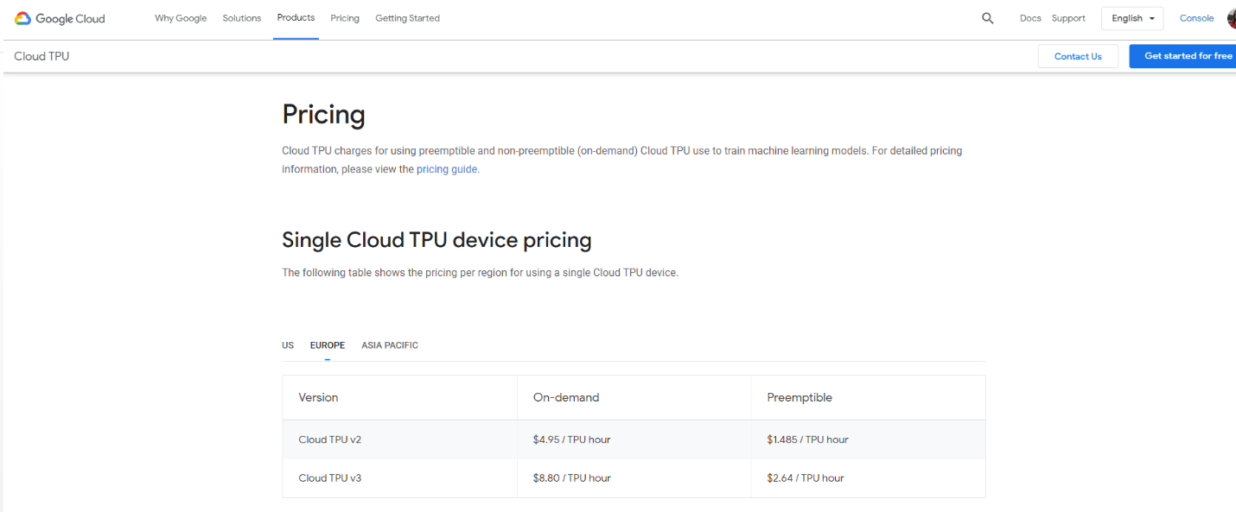

Evo zasto smo izabrale on demand a ne preemptible

You can save money by using preemptible Cloud TPUs for fault-tolerant machine learning workloads, such as long training runs with checkpointing or batch prediction on large datasets. Preemptible Cloud TPUs are 70% cheaper than on-demand instances, making everything from your first experiments to large-scale hyperparameter searches more affordable than ever.

Equinix data centar – iskreno ne znam koliko kosta, videla sam negde neki covek prica da cuvanje klastera bi ga izaslo 0.5e po satu u data centru. E sad ne znam. Ali ako je tako:

0.5e * 24h* 17meseci * 30.5dana u mesecu = 6222e Da li nam treba data centar i za gpu i za servere ili ne... Tipa kazemo gpu cemo da cuvamo 4 komada na eth, 4 komada na etf i nema usluga data centra... a data centar nam treba za cuvanje servera onog od 100.000

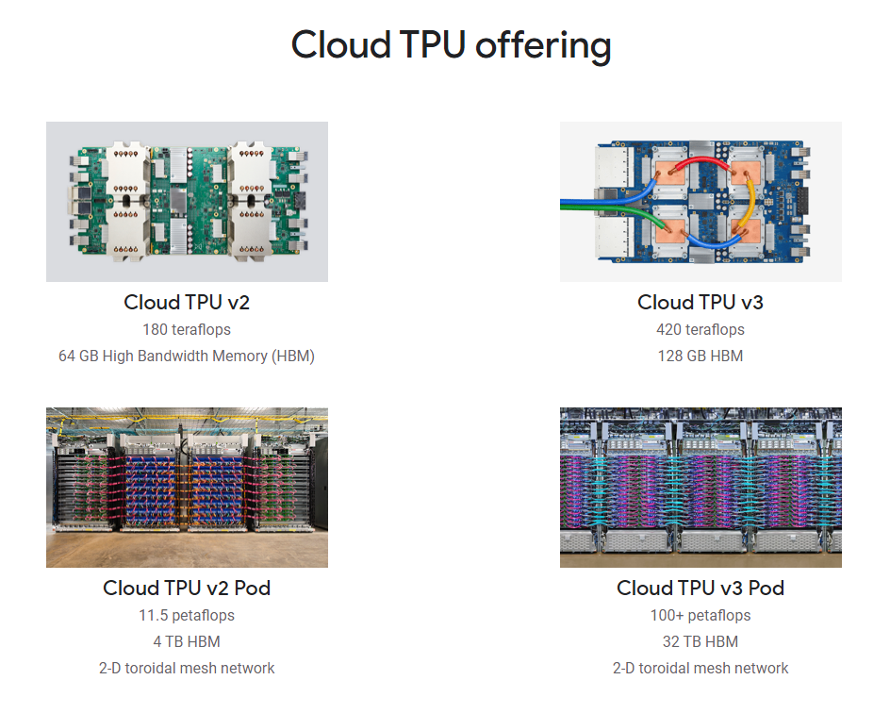

Znaci 1 TPU v3 je kao naše 4 graficke karte. Tj za 4 graficke nam treba 1 tpu

<https://www.dscga.com/colocation-pricing-the-definitive-guide-on-what-to-expect-2019-report/> cene za data centar

U principu cene za 1U su 50 do 250e mesecno. Mi imamo 17 meseci, a server mi izgleda kao da zauzima 2U. To je znaci 8500 za server.

Tier 1:

* Non-redundant systems (no backups for power, network, etc.)
* 99.671% Uptime
* 28.8 hours of downtime per year

Tier 2:

* Partial redundancy for power and cooling
* 99.749% Uptime
* 22 hours of downtime per year

Tier 3:

* N+1 fault tolerant providing at least 72 hour power outage protection
* 99.982% Uptime
* Maximum of 1.6 hours of downtime per year

Tier 4:

* 2N+1 fully redundant infrastructure with 96 hour power outage protection
* 99.995% Uptime per year
* Maximum 26.3 minutes of annual downtime

Nas u minhenu je tier 3, ima n+1 redundant

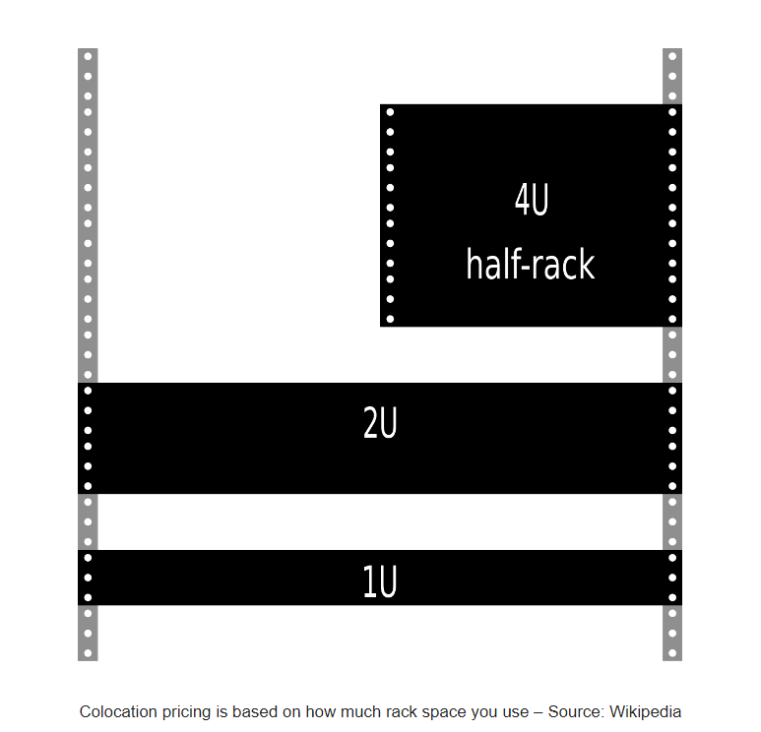

[Average monthly fees](https://www.optimalnetworks.com/2015/01/24/cost-server-colocation/) can range anywhere from $45 to $300 per U per month. The following are average [price ranges](http://www.quotecolo.com/1u-colocation-pricing/) for some of the top data center cities in the United States. These ranges are per U per month.

* **Boston:** $50 to $200 per U per month
* **New York City:** $75 to $300 per U per month
* **New Jersey:** $100 to $300
* **Washington DC:** $79 to $150 per U per month
* **Atlanta:** $45 to $100 per U per month
* **Miami:** $40 to $100 per U per month