MPC-MAP Assignment No.4 - Report

Author: Petr Veselý

Date: 18.04.2026

Task 1

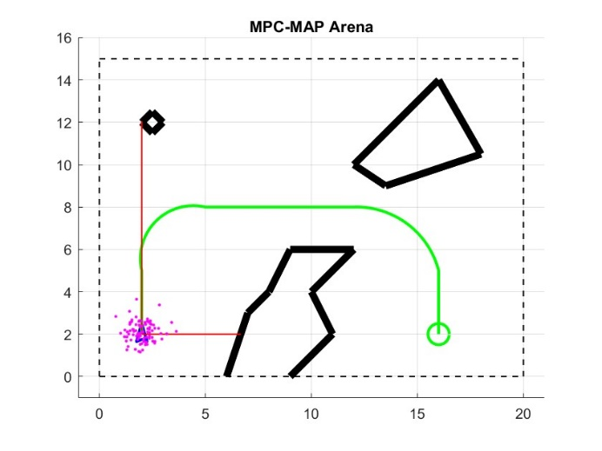
The trajectory was manually designed in the outdoor_1 map. GNSS statistics were computed from data collected in Week 2.

$$mu_gnss=[0.9019, 0.9862]$$

$$Q= \left[\begin{matrix}0.2911 & 0 \\ 0 & 0.2535\end{matrix}\right]$$

Task 3
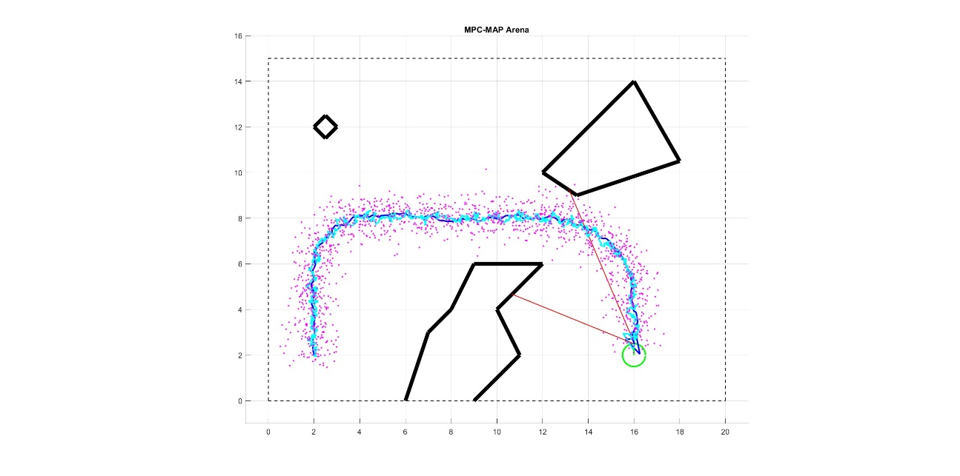
The process noise covariance matrix R was tuned experimentally. Lower values reduced oscillations and produced a smoother trajectory, while higher values increased the influence of noisy GNSS measurements. The final setting R = diag(0.003,0.003,0.001) was selected as a good compromise.

Task 4
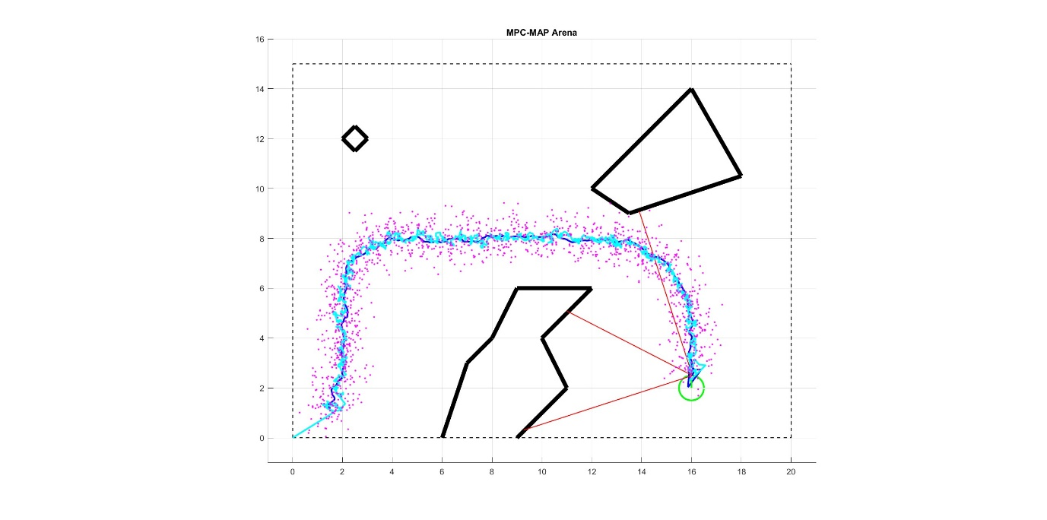
During the first 49 iterations, GNSS measurements are collected and stored in read_only_vars.gnss_history. In the 50th iteration, the initial state estimate $mu$is computed as the mean of the collected data, and the measurement noise covariance matrix $Q$is estimated using the sample covariance. After this initialization step, the Extended Kalman Filter operates in its standard prediction–correction cycle.

