MPC-MAP Assignment No. 1 - Report

Author: Petr Veselý

Date: 30.03.2026

Task 2

LiDAR
The LiDAR measurements were collected over 100 simulation steps with the robot in a static position on the indoor_1 map. The estimated standard deviation for the individual channels ranges approximately from 0.043 to 0.054. The results indicate that the noise level is similar across all LiDAR channels, with only minor differences. Histograms of the measurements confirm that the noise follows an approximately normal distribution.

Senzor 1 | Senzor 2 | Senzor 3 | Senzor 4 | Senzor 5 | Senzor 6 | Senzor 7 | Senzor 8
0.0517 | 0.0519 | 0.0540 | 0.0543 | 0.0527 | 0.0529 | 0.0503 | 0.0430

Histogram
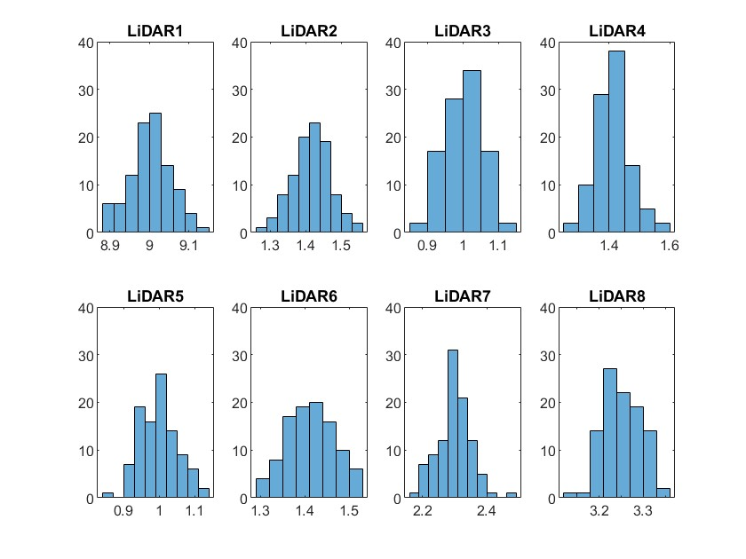

GNSS
GNSS measurements were collected over 100 simulation steps with the robot in a static position on the outdoor_1 map. The estimated standard deviation is approximately 0.5395 for the X axis and 0.5034 for the Y axis. Compared to the LiDAR sensor, the GNSS exhibits significantly higher noise. The standard deviation is similar for both axes, indicating consistent noise characteristics. The histograms show an approximately normal distribution, although slight deviations can be observed due to the limited number of samples.

GNSS X | GNSS Y
0.5395 | 0.5034
Histogram
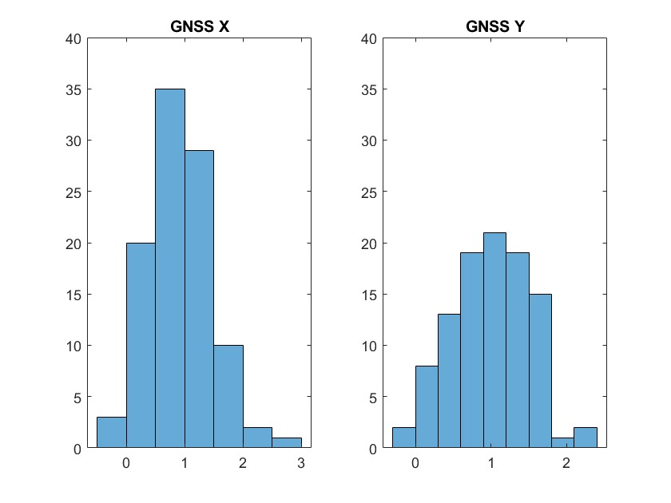

Task 3
LiDAR
The covariance matrix of the LiDAR measurements has a size of 8×8, corresponding to the 8 LiDAR channels. The diagonal elements represent the variance of each channel and are consistent with the squared standard deviation values obtained in Task 2. The off-diagonal elements are close to zero, indicating low correlation between individual LiDAR channels.

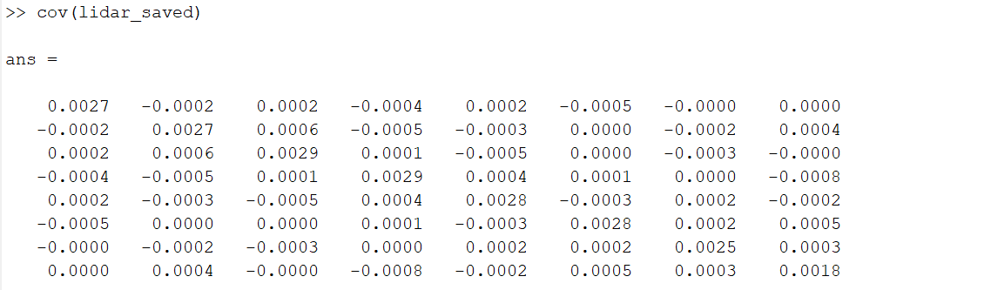

GNSS
The covariance matrix of the GNSS measurements has a size of 2×2, corresponding to the two position axes.
The diagonal elements represent the variance of the X and Y axes and are consistent with the squared standard deviation values obtained in Task 2.
The off-diagonal elements are close to zero, indicating low correlation between the two axes.
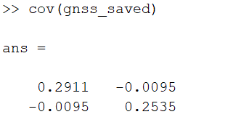

Task 4
A function norm_pdf was implemented to evaluate the probability density function (PDF) of the normal distribution. Using the standard deviation values obtained in Task 2 and assuming zero mean (μ = 0), the PDFs were generated for the first LiDAR channel and the GNSS X axis. The resulting distributions were plotted in a single graph for comparison. The LiDAR distribution is narrow and sharply peaked, indicating low measurement noise, while the GNSS distribution is significantly wider, reflecting higher uncertainty. This confirms that the GNSS sensor is less precise than the LiDAR sensor.

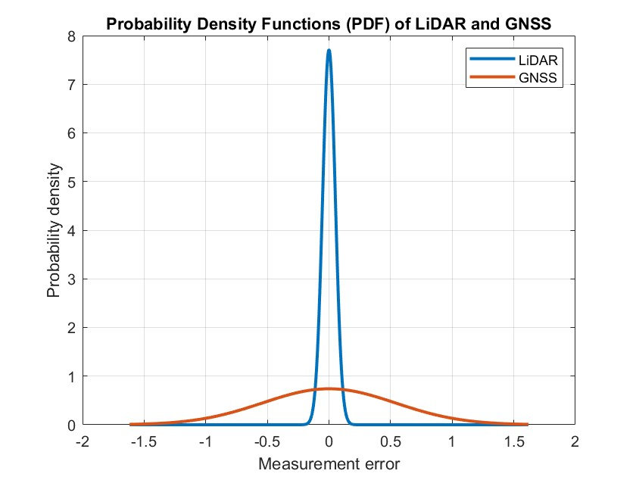

Task 5
The robot was navigated to the goal location without using any sensor feedback by manually defining a sequence of motion commands in the plan_motion.m function. The motion was controlled based on the simulation step counter, specifying forward and rotational velocities. The motion uncertainty is caused by several factors, such as unevenness of the surface, wheel slipping, skipped motor steps, and communication delays or losses.

