MPC-MAP Assignment No. 2 - Report

Author: Petr Veselý

Date: 06.04.2026

Task 2
Custom functions were developed to generate elementary path segments such as straight lines, circular arcs, and sinusoidal curves. These segments were subsequently combined to form a continuous trajectory for the robot, as illustrated in Figure 1.
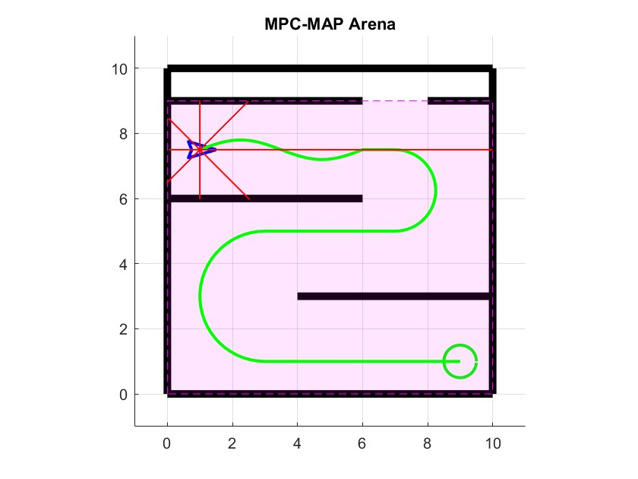
Figure 1 – Planed path

Task 3
A feedback linearization approach was used for motion control of the non-holonomic robot. A virtual point located in front of the robot at a distance ε was introduced and controlled using a proportional controller towards the current target waypoint. The desired motion of this point was then transformed into linear and angular velocities using the kinematic model. This method allows smooth and stable tracking of trajectories composed of straight lines, arcs, and sinusoidal segments.
Figure 2 – Robot following the path
.