MPC-MAP Assignment No. 3 - Report

Author: Petr Veselý

Date: 13.04.2026

Task 1
The prediction step was implemented using a kinematic motion model. Each particle is propagated according to the control input and the sampling period. To model uncertainty, Gaussian noise was added to the position and orientation of each particle. As a result, the particles spread over time, increasing the variance of the particle set.
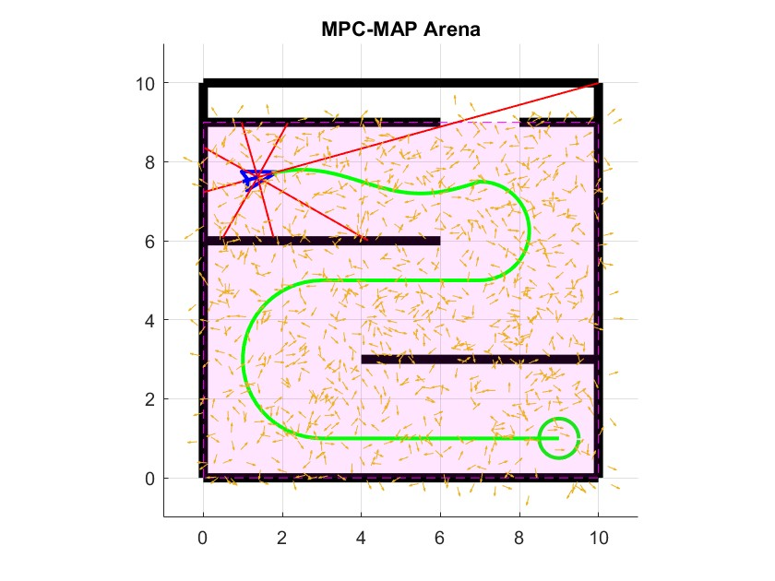

Task 2
In the correction step, particle weights were computed by comparing predicted and measured lidar data using the Euclidean distance. Particles with smaller error were assigned higher weights, reflecting better agreement with the real measurements. The weights were then normalized to form a valid probability distribution.

Task 3
Resampling is implemented using Thrun’s roulette wheel algorithm. Particles are selected based on their weights, where particles with higher weights are more likely to be duplicated. Low-weight particles are removed, which helps concentrate the particle set around the most probable robot pose.

Task 4
Particles were initialized randomly in the indoor map and updated in each iteration by prediction, correction and resampling. After tuning the motion noise and weighting function, the particles converged around the true robot pose. The most important parameters were the number of particles, motion noise and weighting method. The main issue was correct comparison of LiDAR measurements and stable convergence of the particle filter.
