MPC-MAP Assignment No. 5 - Report

Author: Petr Veselý

Date: 27.04.2026

Task 1

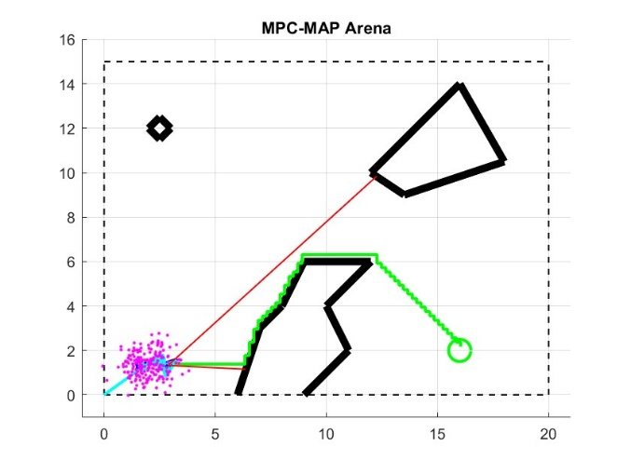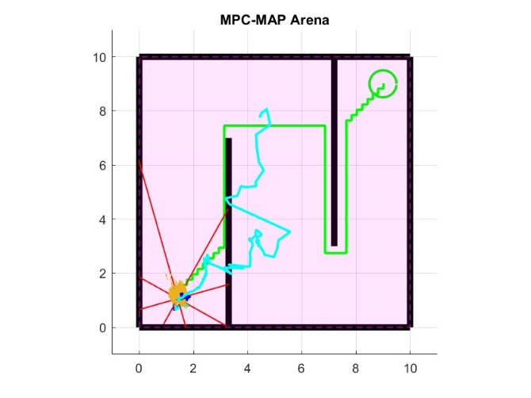

Task 2

To ensure a safe trajectory, the map was converted into a grid and obstacles were inflated by a required clearance, allowing the A* algorithm to plan a path at a safe distance from walls.

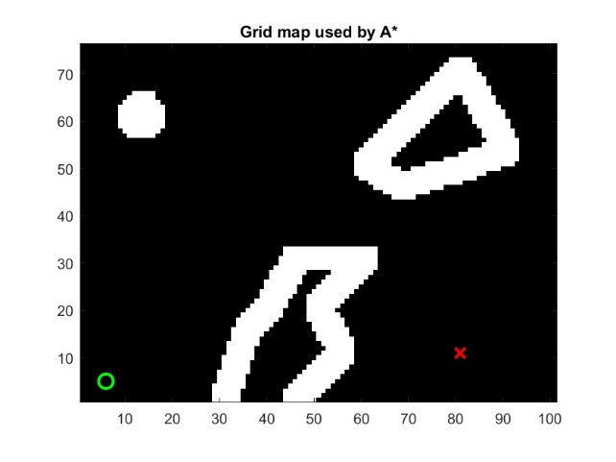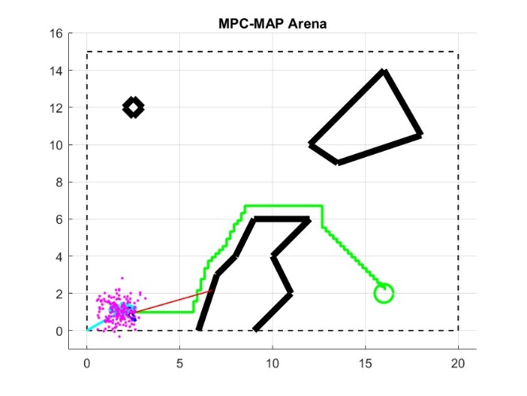
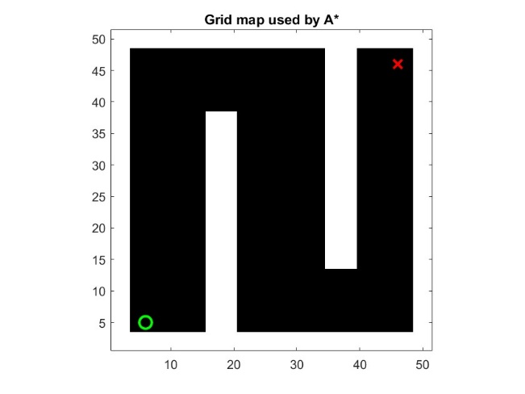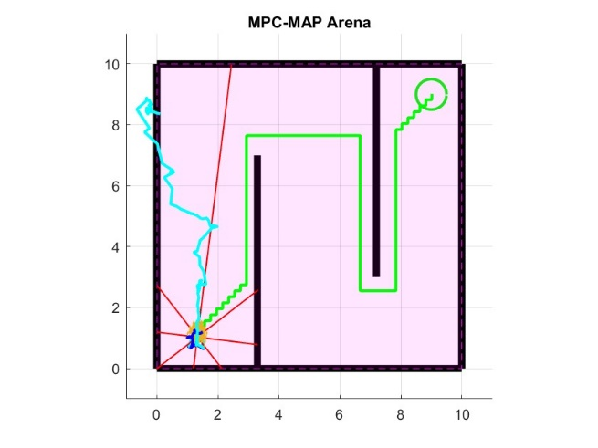

Task 3
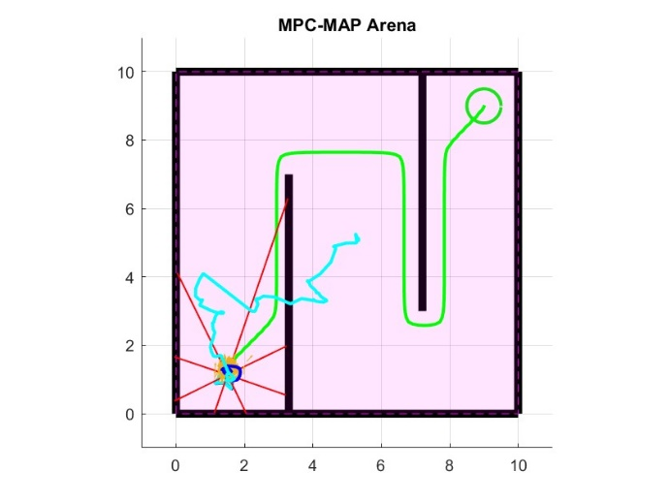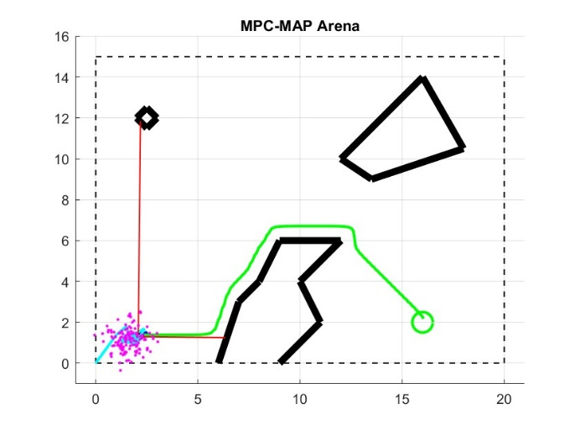
The path was smoothed using an iterative method, where alfa controls adherence to the original path, beta controls smoothness, and the number of iterations determines how strongly the smoothing is applied.

