EC2 Exercies

1. Create a UBUNTU EC2 instance (free tiers). The name of this instance is “Ubuntu_ChooseYourName”
Answer each of the following questions: (Make screenshots)

a) Use the Secure Shell “ssh” in Windows cmd command line to get access to this EC2 instance.
Do whatever is necessary to get ride of “vockey” to access the instance. Use a password instead the “vockey”
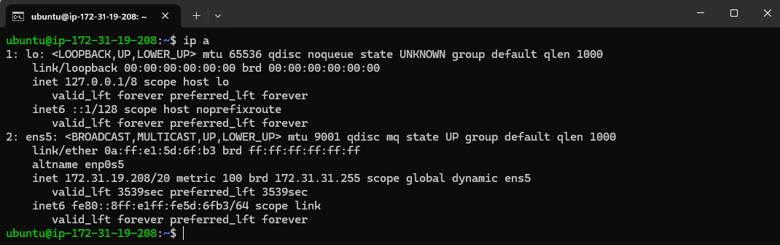

b) Install in this EC2 Ubuntu instance Apache Web Server

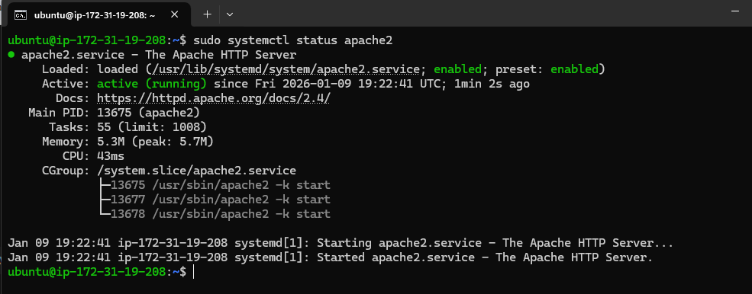

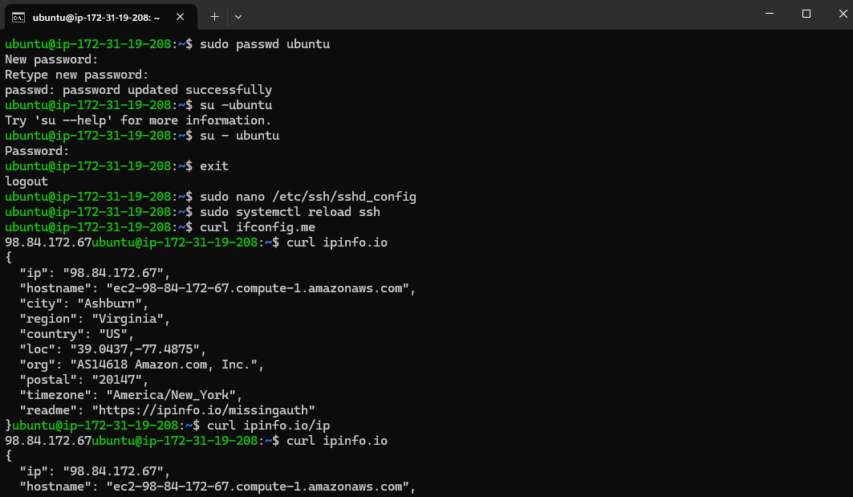

c) Open port 80 in the EC2 Security Group in order to check that the Apache web server is working.

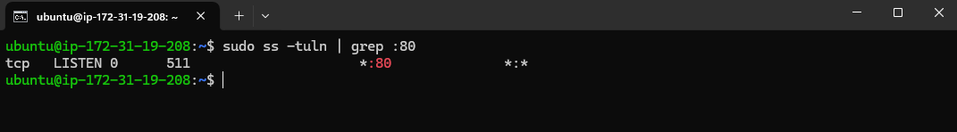

d) Change the content of the default Apache´s web page /var/www/html/ for one of the web pages you have already created in Markup Language subject. Use the (Secure Copy) scp command to do this

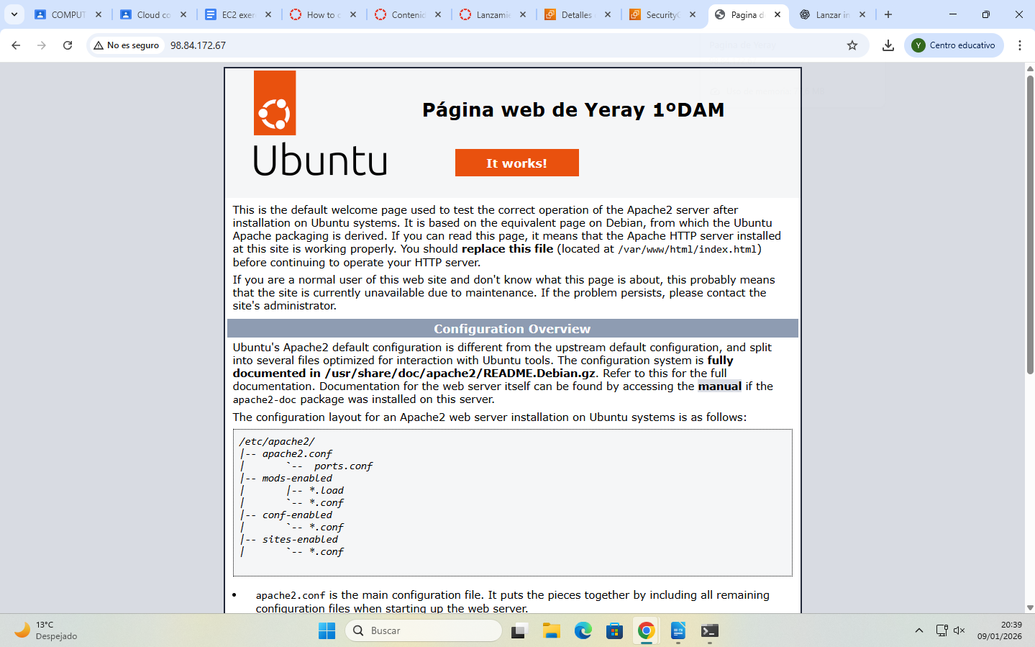

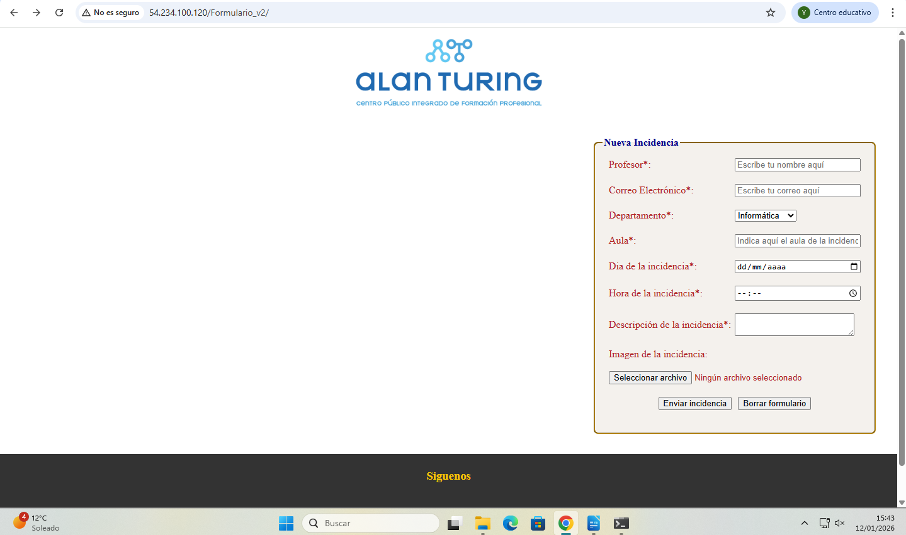

2. Create a Windows E
C2 instance (free tiers). The name of this instance is “WindowsServer”. Answer each of the following questions: (Make screenshots)

a) Use RDP to access this EC2 instance.

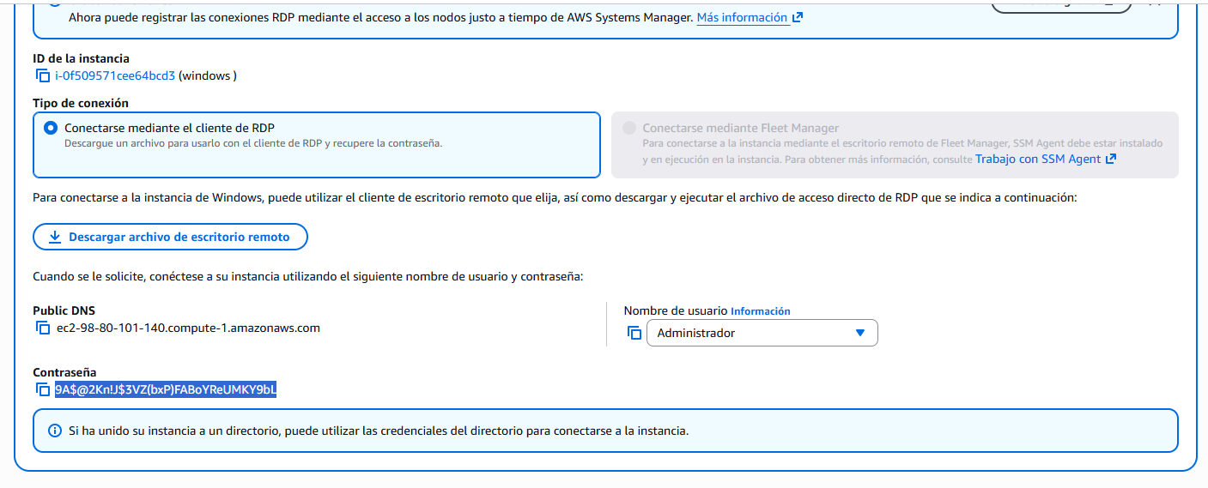

b) Create three new users: “Peter”, “Ana”, “Sam”. Create a password to each of them.

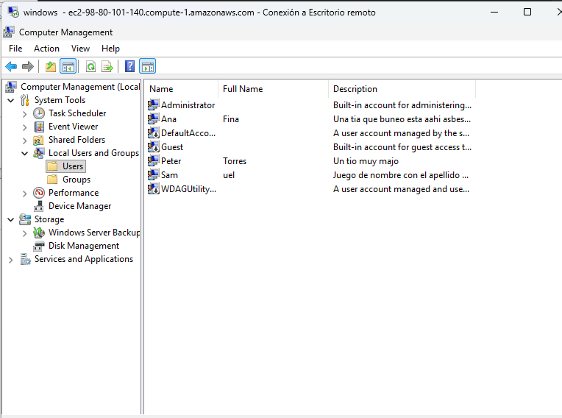

c) Create a group called “Students” and make “Peter”, “Ana” and “Sam” to be part of this group.

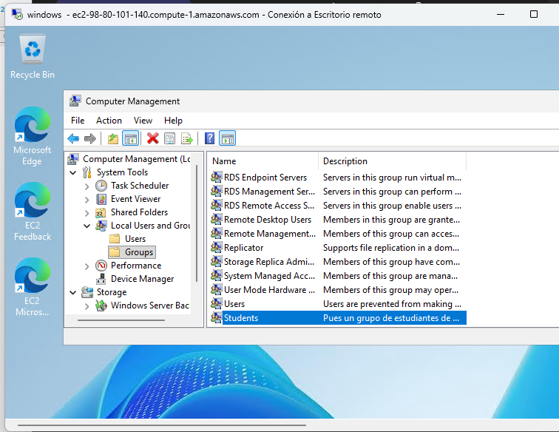

d) Create a shared folder “Documentation” in “c:\Documentation”. This folder is going to be shared in write and read mode with the group “Students”.

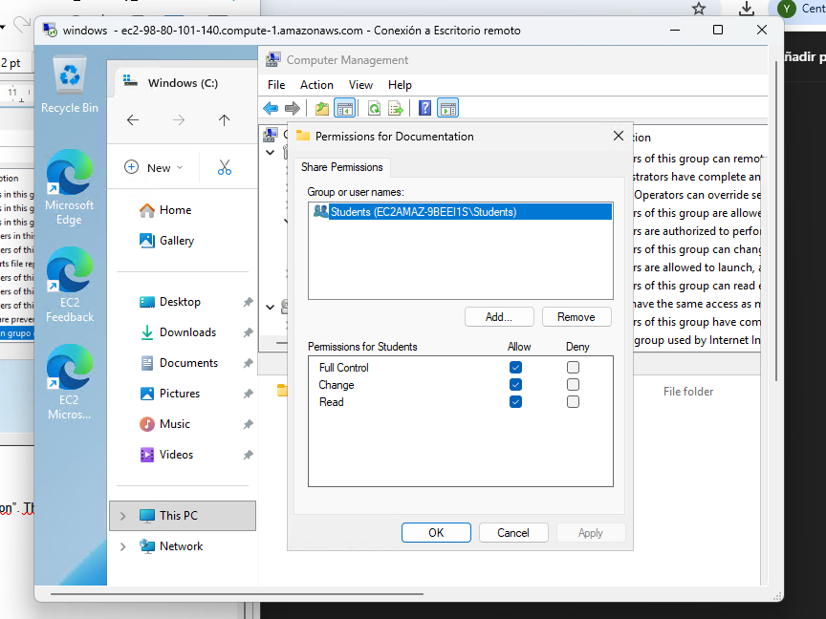

e) Open the necessary port in the EC2 Security Group in order to check that SMB will work.

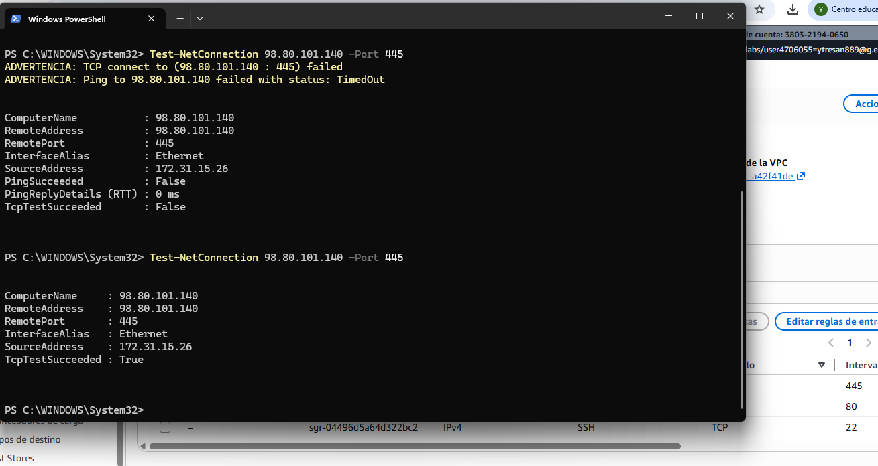
f) Test from your computer that it is possible to access the “Documentation” shared folder in this Windows EC2 instance using the correct credentials.
