Watersports

CS27020 Assignment by Petter Vang Brakalsvalet

November 7, 2018

Contents

Database example 1

Dependencies 3

Normalisation 3

UNF -> 1NF 3

1NF -> 2NF 3

2NF -> 3NF 3

ER diagram 4

PostgreSQL 4

Creating tables 4

Adding all tuples 5

Tuples for Tutors 5

Tuples for meetings 5

Tuples for equipment 5

Tuples for used equipment 5

Tuples for the main table Watersports 6

Queries 6

Assignment part 6.1 6

Assignment part 6.2 6

Assignment part 6.3 6

Evaluation 7

Planning 7

SQL 7

# Database example

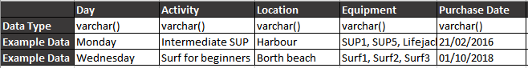  
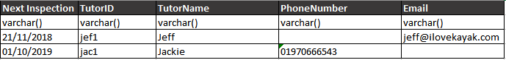

These are all the different table headers I’m using in my database. As you can see, I’m only using varchar in different lengths. The reason I used varchar is because I couldn’t find a better way to do this. I wanted to use the data type data, but I could not get it to work in the time we had so I stuck with what I know how to use. As you can see in the table above, I had to use varchar for the PhoneNumber as well. This is because if I tried to use an integer, it would remove the 0 at the beginning of the number and that would make the phone number invalid.

# Dependencies

Watersport is dependent on TutorID from table Tutor, and Day and Activity from table Meeting.

Used equipment table is dependent on Day and Activity form table Meeting, and Equipment from table Equipment.

# Normalisation

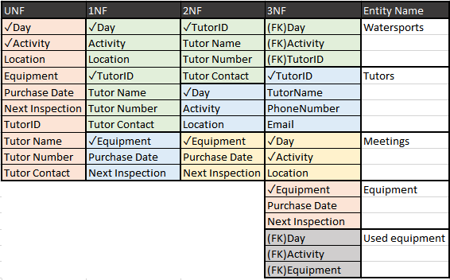

## UNF -> 1NF

First, I separated all the data, so I would have no repeating data in my tuples so that every tuple has atomic data in it. I did that by making a new table for the repeating equipment and keeping the rest in one table for now.

## 1NF -> 2NF

In the second normal form, I separated the table so that the attributes in the table are dependent on the domain but are also dependent on other tables.

## 2NF -> 3NF

In the third normal form, I separated the tables so that none of the tables are dependent on any other tables. If one table needs some of the tuples from another table, I can take that tuple from the first table and add it to the second table as a foreign key; so that the tables aren’t dependent on the other tables, but the attributes from the tables.

# ER diagram

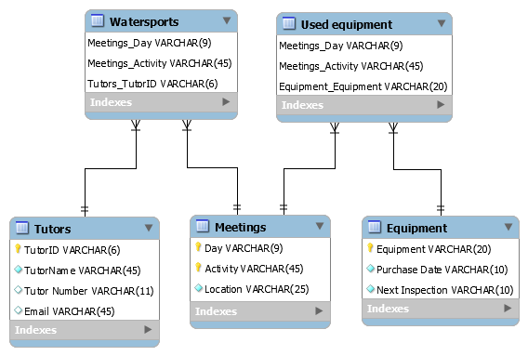

# PostgreSQL

## Creating tables

This is the part of the SQL code where I start to create all the different tables and the attributes the tables contain.

**create table** Tutors (**TutorID varchar(**6) **not null**,  
 **TutorName varchar**(45) **not null**, **phoneNumber varchar**(11),

**Email varchar**(45), **primary key** (**TutorID**)  
);  
**create table** Meetings(  
 **Day varchar**(9)**not null**, **Activity varchar**(45) **not null**,  
 **Location varchar**(25) **not null**, **primary key** (**Day**, **Activity**)  
);  
**create table** Equipment(  
 **Equipment varchar**(20) **not null**, **"purchase Date" varchar**(10) **not null**,  
 **"Next inspection" varchar**(10) **not null**, **primary key** (**Equipment**)  
);  
**create table** UsedEquipment(  
 **Day varchar**(9) **not null**, **Activity varchar**(45) **not null**,  
 **Equipment varchar**(20) **not null**, **primary key** (**Day**, **Equipment**),  
 **foreign key** (**Day**, **Activity**) **references** Meetings,  
 **foreign key** (**Equipment**) **references** Equipment  
);  
**create table** Watersports(  
 **Day varchar**(9) **not null**, **Activity varchar**(45) **not null**,  
 **TutorID varchar**(6) **not null**, **primary key** (**TutorID**, **Day**),  
 **foreign key** (**Day**, **Activity**) **references** Meetings,  
 **foreign key** (**TutorID**) **references** Tutors  
);

Adding all tuples

This is where I’m adding all the tuples to the different tables.

Tuples for Tutors **insert into** Tutors **values** (**'daf1'**, **'Dafydd'**, **'07845333444'**);  
**insert into** Tutors **values** (**'mar1'**, **'Mari'**, **'01970666543'**);  
**insert into** Tutors (**TutorID**, **TutorName**, **Email**) **values** (**'jef1'**, **'Jeff'**, **'Jeff@ilovekayk.com'**);  
**insert into** Tutors **values** (**'ahm1'**, **'Ahmed'**, **'07845333444'**);  
**insert into** Tutors **values** (**'jac1'**, **'Jackie'**, **'01970666543'**);

Tuples for meetings **insert into** Meetings **values** (**'Monday'**, **'Beginners kayaking'**, **'Swimming pool'**);  
**insert into** Meetings **values** (**'Monday'**, **'Beginners SUP'**, **'Harbour'**);  
**insert into** Meetings **values** (**'Monday'**, **'Intermediate SUP'**, **'Harbour'**);  
**insert into** Meetings **values** (**'Tuesday'**, **'Open water swimming'**, **'South beach'**);  
**insert into** Meetings **values** (**'Tuesday'**, **'Intermediate kayaking'**, **'North beach'**);  
**insert into** Meetings **values** (**'Wednesday'**, **'Surf for beginners'**, **'Borth beach'**);  
**insert into** Meetings **values** (**'Thursday'**, **'Beginners kayaking'**, **'Swimming pool'**);

Tuples for equipment **insert into** Equipment **values** (**'Kayak1'**, **'21/02/2016'**, **'21/11/2018'**);  
**insert into** Equipment **values** (**'Kayak2'**, **'21/02/2016'**, **'21/11/2018'**);  
**insert into** Equipment **values** (**'Kayak3'**, **'21/02/2016'**, **'21/11/2018'**);  
**insert into** Equipment **values** (**'Kayak4'**, **'21/02/2016'**, **'21/11/2018'**);  
**insert into** Equipment **values** (**'SUP1'**,**'01/10/2018'**, **'30/10/2018'**);  
**insert into** Equipment **values** (**'SUP2'**,**'01/10/2018'**, **'30/10/2018'**);  
**insert into** Equipment **values** (**'SUP3'**,**'01/10/2018'**, **'30/10/2018'**);  
**insert into** Equipment **values** (**'SUP4'**,**'01/10/2018'**, **'30/10/2018'**);  
**insert into** Equipment **values** (**'SUP5'**,**'01/10/2018'**, **'30/10/2018'**);  
**insert into** Equipment **values** (**'Surf1'**,**'30/03/2017'**, **'30/12/2018'**);  
**insert into** Equipment **values** (**'Surf2'**,**'30/03/2017'**, **'30/12/2018'**);  
**insert into** Equipment **values** (**'Surf3'**,**'30/03/2017'**, **'30/12/2018'**);  
**insert into** Equipment **values** (**'Lifejacket1'**,**'30/06/2018'**, **'30/10/2018'**);  
**insert into** Equipment **values** (**'Lifejacket2'**,**'30/06/2018'**, **'30/10/2018'**);  
**insert into** Equipment **values** (**'Lifejacket3'**,**'30/06/2018'**, **'30/10/2018'**);  
**insert into** Equipment **values** (**'Lifejacket4'**,**'30/06/2018'**, **'30/10/2018'**);  
**insert into** Equipment **values** (**'Lifejacket5'**,**'30/06/2018'**, **'30/10/2018'**);

Tuples for used equipment   
**insert into** UsedEquipment **values** (**'Monday'**, **'Beginners kayaking'**, **'Kayak1'**);  
**insert into** UsedEquipment **values** (**'Monday'**, **'Beginners kayaking'**, **'Kayak2'**);  
**insert into** UsedEquipment **values** (**'Monday'**, **'Beginners kayaking'**, **'Kayak3'**);  
**insert into** UsedEquipment **values** (**'Monday'**, **'Beginners SUP'**, **'SUP2'**);  
**insert into** UsedEquipment **values** (**'Monday'**, **'Beginners SUP'**, **'SUP3'**);  
**insert into** UsedEquipment **values** (**'Monday'**, **'Beginners SUP'**, **'SUP4'**);  
**insert into** UsedEquipment **values** (**'Monday'**, **'Beginners SUP'**, **'Lifejacket2'**);  
**insert into** UsedEquipment **values** (**'Monday'**, **'Beginners SUP'**, **'Lifejacket3'**);  
**insert into** UsedEquipment **values** (**'Monday'**, **'Beginners SUP'**, **'Lifejacket5'**);  
**insert into** UsedEquipment **values** (**'Monday'**, **'Intermediate SUP'**, **'SUP1'**);  
**insert into** UsedEquipment **values** (**'Monday'**, **'Intermediate SUP'**, **'SUP5'**);  
**insert into** UsedEquipment **values** (**'Monday'**, **'Intermediate SUP'**, **'Lifejacket1'**);  
**insert into** UsedEquipment **values** (**'Monday'**, **'Intermediate SUP'**, **'Lifejacket4'**);  
**insert into** UsedEquipment **values** (**'Tuesday'**,**'Intermediate kayaking'**,**'Kayak2'**);  
**insert into** UsedEquipment **values** (**'Tuesday'**,**'Intermediate kayaking'**,**'Kayak3'**);  
**insert into** UsedEquipment **values** (**'Tuesday'**,**'Intermediate kayaking'**,**'Kayak4'**);  
**insert into** UsedEquipment **values** (**'Tuesday'**,**'Intermediate kayaking'**,**'Lifejacket2'**);  
**insert into** UsedEquipment **values** (**'Tuesday'**,**'Intermediate kayaking'**,**'Lifejacket3'**);  
**insert into** UsedEquipment **values** (**'Tuesday'**,**'Intermediate kayaking'**,**'Lifejacket5'**);  
**insert into** UsedEquipment **values** (**'Wednesday'**,**'Surf for beginners'**,**'Surf1'**);  
**insert into** UsedEquipment **values** (**'Wednesday'**,**'Surf for beginners'**,**'Surf2'**);  
**insert into** UsedEquipment **values** (**'Wednesday'**,**'Surf for beginners'**,**'Surf3'**);

**insert into** UsedEquipment **values** (**'Thursday'**, **'Beginners kayaking'**, **'Kayak1'**);  
**insert into** UsedEquipment **values** (**'Thursday'**, **'Beginners kayaking'**, **'Kayak2'**);  
**insert into** UsedEquipment **values** (**'Thursday'**, **'Beginners kayaking'**, **'Kayak4'**);

Tuples for the main table Watersports **insert into** Watersports **values** (**'Monday'**, **'Beginners kayaking'**, **'daf1'**);  
**insert into** Watersports **values** (**'Monday'**, **'Beginners SUP'**, **'mar1'**);  
**insert into** Watersports **values** (**'Monday'**, **'Intermediate SUP'**, **'jef1'**);  
**insert into** Watersports **values** (**'Tuesday'**, **'Open water swimming'**, **'ahm1'**);  
**insert into** Watersports **values** (**'Tuesday'**, **'Intermediate kayaking'**, **'daf1'**);  
**insert into** Watersports **values** (**'Wednesday'**, **'Surf for beginners'**, **'jac1'**);  
**insert into** Watersports **values** (**'Thursday'**, **'Beginners kayaking'**, **'ahm1'**);

# Queries

Assignment part 6.1

**Question: Find all tutors who teach on a given day (say ‘Monday’);**

To do this I’m saying that I want the TutorName from the table Tutor. The way we are obtaining this is by joining Watersports and the Tutor tables together and saying that the TutorID in both of these tables is the same. However, I only want the name of the tutors who are tutoring on a Monday.

**select TutorName from** Tutors **join** Watersports  
 **ON** Tutors.**TutorID** = Watersports.**TutorID WHERE** Watersports.**Day** = **'Monday'**;

**This is the results from the query:**

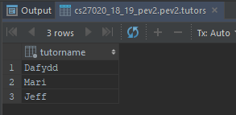

As you can see Dafydd, Mari and Jeff is tutoring an activity on Monday.

Assignment part 6.2   
**Question: Kayak4 is missing – find the contact details of all tutors who have led classes involving this boat.**

To do this I’m saying that I want the TutorName, phoneNumber and Email from the Tutor table by joining it to the Watersport table and telling it that TutorID is the same in both tables. However, I also need to join UsedEquipment to Watersport and clarify that Activity is the same in both tables. Then, I’m saying that I need to select the people that have used the Equipment ‘Kayak4’. However, I’m also saying that the day in UsedEquipment and the day in Watersports have to be the same.

**select TutorName**, **phoneNumber**, **Email from** Tutors **join** Watersports  
 **on** Tutors.**TutorID** = Watersports.**TutorID join** UsedEquipment  
 **on** Watersports.**Activity** = UsedEquipment.**Activity where  
 Equipment** = **'Kayak4' and** UsedEquipment.**Day** = Watersports.**Day**;

**This is the results from the query:**

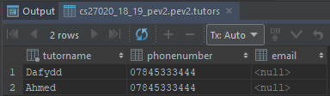

As you can see Dafydd and Ahmed has used Kayak4 during this week.

Assignment part 6.3

**Question: Find all equipment which is not booked on a particular day, again, say ‘Monday’ (and can therefore be hired).**  
To do this, I’m saying that I want equipment from the Equipment table. I’m doing that by joining it to the UsedEquipment table and saying that the Equipment in both of them is the same; also, the second select statement must be ‘notted’ in order to return all the equipment that ISN’T used on a Monday.  
select distinct Equipment.Equipment from Equipment join UsedEquipment  
 on Equipment.Equipment = UsedEquipment.Equipment where UsedEquipment.Equipment NOT IN  
 (select UsedEquipment.Equipment from UsedEquipment where Day = 'Monday');

**This is the results from the query:**  
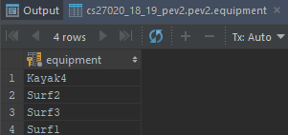  
As you see Kayak4, Surf1, Surf2, Surf3 is the unused equipment on Monday.

# Evaluation

I believe that I deserve 70-80% on this assignment. I feel this because I think my solution is a good and efficient solution but there is probably a better way to do it, and I know that my write-up isn’t the best and most detailed, but I think it explains what I did.

## Planning

I found the first parts of the assignment quite easy once I understood what the question was. However, I had many problems with the normalisation of the tables, because I feel like the test we have to do for the normalisations are vague, and it’s very much up to interpretation by the user.

## SQL

I found that the SQL bit of this was quite simple, but it was a lot of repetitive commands that I had to use to add all the tuples for the tables. I also wrote the SQL in JetBrains IntelliJ because I like the IntelliJ layout and the ease of use. IntelliJ also keeps all the commands I have used for each table, and I can then easily see what I have done if I have a problem.